TEACHERS – please pass this on to your School Council Rep. Thank you
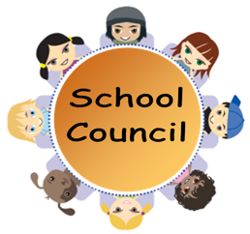
School Council Meeting
Friday 11th October 2019
12:30pm in The Library

Minutes of the Meeting

Present at the Meeting
Stars: Jacob Milky Way: Ben
Galaxy: Skyla Comets: Noah
Saturn: Freya Jupiter: Lottie
Mars: Xavier Venus: Ruby
Mercury: Joshua
Neptune: Evangeline Earth: Brady
Mrs Hardy Mrs Chodynicki

- Welcome, Introductions & Apologies
Mrs C welcomed everyone to the meeting.
Pluto: Joel Dunn was unable to come today.

- Actions from last meeting
Mrs C has ordered the School Council badges and they will be given out in Achievement Assembly. Please wear them as often as you can to promote School Council.

- Chairperson & Secretary
The children who were interested in taking on an extra job for School Council told everyone why. We voted for the jobs and this was the result:
Chairperson: Joel
Deputy Chairperson: Xavier
Secretary: Joshua B
Congratulations and thank you for putting yourselves forward.

- Any Other Business
None

- Date of the next meeting
Friday 1st November, 12:30pm in Earth Classroom.

