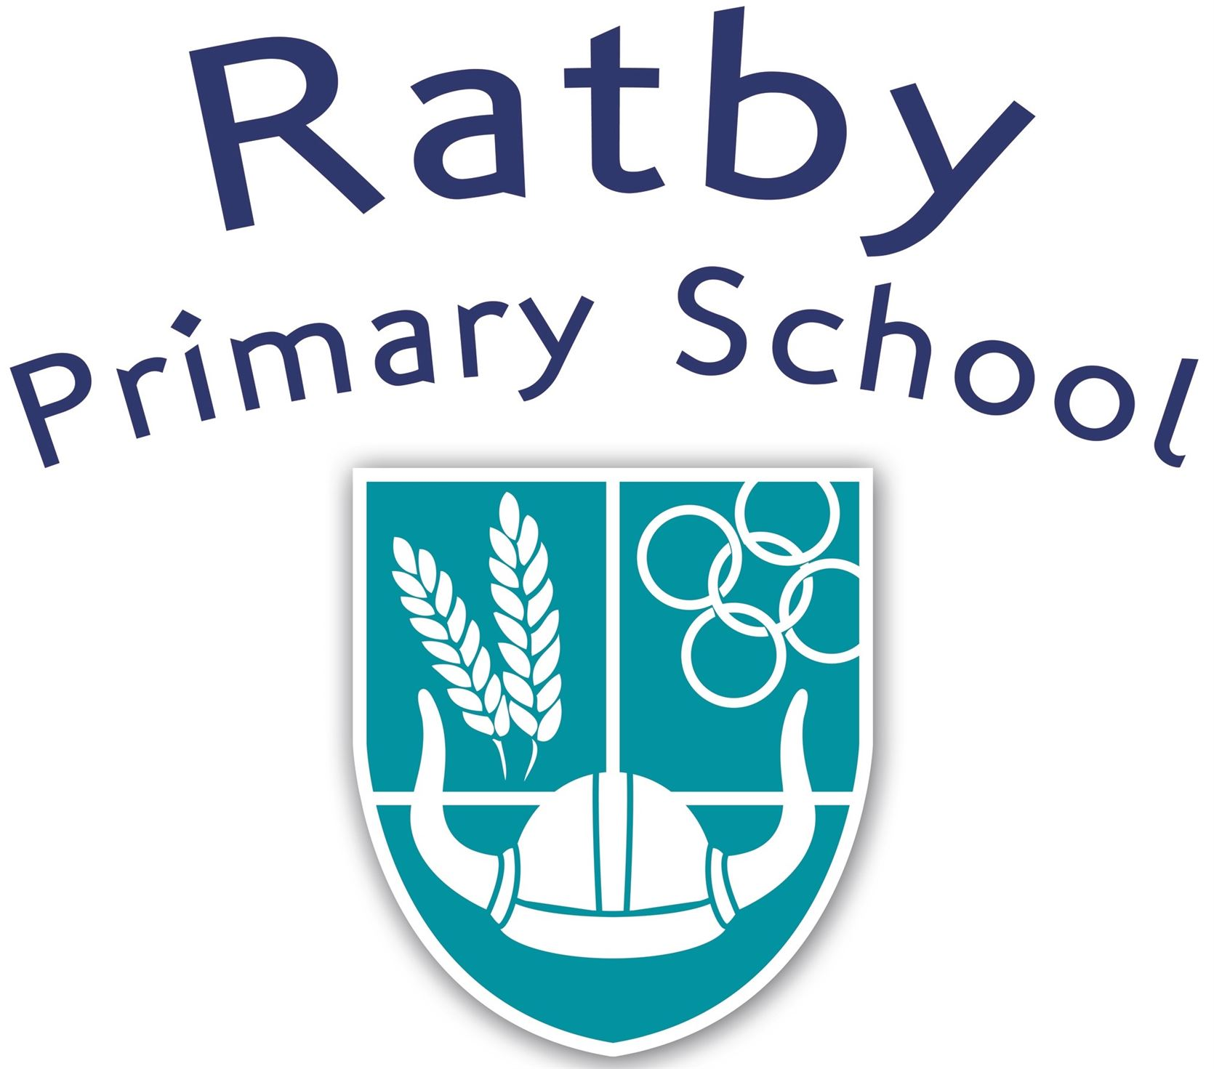



100 Book List Challenge

Key Stage 1

|  |  |  |  |  |  |  |  |  |
| --- | --- | --- | --- | --- | --- | --- | --- | --- |
|  |  |  |  |  |  |  |  |  |
| A Bear Called Paddington  Michael Bond |  | Flat Stanley  Jeff Brown |  | Each Peach Pear Plum  Janet & Allan Ahlberg |  | The Smowman  Raymond Briggs |  | Room On The Broom  Julia Donaldson and Axel Sheffler |
|  |  |  |  |  |  |  |  |  |
| Lost and Found  Oliver Jeffers |  | Sox and Pals  B B Taylor |  | The Tiger Who Came To Tea  Judith Kerr |  | Not Now Bernard  David McKee |  | I Want My Hat Back  Jon Klassen |
|  |  |  |  |  |  |  |  |  |
| I Will Never Not Eat A Tomato  Lauren Child |  | Where The Wild Things Are  Maurice Sendak |  | Owl Babies  Martin Waddell |  | I Can Only Draw Worms  Will Mabbit |  | We’re Going On A Bear Hunt  Michael Rosen |
|  |  |  |  |  |  |  |  |  |
| Supertato  Sue Hendra |  | Stanley’s Stick  John Hegley |  | The Very Hungry Caterpillar  Eric Carle |  | The Day The Crayons Quit  Oliver Jeffers |  | There Was An Old Lady Who Swallowed A Fly  Pam Adams |
|  |  |  |  |  |  |  |  |  |
| If You Give A Mouse A Cookie  Laura Joffe Numeroff |  | Dogger  Shirley Hughes |  | The Tunnel  Anthony Browne |  | Mr Bump  Roger Hargreaves |  | Avocado Baby  John Burningham |
|  |  |  |  |  |  |  |  |  |
| Aliens Love Underpants  Claire Freedman & Ben Cort |  | The Cat In The Hat  Dr Seuss |  | The Book With No Pictures  BJ Novak |  | The Mousehole Cat  Antonia Barber |  | The Fantastic Mr Fox  Roald Dahl |
|  |  |  |  |  |  |  |  |  |
| Beegu  Alexis Deacon |  | The Jolly Postman  Janet & Allan Ahlberg |  | Meerkat Mail  Emily Gravett |  | Meg and Mog  Helen Nicoll & Jan Piekowski |  | Pumpkin Soup  Helen Cooper |
|  |  |  |  |  |  |  |  |  |
| The Loudest Roar  Thomas Taylor |  | Traction Man  Mini Grey |  | Giraffes Can’t Dance  Giles Andrea and Guy Parker Rees |  | Burglar Bill  Janet and Allan Ahlberg |  | Six Dinner Sid  Inga Moore |
|  |  |  |  |  |  |  |  |  |
| The True Story Of The 3 Little Pigs  Jon Scieska |  | Would You Rather…  John Burningham |  | The Bog Baby  Jenne Willis and Glen Millward |  | The Bear and The Piano  David Litchfield |  | The Bear Who Stared  Duncan Beedie |
|  |  |  |  |  |  |  |  |  |
| Leon and the Place Between  Angela McAllister and Grahame Baker-Smith |  | Dave’s Cave  Frann Preston-Gannon |  | Peace At Last  Jill Murphy |  | Farmer Duck  Martin Waddell and Helen Oxbury |  | The Rainbow Fish  Marcus Pfister |
|  |  |  |  |  |  |  |  |  |
| The Owl Who Was Afraid Of The Dark  Jill Tomlinson |  | Journey  Aaron Becker |  | We’re All Wonders  RJ Palacio |  | A First Book Of Animals  Nicola Davies |  | Funnybones  Janet & Allan Ahlberg |
|  |  |  |  |  |  |  |  |  |
| Jack and the Flumflum Tree  Julia Donaldson |  | Elmer  Dacid McKee |  | The Tale Of Peter Rabbit  Beatrix Potter |  | Handa’s Surprise  Eileen Browne |  | The Great Dog Bottom Swap  Peter Bently & Mel Matsuoka |
|  |  |  |  |  |  |  |  |  |
| The Grumpalump  Sarah Hayes |  | Zagazoo  Quentin Blake |  | The Snail and the Whale  Julia Donaldson |  | Dear Mother Goose  Michael Rosen and Nick Sharratt |  | The Storm Whale  Benji Davies |
|  |  |  |  |  |  |  |  |  |
| The Tin Forest  Helen Ward and Wayne Anderson |  | The Giant Jam Sandwich  John Vernon Lord and Janet Burroway |  | Funny Fairy Tales  Laurence Anholt and Arthut Robins |  | Please Mr Panda  Steve Antony |  | Mama Panya’s Pancakes  Mary and Rich |
|  |  |  |  |  |  |  |  |  |
| The Enormous Crocodile  Roald Dahl |  | Tattybogle  Sandra Horn & Ken Brown |  | Badger’s Parting Gifts  Susan Varley |  | That Rabbit Belongs to Emily Bown  Cressida Coweel & Neal Layton |  | The Promise  Nicola Davies |
|  |  |  |  |  |  |  |  |  |
| Flotsam  David Wiesner |  | Otto The Book Bear  Katie Cleminson |  | Rosie’s Walk  Pat Hutchinson |  | A Place To Call Home  Alexis Deacon |  | I’ll Take You To Mrs Cole  Nigel Gray |
|  |  |  |  |  |  |  |  |  |
| Are We There Yet?  Dan Santat |  | Footpath Flowers  Jon Arno Lawson |  | Tortuga  Paul Geraghty |  | The Great Paper Caper  Oliver Jeffers |  | The Snowy Day  Ezra Jack Keats |
|  |  |  |  |  |  |  |  |  |
| The Giving Tree  Shel Silverstein |  | The Story of Babar  Jean De Brunhoff |  | The Polar Express  Chris Van Allsburg |  | No, David!  David Shannon |  | Don’t Let The Pigeon Drive The Bus  Mo Willems |
|  |  |  |  |  |  |  |  |  |
| Goodnight Moon  Margaret Wise Brown |  | Make Way For Ducklings  Robert McCloskey |  | Knuffle Bunny  Mo Willems |  | Alexander and the Terrible, Horrible, No Good, Very Bad Day  Judith Viorst |  | Edward The Emu  Sheena Knowles |
|  |  |  |  |  |  |  |  |  |
| Who Sank The Boat?  Pamela Allen |  | Where The Forest Meets The Sea  Jeannie Baker |  | Guess How Much I Love you  Sam McBratney |  | The Whisperer  Nick Butterworth |  | The Gruffalo  Julia Donaldson |

|  |  |  |  |  |  |  |
| --- | --- | --- | --- | --- | --- | --- |
|  | **Book Title & Author** | **Date** |  |  | **Book Title & Author** | **Date** |
| 1 | A Bear Called Paddington  Michael Bond |  |  | 26 | The Cat In The Hat  Dr Seuss |  |
| 2 | Lost and Found  Oliver Jeffers |  |  | 27 | The Jolly Postman  Janet & Allan Ahlberg |  |
| 3 | I Will Never Not Eat A Tomato  Lauren Child |  |  | 28 | Traction Man  Mini Grey |  |
| 4 | Supertato  Sue Hendra |  |  | 29 | Would You Rather…  John Burningham |  |
| 5 | If You Give A Mouse A Cookie  Laura Joffe Numeroff |  |  | 30 | Dave’s Cave  Frann Preston-Gannon |  |
| 6 | Aliens Love Underpants  Claire Freedman & Ben Cort |  |  | 31 | Journey  Aaron Becker |  |
| 7 | Beegu  Alexis Deacon |  |  | 32 | Elmer  Dacid McKee |  |
| 8 | The Loudest Roar  Thomas Taylor |  |  | 33 | Zagazoo  Quentin Blake |  |
| 9 | The True Story Of The 3 Little Pigs  Jon Scieska |  |  | 34 | The Giant Jam Sandwich  John Vernon Lord and Janet Burroway |  |
| 10 | Leon and the Place Between  Angela McAllister and Grahame Baker-Smith |  |  | 35 | Tattybogle  Sandra Horn & Ken Brown |  |
| 11 | The Owl Who Was Afraid Of The Dark  Jill Tomlinson |  |  | 36 | Otto The Book Bear  Katie Cleminson |  |
| 12 | Jack and the Flumflum Tree  Julia Donaldson |  |  | 37 | Footpath Flowers  Jon Arno Lawson |  |
| 13 | The Grumpalump  Sarah Hayes |  |  | 38 | The Story of Babar  Jean De Brunhoff |  |
| 14 | The Tin Forest  Helen Ward and Wayne Anderson |  |  | 39 | Make Way For Ducklings  Robert McCloskey |  |
| 15 | The Enormous Crocodile  Roald Dahl |  |  | 40 | Where The Forest Meets The Sea  Jeannie Baker |  |
| 16 | Flotsam  David Wiesner |  |  | 41 | Each Peach Pear Plum  Janet & Allan Ahlberg |  |
| 17 | Are We There Yet?  Dan Santat |  |  | 42 | The Tiger Who Came To Tea  Judith Kerr |  |
| 18 | The Giving Tree  Shel Silverstein |  |  | 43 | Owl Babies  Martin Waddell |  |
| 19 | Goodnight Moon  Margaret Wise Brown |  |  | 44 | The Very Hungry Caterpillar  Eric Carle |  |
| 20 | Who Sank The Boat?  Pamela Allen |  |  | 45 | The Tunnel  Anthony Browne |  |
| 21 | Flat Stanley  Jeff Brown |  |  | 46 | The Book With No Pictures  BJ Novak |  |
| 22 | Sox and Pals  B B Taylor |  |  | 47 | Meerkat Mail  Emily Gravett |  |
| 23 | Where The Wild Things Are  Maurice Sendak |  |  | 48 | Giraffes Can’t Dance  Giles Andrea and Guy Parker Rees |  |
| 24 | Stanley’s Stick  John Hegley |  |  | 49 | The Bog Baby  Jenne Willis and Glen Millward |  |
| 25 | Dogger  Shirley Hughes |  |  | 50 | Peace At Last  Jill Murphy |  |

|  |  |  |  |  |  |  |
| --- | --- | --- | --- | --- | --- | --- |
|  | **Book Title & Author** | **Date** |  |  | **Book Title & Author** | **Date** |
| 51 | We’re All Wonders  RJ Palacio |  |  | 76 | A Place To Call Home  Alexis Deacon |  |
| 52 | The Tale Of Peter Rabbit  Beatrix Potter |  |  | 77 | The Great Paper Caper  Oliver Jeffers |  |
| 53 | The Snail and the Whale  Julia Donaldson |  |  | 78 | No, David!  David Shannon |  |
| 54 | Funny Fairy Tales  Laurence Anholt and Arthut Robins |  |  | 79 | Alexander and the Terrible, Horrible, No Good, Very Bad Day  Judith Viorst |  |
| 55 | Badger’s Parting Gifts  Susan Varley |  |  | 80 | The Whisperer  Nick Butterworth |  |
| 56 | Rosie’s Walk  Pat Hutchinson |  |  | 81 | Room On The Broom  Julia Donaldson and Axel Sheffler |  |
| 57 | Tortuga  Paul Geraghty |  |  | 82 | I Want My Hat Back  Jon Klassen |  |
| 58 | The Polar Express  Chris Van Allsburg |  |  | 83 | We’re Going On A Bear Hunt  Michael Rosen |  |
| 59 | Knuffle Bunny  Mo Willems |  |  | 84 | There Was An Old Lady Who Swallowed A Fly -Pam Adams |  |
| 60 | Guess How Much I Love you  Sam McBratney |  |  | 85 | Avocado Baby  John Burningham |  |
| 61 | The Smowman  Raymond Briggs |  |  | 86 | The Fantastic Mr Fox  Roald Dahl |  |
| 62 | Not Now Bernard  David McKee |  |  | 87 | Pumpkin Soup  Helen Cooper |  |
| 63 | I Can Only Draw Worms  Will Mabbit |  |  | 88 | Six Dinner Sid  Inga Moore |  |
| 64 | The Day The Crayons Quit  Oliver Jeffers |  |  | 89 | The Bear Who Stared  Duncan Beedie |  |
| 65 | Mr Bump  Roger Hargreaves |  |  | 90 | The Rainbow Fish  Marcus Pfister |  |
| 66 | The Mousehole Cat  Antonia Barber |  |  | 91 | Funnybones  Janet & Allan Ahlberg |  |
| 67 | Meg and Mog  Helen Nicoll & Jan Piekowski |  |  | 92 | The Great Dog Bottom Swap  Peter Bently & Mel Matsuoka |  |
| 68 | Burglar Bill  Janet and Allan Ahlberg |  |  | 93 | The Storm Whale  Benji Davies |  |
| 69 | The Bear and The Piano  David Litchfield |  |  | 94 | Mama Panya’s Pancakes  Mary and Rich |  |
| 70 | Farmer Duck  Martin Waddell and Helen Oxbury |  |  | 95 | The Promise  Nicola Davies |  |
| 71 | A First Book Of Animals  Nicola Davies |  |  | 96 | I’ll Take You To Mrs Cole  Nigel Gray |  |
| 72 | Handa’s Surprise  Eileen Browne |  |  | 97 | The Snowy Day  Ezra Jack Keats |  |
| 73 | Dear Mother Goose  Michael Rosen and Nick Sharratt |  |  | 98 | Don’t Let The Pigeon Drive The Bus  Mo Willems |  |
| 74 | Please Mr Panda  Steve Antony |  |  | 99 | Edward The Emu  Sheena Knowles |  |
| 75 | That Rabbit Belongs to Emily Bown  Cressida Coweel & Neal Layton |  |  | 100 | The Gruffalo  Julia Donaldson |  |