Our Rules to Keep Us Safe at School

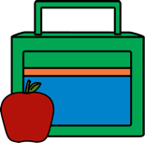
- Wash your hands before leaving your house and travelling to school.
- Bring ONLY a water bottle, lunch-box, a coat and sun-hat to school.
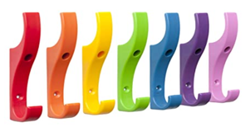
- On arrival, go straight to your classroom with you coat on (weather dependent)
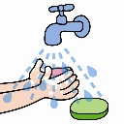
- DO NOT use the cloakrooms
- On entering the classroom wash and dry your hands
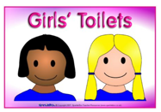
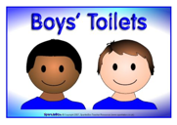
- Follow the arrows when you are moving around school.
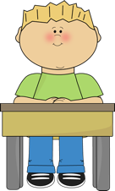
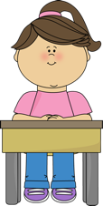
- Use ONLY the toilets for your group.
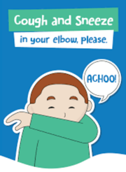
- In the classroom, ONLY sit at the table with your name on.
- If you sneeze or cough, catch it in your elbow.
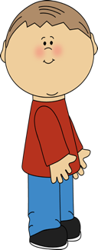
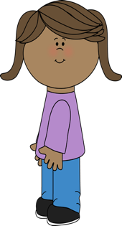
- At play-times, play only in the area which you asked to play in.
2m
- Try to keep 2 meters away from other people.
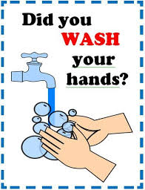
- Try not to touch anybody else in school.
- Wash your hands with soap, for 20 seconds, after going to the toilet.
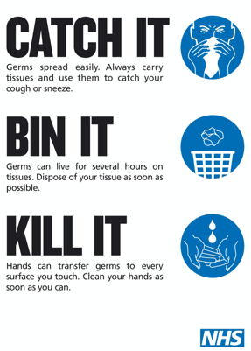
- Wash your hands with soap, for 20 seconds, before you eat.
- If you cough or sneeze follow the guide “catch it, bin it, kill it” and wash your hands straight away

- If you feel unwell tell an adult straight away

