A new way to record, track and monitor homework at Ratby Primary School.
Friday 16th October 2020

We are excited to be launching Show My Homework, an online tool to help you keep track of your child’s homework. Show My Homework will allow you to see the details of the tasks your child has been set, all their deadlines and their submission status and grades. We have decided to bring on this system to improve the way we communicate with parents and give you greater visibility into the homework we set.

You will be provided with a login to set up accounts for each child. You will need to enter a parent’s email address the first time you login to set up each child’s account. This will then link to your child’s homework calendar where you will be able to see your child’s To-do List and any homework that is overdue. These logins will be sent out during week beginning 26th October but in the meantime, you are still able to view all homework.
To view all homework set without login details please visit: https://www.ratbyprimary.co.uk the link for Show My Homework is on our Homework and Remote Learning Page under the Pupils Section. On there you will find a logo link for Satchel One, which will take you to our school page for Show My Homework.
Please note you will need to use the filter options at the top of the page to find your child’s homework.

- 24/7 access
- View quality and quantity of homework
- Translation into over 50 languages
- Apps available for iPhone, iPad, iPod Touch and Android devices
- Receive automated notifications before homework is due

We’ll be launching Show My Homework on Monday 26th October and we hope that this service will provide parents with a deeper insight into the homework your child receives. More importantly, we hope that it will improve your child’s organisation, time-management and help them to keep on top of their workload.

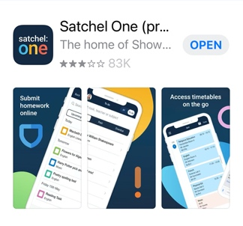
To keep up to date on the move please download the Show My Homework app (Apple Store/Google Play) once you receive your login details, you will then be sent push notifications to let you know what homework is due. You will also be notified of grades, overdue homework and announcements/events.

If you have more than one child you can link the accounts to one email address. Here is the link to the advice to do this:
https://help.satchelone.com/en/articles/3058943-add-another-student-to-your-account

If you or your child have any questions about the service, please don’t hesitate to get in touch with the team at Show My Homework, who are always happy to help. Just visit help.showmyhomework.co.uk or call 0207 197 9550.

Thank you once again for your support.

Yours Sincerely,

Lisa Jones
Headteacher

