Remote Learning

Please see below ideas for additional activities/ideas/information for this half term’s topics as well as other more general links to ideas for remote learning

Year 1: Dinosaur Planet

https://www.nhm.ac.uk/ - National History Museum, London.
http://www.bbc.co.uk/schools/primaryhistory/famouspeople/mary_anning/ - Website on Mary Anning a famous fossil hunter.
https://www.enchantedlearning.com/subjects/dinosaurs - Information about different dinosaurs.
https://www.bbc.co.uk/bitesize/topics/zdp4382/articles/znc3y9q - Dinosaur discovery game.

Year 2: Beat Band Boogie

http://www.bbc.co.uk/learning/schoolradio/subjects/earlylearning/nurserysongs/F-J/duke_of_york - Nursery rhymes with lyrics
http://www.songsforteaching.com/nurseryrhymes/hotcrossbuns.php - Song lyrics and sound clips.
http://www.howcast.com/guides/841-How-to-Make-Musical-Instruments-for-Kids - How to make musical instruments.
http://www.bbc.co.uk/programmes/p00hgq7k - Video clip of bands.
https://www.youtube.com/watch?v=1-s26lBcu_M - Clip of a marching band.

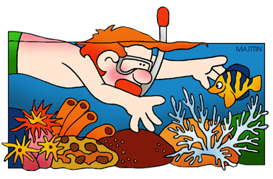Year 3: Blue Abyss

https://greatbarrierreef.org/ - Website all about the Great Barrier Reef.
https://www.attenboroughsreef.com/ - An interactive journey with David Attenborough.
https://primaryfacts.com/4731/antony-gormley-facts-and-information/
https://www.natgeokids.com/uk/discover/animals/sea-life/strange-sea-creatures/

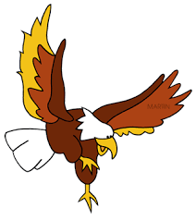Year 4: Predator
http://www.bbc.co.uk/nature/adaptations/Predation - Clips and information about a wide range of predators.
http://animals.nationalgeographic.com/animals/facts/ - Information about animals around the world.
http://www.bbc.co.uk/bitesize/ks2/science/living_things/food_chains/read/1/ - A simple introduction to food chains, including definitions of producers, consumers, predators and prey.
http://www.rspb.org.uk/discoverandenjoynature/families/children/learn/birdsofprey.aspx - Specific birds to research.

Year 5: Hola Mexico

https://www.speakinglatino.com/13-cool-and-interesting-facts-about-the-day-of-the-dead/
https://www.natgeokids.com/uk/discover/geography/countries/country-fact-file-mexico/ - Facts about Mexico
https://www.kids-world-travel-guide.com/mexico-facts.html - A travel guide about Mexico.
https://www.bbcgoodfood.com/recipes/collection/mexican-recipes - A selection of Mexican recipes.

Year 6: Fallen Fields and A Child’s War

http://www.britishlegion.org.uk/
https://www.bbc.co.uk/bitesize/topics/zqhyb9q
http://www.thenma.org.uk/ - The National Memorial Arboretum.
http://www.iwm.org.uk/ - The Imperial War Museum.
http://www.bbc.co.uk/cbbc/shows/horrible-histories - Horrible Histories clips are always very popular.
http://www.nationalarchives.gov.uk/education/greatwar
http://www.firstworldwar.com/
http://www.greatwar.co.uk/
http://www.primaryhomeworkhelp.co.uk/Britain.html
https://www.theschoolrun.com/homework-help/world-war-2

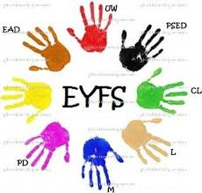

Instagram - @play.hooray – Play Coach for Parents - Live play along session at 10am daily as well as lots of lovely play based activities that you can do at home

Mamatribe – Free Facebook Live Classes including Kids Yoga, Diddi Dance, Kids Musical Tots

Maths

 | Timestable Rockstars (Free with school subscription)  https://ttrockstars.com |  | Prodigy Maths (Free App)  https://www.prodigygame.com
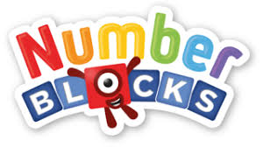 | Cbeebies – Numberblocks  https://www.bbc.co.uk/cbeebies/shows/numberblocks |  | White Rose Maths  https://whiterosemaths.com/homelearning/
 | ICT Games for Literacy & Maths  http://www.ictgames.co.uk |  | Top Marks  Ideal for a range of maths concepts from 3-14 years  https://www.topmarks.co.uk/
 | The Maths Factor  Created by Carol Vorderman - Let Carol teach your child Maths during this difficult period – Join Free today!  https://www.themathsfactor.com |  | My Maths – School Subscription  https://www.mymaths.co.uk

Computing

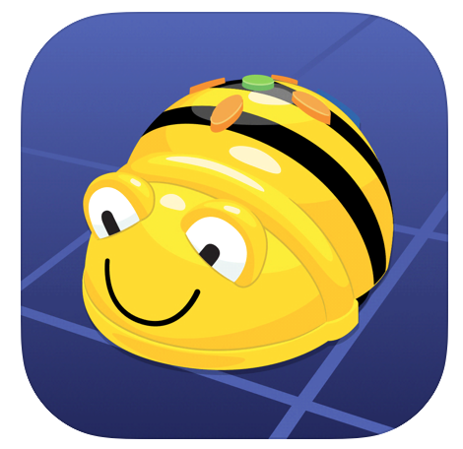 | https://apps.apple.com/gb/app/bee-bot/id500131639 (Free App) |  | Dragon Box (Paid App)  www.dragonbox.com

Reading, Writing, Phonics

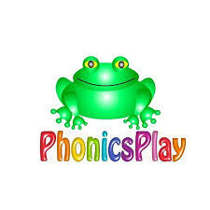 | Phonics Play – Free during the school closure period  https://www.phonicsplay.co.uk  Username:march 20  Password:home |  | Spelling Shed (Free with school subscription  https://www.spellingshed.com
 | Phonics Bloom  https://www.phonicsbloom.com |  | Scholastis Classroom Magazines  https://classroommagazines.scholastic.com/support/learnathome.html
 | Letters and Sounds  http://www.letters-and-sounds.com |  | First News – Download free digital copies of the First News newspaper  https://subscribe.firstnews.co.uk/free-downloadable-issue/
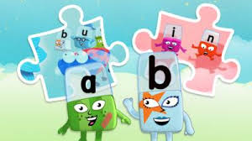 | Cbeebies – Alphablocks  https://www.bbc.co.uk/cbeebies/shows/alphablocks |  | Read Theory  https://readtheory.org
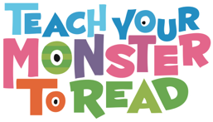 | Teach Your Monster to Read  https://www.teachyourmonstertoread.com |  | Jane Constantine Sentence Builder  A free resource and video to help with sentence writing. A live video that can be watched at a later date https://www.youtube.com/user/Devouefrenchbulldogs
 | Oxford Owl  https://home.oxfordowl.co.uk | 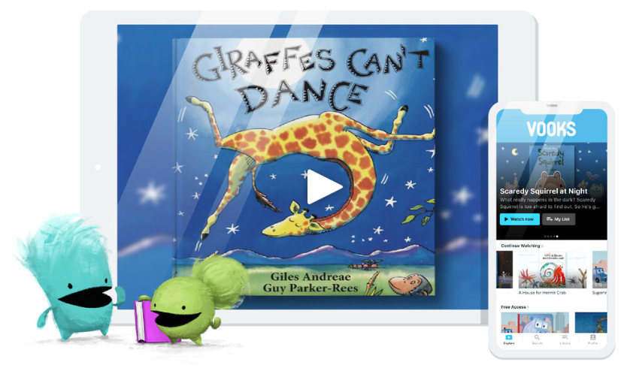 | Vooks – Storybooks Brought to Life  https://www.vooks.com/parent-resources
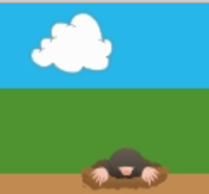 | Teaching Handwriting – Cursive Practise  https://www.teachhandwriting.co.uk |  | Get Epic  A website to access reading books for free for 30 days. Children can pick a range of different books and read through their electronic devices.  https://www.getepic.com/
 | David Walliams Free Audio Books  David Walliams is reading short stories every day at 11am. You don’t have to listen to it at 11, https://www.worldofdavidwalliams.com/elevenses/ |  | BorrowBox  Free to borrow if you have a library card for adults and children  www.borrowbox.com
Amazon Audible
All stories are free to stream on your desktop, laptop, phone or tablet using the following link https://stories.audible.com/start-listen.

Physical Activity

 | Go Noodle  https://www.youtube.com/user/GoNoodleGames  Hundreds of ‘braincercise’, dancing, strength and mindfulness videos- as well as videos that are ‘just for fun’. |  | BBC Supermovers  Interactive videos to support with KS1 and KS1 Maths, Literacy ,PSHE and PE Learning. Great for times-tables – as well as videos that are ‘just for fun’.
 | Premier League Stars  https://plprimarystars.com/for-families |  | Cosmic Yoga  https://www.youtube.com/user/CosmicKidsYoga  Yoga videos designed for children aged 3+
 | The Body Coach  Join Joe Wicks everyday at 9am for a live PE workout  https://www.youtube.com/user/thebodycoach1https://www.youtube.com/user/thebodycoach1 |  | Oti Mabuse - Oti and Marius kids dance class  Streaming live at 11:30 each day  https://www.youtube.com/channel/UC58aowNEXHHnflR_5YTtP4g

Music
 | Out of the Arc  https://www.outoftheark.co.uk/ootam-at-home/ | 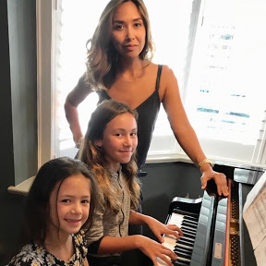 | Music with Myleene Klass  https://www.youtube.com/channel/UCQh2wgJ5tOrixYBn6jFXsXQ
Art
 | Draw with Rob  Draw like the famous illustrator Rob Biddulph. The illustrator of Flat Stanley, Kevin and Odd Dog Out. Remember to share your illustrations with us on twitter. http://www.robbiddulph.com/draw-with-rob |  | Virtual View of Museums Around the World  Take a look around many different museums from around the world.? Perhaps you can recreate some of the art work at home?  https://artsandculture.google.com/partner?hl=en
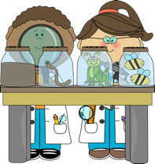
Science

 | Explorify for Science  https://explorify.wellcome.ac.uk |  | Science Fun  Ideas of experiments that could be done at home  www.sciencefun.org
Science with Maddie Moat
www.youtube.com/maddiemoate

 | Edinburgh Zoo Live Cam  This website is amazing – you can access different webcams live so that you and your children can see the animals and what they’re getting up to in the sunshine. You could write what you see on Seesaw and share with us if you want to! Use the drop down to pick which animal you want to see! https://www.edinburghzoo.org.uk/webcams/panda-cam/ |  | California Science Centre  Some of these activities can be done at home using the ingredients that most households will have readily available. Watch the video and download the resources and simple sets to follow. Make sure you take a video or picture to post on your Seesaw or our Twitter! https://californiasciencecenter.org/stuck-at-home-science

Twinkl
Twinkl have free some free resources for parents to access:

https://www.twinkl.co.uk/resources/parents/free-resources-parents/free-resources-for-parents-free-resources-parents

 | Girlguiding  Lots of ideas to keep your children entertained  https://www.girlguiding.org.uk/what-we-do/adventures-at-home/adventures-and-activities/ |  | Scouts  Here are lots of ideas from Scouts to keep you occupied indoors.  https://www.scouts.org.uk/the-great-indoors/

