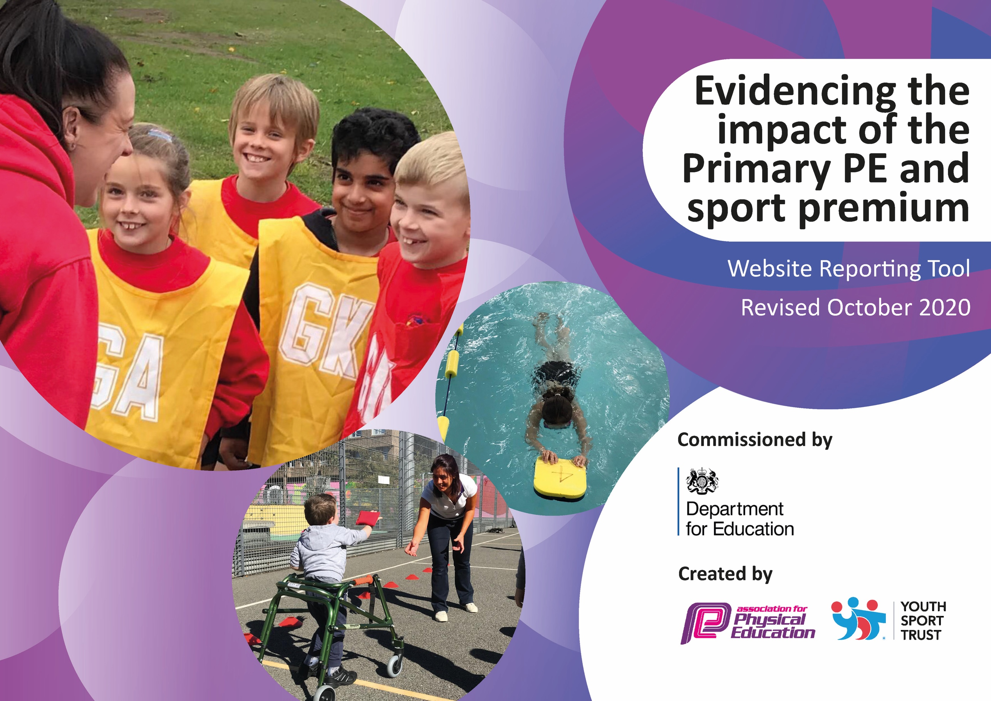
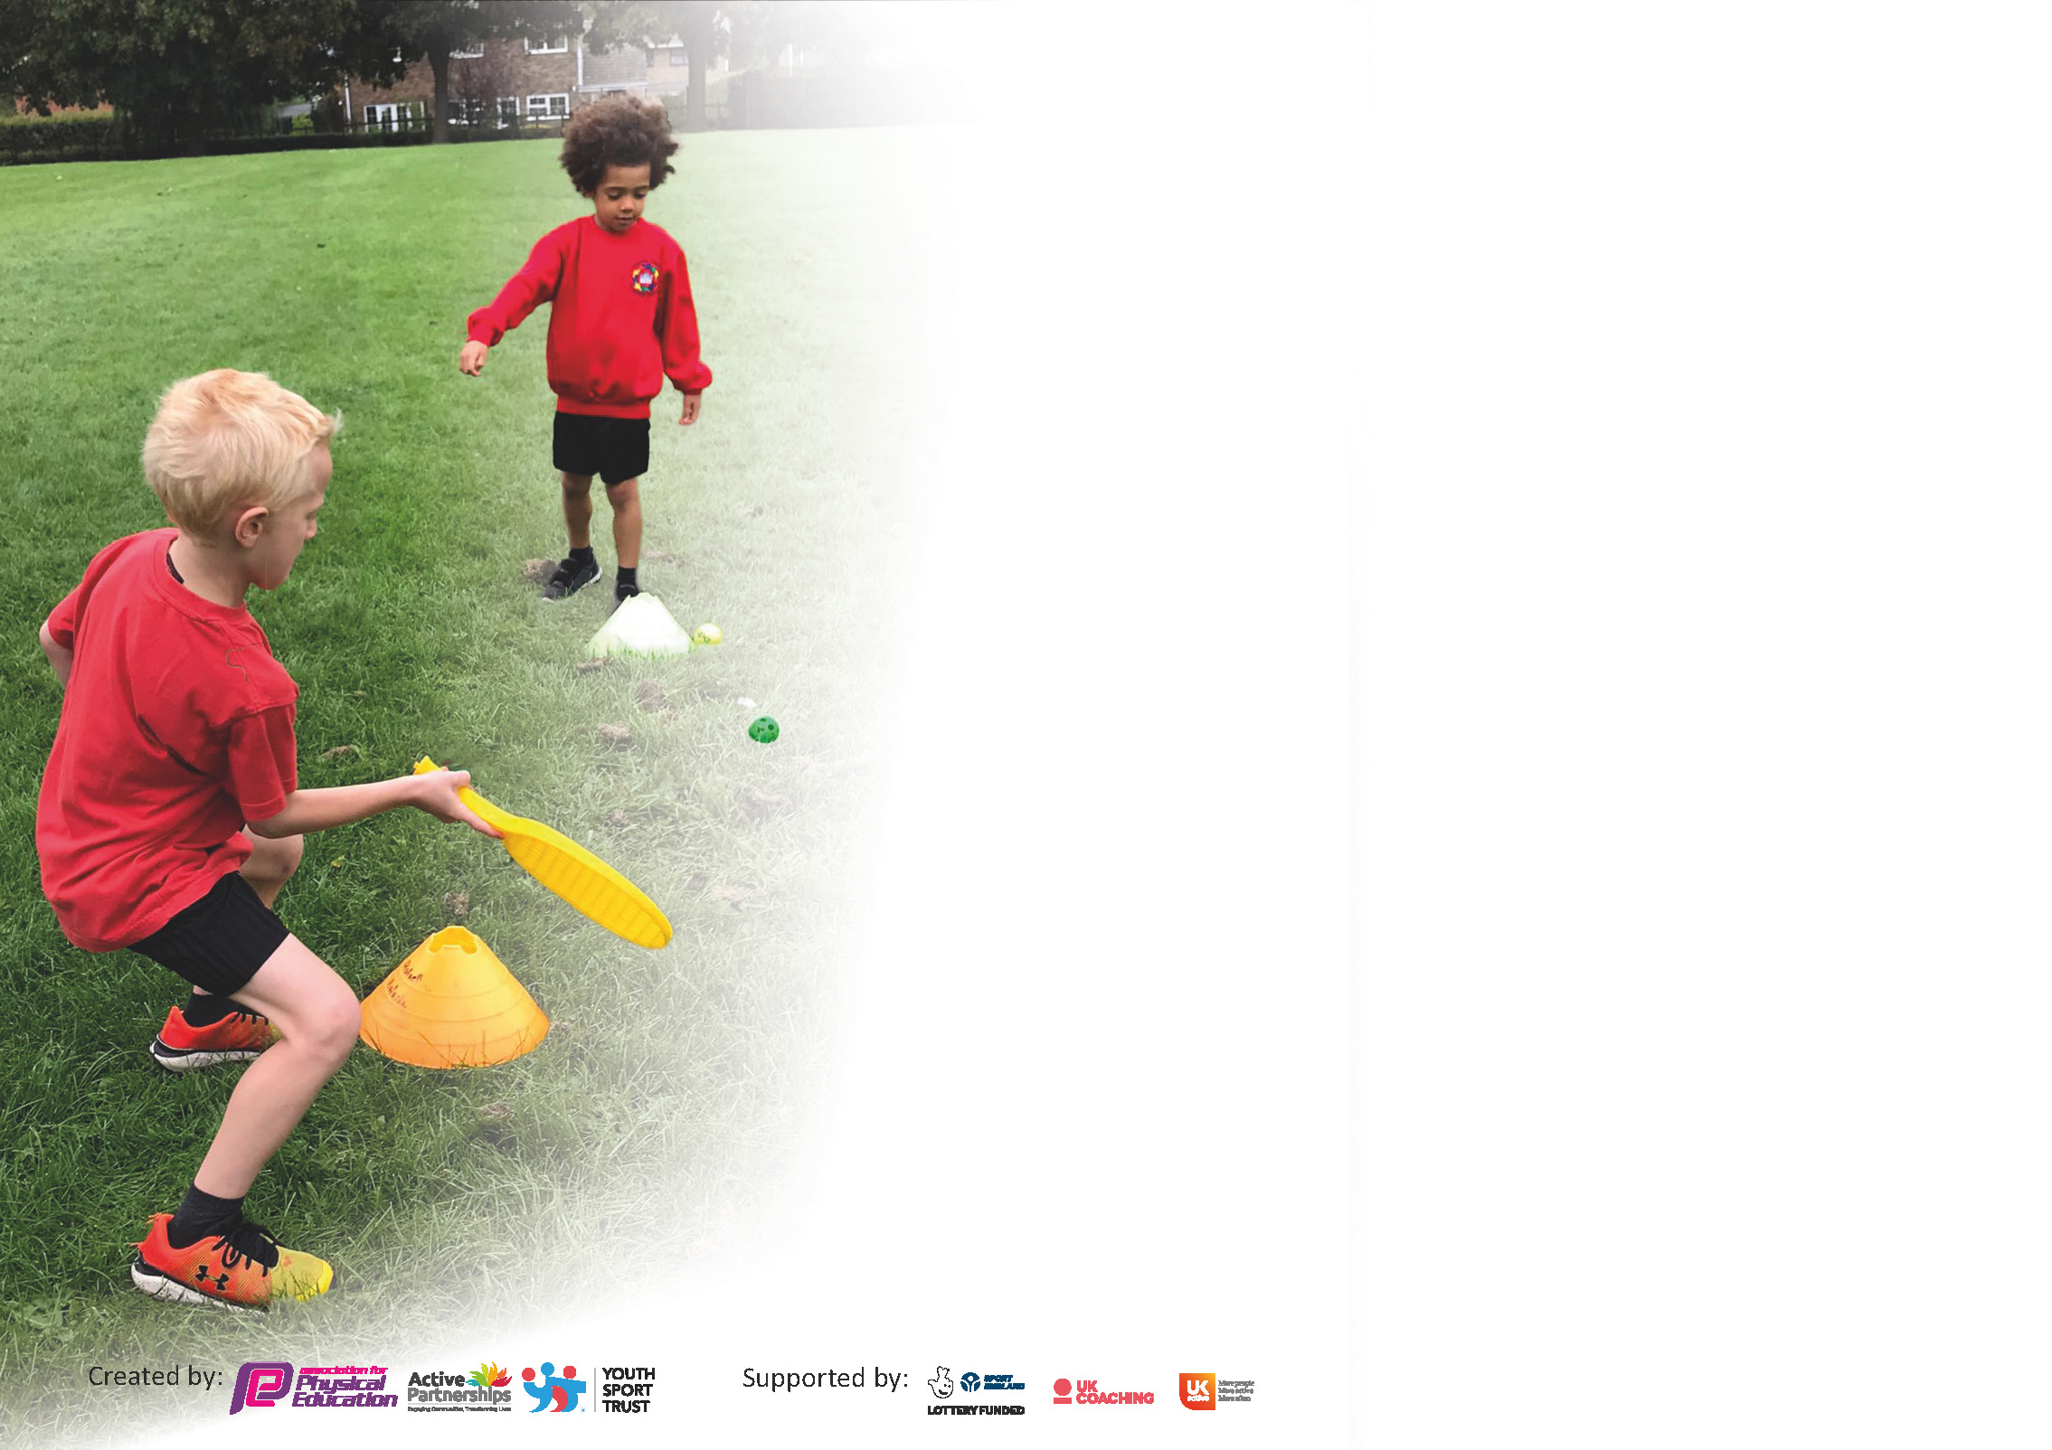

It is important that your grant is used effectively and based on school need. The Education Inspection Framework (Ofsted 2019 p64) makes clear there will be a focus on ‘whether leaders and those responsible for governors all understand their respective roles and perform these in a way that enhances the effectiveness of the school’.

Under the Quality of Education criteria (p41) inspectors consider the extent to which schools can articulate their curriculum (INTENT), construct their curriculum (IMPLEMENTATION) and demonstrate the outcomes which result (IMPACT).

To assist schools with common transferable language this template has been developed to utilise the same three headings which should make your plans easily transferable between working documents.

Schools must use the funding to make additional and sustainable improvements to the quality of Physical Education, School Sport and Physical Activity (PESSPA) they offer. This means that you should use
the Primary PE and sport premium to:

- Develop or add to the PESSPA activities that your school already offer
- Build capacity and capability within the school to ensure that improvements made now will benefit pupils joining the school in future years

Please visit gov.uk for the revised DfE guidance including the 5 key indicators across which schools should demonstrate an improvement. This document will help you to review your
provision and to report your spend. DfE encourages schools to use this template as an effective way of meeting the reporting requirements of the Primary PE and sport premium.

We recommend you start by reflecting on the impact of current provision and reviewing the previous spend.

Schools are required to publish details of how they spend this funding as well as on the impact it has on pupils’ PE and sport participation and attainment by the end of the summer term or by 31st July 2021 at the latest.

** In the case of any under-spend from 2019/20 which has been carried over this must be used and published by 31st March 2021.

We recommend regularly updating the table and publishing it on your website throughout the year. This evidences your ongoing self-evaluation of how you are using the funding to secure maximum, sustainable impact. Final copy must
be posted on your website by the end of the academic year and no later than the 31st July 2021. To see an example of how to complete the table please click HERE.
Created by: Supported by:

Please note: Although there has been considerable disruption in 2020 it is important that you publish details on your website of how you spend the funding - this is a legal requirement.
Support for review and reflection - considering the 5 key indicators from DfE, what development needs are a priority for your setting and your pupils now and why? Use the space below to reflect on previous spend and key achievements and areas for development.

N.B. In this section you should refer to any adjustments you might have made due to Covid-19 and how these will influence further improvement.
Key achievements to date until July 2020: | Areas for further improvement and baseline evidence of need:
Raising standards and accessibility for all our children in Physical Education  - Teachers’ subject knowledge and confidence is improving as a result of team teach sessions delivered with Sports Coaches  - Children’s gymnastics, dance and games skills are improving as a result of quality first teaching  - PE lessons are engaging and pupils full participate in every lesson  - HASSPAN events have encouraged those more reluctant pupils to engage in enjoyable physical activities  Increasing Pupils’ Participation in Competitive Sports  - Linking to Enrich and HASSPAN has widened the number of opportunities for pupils to engage in competitions and festivals  - Maintenance of School Games Gold Award in July 2019.  - Participation in The Rice Bowl Football Competition  - Participation in the Y3/4 Girls Bosworth Football Festival  - Participation in the Y5/6 Mixed Football League  - Organisation of a Virtual Sports Day during Summer 2020  - Organising the curriculum to enable children to practise skills needed for competition, allowed them to feel more confident and better prepared  Ensuring our children have healthy lifestyles by having access to regular exercise  - The number of children attending lunchtime and after-school clubs increased until lockdown period. | - Appoint 2 staff members to take on role of PE Subject Leaders to drive sustainable improvements surrounding high quality PE, Competitive Sport, Physical Activity, Health and Well-Being for all pupils  - Invest in high quality CPD for teaching staff and PE Curriculum for pupils through REAL PE.  - Identify Sports Ambassadors to represent the pupil voice and celebration of achievements and to take an active role in decision making for after-school club requirements to increase pupil well-being and physical activity levels.  - Explore clubs and organisations in the local area offering after-school clubs and extra-curricular provision and promote within school  - Promote active playtimes and lunchtimes through training Sports Leaders  - Increase number of pupils attending after-school clubs and in school opportunities for those who currently do not participate in any extra-curricular sport outside of school. Target of 75% to attend at least one club.  - Promote participation in physical activity with Daily Mile and Sports Relief 2021  - Increase opportunities for pupils accessing a wide range of competitive sports  - Promotion of the Tokyo Olympics  - Use PE tracking system more effectively and share with teacher pupils attainment at the end of each term.  - Maintain GOLD status for School Games Mark.  - Use more whole school approaches to getting active, share classroom ideas for keeping children more active during lesson times.

Did you carry forward an underspend from 2019-20 academic year into the current academic year? YES

If YES you must complete the following section
If NO, the following section is not applicable to you

If any funding from the academic year 2019/20 has been carried over you MUST complete the following section. Any carried over funding MUST be spent by 31 March 2021.
Academic Year: September 2020 to March 2021 | Total fund carried over: £ 4,794 |  | Date Updated:
What Key indicator(s) are you going to focus on? |  |  |  |  | Total Carry Over Funding:
 |  |  |  |  | £4794
Intent | Implementation |  |  | Impact
To increase confidence, knowledge and skills of all staff in teaching of PE and Sport | Purchase of REAL LEGACY which includes REAL PE scheme of work, whole school and PE Lead training, assessment and whole school self-evaluation tool | £3,997.50 |  | The impact will be measured through the Assessment Wheel and Self-Evaluation Tools.  As a result | Funding for REAL PE Legacy will be set aside to cover year 2 of the subscription and to enable school to building on the success of 2020-2021

Meeting national curriculum requirements for swimming and water safety.

N.B Complete this section to your best ability. For example you might have practised safe self-rescue techniques on dry land.
What percentage of your current Year 6 cohort swim competently, confidently and proficiently over a distance of at least 25 metres?  N.B. Even though your pupils may swim in another year please report on their attainment on leaving primary school at the end of the summer term 2020. | 90%
What percentage of your current Year 6 cohort use a range of strokes effectively [for example, front crawl, backstroke and breaststroke]? | 90%
What percentage of your current Year 6 cohort perform safe self-rescue in different water-based situations? | 90%
Schools can choose to use the Primary PE and sport premium to provide additional provision for swimming but this must be for activity over and above the national curriculum requirements. Have you used it in this way? | No.

Action Plan and Budget Tracking
Capture your intended annual spend against the 5 key indicators. Clarify the success criteria and evidence of impact that you intend to measure to evaluate for pupils today and for the future.

Academic Year: 2020/21 | Total fund allocated: £19,330 + £4794 |  | Date Updated: October 2020
Key indicator 1: The engagement of all pupils in regular physical activity – Chief Medical Officers guidelines recommend that primary school pupils undertake at least 30 minutes of physical activity a day in school |  |  |  |  | Percentage of total allocation:
 |  |  |  |  | 15%
Intent |  | Implementation |  | Intended Impact
Your school focus should be clear what you want the pupils to know and be able to do and about  what they need to learn and to  consolidate through practice: |  | Make sure your actions to achieve are linked to your intentions: | Funding allocated: | Evidence of impact: what do pupils now know and what can they now do? What has changed?: | Sustainability and suggested next steps:
To offer high-quality lunchtime experiences for pupils, expanding opportunities available for physical activity and school sports for pupils |  | - Continue lunchtime strategy to maximise physical activities on offer to pupils.  - Use of Lead PE specialist to strategically plan our outdoor lunchtime provision, providing activities for all classes.  - Sustainable use of PE specialist coaches to enhance the lunchtime experience.  - Lunchtime activities to continue to specifically target the involvement of underactive pupils through championing ‘non-sporting’ physical activities. (e.g. traditional games, orienteering treasure hunts etc.) | £3,800  2 Additional Lunchtime Sports Coaches | Increased number of pupils chose to engage in range of physical activities at lunchtimes.  Through setting up of non-competitive physical activities the number of targeted under-active pupils taking part in physical activity at lunchtime  Wider Impact as a result  Improved behaviour at lunchtime  Fewer incidents of children not bring in kit to school  95% of pupils say they enjoy PE and Sport | Allocated funds will be set aside to continue the CPD and embedded of the REAL PE curriculum across school.
Daily Mile – Continue to promote the ‘Daily Mile’ to get all pupils undertake at least 15 minutes of additional activity per day. |  | - Sports Leaders and Sports Coaches promote the daily mile through a stamp card and reward system for participants. | n/a | Daily mile firmly embedded in choice of activities to complete at break or lunchtime. | Daily mile firmly embedded in choice of activities to complete at break or lunchtime.
Key indicator 2: The profile of PESSPA being raised across the school as a tool for whole school improvement |  |  |  |  | Percentage of total allocation:
 |  |  |  |  | 0.6%
Intent |  | Implementation |  | Intended Impact
Your school focus should be clear what you want the pupils to know and be able to do and about  what they need to learn and to  consolidate through practice: |  | Make sure your actions to achieve are linked to your intentions: | Funding allocated: | Evidence of impact: what do pupils now know and what can they now do? What has changed?: | Sustainability and suggested next steps:
To raise the profile of PE. Physical Activity and School Sport across school |  | Maintain School Games Gold Award through participation in inter and intra-school competitions and the promotion of PE within school. |  | School will maintain its achievements in the School Games Mark  *Currently on pause due to covid  https://www.yourschoolgames.com/sgo/southfields/school-games-mark-2020-update/ | Continue to build on successes so far
 |  | Provide PE Lead and Sports Coach with leadership time to promote and organise PE and Extra-Curricular opportunities for pupils |  | PE Leads will have access to information regarding upcoming festivals, competitions and events that pupils are able to participate in and will be able to plan for school entry into a wide variety of events promoting a wider range of sports | Continued to raise profile of PESSPA across school.
 |  | Create new noticeboard area to promote the principles of REAL PE within school and extra-curricular opportunities |  | Notice boards provide clear information about matches/clubs/results and the REAL PE Skills ( Applying Physical, Creative, Social, Personal, Health & Fitness , Cognitive) | Continued to raise profile of PESSPA across school.
 |  | Appoint Sports Ambassadors – Conduct a school survey to share with class regarding current and future provision of lunchtime activities and after-school clubs. |  | Sports Ambassadors will help to create the pupil voice regarding the current and future provision for break, lunchtime and after school physical activities. PE Leads will be able to respond to requests for new clubs  Greater % of pupils participate in extended provision available  Sports Ambassadors promote upcoming events and hand out weekly certificates linked to sports values | Continue to offer wide variety of afterschool clubs and lunchtime activities to meet the needs and requests of. pupils
 |  | Celebration Assembly every week to ensure the whole school is aware of the importance of PE and Sport and to encourage all pupils to aspire to being involved in the assemblies  - Pupils encouraged to bring trophies, medals, awarded achieved outside of the school day  - PE Coach to award ‘ Sports Personality of the Week’ certificates each week  - Pupils representing school in competitions & festivals are recognised in assemblies | £150 for certificates and stickers | The school games values profile has been raised across school through the weekly award of Sport Certificates and stickers awarded in PE lessons in weekly Celebration Assemblies | Continued to raise profile of PESSPA across school.

Key indicator 3: Increased confidence, knowledge and skills of all staff in teaching PE and sport |  |  |  | Percentage of total allocation:
 |  |  |  | 55 %
Intent | Implementation |  | Intended Impact
To support teachers in planning and delivery of high quality PE Lessons  To use PE Specialists to ‘team-teach’ with teaching staff to provide high quality lessons and provide CPD opportunities for staff to observe outstanding practice leading to raised standards of attainment in PE | Purchase of 2 year subscription and Jasmine licence for REAL Legacy which will provide:  - Staff training and support  - Teaching and learning, assessment and planning  - Support with inclusion, engagement and developing the school culture  - Tracking system for pupil achievement and progress  - Development of health and well-being  - Competitive opportunities  - Enrichment opportunities  - Whole school self-evaluation tool.  https://spark.adobe.com/page/EkGukLIQiLuXg/ | £3,997.50  Year 1 of 2 years  £9,120  Team Teach Lessons | Staff to feel more confident and empowered when teaching the primary PE curriculum as a result of high quality CPD training through REAL PE and REAL Legacy programme being implemented across school. | Following year will be Y2 using the self-evaluation tool at the end of the year to analyse successes and next steps in areas for development.
To support teachers in planning and delivery of high quality dance lessons | Purchase of annual licence for Dance Notes | £216.00 | Staff to feel more confident and empowered to deliver high quality dance lessons linked to the Cornerstones Curriculum | Plan will be to build on REAL PE through introduction of REAL Dance building on teacher’s knowledge and skills in the delivery of dance lessons.
To develop the roles of the PE Leads in monitoring and evaluating the quality of teaching and learning of PE across school through high quality CPD with REAL PE. |  |  | Subject Leaders more confident to evaluate the 3Is and to offer support to those less experienced staff members or those lacking confidence  PE Leads have a sound understanding of all aspects of the REAL PE curriculum and the Create Assessment Wheel | PE Leads will feel confident in assessing the strengths within school and the next development steps.  PE Leads will have a thorough understanding the Intention, Implementation and Impact with regard to PE
To develop an effective tracking system to assess pupils attainment and progress in PE and participation in extra-curricular activities | To purchase and embed an PE planning, teaching and learning and assessment tool to track attainment and progress (Create Wheel) | Included in cost of Real PE | PE Lead and Sports Coach are able to effectively observe pupils to inform assessment of PE skills and to use the tool to inform future planning.  PE Lead is able to evaluate the attainment and progress of all pupils using PE passport and identify areas for whole school development. | Create Assessment wheel and individual pupil assessment will be embedded to support all pupils to make good progress and achieve good outcomes in PE.  The Create Assessment Tool will provide clear next steps for the development of PESSPA

Key indicator 4: Broader experience of a range of sports and activities offered to all pupils |  |  |  | Percentage of total allocation:
 |  |  |  | 13%
Intent | Implementation |  | Intended Impact
Forest School – To increase the opportunities for pupils to learn and play outside though engaging in outdoor and adventurous activities | To provide opportunities for all classes to experience at least one forest school session within school to promote being outside, team work and negotiating, problem solving skills, | £3000 | Pupils enjoy and engage well in learning and playing outside.  Supports wider school priorities such as meeting the needs of SEND pupils and PP pupils to engage in problem solving, teamwork and | Allocation of Funds to support FS session in school and after-school
To provide pupils with opportunity to experience new sports and activities | Provide KS2 pupils with opportunity to attend 1 day outdoor pursuits day at Beaumanor and 4 night residentials with a focus on outdoor and adventurous activities |  | Pupils have opportunity to experience new sporting activities such as canoeing, rock climbing, abseiling, zip wires, archery ect) | Residential programmes take place each year

Key indicator 5: Increased participation in competitive sport  *This will be dependent on the competitive sport restrictions in place as a result of the Coronvirus pandemic. Targets below are based on a return to ‘normal’. |  |  |  | Percentage of total allocation:
 |  |  |  | 16 %
Intent | Implementation |  | Impact
Ratby Primary School to continue to participate in the HBSSPAN / Enrich/BEP competitions and festivals to provide increased number of opportunities to participate in sporting activities and competitions. | Continue to offer and access a wide range of activities both within and outside of the curriculum in order to get more pupils involved in competition across an increasing number of sports  Focus particularly on those who do not take up additional PE and Sport Opportunities  To participate in competitions and Festivals including Football Rice Bowl Competition, Primary Cross County  Ratby PE Co-ordinators in partnership with Metcalf Sports to strategically plan a high quality competition and festival schedule for the year | £2899.50  HBSPPAN  Subscription  £1000  Richer Sports  Subscription  Rice Bowl £5.00  Cross Country Entry Fee £45.00 | More pupils across KS1 and KS2 are given the opportunity to participate in competitive sport and signposted to clubs outside of school to further develop their skills  Encouraging more girls to participate in competitive sport.  Improved standards in invasion games in curriculum tome

Signed off by
Head Teacher: | Lisa Jones | Subject Leader: | Lee Barber | Governor: | Sam Ward
Date: | July 2020 | Date: | July 2020 | Date: | Sept 2020

