Year  EYFS | Autumn 1  (8 weeks) | Autumn  (8 weeks) | Spring 1  (6 weeks) | Spring 2  (5 weeks) | Summer 1  (7 weeks) | Summer 2  (5 weeks)
Topic Title | If you go down to the woods today!  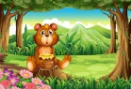 | Dinosaurs roar!  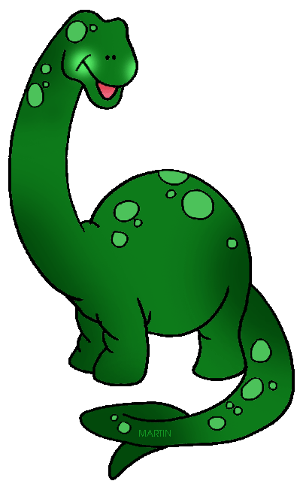  Catch me if you can! | Lost and Found  The Perfect Pet! | Supertato | Fee Fi Fo Fum!  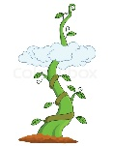 | Jungle safari and Ugly Bugs!  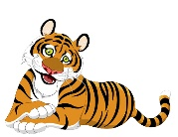
Cornerstones Units | Why do squirrels hide their nuts? | Which was the biggest dinosaur? (adapted Nursery unit)  Are we there yet?  Do you want to be friends? | What is a reflection? (water and ice)  Can I have a dog yet? (adapted Nursery unit) | Are carrots orange? | Will you read me a story?  Can I switch it on?  Do cows drink milk? | Why do zebras have stripes?  Why do ladybirds have spots?  What’s that sound?
Topic / texts | Settling in  Owl Babies – 2 weeks  Goldilocks- 4 weeks  Bear Hunt - 2 weeks | Dinosaur Roar! Harry and his bucketful of dinosaurs –3 weeks  Gingerbread Man – 3 weeks  Christmas -2 weeks | Lost and found – 2 weeks  Pets - Cat in a tree – 4 weeks | Supertato – 5 weeks  Creative scenarios | Jack and the Beanstalk  Farm trip – 1 week | Jungle safari – 2 weeks  Mini beasts – 3 weeks
Memorable Experience | Visit from a hedgehog | Dinosaur Museum | Handling real fish  Pet Roadshow | Superhero day | Visit to a farm  Drama | Ugly Bug Ball
Personal, social and emotional Development | Daily routines, rules and responsibilities  Sense of belonging / families / school family | Learning to work and play together / recognising and coping with feelings | Growth mindset | Resilience | Resilience | Sex and Relationship education
Communication and language | Participation songs, rhymes and familiar stories  Barnaby Bear, Show and tell, talking about familiar things and asking questions to find out more  Role play – woodland area, Home corner | Extend questioning skills  Vocabulary  Oral story telling  Making observations  Comparative language  Role play – dinosaur museum, Home corner, McDonald’s, Christmas Post Office | Extend questioning skills  Vocabulary  Making observations  Role play – Dark / ice cave, School role play, Pet shop / vets | Vocabulary  Oral recounts and story telling  Role play – bakery, Superhero centre, School | Vocabulary – improving a sentence  Role play – shoe shop, Home corner | Vocabulary – improving a sentence / adjectives  Making observations, using all senses  Role play – jungle, home corner
Maths | Number: Counting assessments  Shape, Space & Measures: sorting and pattern, 2D shapes,  comparison of size and weight | Number: 0 – 4. Addition and subtraction  Shape, Space & Measures:  2D and 3D shape, capacity, size, length and weight, positional language, money | Number: 5 – 7. Addition and subtraction, Data handling  Shape, Space & Measures:  Pattern, length and weight in pet shop, money | Number: 8 – 10. Addition and subtraction ( including counting on and back), Sharing, halving  Shape, Space & Measures: symmetry, money, time | Number: 11 - 15, double and half, grouping in twos, number bonds to 10, writing numerals  Shape, Space & Measures:  Length (measuring giants and beanstalks, feet, shoes) 2D and 3D shape, money, time | Number: 16 - 20, double and half, grouping in fives and tens  Shape, Space & Measures: Symmetry
Literacy | Narrative: Stories with predictable and patterned language  Traditional story Goldilocks  Labels and captions  Writing a letter  Sequencing a story / story maps  Composition – writing a caption / sentence  Non fiction: books about owls, hedgehogs, woodland animals and bears  Big Write: Recount of what we like to do in school | Narrative: Stories about the same character – Harry and his dinosaurs, writing a sentence  Recount what the dinosaurs did, Rhyming words  Non fiction: Descriptions of dinosaurs and Gruffalo and own monster, signs and labels, recounts, lists, information books about dinosaurs, sequencing instructions to make Gruffalo Krispies  Big Write: Monsters Inc – what is behind the door? | Narrative: story structure and composition – extending writing to 2 sentences or more / conjunctive ‘and’  ‘Speech’ – what did penguin say?  Books by Oliver Jeffers  Recount what was frozen in the ice?  Rhyming words  Sequencing story  Non fiction: books and information posters about pets / comparing fiction and non fiction books  Lists, labels  Big Write: Letter to recommend a pet | Narrative: Story maps, story writing – beginning to write at length  Labelling maps  Recounts / newspaper reports of where the evil pea is and what he has done  Big Write: How will you get the gingerbread man across the river? | Narrative: Sequencing a story, writing a letter, retelling a familiar story, rhyming pairs  Non fiction: Instructions to plant a bean  Big Write: write the ending of the story | Narrative: Jungle report, Farm recount, animal poetry and songs  Non fiction: books and information posters about jungle animals and bugs / comparing fiction and non fiction books  Big Write: recount of farm visit
Understanding the World | Woodland area and animals  Settings  Hibernation  Developing observation and language skills  Science experiment: Squirrel muffins  ICT: Beats and rhythms | Autumn festivals: Bonfire night, Diwali, Christmas  Seasonal changes - signs of Autumn  All about dinosaurs / what’s in the egg? / fossils / bones  Selecting healthy food  ICT: Technology and me  (Dinosaur museum) | Ice experiments  Caring for living things  Handling real fish  Playing with light toys / shadows / reflection  Caring for pets – how to keep them safe, happy and healthy  Feeding the birds  Spring festival – Easter, Chinese New Year  Science experiment: Snowman melting / handling real fish  ICT: Animal safari (Pets)  Shape Hunt | Maps of where evil pea is hiding  Healthy eating - vegetables  Science experiment: Dissolving a gingerbread biscuit  ICT: Robots  (Catch the gingerbread / maps) | Life cycle of a frog  Planting beans / diary of growth  Food from the farm  Science experiment:  Floating and sinking  ICT: My Online Life | Using all of our senses in the jungle  Jungle setting and animals  Recycling – make a junk costume for Ugly Bug Ball  Investigating bugs  Observation of snails  Science experiment: camouflage, spots and stripes  ICT: Pretty Pictures  (Jungle)
Expressive Arts and designs | Ongoing provision throughout the year Creative table, role play, small world play, construction, sand, water, dressing up costumes, musical instruments etc
 | Make a birthday card  Make puppets in different ways – paper bag and stick  Paint bears  Woodland art  Music Pitch | Making junk instruments  Mixing Autumn colours  Dinosaur art  Dinosaurs skeletons  Fossil print in clay  Drawing skills – how to draw a dinosaur | Junk modelling - make something to cheer up the penguin  Penguins on ice collage art work  Clay pets and habitats  Learning new songs for Spring Production | Design a gingerbread man  Design a junk model trap to catch the evil peas  Design own Supertato  Music C20th music  Spring Production | Build a castle / den building  Painting a giant  Create a beanstalk  Make 3D castles with bricks  Make stick puppets  Make a moving toy  Drawing castles  Monet Waterlillies / pond plate | Jungle art – torn paper  Matisse snail collage  Stone bugs  African prints and jewellery making  Music Rhythm
Physical Development | Ongoing provision throughout the year  Shake up wake up routines: Cosmic kids yoga / Big Moves Island Adventure / Dough Disco / Go Noodle  Forest Schools  Muddy Kitchen  Small apparatus equipment  Big play: crates, planks, stepping stones, den building, bikes, slide, climbing frame etc  Junk modelling  Construction  Fine motor activities
REAL PE | Unit 1: Personal | Unit 2: Social | Unit 3: Cognitive | Unit 4: Creative | Unit 5: Applying Physical | Unit 6: Health & Fitness

Discrete Cornerstones units and provision
What can you see in Summer? / What is a reflection? Forest Schools provision

