Educational Visits Policy

Approved: Trust Board 09/12/20
Review Date: November 2022
Responsible Officer: Director of Schools

1. Context/Policy Statement
Bradgate Education Partnership (“the Trust”) believes that outdoor learning, off-site visits and learning outside the classroom are an integral part of the entitlement of every child to an effective and balanced curriculum. Appropriately planned visits are known to enhance learning and improve attainment and so form a key part of making a supportive and effective learning environment. The benefits of pupils taking part in visits and learning outside the classroom include (but are not limited to):

- Improvements in their ability to cope with change and novelty.
- Increased critical curiosity and resilience.
- Opportunities for meaning making, creativity, developing learning relationships and practicing strategic awareness.
- Increased levels of trust and opportunities to examine the concept of trust (us in them, them in us, them in themselves, them in each other).
- Improved achievement and attainment across a range of curricular subjects. Pupils are active participant’s not passive consumers and a wide range of learning styles can flourish.
- Enhanced opportunities for ‘real world’ ‘learning in context’ and the development of the social and emotional aspects of intelligence.
- Increased risk management skills through opportunities for involvement in practical risk-benefit decisions giving them the tools and experience necessary to assess their own risks in a range of contexts.
- Greater sense of personal responsibility.
- Possibilities for genuine team working including enhanced communication skills
- Improved environmental appreciation, knowledge, awareness and understanding of a variety of environments.
- Improved awareness and knowledge of the importance and practices of sustainability.
- Physical skill acquisition and the development of a fit and healthy lifestyle.

The Trust fully recognises that learning outside the classroom helps to bring the curriculum to life as it provides deeper subject learning and increases self-confidence. It also helps pupils develop their risk awareness and prepares them for their future working lives the Bradgate Education Partnership adopts the Outdoor Education Adviser’s Panel (OEAP) National Guidance for all educational visits available at www.oeapng.info
Ratby Primary Academy will adopt and implement the Bradgate Education Partnership Educational Visits Policy.

2. Employer responsibilities

As employer the Trust meets its obligations to provide staff with guidance, training and support in the following ways:
- Appropriate guidance.
- The appropriate guidance for the management of outdoor learning and off site visits is the OEAP National Guidance web site – www.oeapng.info

- Training to support the guidance to ensure that it is understood.
- For those involved in managing and leading visits the relevant training courses are:
- Educational Visit Coordinator (EVC) Training – The Bradgate Education Partnership requires the academy EVC to be appropriately trained.
- Visit Leader Training – The Bradgate Education Partnership requires all those who lead trips or visits of a residential nature (excluding residential facilities who meet the requirements of section 5) or whereby they lead an adventurous activity to undertake this training.

Note: Local trips within the Academy Learning Area (see appendix 1) or regularly undertaken day trips to environments regularly visited by schools may be led by competent staff who have not attended Visit Leader training on authorisation of the Head Teacher.
- Suitable systems and processes to ensure that those trained are kept updated.
- For the purposes of day-to-day updating of information, EVCs and Visit/Activity Leaders are directed to the periodic news items and updates of OEAP National Guidance.

- Access to advice, support and further training.
- Where an employee experiences problems with finding the material they are looking for, or require clarification or further help, guidance or bespoke training, they should contact their appointed Education Visit Advisor Service.

3. Application
This policy covers any visit that leaves the academy grounds, whether as part of the curriculum, during academy time or outside the normal academy day.
The Bradgate Education Partnership adopts the Outdoor Education Adviser’s Panel (OEAP) National Guidance available at www.oeapng.info
All staff are required to plan and execute visits in line with this policy and National Guidance. Staff are particularly directed to be familiar with the roles and responsibilities outlined within National Guidance.

4. Roles and responsibilities
Visit Leaders are responsible for the planning of visits, but should involve both accompanying colleagues and the pupils in this process. Staff must make appropriate checks on venues and third party providers. Staff are advised to obtain outline permission for a visit from the Head Teacher before beginning to plan/making any commitments.
See Outdoor Education Adviser’s Panel National Guidance for the role of the Visit Leader - http://oeapng.info/visit-leader/
The Education Visit Coordinator (EVC) is Lisa Jones who will support and challenge colleagues over visits and learning outside the classroom. They are the first point of call for advice on visit related matters. The EVC will check final visit plans before submitting them to the Head Teacher.
See Outdoor Education Adviser’s Panel National Guidance for the role of the EVC http://oeapng.info/evc/
The Head Teacher has responsibility for the monitoring and final approval of all visits.
See Outdoor Education Adviser’s Panel National Guidance for the role of the Head Teacher http://oeapng.info/head-manager/
See Outdoor Education Adviser’s Panel National Guidance for the role of the governing body http://oeapng.info/governors/

Bradgate Education Partnership (“the Trust”)
The Health and Safety at Work etc. Act 1974 places overall responsibility for health and safety with the employer.
As the employer the Trust must be informed of all residential visits, foreign travel and any adventurous activities for example climbing, caving and water sports. This can be achieved by Trust academies using the online eVisit system.
Educational Visit Advisor Service
It is advisable that the visits and activities, listed below, are checked by your Education Visits Advisor Service (who should be deemed competent to provide advice and guidance) before the activity takes place – see page 6 of this policy detailing the process to be followed.
- overnight stays
- foreign travel
- adventurous activities

The Trust obtains advice/support relating to Educational Visits from the H&S professionals at YMD Boon Ltd.
The following visits will not fall under the remit of YMD Boon Ltd H&S Professionals.
- Visits where schools choose to directly lead and deliver adventurous activities i.e. school staff member leading a climbing activity, kayaking, skiing etc.
- Give specific advice regarding Duke of Edinburgh Expeditions.
The Trust requires all adventurous activities to be delivered by a LoTC/AALS badge/licence holder unless specific permission to deviate from this has been given by the Bradgate Education Partnership Chief Executive Officer.

5. Preliminary Visits and Provider Assurances

Preliminary Visits
The Trust requires that all visits are thoroughly researched to establish the suitability of the venue and to check that facilities and third party provision will meet group expectations. Such information gathering is essential in assessing the requirements for effective supervision of young people, it is a vital dimension of risk management.
It is good management practice to carry out a preliminary visit. The following identifies the circumstances where preliminary visit is a requirement.
- Pre visit required for visits where there is a high complexity factor and the visit has not happened previously.
- Additionally required when visit is solely led by the academy.
- Residential visits, visits abroad, exchange visits, adventure led by the academy, staff all have aspects of complexity.

If the visit is led and managed by the provider, then a variety of approaches can reduce the need to pre visit.
Visit Leaders can take full advantage of the nationally accredited provider assurance schemes that are now available and assist to reduce bureaucracy – examples include: -
- The LotC Quality Badge
- AALS licensing
- Adventuremark

The Trust takes the view that where providers holds one of the above accreditations, there should be no need to seek further assurances.
The OEAP National Guidance 4.4f – Assessing an adventure activity provider check list, 4.4h – using external providers and facilities and 8.8p – Provider Questionnaire - http://oeapng.info/downloads/all-documents/ should be followed when undertaking pre visits and assessing providers.

6. Types of visit and approval
There are four types of visit, for each of which the approval process is slightly different:
- Visit / activities within the Academy Learning Area (see appendix 1) and which involve no more than an everyday level of risk. Visits that are part of the curriculum and take place during the academy day do not require consent. Those that are not part of the curriculum or extend beyond the academy day can be covered by blanket consent but information will be provided to parents in advance and they will have the opportunity to withdraw their child.
These follow the learning area operating procedure (appendix 1).
Ratby Primary School Academy will not log these visits on the eVisit system.
Other day visits within the UK excluding adventurous activities. Visit Leaders to gain outline permission for visit from Head Teacher. Visit leader to collate and input information onto the eVisit system, all information must be uploaded prior to submitting to the EVC for approval at least 6 weeks in advance, once reviewed by the EVC, final approval for the visit will be given by the Head Teacher.
- For all residential visits, adventurous activities or visits involving foreign travel. Visit Leaders to gain outline permission for visit from Head Teacher. Visit leader to collate and input information onto the eVisit system, all information must be uploaded prior to submitting to the EVC for approval at least 6 weeks in advance, once reviewed by the EVC, the visit will be given outline approval by the Head Teacher. Once outline approval has been given, the visit will then be scrutinised by the Educational Visits Advisor to ensure the visit complies with the OEAPNG after which final approval will be given by the Headteacher. The Educational Visits Advisor must receive the visit notification at least 4 weeks in advance of the visit occurring.
For visits involving adventurous activities: Visit Leaders must check if an activity provider holds either an AALA licence (http://www.aals.org.uk/aals/provider_search.php) or a LOTC quality badge (http://www.lotcqualitybadge.org.uk/search). If not, the Visit Leader must send the OEAP National Guidance document 8p/q provider questionnaire) http://oeapng.info/downloads/model-forms-mind-maps-and-checklists/). Returned questionnaires must be scrutinised by visit leaders.
For visits involving travel abroad: Visit Leaders are required to complete detailed planning well in advance and the EVC must be kept up to date with progress. Checks must be made on any third party providers and permission from the Head Teacher to use them be obtained before any deposits are paid. Third party providers who hold the LOTC quality badge do not require further checks. Those who do not hold this accreditation should complete and return a provider form (NG document 8p/q provider questionnaire) http://oeapng.info/downloads/model-forms-mind-maps-and-checklists/). Returned questionnaires must be scrutinised by Visit Leaders.

7. Staff Competence
The Trust recognises that staff competency is the single most important aspect of safe visit management and supports staff in developing this competence in the following ways:
- A mentoring system, where staff new to visits assist and work alongside experienced trip leaders before taking on a leadership role.
- Supervision by Senior staff of some educational visits
- Support for staff to attend training courses relevant to the role of visit leader

In deciding whether any member of staff is competent to be a Visit Leader the Head Teacher will take into account the following factors:
- Level of relevant experience
- Any relevant training undertaken.
- The emotional and leadership ability of any prospective visit leader to make dynamic risk management judgements and take charge of any emergencies that may arise.
- Knowledge of the pupils, the venue and the activities to be undertaken.

8. Requirement to Ensure Effective Supervision
Health and Safety laws do not prescribe activity specific staffing ratios, but it does require that the level of supervision and group management is ‘effective’.
Ratby Primary School Academy will assess/determine effective supervision by proper consideration of:
- Staff competence.
- Activity – nature and location of the activity (including the type of activity, duration, skill levels involved).
- Group – age (including the development age) of the group, ability of the group (including special learning needs, behaviour, medical and vulnerability characteristics etc.).
- Environment – nature and location of the activity including the type of the activity, duration, skill levels involved, as well as the time of year and prevailing conditions.
- Distance away from base.

However, as an exception to the above, Ofsted and DfE guidance prescribe ratios for Early Years
The Visit Leader should follow OEAP National Guidance 4.3b Ratio and effective supervision http://oeapng.info/downloads/download-info/4-3b-ratios-and-effective-supervision/
and 4.3c Risk Management http://oeapng.info/downloads/download-info/4-3c-risk-management/

9. Emergency procedures
A critical incident is any incident where events go beyond the normal coping mechanisms and experience of the visit leadership team.
Ratby Primary School Academy has an emergency plan in place to deal with a critical incident during a visit (see Appendix 2). All staff on visits are familiar with this plan and it is tested at least bi-annually and following any major staffing changes. See also http://oeapng.info/downloads/good-practice/

When an incident overwhelms the establishment’s emergency response capability; where it involves serious injury or fatality or where it is likely to attract media attention then assistance will be sought from the Bradgate Education Partnership.

Ratby Primary School Academy will practice their response to emergency situations on educational visits at regular intervals i.e. academy inset training.

10. Visit Planning
The Visit Leader checklist – National Guidance document 3.3e http://oeapng.info/visit-leader/ is an important check on the planning of a visit. When a Visit Leader cannot answer yes to a question on this checklist there should be a discussion with the EVC and or Head Teacher. In addition the following steps must be completed for any visit:
- Gain outline approval from the Head Teacher to begin planning the visit and agree funding mechanism / charging policy.
- Ensure the visit:
    - has clear learning outcomes
    - has activities appropriate to the group
    - is planned to maximise benefits to the pupils while managing significant risks
    - is appropriately staffed
    - complies with the academy’s safeguarding policy
- Involve pupils in the planning of the visit, and how it will be managed, wherever possible.
- Ensure emergency procedures include what would happen in the event of illness or injury affecting the visit leader.
- Ensure the base contact back at academy is fully briefed and has copies of all relevant information.
- Ensure that the visit is correctly approved and recorded.

11. Risk Management
The risk management of an activity/visit should be informed by the benefits to be gained from participating. It is recommended a “Risk-Benefit Assessment” approach, whereby the starting point for planning should be a consideration of the targeted benefits and learning outcomes. This appreciation of the benefits to be gained, through participation, provides some objectivity to a decision that any residual risk (i.e. the risks remaining after control measures have been put in place) is “acceptable”. The Health and Safety Executive endorse this approach through their “Principles of Sensible Risk Management” and advocate that it is important that young people are exposed to well-managed risks so that they learn how to manage risk for themselves.
There is a legal requirement for the risk assessment process to be recorded and for suitable and sufficient control measures to be identified for any significant risks. There is no legal requirement to produce this risk assessment record in a particular format but academies and visit leaders should use the format that has been identified in the academy risk assessment procedure and follows the Health and Safety Executives guidance on risk assessment http://www.hse.gov.uk/pubns/indg163.htm

See National Guidance on good practice for risk management http://oeapng.info/downloads/good-practice/

12. Parental Consent
Some visits do not require consent, all the rest can be covered by a combination of blanket consent (with subsequent information to parents) and visit specific consent - See the National Guidance document 4.3d on consent http://oeapng.info/downloads/all-documents/. It is advisable that all parents/guardians are advised of educational trips and permission obtained for visits which take place off the academy site.

13. Monitoring

The Visit Leader should undertake an evaluation of each educational visit and submit this to the Head Teacher and EVC.

14. Inclusion
All academies must follow the National Guidance on inclusion see 3.2e http://oeapng.info/downloads/all-documents/

15. Charging / funding for trips
All academies must follow the National Guidance on charging for academy trips 3.2c
http://oeapng.info/downloads/all-documents/

16. Transport
All academies must follow the National Guidance on Transport for academy trips see 4.5a transport, 4.5b minibuses, 4.5c Transport in private cars and 4.5d seat belts http://oeapng.info/downloads/all-documents/

17. Insurance
Insurance cover for approved educational visits is usually provided by the academy insurance provider (public liability) insurance policy. However, as academies may have moved to different insurance providers when they moved away from local authority control confirmation/checks should be made with the insurance provider before the visit takes place. See National Guidance 4.4c Insurance http://oeapng.info/downloads/all-documents/

Appendix 1
Academy Learning Area
General
This operating procedure applies to visits within the Academy Learning Area. It covers:
- Visits / activities that are part of the normal curriculum and take place during the normal academy day. These do not require parental consent.
- All other visits / activities within the Learning Area (those that take place beyond the academy day or are not part of the curriculum) are covered by blanket consent but parents will be informed in advance and given the opportunity to withdraw their child.

These visits/activities:
- Do not normally need additional risk assessments / controls beyond following the operating procedure below. However, where a specific risk is identified because, for example, a particular pupil’s needs then a review of the individual pupils risk assessment should be made and a record kept.

Boundaries
The boundaries of the territory are shown on the attached map (optional). This area includes, but is not limited to the following frequently used venues see examples below:
- Park (Ferndale Park, Ferndale Drive, Ratby )
- Shopping Centre (Post Office, Newsagents/Hairdressers/Take-aways, Main Street, Ratby)
- Co-op (Old Bakery Close, Ratby)
- Ratby Library ( Ratby Library, Main Street)
- Church (St.Phillips and St.James, Church Lane)
- Lady Jane Grey Primary School
- Martinshaw Primary School
- Elizabeth Woodville Primary School
- Brookvale Groby Learning Campus
- Burroughs School Playing Fields
- Ratby Sports and Social Club

Ratby Primary School – Academy Learning Area

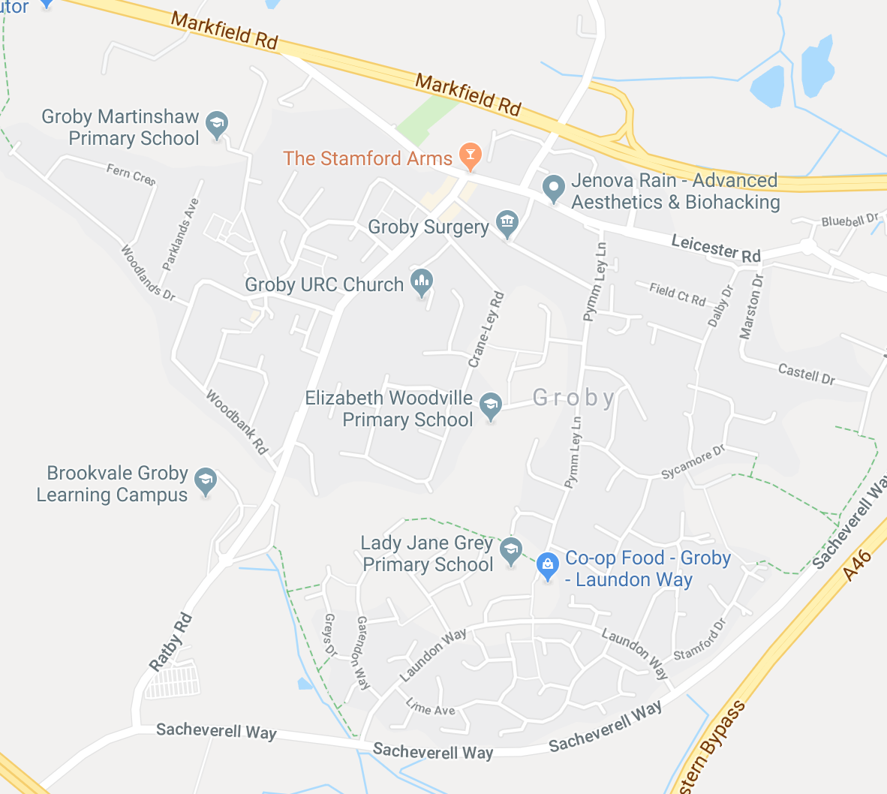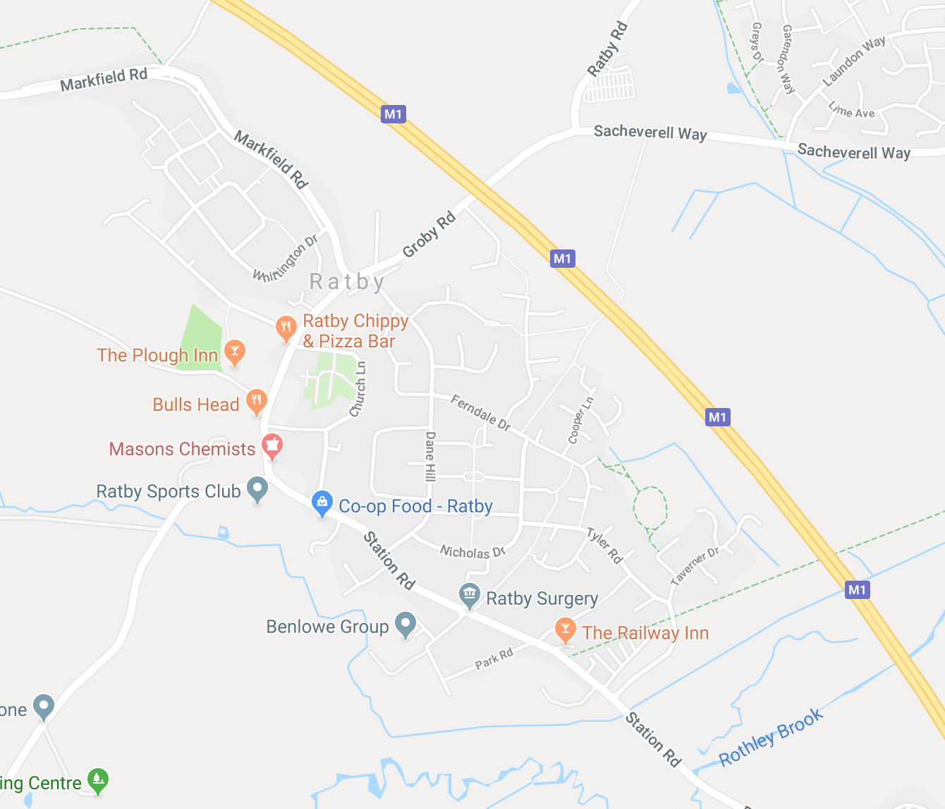
Groby Ratby

Operating Procedure for Academy Learning Area
The following are potentially significant hazards within Ratby Primary School Academy Learning area:
- Accessing the School Playing Fields via Burroughs Road
- Road traffic
- Other people / members of the public / animals
- Losing a pupil
- Uneven surfaces and slips, trips, falls
- Weather conditions
- Activity specific issues when doing environmental fieldwork (nettles, brambles rubbish etc)

These are managed by a combination of the following:
- The Head Teacher must give approval before a group leaves.
- Only staff judged competent to supervise groups in this environment are approved. A list of approved staff should be maintained by the EVC and Head Teacher.
- The concept and operating procedure of the extended learning area is explained to all new parents when their child joins the academy.
- There will normally be a minimum of two adults. (This depends on the area and the age / maturity of the pupils).
- Staff are familiar with the area and visited previously, including any ‘no go areas’ and have practiced appropriate management techniques.
- Pupils have been trained and practiced standard techniques for road crossings in a group.
- Where appropriate, pupils are fully briefed on what to do if they become separated from the group. (This needs a decision and will depend on the area you are in – return to academy, wait where they are, go to x and ask for help, etc.).
- All remotely supervised work in the Academy Learning Area is done in ‘buddy’ pairs as a minimum. (this depends on age/maturity and location).
- Pupil’s clothing and footwear is checked for appropriateness before leaving academy.
- Staff are aware of any relevant pupil medical information and ensure that any required medication is available and staff are appropriately trained.
- Staff will deposit in the office a list of all pupils and staff, a proposed route and an estimated time of return.
- An academy mobile is taken with each group and the office have a note of the number.
- Appropriate personal protective equipment is taken when needed (e.g. Hi-viz waist coat for infants).
- A member of the staff accompanying the group is first aid trained.

Appendix 2
Emergency procedure
The academy’s emergency response to an incident is based on the following key factors:
- There is always a nominated emergency base contact for any visit (during academy hours this is the office).
- This nominated base contact will either be an experienced member of the senior management team or will be able to contact an experienced senior manager at all times.
- The visit leadership team and the emergency base contact will both have relevant medical and emergency contact information on all the visit participants, including staff.
- The visit leader(s) and the base contact know to request support from the Bradgate Education Partnership in the event that an incident overwhelms the establishment’s emergency response capability; involves serious injury or fatality or where it is likely to attract media attention.
- The Academy Head Teacher has an emergency out of hours contact for the Bradgate Education Partnership to obtain additional support and resources as required.
- The academy has personalised National Guidance emergency action cards and the appropriate cards are held by:
  - The visit leader(s) http://oeapng.info/downloads/download-info/4-1d-8-1d-visit-leader-emergency-action-card
The visit leader should also have a copy of the visit leader emergency checklist http://oeapng.info/downloads/download-info/4-1k-visit-leader-emergency-checklist/
  - The first point of contact ( Head Teacher) http://oeapng.info/downloads/download-info/4-1e-8-1e-first-contact-emergency-action-card/
  - The designated emergency contact senior manager http://oeapng.info/downloads/download-info/4-1f-8-1f-establishment-management-emergency-action-card/
- This emergency procedure is tested through both desk top exercises and periodic scenario calls from Visit Leaders.

Appendix 3

Ratios and First Aid Requirements

- Whilst there is no longer a statutory requirement in general for a set ratio of supervision or for having a First Aider on trips; there is an exception with regard to children under five, where a Paediatric First Aider must accompany the group.

- In respect of Item 1 however, BEP schools are expected to adhere to the principle of previous National guidance on ratios that reduce as children get older. The principle that all trips should be assessed on location, risk and the specifics of the cohort is sound, but whilst local discretion may be used, a change in ratio and/or first aid cover must not result in increased risk.

- BEP expects ALL trips away from the school site to have a First Aider present (Paediatric First Aider for 4+ and Year 1 age groups).

- All sports event leaders must have access to a First Aid Kit and a First Aider. A First Aider should be present at any sports fixture. All Sports Club Leaders should have a First Aid Certificate, or be accompanied by a qualified First Aider.

Supervision Ratios

- Ratio for 4+ to be 1:5

Ratio for KS1 to be 1:8

Ratio for KS2 to be 1:10 (ratio for low risk trips can be reduced to 1:15 for KS2)

- Low risk walks, e.g. to the local church, park or swimming pool, when support from base can be quickly summoned, can be reduced to 1:15 for KS2. However each trip MUST be individually assessed and the nature of the cohort considered for behaviour, medical needs, SEND and general maturity.

Where trips are deemed to be low risk a narrative must be included on the risk assessment giving an explanation and reasons for the decision.

- Trip planning should consider gender issues where children will be required to use public toilets; and where possible include male and female supervisors in the group.

Appendix 4

Visit Leader Emergency Action Card

This card should be carried by all staff accompanying a visit and spare copies should also be placed in first aid kits.

Emergency Procedure

In the event of an incident overwhelming your team’s coping mechanisms, use the following to guide your actions:
- REMAIN CALM – Assess the situation.
- Safeguard yourself and then any other uninjured members of the group. Make sure all other members of the party are:
  - accounted for
  - safe
  - adequately supervised
  - briefed to ensure they understand what to do to remain safe
- Delegate Assistant Leaders if possible so you can keep an overview of the event and to allow ‘concurrent’ activity to take place.
- Call emergency services as appropriate
- Carry out first aid to the best of your abilities. Remember the aims of first aid are to:
  - Preserve life
  - Prevent the condition worsening
  - Promote recovery

Essential First Aid
- Casualties need to be able to breathe – if they are unconscious this means being put into a safe airway position
- Try find and stop any serious external bleeding
- Protect the casualty from the environment – keep them warm
- Monitor their condition, talk to them, reassure them, hold their hand and provide emotional support.

Once the immediate situation is contained:
- Inform school’s Emergency Contact or, if they are unavailable, another member of the Senior Leadership Team. They will need the following information:
  - Who are you and what is your role within the group.
  - What number can you be called back on?
  - What is the nature of the emergency?
  - How many casualties are there and their status
  - The total number of people in your party
  - Your current location
  - Whether you are staying where you are or moving – if you are moving… where to?
  - What time did the accident/incident happen?
- Liaise with, and take advice from, emergency services if they have attended the scene
- Consider the physical needs of the group and casualties in terms of shelter, refreshments, transport/repatriation
- Consider the emotional needs of the group such as removing them from the scene, providing emotional support (they can often do this for each other), giving them useful things to do.
- Control communications – prevent group members from using their phones or going online unsupervised or until approval is given.
- Keep a written log of all action taken, conversations held and a timescale.
- Refer all media, parental or other enquiries to the School Office.
- Inform the Foreign Office Consular Assistance Team if abroad.

Emergency Numbers
First Point of Contact (HT) | School / Home/ Mobile – see below
Headteacher (DSL Lead) | 01530 482318 (Home) | 0790 437 6604 (Mobile)
EVC ( Headteacher) (DSL) | 01530 482318 (Home) | 0790 437 6604 (Mobile)
Deputy Headteacher | 07890397742 (Mobile
Ratby Primary Office | 0116 2393610
Nominated Office Contact | 07713 287150 (Verity)
Emergency Services | 999
Foreign Office Consular Assistance | +44 20 7008 1500
Major Incident Support (LA)  Resilience Partnership Team Duty Officer | 07786 198283 | 07659 170195 (Pager)

Add any numbers below particular to the Educational Visit/Residential e.g. transport company / place you are visiting.
Appendix 5
VISIT LEADER EMERGENCY CHECKLIST
Use this checklist to guide and record your actions in an emergency. The sequence of events will depend on the nature of the emergency.
PRESERVE | IMMEDIATE ACTION
 | Ensure own safety
 | All subsequent actions are better delegated to other members of the visit leadership team when possible- allowing the Visit Leader to remain in charge of the whole situation.
 | Ensure safety of uninjured group members and other leaders
 | Ensure safety of any casualties and triage
 | Deal with life threatening first aid
 | Call emergency services as appropriate
PREVENT WORSENING | URGENT ACTION – Use resources to do this efficiently and concurrently if possible
 | Take stock and make a plan
 | Allocate resources to maximise concurrent activity
 | Continue first aid
 | Inform emergency contact as per your plan – HT/SBM
 | Liaise with emergency services as they arrive
Deal with urgent physical needs of group
- Shelter
- Warmth
- Water
Deal with urgent emotional needs of group
- Remove from stress
- Protect from intrusion
- Useful things to do
 | Control outward communications – no texting/social media by pupils or other members of staff
 | Begin written log/note keeping

PROMOTE RECOVERY | FOLLOW UP ACTION – Much of this can be done at the same time as Urgent Actions with efficient use of resources (including young people and emergency base contact).
 | Take stock again and replan next phase – What, if anything, have you forgotten?
Deal with casualties in care of emergency services:
- Accompanied to the hospital
- Keep track of who is where
 | Consider needs of self and fellow leaders – Are you/they coping?
 | Liaise with establishment /employer as per your emergency plan
Deal with physical needs of the group members:
- Food
- Toilets, Washing facilities and clean clothes if necessary
- Accommodation and/or onward transport
Deal with emotional needs of group members:
- Emotional support
- Contact with home
 | Deal with press – via employer
 | Contact support agencies e.g. travel company, insurers, Consular Assistance Team
Emergency Procedure
In the event of an incident overwhelming your team’s coping mechanisms, use the following to guide your actions:
- REMAIN CALM – Assess the situation.
- Safeguard yourself and then any other uninjured members of the group. Make sure all other members of the party are:
- accounted for
- safe
- adequately supervised
- briefed to ensure they understand what to do to remain safe
- Delegate Assistant Leaders if possible so you can keep an overview of the event and to allow ‘concurrent’ activity to take place.
- Call emergency services as appropriate
- Carry out first aid to the best of your abilities. Remember the aims of first aid are to:
  - Preserve life
  - Prevent the condition worsening
  - Promote recovery

Essential First Aid

- Casualties need to be able to breathe – if they are unconscious this means being put into a safe airway position
- Try find and stop any serious external bleeding
- Protect the casualty from the environment – keep them warm
- Monitor their condition, talk to them, reassure them, hold their hand and provide emotional support.
Emergency Numbers
First Point of Contact (HT) | School / Home/ Mobile – see below
Headteacher (DSL Lead) | 01530 482318 (Home) | 0790 437 6604 (Mobile)
EVC ( Headteacher) (DSL) | 01530 482318 (Home) | 0790 437 6604 (Mobile)
Deputy Headteacher | 07890397742 (Mobile
Ratby Primary Office | 0116 2393610
Nominated Office Contact | 07713 287150 (Verity)
Emergency Services | 999
Foreign Office Consular Assistance | +44 20 7008 1500
Major Incident Support (LA)  Resilience Partnership Team Duty Officer | 07786 198283 | 07659 170195 (Pager)

Appendix 6
First Contact Emergency Action Card

This card should be placed visibly in any office when such calls may be received. It may be laminated, or if used to record information directly, placed in a clear pocket with several back-up paper copies.
Headteacher (DSL Lead) | 01530 482318 (Home) | 0790 437 6604 (Mobile)
EVC ( Headteacher) (DSL) | 01530 482318 (Home) | 0790 437 6604 (Mobile)
Deputy Headteacher | 07890397742 (Mobile
Ratby Primary Office | 0116 2393610
Nominated Office Contact | 07713 287150 (Verity)
Emergency Services | 999
Foreign Office Consular Assistance | +44 20 7008 1500
Major Incident Support (LA)  Resilience Partnership Team Duty Officer | 07786 198283 | 07659 170195 (Pager)

On receiving a call
In the event of receiving an emergency call from a group on a Visit, remember they will be very stressed. You need to remain calm to be able to take down some key information without missing anything. Carry out the actions below, as appropriate:
1. Take down the following information:
Who is calling?
If you have more than one Establishment, which one are they from?
What is their role in the group (Visit Leader, Assistant Leader, Helper, Participant)?
What number can they be called back on should you be disconnected?
What has happened? What is the nature of the emergency?
What is the number and status of any casualties?
What is their current location?
What is the total number of people in the party?
Are they staying where they are or moving? If they are moving where to?
What help do they require?
What time did the accident happen?
What time is it now? If the group is outside the UK, what is the time difference?
2. Reassure them and tell them they will be called back once you have contacted a Senior Leader (within 30 mins).
- Contact staff in the following priority order and give them the information you have noted:
  - Lisa Jones
  - Clare Astill
- If you receive a call from the media or a Parent, refer them to the Headteacher.

Appendix 7
Establishment Management Emergency Action Card
This card should be used by by Senior Leaders when called upon to take charge of managing an emergency on an off-site visit.

On receiving a call – See First Contact Emergency Action Card for questions to ask
In the event of being alerted to an emergency on an off-site visit use the following to guide your actions:
- STAY CALM – consider the actions you need to take and the people you need to contact to help you. Decide what immediate help you need and contact these people.
- TAKE CHARGE of the incident until relieved by a more senior colleague. It is essential that one person is clearly designated as controller of the emergency response, and that it is clear to all who this is. This should be the Headteacher/Deputy Headteacher/School Business Manager
- CONTACT the group in difficulty to reassure them, get up to date information and keep them informed of your actions.
- RECORD all information you receive and actions you take.
- DELEGATE TASKS as and when possible/appropriate to allow you to manage the situation and allow for ‘concurrent’ activity.
Depending on the circumstances and the support required you may need to consider some or all of the following:
- Inform your own Senior Leaders ( HT/DHT/SBM only)
- Establish an Emergency Support Team, which may need to include the following roles (combine if insufficient staff are available):
- Overall Controller
- Coordinator/contact with group (consider keeping the same person to always speak to the group leader)
- Communications (could be a number of people dealing with different aspects)
- Logistics – arranging transportation, accommodation etc for group and any travelling team
- Resources – e.g. office space, reception for any visitors (parents, media etc), refreshments / food – Site Service Officer(s), Admin support
- Record/log keeper
- Inform your Employer (e.g. Bradgate Education Partnership), governors, and, if media interest is possible, your Employer’s communications team (LA – Legal & Media Team). If necessary, your Employer should implement a Critical Incident Plan to give support to you, the party, and the parents.
- Keep a log of all actions, communications and decisions, including people involved and times.
- Arrange alternate and additional phone lines so that incoming calls do not swamp communications. Consider other means of communication such as internet, email and text.
- Liaise with your employer over provision of links with emergency services, media, tour operators, insurance companies etc. - as necessary.
- Carry out the actions required to support the Visit Leadership Team.
- Decide if a ‘Travelling Team’ is needed to provide support at the scene.
- Ensure the security of your site and ensure the access gates are staffed to control access (elements of the press may well seek to gain access wherever they can).
- Make arrangements for relatives etc. to be catered for on site or nearby, if possible, while they wait for news.
- Arrange for the return or onwards travel of the party, and/or arrange transport for parents to the scene/hospital
- Control communications and the flow of information to the affected group, parents, other Establishment staff (beware of other staff inadvertently starting rumours circulating).
- Control information to the media – use the expertise of your Employer’s communications team and direct all media enquiries to them.
- Make arrangements for meeting the group back from the visit and returning children to parents.
- Consider the possible need for future emotional support and care for anyone involved (don’t forget other staff, young people and the Emergency Support Team as well as those directly involved).
Emergency Numbers
This emergency numbers table should be completed with names and numbers of those who should be informed, in order of priority.
In addition to this list, all numbers relating to a specific visit should be lodged with the emergency base contact.
Headteacher (DSL Lead) | 01530 482318 (Home) | 0790 437 6604 (Mobile)
EVC ( Headteacher) (DSL) | 01530 482318 (Home) | 0790 437 6604 (Mobile)
Deputy Headteacher | 07890397742 (Mobile
Ratby Primary Office | 0116 2393610
Nominated Office Contact | 07713 287150 (Verity)
Emergency Services | 999
Foreign Office Consular Assistance | +44 20 7008 1500
Major Incident Support (LA)  Resilience Partnership Team Duty Officer | 07786 198283 | 07659 170195 (Pager)
Add any numbers here specific to your visit. e.g. Place of visit/Transport Company

Appendix 8
Safeguarding Protocol for Educational Visits / Residential
Our Designated Safeguarding Leads
1st Lisa Jones |  | 2nd Clare Astill
Headteacher |  | Deputy Headteacher

Nominated Safeguarding Governor: Catherine Stretton
What should I do if a child makes a disclosure or if I have concerns about the welfare of a child?

- When a child makes a disclosure, or if you have concerns regarding the welfare of a pupil during an educational visit/residential do not investigate, ask leading questions, examine children, or promise confidentiality. Children making disclosures should be reassured and if possible at this stage should be informed what action will be taken next.

- As soon as possible (within 15 minutes) write a dated, timed and signed note of what has been disclosed or noticed, said or done. This should be kept confidential.

- This should be handed in person to the Visit Leader of the Educational Visit/Residential. DO NOT discuss the matter with other members of staff, volunteer or parent. The Visit Leader will make a decision as to further action that needs to taken at this point. They may chose to phone a school DSL immediately to seek further advice.

- If the concern involves the conduct of a member of staff or volunteer, a visitor, a governor, a trainee or another young person or child on the Educational Visitor the Visit Leader, the Headteacher (Lead DSL) must be informed immediately. Mobile numbers and Landline numbers for DSLs are provided as part of Risk Assessment pack.

- If this has not already been done, inform the child (or other party who has raised the concern) what action you have taken.

Appendix 8
Date of Visit: | Visit Leader: |  |  | Classes/Year Group: |  |  | Visit to:
Brief Description of the Day: |  |  |  |  | Activities covered by this Assessment:

Will the pupils be involved in Adventurous activities? Yes No If, yes, an EVA1 form needs to be completed and submitted to YMD Boon and BEP. This should be attached.
Address/Location: |  |  |  |  |  |  |  | Telephone:
Transport Company: |  | Phone Number |  |  | Departure Time |  |  | Return Time:
Adult: Pupil Ratios  Ratio for 4+ to be 1:5  Ratio for KS1 to be 1:8  Ration for KS to be 1:10 (1:15 for low risk |  | Age-Range |  |  | Number of Pupils: |  |  | No of Adults Required:
Teachers: |  | Support Staff: |  |  | Volunteers/Parents: |  |  | Nominated First Aider:
 |  |  |  |  |  |  |  | Note for EYFS & Y1 there must be a Paediatric First Aider

Medical Needs / SEND Needs of Individuals

Clothing/Equipment:

Pre-Visit undertaken by: …………………………………………………………………………………Please explain why if pre-visit has not been undertaken. e.g. Visit Leader and other staff members have been before

Visit Leader Emergency Action Card completed: Yes No |  |  | Visit Leader Emergency Checklist: Yes No |  |  | Trip Briefing and Child Protection Briefing planned : Yes No
Signed (Group leader): |  |  | Risk Assessment Approved by EVC: |  |  | Authorised by Headteacher:

What are the hazards? | Who might be harmed and how? | What are you already doing? | Do you need to do anything else to manage this risk? | Action by whom and when? | Completed
Safeguarding /Group control | Pupil/student/staff injury, death. | - Pupils/students in supervised groups appropriate to age (SAGE)  - Group Leader known to pupils.  - Agree a rendezvous point for all groups  - Visit Leader remains in touch with all groups and can recall effectively | Pre-planning of activities and supervision.
Welfare arrangements | Safeguarding of pupils/students within public toilets | - Pupils/students do not go into public toilets alone (at least 2 together)  - Primary pupils are accompanied by an adult into public toilets  - If there is not an appropriate same sex member of staff to accompany pupils, wherever possible the disabled facilities are used | If all staff M or F detail how public toilet arrangements will be managed – pupil/student age dependent
Pupil lost or separated from group, inadequate supervision. | Pupils/students - injury, death. | - Ensure supervising staff competent and understand their roles.  - Sufficient supervision (SAGE)  - Plan and use suitable group control measures (for example, buddy systems, large groups split in small groups each with named leaders, identification system).  - Discuss itinerary and arrangements with pupils.  - Briefing to all on what to do if separated from group.  - Head counts by leaders particularly at arrival/departure points, and when separating and reforming groups. | Plan supervision before visit and brief staff and pupils.
Illness/injury | Pupils/students/staff injury, illness, death | - Appropriate first aid trained members of staff accompanying visit  - EYFS first aid cover – member of staff must have Paediatric First Aid qualification  - Leaders know how to call emergency services.  - Pupils and parents are reminded to bring individual medication and this is securely kept.  - Individual pupil medication management as per policy  - Individual pupil allergy information available  - First aid kits, adequately stocked, and travel sickness equipment carried.  - Mobile phones carried if available.  - Emergency contacts arranged | Check first aid certificates current.  Medication available for pupils.  First aid arrangements at venues checked as part of planning
Indirect/remote supervision (includes field work, souvenir shopping, theme parks, historic sites, etc) |  | - Check location as suitable for this mode of supervision.  - Ensure pupils sufficiently briefed and competent (any individual pupils for whom indirect supervision not suitable must be directly supervised).  - Pupils remain in pairs or groups (buddy system – each responsible for named other).  - Rendezvous points and times set to meet  - Pupils know how to contact staff.  - Staff understand they are still responsible.  - Parents informed and consent given.
Adverse Event at venue | Pupils/students/staff may witness or be involved in unforeseen emergency  Media coverage of incident during the visit  Parent/carers become upset/concerned | - Clear guidelines and emergency procedures set and understood.  - Staff/pupils/students are aware of the emergency rendezvous point in the event of an emergency/incident occurring during the visit  - Emergency head count of pupils at rendezvous point.  - Member of staff to contact the school immediately so that a clear message can be communicated to parent/carers for reassurance.
Special needs of specific pupils – medical, behavioural, educational. | Illness/injury  Pupils/students | - Obtain information from parents  - Take advice from SENCO if appropriate  - Make necessary arrangements for individual pupils including individual risk assessment and additional staffing as necessary.
Exposure to weather. | Cold injury, heat injury, over-exposure to sun. Pupils/students/staff | - Weather conditions to be checked by the visit leader before the trip commences.  - Pupils to have suitable clothing for conditions i.e. waterproofs wet conditions or sun cream and hats for warm/sunny day  - Check before departure and/or bring spares. | Provide clear information about suitable clothing and equipment to pupils and parents.

I have read and understood the Risk Assessment. I have been briefed on Safeguarding Protocols and have been given a copy of the Visit Leader Emergency Action Card and Visit Leader Emergency Checklist.
Name of Adult | Signature: | Date:

Major Incident Line - Information and Guidance
From 1st February 2013 the new arrangements have taken effect.

Under these arrangements, schools and academies will be expected to ensure that their own resilience planning arrangements are in place, including planning and preparation for trips, minor and major incidents, and for business disruption. Issues that should be dealt with directly by the school or academy via these arrangements include:
- sudden school closures (e.g. due to sickness, severe weather, major flooding, fire or loss of utilities confined to the school premises);
- isolated fighting incidents or criminal activity (which should be referred to the Emergency Services);
- property related problems (which should be referred to the Council’s FM Help Desk or to the academy’s own contractor);
- curtailment or postponement of field trips in the UK or overseas (which should have been taken into account in the school’s own planning arrangements)

However, when events go beyond those anticipated by the normal resilience and business continuity planning, the Resilience Partnership Team will provide a 24 hour, 7 days a week, 365 days a year ‘Major Incident’ telephone support service. This is to ensure that, in those few isolated instances which cannot be managed within the scope of the school’s or academy’s own resources, the relevant support and advice can be obtained at all times.
The types of Major Incident likely to require support from the Resilience Partnership Team are: a fatality, a bereavement involving a pupil, a bereavement involving a member of staff, or major trauma (not necessarily fatality) triggered by an incident.
This support line will be available to maintained schools and academies. This does not replace the school’s, or academies, own resilience arrangements or the need to contact the emergency services, where appropriate, rather it will provide additional support to help schools/academies implement their own systems in times of major incidents.
If Major Incident support is required, the Resilience Partnership Team Duty Officer can be contacted on:
- 07786 198283 or
- 07659 170195 (Pager)

These numbers are accessible worldwide.
If you require any further information please contact businesscontinuity@leics.gov.uk

