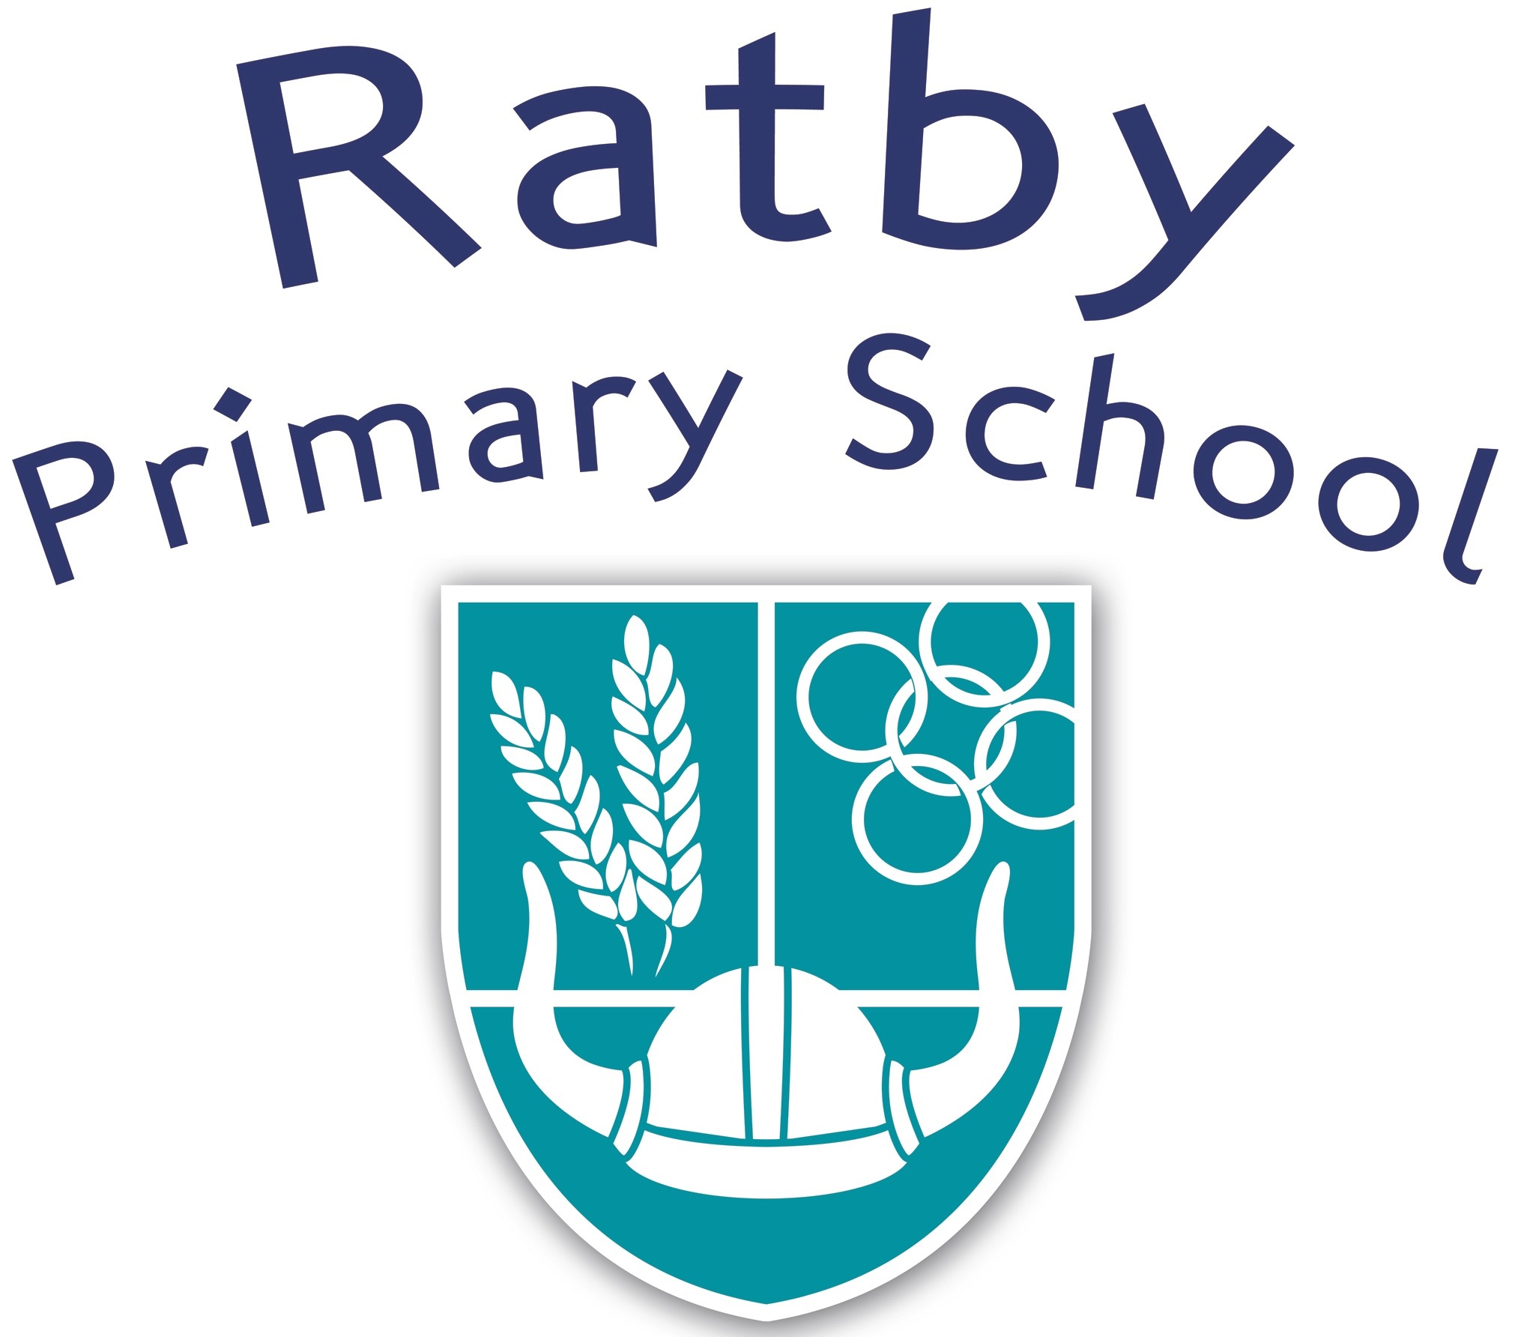

Relationship and Sex Education Policy
2019

Reviewed | September 2019
Frequency of Review | 3 Years
Written by | Nicola Oliver
Approved by: | RSE Coordinator

What is Relationship and Sex Education?

This policy covers our approach to Relationships Education; a statutory component of the PSHE and Citizenship curriculum from September 2020. It aims to set out the purpose of Relationships Education and the intended outcomes for pupils, what is covered in our curriculum and how it is delivered.
We define Relationships Education as learning about the many strands of relationships and growing up. This includes family relationships, friendships and relationships with peers and adults, healthy and unhealthy relationships, the characteristics of positive relationships, relationships online and the emotional, social and physical aspects of growing up.

At Ratby Primary School we believe:

At our school, we believe in providing every pupil with open, honest, accurate and age-appropriate lessons all about relationships. Through the school’s ethos and values, we aim to develop children’s knowledge, skills, opinions, strategies and confidence - enabling them to cope with life and live safely and happily in the modern world.

We highly value the partnership between school and home and will promote open and informative two-way communication. We aim to provide parents and carers with accurate information about what their child is learning in school and to provide the best learning environment and opportunities for our children.

Our Relationship and Sex Education curriculum is inclusive and meets the needs of all children, including those with special educational needs or disabilities (SEND). We also aim to promote gender, age, racial equality and diversity and represent the LGBT+ community through our Relationships curriculum.

Through our comprehensive Relationships and Sex Education provision, we aim to provide all pupils with:

- the knowledge and understanding of a variety of relationships;
- the ability to identify any concerns they have about a relationship;
- coping strategies, understanding emotions and an awareness of how and where to seek support;
- an understanding of their rights and responsibilities within a range of relationships;
- an awareness of the process of growing up and the changes they and others will experience;
- an understanding of the characteristics of positive relationships.

We also aim to enable young people to gain information, develop and transfer skills and explore attitudes and values, in order to support informed decision-making by;

- promoting a healthy, safe and caring environment for all pupils and staff;
- providing a broad and balanced curriculum for all our pupils, which values their diverse backgrounds and needs;
- promote pupil’s self-esteem and emotional wellbeing and help them to form and maintain worthwhile and satisfying;
- relationships, based on respect for themselves and for others, at home, at school, at work and in the community;
- prepare our pupils to confidently engage with the challenges of adult life;
- provide sufficient information and support to enable our pupils to make safe choices.

Statutory Regulations

From September 2020, all primary schools must deliver Relationship Education. Under the Education Act 2002/Academies Act 2010, all schools must provide a balanced and broadly-based curriculum which:
promotes the spiritual, moral, cultural, mental and physical development of pupils at the school and of society, and prepares pupils at the school for the opportunities, responsibilities and experiences of later life.

Documents that inform the school’s Relationship and Sex Education Policy include:

- Education Act (1996)
- Learning and Skills Act (2000)
- Education and Inspections Act (2006)
- Equality Act (2010),
- Supplementary Guidance SRE for the 21st century (2014)
- Keeping children safe in education – Statutory safeguarding guidance (2016)
- Children and Social Work Act (2017)

Other school policies that are relevant to our provision of RSE are:

- PSHE and Citizenship
- Safeguarding and Child Protection
- Science
- Confidentiality
- Behaviour
- Anti-Bullying
- Inclusion
- Equality
- Staff Health and Wellbeing
- Healthy Schools.

Our Relationship and Sex Education policy has been developed through discussion with the Governor responsible for Relationship Education in school along with the Local Advisory Board, Staff, PSHE Co-ordinator and with the support of the Head Teacher.

It was discussed and ratified by the Local Advisory Board on Monday 30th September 2019.

Delivering the Curriculum

Our lessons are taught by staff who are trained in delivering the specific content of the lessons. They will consist of PSHE (physical, social, health and wellbeing), Citizenship (living in the wider world) and RSE (relationship and sex education)

Ground rules will be established in class and children reminded of these. Special consideration will be given when teaching particularly sensitive content and staff will be fully aware of the children in their class and how they might relate to the lesson content.

We aim to create and maintain a safe environment within which all children feel able to ask questions and discuss issues openly. For any child wishing to discuss something confidential, relating to the lesson content, an opportunity will be provided.

We acknowledge that sensitive and potentially difficult issues will arise in RSE as children will naturally share information and ask questions. Each class also has a question box, which gives children the option to write down their questions and receive an answer on a one-to-one basis, rather than in front of the whole class. If a member of staff is uncertain about the answer to a question, or indeed whether they wish to answer it they will seek guidance from the PSHE leader.

Distancing techniques will be employed in our RSE, as with other areas of the PSHE curriculum, meaning that children are able to discuss fictional characters and scenarios, rather than discuss their own lives and experiences.

Our inclusive curriculum supports the statutory requirements for Key Stage 1 and 2 set out by the DfE. It forms a core part of our comprehensive Personal, Social and Health Education (PSHE) curriculum.

We are committed to working closely with parents and carers and we do this by:
communication about when relationships lessons will be taking place and the content;
leaflets;
links to other websites on school website;
home learning opportunities to follow-up learning at home.

This policy will be available to view on our school website by all stakeholders.

What is taught?

Below is a summary of the key learning objectives for Sex Education lessons. These are taught in our topics; It’s my Body and Growing Up and include some relationship lessons. Other topics areas taught will also cover Relationship Education, Health and Well Being and Living in the Wider World. These topics are called Teams, VIPs, Britain, Be Yourself, Safety First, Think Positive and Aiming High.

Year 1

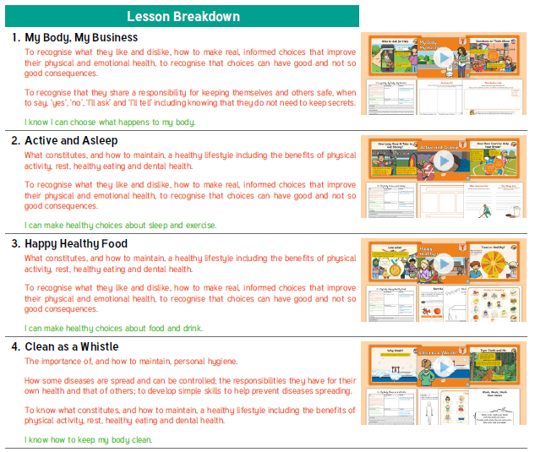
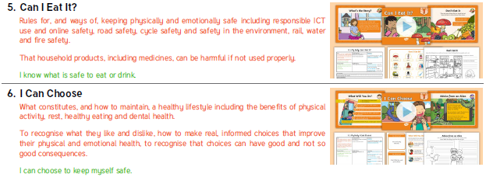

Year 2

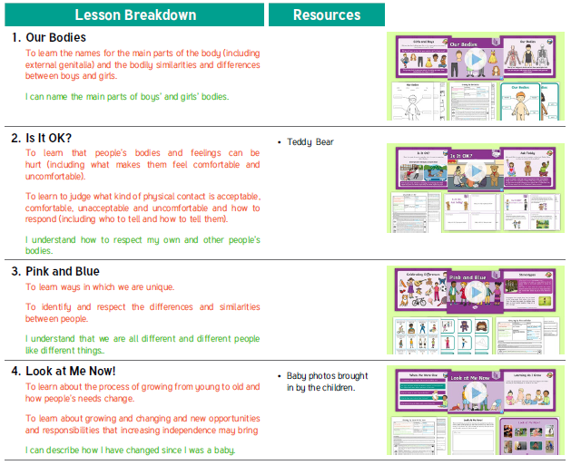
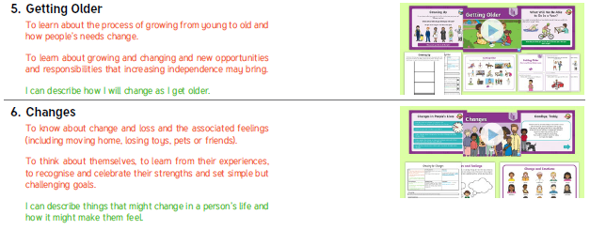

Year 3

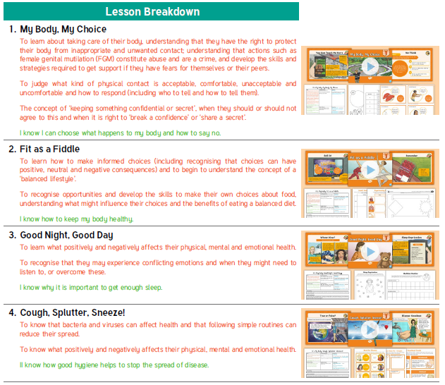

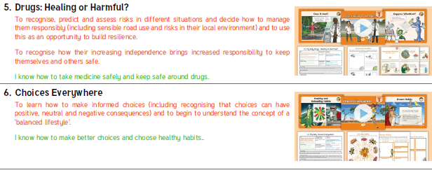

Year 4

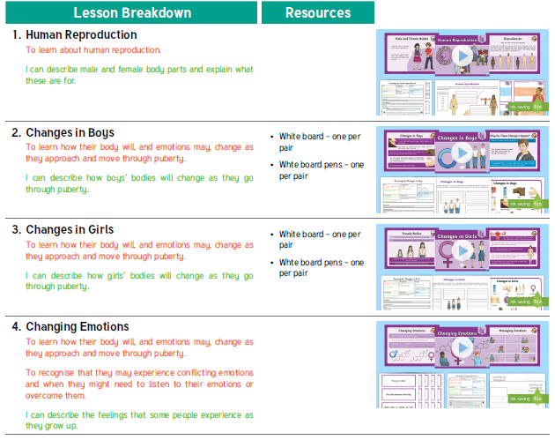

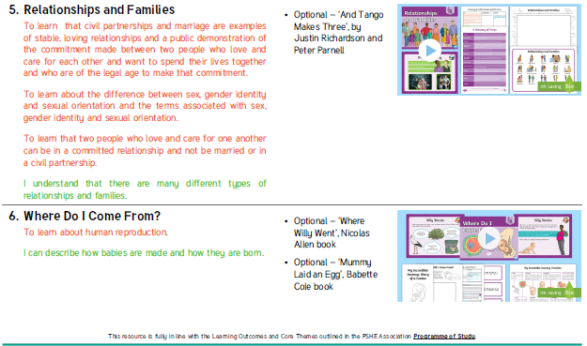

Year 5
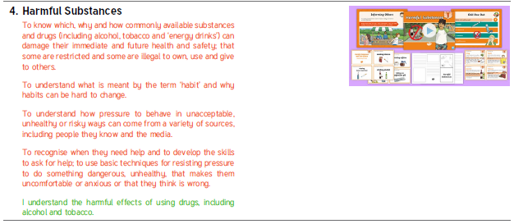
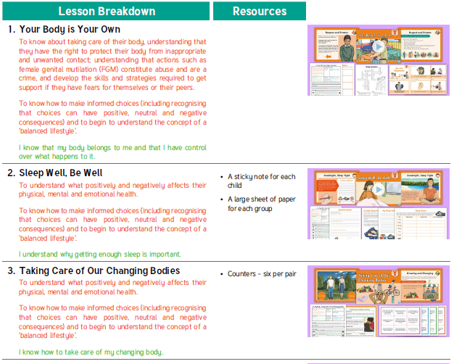

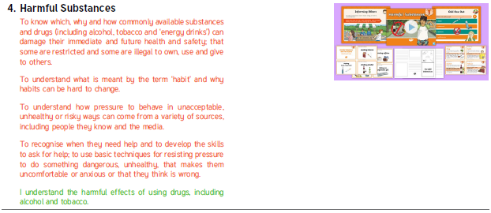

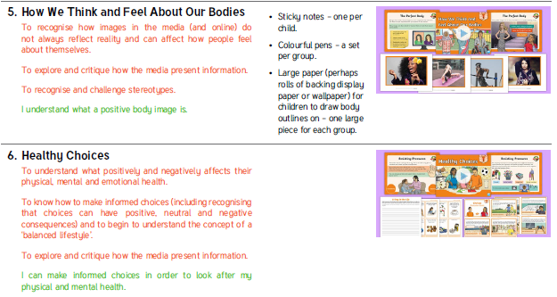

Year 6

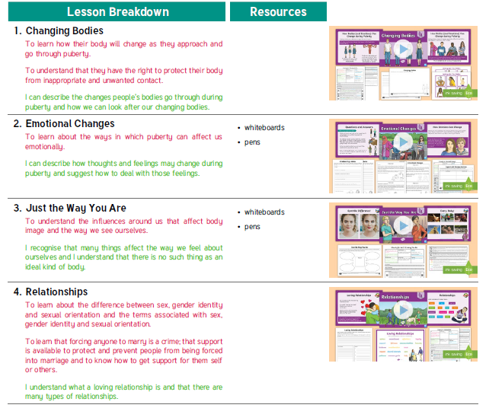

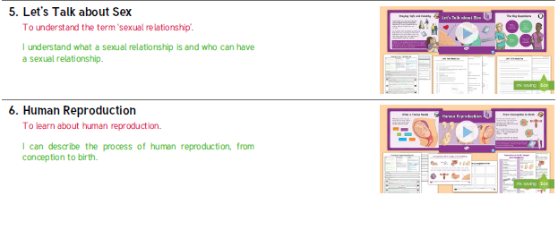

We understand that at times children will benefit from varying methods of delivering the RSE curriculum. For example, we will use single-sex groups or small group teaching where this will help us to meet the needs of children more effectively, we will use team teaching where this enables us to best use teacher expertise. We will ensure there are positive educational reasons for each method of delivery.

We recognise the importance of ensuring that young people understand about the physical and emotional changes of puberty before they reach it, in order to allay fears or concerns. We also recognise that young people develop at different rates. When teaching about puberty in our RSE programme, we will be sensitive to the needs of those developing at different rates.

We recognise that many primary-aged children are aware of some forms of contraception and have begun to understand that adults do not only engage in sexual activity when they wish to reproduce. Children may ask direct questions about contraception, or may reveal knowledge (accurate or inaccurate) about contraception in discussion with adults or their peers. We will address this issue directly in very broad terms as part of the taught RSE Curriculum at Year 6. The learning will be set in the context of responsible parenting decisions.

Inclusion

We understand the importance of ensuring that all children in our school receive their entitlement to RSE. We will carefully consider special educational needs or disability, gender, sexual orientation and age, nationality, religion, cultural and linguistic background when planning and delivering SRE.
In relation to nationality, sexual orientation, religion and cultural diversity, we value the different backgrounds of our pupils and, in addressing different views and beliefs, seek to promote tolerance and understanding.

In order to ensure the RSE Curriculum meets the needs of all:

- We will not promote one particular lifestyle over another.
- We will not seek to gain consensus, but will accept and celebrate difference.
- We will encourage respect and discourage abuse and exploitation.
- We will not ask children to represent the views of a particular religious or cultural group to their peers, unless they choose to do so.

In relation to those with special educational needs or disability, we will review our RSE programme to ensure that provision is made for those with additional needs. We will consider:
- their level of vulnerability
- their need to learn and demonstrate appropriate behaviour
- their need to develop self-esteem and positive body image
- the need to involve all staff, including ancillary staff and carers, in policy development, planning and training
- the management of personal care
- clarity about sources of support for pupils.

Working with Stakeholders and our School Community

Parents and carers are the key figures in supporting their children through the emotional and physical aspect of growing up. We recognise that many children would prefer to receive information about RSE from their parents and carers. Therefore, we seek to work in partnership with parents and carers when planning and delivering SRE. We will encourage this partnership by:

- Informing parents and carers by letter of our school RSE curriculum.
- Providing parents with an opportunity to comment on RSE within school and voice any concerns
- Inviting parents to learn more about resources and activities used in RSE
- Gathering parents’ views on the RSE Policy and taking these into account when it is being reviewed
- Informing parents and carers about the RSE programme as their child joins the school through the school brochure/prospectus/website
- Providing supportive information about parents’ role in RSE
- Inviting parents to discuss their views and concerns about RSE on an informal basis.

Right to Withdraw

Parents and carers have the legal right to withdraw their child from all or part of sex education taught as part of statutory Relationships Education, with the exception of the objectives included in National Curriculum for science. Those considering this option are asked to speak with Mrs Oliver (Lead Teacher for PSHE) or contact Mrs Jones (Head Teacher) in order to find out more about this.

Safeguarding

Teachers are aware that effective RSE, which brings an understanding of what is and what is not appropriate in a relationship, can lead to a disclosure of a child protection issue. Where a question or comment from a pupil in the classroom indicates the possibility of abuse, teachers will pass this information to the designated person for child protection in line with school policy.
In all instances, teachers will consult with the designated safeguarding lead and in his/her absence, their
deputy.
- Designated Safeguarding Lead: Mrs Lisa Jones
- Deputy Designated Safeguarding Lead: Mrs Bedder
- Deputy Designated Safeguarding Lead: Mrs Astill

Visitors and external agencies which support the delivery of Relationships Education will be required to
adhere to the school’s safeguarding policy and policies relating to the subjects they are teaching or
contributing towards.

Assessment, Monitoring and Reporting

Self-assessment is an important part of learning in Relationships Education and PSHE. Children will reflect
on their learning throughout the units. We highly value pupil voice and will take into account the opinions
and comments of our children about what they would like to learn.

Staff delivering the Relationships curriculum will critically reflect on their teaching and best practice will be
shared through lesson observations, monitoring of planning and children’s work and training opportunities.
Comments on children’s learning and progress in Relationships Education, as part of their learning in PSHE, will be reported to parents and carers during parent’s meetings and in school reports. Monitoring and evaluation of the Policy is the responsibility of the Local Advisory Board

The Policy will be formally reviewed every year. The next review will take place in 2020.

Chair of Governors:…………………………………………………………………………. Mr Sam Ward Sept 2020

