Our Rules to Keep Us Safe at School

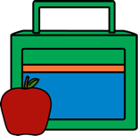
- Wash your hands before leaving your house and travelling to school.
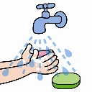
- Bring ONLY a lunch box or your school bag. (No toys)
- On entering the classroom wash and dry your hands or use hand sanitizer
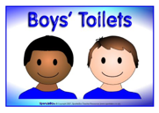
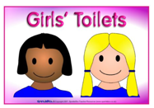
- Follow the arrows when you are moving around school.
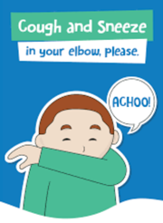
- Use ONLY the toilets for your group where possible and follow the rule for how many children are allowed in at one time.

- If you sneeze or cough, catch it in your elbow.
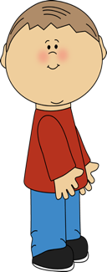
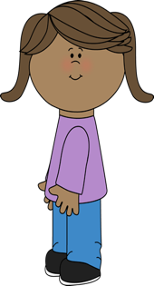
- At play-times, play only in the area which you asked to play in.
2m
- Try to keep 2 meters away from other people.
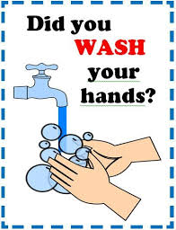
- Try not to touch anybody else in school.
- Wash your hands with soap, for 20 seconds, after going to the toilet.
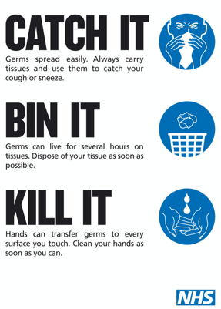
- Wash your hands with soap, for 20 seconds, before you eat.
- If you cough or sneeze follow the guide “catch it, bin it, kill it” and wash your hands straight away

- If you feel unwell tell an adult straight away

