Wednesday 3rd March 2021
Dear Parents,

As many of you are breathing a deep sigh of relief as Remote Learning comes to an end this week, we have been busy in school finalising preparations for the re-opening of school on Monday 8th March 2021. Much of the detail below is a repeat of the organisation that was in place in the Autumn Term, but I thought it wise to recap on some of the key points.
Drop Off and Pick Up Times
All children should be picked up or dropped off by one adult only. If an older sibling is dropping off or picking up they should also arrive alone (not with friends) and adhere to the measures of social distancing and the wearing of a face mask).
Year Groups | Drop Off Time | Pick Up Time
Year 5 and 6 | 8:45 to 8:55am | 3:10 pm
Year 3 and 4 | 8:45 to 8:55am | 3:10 pm
Year 1 and 2 | 8:45 to 8:55am | 3:00pm
EYFS | 8:45 to 8:55am | 3:10pm
Please note there is a 10 minute window to arrive at school to ensure that children are in school ready for the register at 9:00am. After 9:00am children will be late for school.
Pick Up Times
A polite reminder that parents should not be gathering at the school entrances or on the school grounds. Adults are expected to maintain 2m social distancing whilst on school grounds and should take this into account when speaking to a staff member. Parents should continue to communicate with staff as much as possible through the Home-School Book, Phone Calls and Emails (office@ratby.bepschools.org). All meetings with staff need to be by prior appointment.
Please could I also ask that all children stand with the adult that is collecting them and not run around the playground unaccompanied. This is to again ensure the safety of all parents, pupils and staff on site.
Year 6 – Can I ask that all parents speak to their children about ensuring they are maintaining social distancing walking to school and when waiting for the school gates to open. This is also the case for the end of the school day when walking home from school.
EYFS
EYFS parents should drop their children at the main green gates (like those who have been in school are currently doing). EYFS staff will be on the main playground to greet and collect your child. Pick up will be as the Autumn term. Please note that due to the stage of Miss Hughes’ pregnancy, she is considered more at risk. Therefore, we politely ask that adults do maintain 2m distance from her when in the FS playground and do adhere to the compulsory face masks. This will be much appreciated.

Face Coverings
Children in primary school do not need to wear a face covering. We would also request that ALL parents continue to wear masks on site for dropping off and picking up their child, unless medically exempt. Parents who do not wear masks may be asked to leave and asked not to enter the site without a face covering.
Minimising Coronavirus Risk
I would like to remind all parents that if your child(ren) is displaying symptoms of COVID-19 (persistent cough, loss of taste and/or smell, high temperature) or appear unwell in any way, they should remain off school. They should also not attend school if they are required to quarantine having recently visited countries outside the Common Travel Area. If anyone in your household is isolating due to a positive test, showing symptoms of COVID-19 and are awaiting test results all members of the household should remain isolated until either the end of their isolation period (as advised by Track & Trace) or a negative test result is received. DO NOT send your children to school whilst awaiting test results.
They must immediately cease to attend and not attend for at least 10 days from the day after:
- the start of their symptoms
- the test date if they did not have any symptoms but have had a positive test (whether this was a Lateral Flow Device (LFD) or Polymerase Chain Reaction (PCR) test)
Can I remind ALL parents to report any PCP test outcomes via the ms form the school website for our records and returns to the DfE. This can be done by clicking on the link: https://www.ratby.bepschools.org/information/covid-19-update/
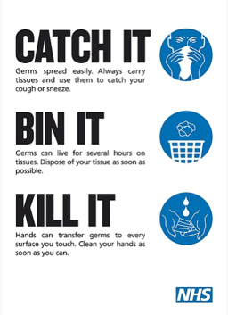
In preparation for their return to school I would be grateful if parents could take the time to reiterate the principles of hand and respiratory hygiene which will help to minimise the spread of infection.

Hand Hygiene
Pupils will be expected to clean their hands regularly, including:
- when they arrive at the school
- when they return from breaks
- when they change rooms
- before and after eating
Respiratory Hygiene
The ‘catch it, bin it, kill it’ approach continues to be very important. Please continue to promote this at home, in preparation for the return to school. The e-Bug coronavirus (COVID-19) website contains free resources, including materials to encourage good hand and respiratory hygiene.
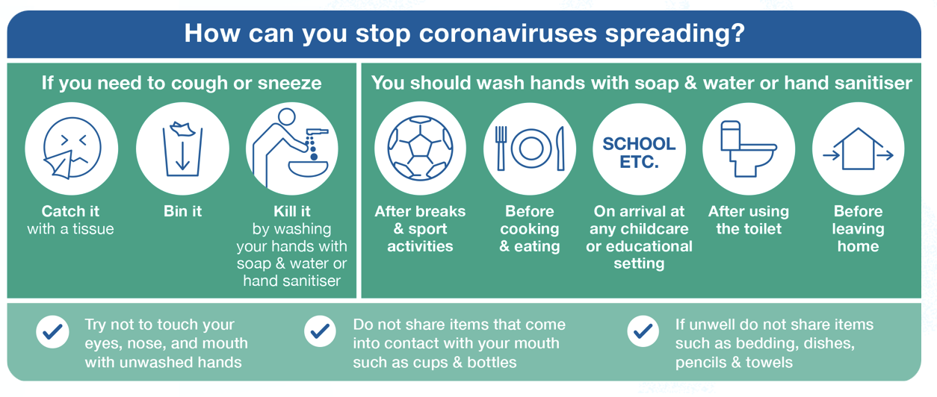
Self-Isolation
In the event of pupils having to self-isolate teachers will continue to provide remote learning (should the child be well enough to complete it) via Tapestry or Seesaw. If necessary, we may be able to loan pupils a device during this period of time. Please contact the school office, if you require a device.
PE
PE will start immediately on our return. Please ensure that your child wears their PE kit to school on their PE days as previously advised. As it is cold outside, children's PE kit should include tracksuit bottoms, a t-shirt and a hoody/sweatshirt and a thin coat to keep them warm if you have one. PE will only take place outside, so if the weather does not permit it, PE will not take place. If they are attending an after school club not on their allocated PE day, they may bring a change of clothes.
Extra Layers in school
In following the Government guidance, the school needs to ventilate classrooms and shared spaces as much as possible. This means that windows will be open during class time. As we are still in the colder months we would advise that children wear extra layers i.e. base layers/thermals, fleeces (if you have one).
Lunches
We will be returning to a staggered lunchtime with the vast majority of pupils eating their lunch in the hall and sitting only with their class bubble. Outside children will be grouped in Year group bubbles for playing outside.
In Year 6 children will continue to have a ‘take-away’ style hot or cold lunch that can be eaten in the classroom to reduce the number of pupils gathering in the hall at any one time.

Equipment and Resources

Please can we ask that pupils only bring in to school the equipment they need (water bottle, lunch box, reading book, home-school book) and that bags are as small as possible. No toys (especially soft toys) or personal belongings should be brought into school to help reduce transmission of germs.

Children will continue to be provided with their own set of resources such as pens, pencils, scissors, glue sticks, whiteboards etc and children will not be allowed to share items.

Classroom resources can be shared within the bubble but will need to be cleaned regularly, along with all frequently touched resources.
Any shared equipment such as DT or Science resources will be thoroughly cleaned after each bubble has used it.
With regard to Reading Books, these will be stored for 72 hours following any children returning their book to school before they are re-issued to another group.

Assemblies
There will be no whole school assemblies for the time being and any assemblies will take place in classroom.

Attendance
From Monday 8th March school attendance will be mandatory for all pupils. If you have any concerns about your child returning please phone school or send an email so that we can discuss the situation with you.

Systems of Controls in place at school
- Pupils and staff are required to self-isolate by ensuring they DO NOT attend school if they display any Covid 19 symptoms
- Face coverings will be worn by staff in communal areas such as corridors and the staffroom and in areas where social distancing cannot be maintained.
- All pupils and staff are expected to clean their hands thoroughly and more often than usual. We will be using hand sanitiser in school.
- All pupils and staff are encouraged to demonstrate good respiratory hygiene for everyone by promoting ‘catch it, bin it, kill it’ approach.
- All staff will continue to ensure that enhanced cleaning measures are in place such as cleaning frequently touched surfaces more often.
- We will continue to minimise contact between bubbles across the site by minimising movement around the site and maintaining social distancing wherever possible.
- The school building will continue to be well ventilated
- We will continue to promote and engage with asymptomatic testing of staff in school twice a week.
- LA Risk Assessment shared with staff
- LA Premises Covid Toolkit Premises Document completed
- BEP Re-opening plan completed and shared with staff
- Deep Cleaning for Influenza Virus Risk Assessment completed and share with staff.

Looking forward to welcoming all of the children on their return on Monday 8th March.
Stay safe

Yours Sincerely,

Lisa Jones
Headteacher

