Friday 26th February

FAO All families of Bradgate Education Partnership

Dear All

Re: Re-opening of schools

As I am sure you are already aware I am really pleased to be able to write to you and confirm that we will begin fully re-opening our schools from Monday 8th March.

This is obviously fabulous news and we are thrilled at the prospect of seeing all of our pupils back. However, we know that some of you may remain anxious about the safety and well-being of your children and the ongoing challenges presented by the pandemic. Please can we assure you that all of our schools are currently re-visiting all of their health and safety protocols and risk assessments to ensure that schools are as safe as possible.

Your child’s school will write to you explaining the local details and arrangements for their return. In primaries this will likely include a return to slightly amended and staggered drop-off and collection times. In our secondaries this may also include a staggered return to school on a year group-by-year group basis across the first week to allow for the lateral flow testing. For clarity we are expecting the return of all pupils – this is also the legal expectation. Therefore, if you or your child have truly exceptional circumstances which will make return to school difficult please contact your child’s school.

In the first few weeks of return we will begin the job of assessing and supporting the learning needs of the pupils. However, we also intend to concentrate on providing our pupils with a return to normality, hopefully a chance to safely socialise within their school community and to consider the wider well-being of our students. Thanks to the supreme efforts of the staff across our schools alongside the dedication shown by both pupils and their families we remain confident that we will be able to support the return to school and the subsequent recovery of lost learning in the coming months.

Can I conclude by once again thanking you for your efforts. Although we all hope fervently that we will never deal with anything like this pandemic again it has been amazing to see such ingenuity, creativity, resilience and character from schools, pupils and families.

If you have any concerns, please do not hesitate to contact the Trust or your child’s school.

Yours Sincerely,

Gareth Nelmes Dean Pomeroy
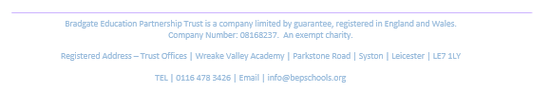
Chief Executive Officer Director of Schools

