Ratby Primary School
Part of the Bradgate Education Partnership

Re-Opening Guidelines – 8th March 2021

1.0 Introduction
This document aims to set out Ratby Primary School plans to ensure all year groups return to school from 8th March 2021.

Implementing the system of controls and our risk assessments will help to create a safer environment for pupils/students and staff.

Please ensure you refer to:
https://assets.publishing.service.gov.uk/government/uploads/system/uploads/attachment_data/file/964351/Schools_coronavirus_operational_guidance.pdf

2.0 System of Controls – Page 7 onwards in the above mentioned guidance.

Set Up -
As per updated Trust risk assessments and the DfE guidance.

BEP Academy Re-Opening Plan – March 21
COVID Re-Opening Checklist –March 21
COVID Toolkit Premises and Facilities
Deep Cleaning for Influenza Virus
LA Re-Opening Risk Assessment
BAME Risk Assessment

3.0 Trust Trackers
Building Compliance Tracker – Trust doc
Health and Safety Compliance Tracker – Trust doc
Please review and ensure everything is in place, serviced and compliant.

4.0 DfE
Please refer to the ‘System of controls’ for prevention as per DfE advice.

5.0 Letters
Letter to parents – 26th February 2021
Trust letter to staff – 26th February 2021

6.0 PLEASE TALK TO ALL STAFF:
Maintain 2m social distancing where possible from children and staff/parents.
Wear face masks when entering/leaving and moving around the building.
Ensure staff are aware of all risk assessments.
Ensure they understand the System of Controls as outlined by the DfE.

Ensure everyone is advised to clean their hands thoroughly and more often than usual Coronavirus (COVID-19) is an easy virus to kill when it is on skin. This can be done with soap and water or hand sanitiser.
You must ensure that pupils clean their hands regularly, including:
• when they arrive at the school
• when they return from breaks
• when they change rooms
• before and after eating

7.0 Planning for returning – All year groups
-Keep children /students in consistent groups to reduce the risk of transmission, limit the number of pupils and staff in contact with each other.
-Maintain distinct bubbles that do not mix

-Regular cleaning of shared spaces;
-Playgrounds & equipment
-Dining halls
-Toilets and frequently touched surfaces

-Whatever size of the group, keep apart from other groups where possible.
-Pupils to be encouraged to keep their distance within groups.
-Try to limit interaction, sharing of rooms, social spaces where possible.

-You can allow mixing for wider groups:
-Specialist teaching
-Wraparound care
-Transport
-Siblings may well be in different groups

-Teachers and staff can operate across different classes and year groups to ensure the delivery of timetable and specialist provision

8.0 Key Worker / Vulnerable Children who are not attending
- Daily contact will be needed.
- Log with appropriate person (HT / DSL).
- Log on CPOMs
- Work with social care to resolve and / or support from home with online offer if needed.
- Liaise with Attendance and Welfare Lead (DC) with any concerns.
- These cases should be minimal, attendance is mandatory.

9.0 Classrooms
Follow DfE / Trust guidance and ‘System of Controls’.
-Class bubbles must be maintained in infant / primary settings
-Yr group bubbles must be maintained in secondary settings
-Maintain 2m distances where possible from children and adults
-If a pupil requires close medical or intimate care, PPE should be worn.
-Seat children side by side and facing forwards where possible
-Classrooms will be well ventilated with doors and windows left open.
-Fire doors should be closed at the end of day for fire prevention.
-Children will sit in the same seat throughout the day.
-Children will have access to the same stationary.
-All unnecessary furniture /toys / equipment will be removed from the classrooms.
-Don’t share resources outside of bubbles unless cleaned thoroughly.
-If resources are moved between classrooms, clean them before they are moved or leave unused for 48 hours (72 for plastics)
-Keep classrooms well ventilated and comfortable for children.

10.0 Other Measures – In School
-Avoid assemblies / gatherings with more than one group
-Timetable movement around the school to avoid contact and to keep groups apart
-Stagger breaks and lunchtimes
-Allow time for cleaning surfaces in the dining hall and other areas as needed
-Help staff distance from each other, reducing shared spaces in staff rooms, although staff will need to have breaks during the day

11.0 Other Measures – Arriving at and Leaving School
-Stagger starts and finish times and keep under review
-Advise parents/carers to not gather in groups, and to wear face masks
-The length of the teaching day must not be reduced
-Remind parents on the drop off and collection arrangements
-Do not allow visitors without an appointment
-Reduce all visitors where possible

12.0 Trust Building Compliance / Health and Safety Compliance
There is no relaxation to our Health and Safety requirement. Please ensure your site is fully operational and that all procedures and assurances are in place.
-Where external reports are required (e.g. Fire Risk Assessment, Fixed Wire Reports, Asbestos Management Reports, Legionella & Tank Inspections etc) please ensure you book these in with contractors early to avoid trackers going into the ‘red’.
-Where internal monitoring, reporting or repairs are managed, please ensure the PO has completed the necessary work and that the PO Logbook is regularly signed off by the HT.
-Encourage visits outside of school hours or weekends where possible
-Any concerns, please talk to Andy Marshall.

13.0 Contractors
-Pre-booked only
-Ensure site guidance with physical distancing / hygiene / safeguarding is in place
-Encourage visits outside of school hours where safe to do so
-Please keep a record of visitors

14.0 Toilets
Increased cleaning / monitoring.
There will be a system so that toilets can be cleaned frequently
Cleaning log sheet display outside toilets and all other areas which need to regularly cleaned (template in – COVID Toolkit Premises & Facilities)

15.0 Movement Around School
- All non-essential movement around the school will be avoided.
- All areas of the school will be marked with the appropriate signage.
- Where possible, children will be supervised in corridors and the main areas of the school to manage the number of children in these spaces.
- To the best of our ability, class groups / year groups of children will not mix.
- Where possible (in accordance with fire regulations), doors will be propped open to reduce contact with door handles, but closed at the end of each day as per HSE / Fire advice.
- A fire drill will be conducted when all children are back in school and it will be logged.

16.0 Face Masks
Faces masks should be worn by adults in any situation where social distancing is not possible.
- Primary – pupils not expected to wear – staff please see HR guidance
- Secondary – pupils expected to wear when moving around the building – staff please see HR guidance
- Parents – Trust position is that they are expected to wear masks for drop off / collection.

17.0 Staff Room
Restrict access where possible
- Furniture will be positioned 2m apart where possible, facing forwards.
- Staff should only use the staff room if they are able to socially distance.
- Staff are encouraged to bring a flask / thermal mug for hot drinks.
- Staff will not share food
- Wash hands on entry / exit to staffroom

18.0 Break-time and Lunch-time arrangements
- Children will all wash their hands before and after lunch.
- Children will line up at their designated time following the <e.g.floor markers> to collect a ‘Packed Lunch’ and when the weather is nice enough to eat outdoors, children will have a picnic style lunch adhering to social distancing (1m+) on the school field.
- If the weather does not permit children to eat outdoors, they will eat in their class groups in the school hall / classrooms.
- All tables will be cleaned with disinfectant before and after lunch.
- Ensure class bubbles remain socially distanced, where possible.
- Staff to maintain 2m from each other and pupils where possible.

19.0 Remote Learning:
- Provide for those children / students not in attendance (if needed)
- Regular feedback will be needed.
- Regular safeguarding checks / logs in place.
- Access to online lessons, teacher interaction and a mix of live and recorded.
- Discuss with the HT and plan for virtual lessons (pre-recorded and live)
- Remote learning is mandatory for groups who are self-isolating or are unable to attend school. The offer should up and running by the following school day.

20.0 Attendance:
- Attendance School attendance will be mandatory for all pupils from the 8th March. The usual rules on school attendance apply, including:
  - Parents’ duty to secure their child’s regular attendance at school (where the child is a registered pupil at school and they are of compulsory school age)
  - The ability to issue sanctions, including fixed penalty notices in line with local authorities’ codes of conduct. As usual, you are responsible for recording attendance, following up absence and reporting children missing education to the local authority / Trust.
  - Whilst fixed penalty notices may be considered, please ensure all avenues are exhausted prior to moving towards fining parents.

21.0 Testing: This is an offer
- Primary – Staff will be able to access a test with LFDs twice a week at home, as per existing guidance. If positive, a PCR test will be needed and staff will self-isolate until they get a result and if they test positive
- Primary age pupils will not be tested with LFDs.
- Secondary – Staff will be able to access a test with LFDs twice a week, if positive a PCR test will be needed and staff will self-isolate until they get a result and if they test positive
- Secondary age students - During the week commencing 8th March, pupils will be offered asymptomatic testing on site in secondary schools. Pupils who consent to testing should return to face-to face education following their first negative test result. Pupils not undergoing testing should attend school in line with your phased return arrangements.
- Vulnerable children and children of critical workers in secondary schools should continue to attend school throughout, unless they receive a positive test result. Testing is voluntary, but strongly encouraged.
- Please communicate and clearly and consistently and encourage attendance, working with families to reassure them where needed.

22.0 Rotas:
You should not plan for rotas as there is no requirement to reduce occupancy in schools. Instead, everyone must follow the system of controls.

23.0 Staffing
Please refer to the HR guidance for all staff related processes/information

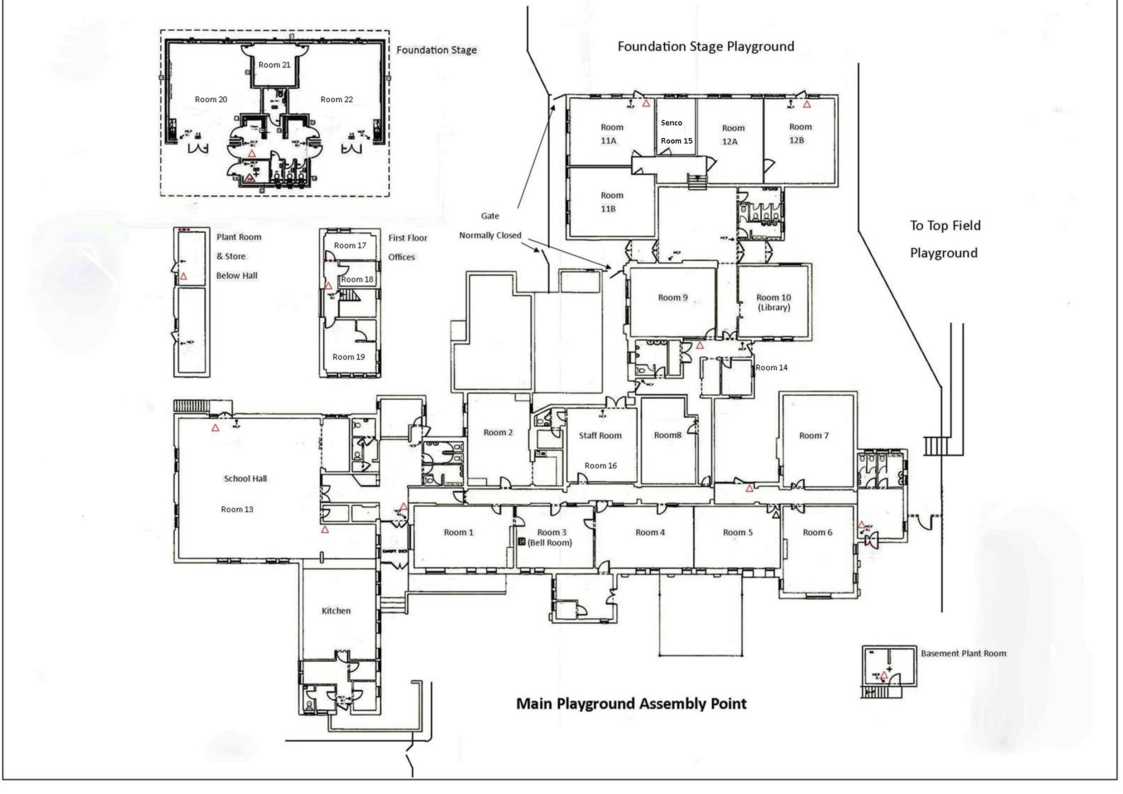
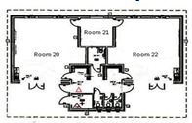
Year 5 & 6 Playground
Zone 3

Rainbows

Sunshines
Room23
Room 24

Room 25

Isolation Room
Library
Y4 Venus
Year 4 Mars
Sharman Hall
Peake Hall
Y1 Milky Way
Main Entrance & Exit
Main Playground Zone 1
Main Playground Zone 2
Y6 Neptune
Y6 Earth
Y1 Stars
Y2 Comets
Y2 Galaxy
Y5 Mercury
Y5 Pluto
Y3 Saturn
First Aid Room
Y3 Jupiter
Lunchtime Rota (wb 8th March 2021 onwards)
 | EYFS (41) | Y1(48) | Y2 (52) | Y3 (48) | Y4 (59) | Y5 (62) | Y6 (58)
Timing | 11:30pm- 12:30pm | 11:45 – 12:45pm | 11:45 – 12:45pm | 12:30 – 1:30pm | 12:30 – 1:30pm | 12:00 – 1:00pm | 12:30 – 1:30pm
Hall | 11:30 – 12:00 | 11:45 – 12:15pm | 11:45 – 12:15pm | 12:30 to 12:45pm  Minimum | 12:30 to 12:45pm  minimum | 12:00 – 12:30pm | 12:30 – 1:00pm
 |  |  |  | Michelle P
 | Carrie B  Kelly W | Karen | Teresa | Mon:TH  Tues:TH  Wed:  Thurs:TC TH  Fri:TC TH | Mon:CW  Tues: CW  Wed: BW | Jenna til 12:25  Nicola G | Jenna
Playground Zone  Outside | 12:00 -12:30pm | 12:15 to 12:45pm | 11:45 – 12:15pm | 12:45 to 1:30pm | 12:45 to 1:30pm | 12:30 -1:00pm | 1:00 – 1:30pm
 | EYFS | Zone 1 | Zone 2 | Zone 1 | Zone 2 | Zone 3 – Top Field | Zone 3 – Top Field
 | Sports Coach  Nicola Fox | Maddie | Kirsty M | Michelle P  Shyam 1:00-1:15 | Kirsty M  Sports Coach til 1pm | Shyam til 1:00pm  Nikki Fox | Jenna  Nikki Fox
1:1 provision |  |  | Rhiannon (NP)  12:15 - 12:45 |  | MC – To seek support from KM | Georgia DM  Sarah TK
Sports Coach – 12:00 to 1:00
Shyam 12:15 to 1:15pm
New Staff to start in the next few weeks/after Easter:
- Louise
- Kaye
- Amanda
Playground Rota
 | Monday | Tuesday | Wednesday | Thursday | Friday
 | Front Playground | Front Playground | Front Playground | Front Playground | Front Playground
KS1 | 10:15 – 10:30 | 10:15 – 10:30 | 10:15 – 10:30 | 10:15 – 10:30 | 10:15 – 10:30
 | Teresa | Kirstie | Emma | Helen | Pam
 | Vanessa | Karen | Tracey P | Victoria | Cath J
 | Front Playground | Front Playground | Front Playground | Front Playground | Front Playground
Y3/4 | 10:45 – 11:00 | 10:45 – 11:00 | 10:45 – 11:00 | 10:45 – 11:00 | 10:45 – 11:00
 | Nickie O | Jesseca | Leesa | Lee | Sarah H
 | Tracey H | Charlie | Rachel H & Ella | Tiffany | Georgina
 | Top Field | Top Field | Top Field | Top Field | Top Field
Y5 | 10:30 – 10:45 | 10:30 – 10:45 | 10:30 – 10:45 | 10:30 – 10:45 | 10:30 – 10:45
Y6 | 10:45 – 11:00 | 10:45 – 11:00 | 10:45 – 11:00 | 10:45 – 11:00 | 10:45 – 11:00

