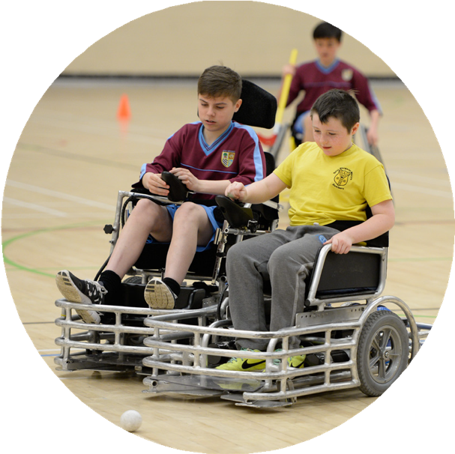
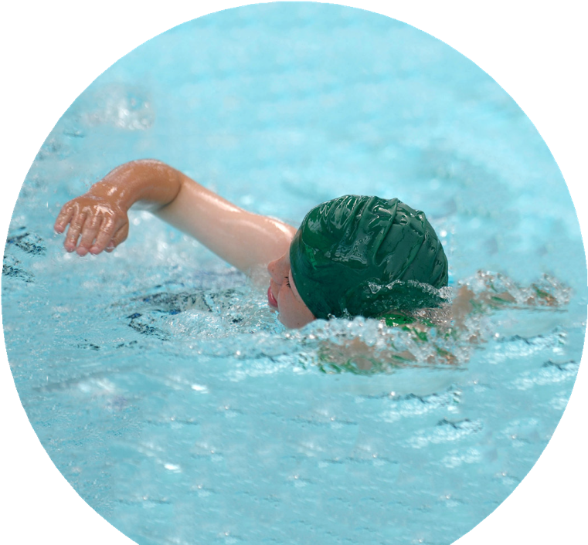
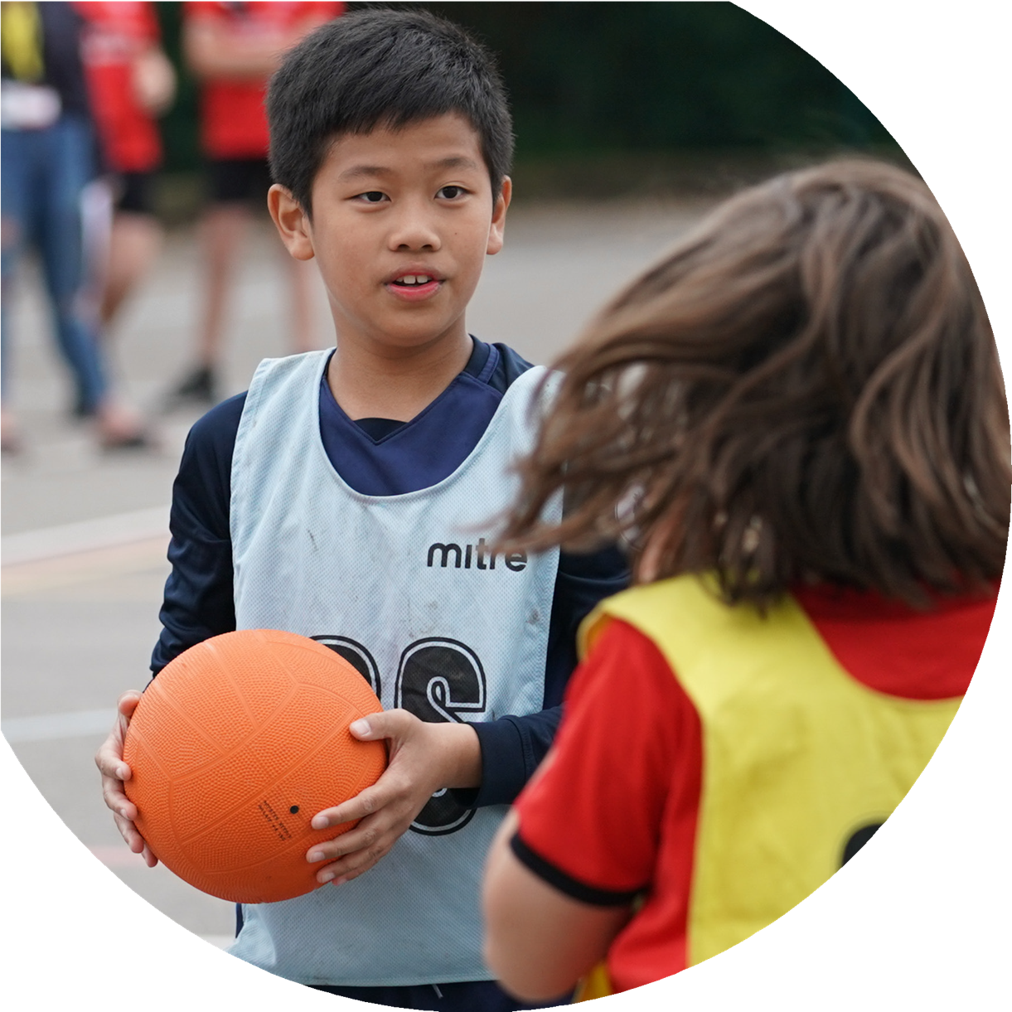

Evidencing the impact of the Primary PE and sport premium
Website Reporting Tool Revised July 2021

Commissioned by

Created by

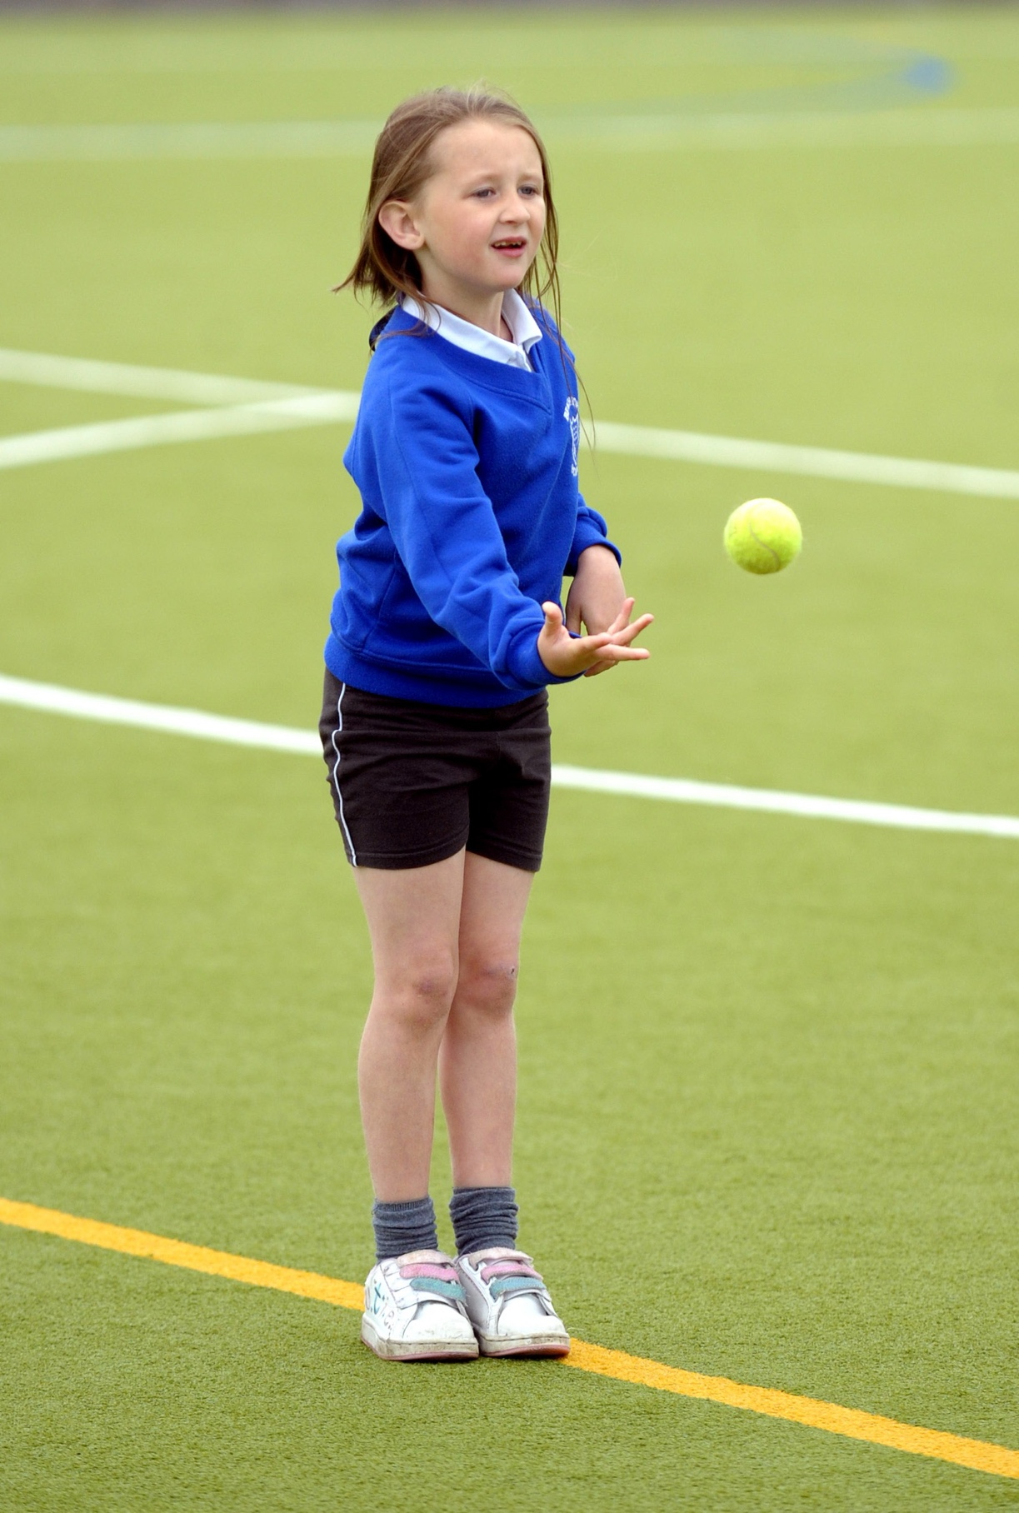
It is important that your grant is used effectively and based on school need. The Education Inspection Framework makes clear there will be a focus on ‘whether leaders and those responsible for governors all understand their respective roles and perform these in a way that enhances the effectiveness of the school’.

Under the Quality of Education Ofsted inspectors consider:
  - Intent - Curriculum design, coverage and appropriateness
  - Implementation - Curriculum delivery, Teaching (pedagogy) and Assessment
  - Impact - Attainment and progress

To assist schools with common transferable language this template has been developed to utilise the same three headings which should make your plans easily transferable between working documents.

Schools must use the funding to make additional and sustainable improvements to the
quality of Physical Education, School Sport and Physical Activity (PESSPA) they offer.
This means that you should use the Primary PE and sport premium to:

- Develop or add to the PESSPA activities that your school already offer
- Build capacity and capability within the school to ensure that improvements made now will benefit pupils joining the school in future years
- The Primary PE and sport premium should not be used to fund capital spend projects; the school’s budget should fund these.

Please visit gov.uk for the revised DfE guidance including the 5 key indicators across which schools should demonstrate an improvement. This document will help you to review your provision and to report your spend. DfE encourages schools to use this template as an effective way of meeting the reporting requirements of the Primary PE and sport premium.

We recommend you start by reflecting on the impact of current provision and reviewing the previous spend.

Schools are required to publish details of how they spend this funding, including any under-spend from 2019/2020, as well as on the impact it has on pupils’ PE and sport participation and attainment.
All funding must be spent by 31st July 2022.

We recommend regularly updating the table and publishing it on your website throughout the year. This evidences your ongoing self-evaluation of how you are using the funding to secure maximum, sustainable impact. Final copy must be posted on your website by the end of the academic year and no later than the 31st July 2021. To see an example of how to complete the table please click HERE.
Created by: Supported by:

Details with regard to funding
Please complete the table below.

Total amount carried over from 2019/20 | £4,4167
Total amount allocated for 2020/21 | £19,220
How much (if any) do you intend to carry over from this total fund into 2021/22? | £5,600
Total amount allocated for 2021/22 | £19,690
Total amount of funding for 2021/22. To be spent and reported on by 31st July 2022. | £ 25,290
Swimming Data
Please report on your Swimming Data below.

Meeting national curriculum requirements for swimming and water safety.

N.B. Complete this section to your best ability. For example you might have practised safe self-rescue techniques on dry land which you can then transfer to the pool when school swimming restarts.
Due to exceptional circumstances priority should be given to ensuring that pupils can perform safe self rescue even if they do not fully meet the first two requirements of the NC programme of study
What percentage of your current Year 6 cohort swim competently, confidently and proficiently over a distance of at least 25 metres?  N.B. Even though your pupils may swim in another year please report on their attainment on leaving primary school at the end of the summer term 2021.  Please see note above | 0%
What percentage of your current Year 6 cohort use a range of strokes effectively [for example, front crawl, backstroke and breaststroke]?  Please see note above | 0%
What percentage of your current Year 6 cohort perform safe self-rescue in different water-based situations? | 0%
Schools can choose to use the Primary PE and sport premium to provide additional provision for swimming but this must be for activity over and above the national curriculum requirements. Have you used it in this way? | No

Action Plan and Budget Tracking
Capture your intended annual spend against the 5 key indicators. Clarify the success criteria and evidence of impact that you intend to measure to evaluate for pupils today and for the future.

Academic Year: 2021/2022 | Total fund allocated: | Date Updated:
Key indicator 1: The engagement of all pupils in regular physical activity – Chief Medical Officers guidelines recommend that primary school pupils undertake at least 30 minutes of physical activity a day in school |  |  |  | Percentage of total allocation:
 |  |  |  | %
Intent | Implementation |  | Intended Impact
Your school focus should be clear what you want the pupils to know and be able to do and about what the need to learn and to consolidate through practice: | Make sure your actions to achieve are linked to your intentions: | Funding allocated: | Evidence of impact: what do pupils now know and what can they now do?  What has changed?: | Sustainability and suggested next steps:
To offer high-quality lunchtime experiences for pupils, expanding opportunities available for physical activity and school sports for pupils | - Continue lunchtime strategy to maximise physical activities on offer to pupils.  - Use of HT/PSHE Lead/Midday Manager to strategically plan our outdoor lunchtime provision, providing activities for all classes.  - Sustainable use of PE specialist coaches to enhance the lunchtime experience.  - Lunchtime activities to continue to specifically target the involvement of underactive pupils through championing ‘non-sporting’ physical activities. (e.g. traditional games, orienteering treasure hunts etc.)  - Train lunchtime supervisors to deliver high quality activities each day to engage ALL pupils through the provision of Happy Lunchtime Award/Training | £4,275  1 Additional Lunchtime Sports Coaches  £675  Happy Lunchtime Award & Training | Through setting up of non-competitive physical activities the number of targeted under-active pupils taking part in physical activity at lunchtime increases  Increased number of pupils chose to engage in range of physical activities at lunchtimes.
Daily Mile – Continue to promote the ‘Daily Mile’ to get all pupils undertake at least 15 minutes of additional activity per day. | Sports Leaders and Sports Coaches promote the daily mile through a stamp card and reward system for participants. | n/a | Daily mile firmly embedded in choice of activities to complete at break or lunchtime. | Daily mile firmly embedded in choice of activities to complete at break or lunchtime.
Key indicator 2: The profile of PESSPA being raised across the school as a tool for whole school improvement |  |  |  | Percentage of total allocation:
 |  |  |  | %
Intent | Implementation |  | Intended Impact
Your school focus should be clear what you want the pupils to know and be able to do and about what they need to learn and to  consolidate through practice: | Make sure your actions to achieve are linked to your intentions: | Funding  allocated: | Evidence of impact: what do pupils now know and what can they now do?  What has changed? | Sustainability and suggested  next steps:
To raise the profile of PE Physical Activity and School Sport across school | Maintain School Games Gold Award through participation in inter and intra-school competitions and the promotion of PE within school. | £700  HBSSPAN Buy In | School will maintain its achievements in the School Games Mark in 2021  https://www.yourschoolgames.com/sgo/southfields/school-games-mark-2020-update/
 | Provide PE Lead and Sports Coach with leadership time to promote and organise PE and Extra-Curricular opportunities for pupils |  | PE Leads will have access to information regarding upcoming festivals, competitions and events that pupils are able to participate in and will be able to plan for school entry into a wide variety of events promoting a wider range of sports
 | Create new noticeboard area to promote the principles of REAL PE within school and extra-curricular opportunities |  | Notice boards provide clear information about matches/clubs/results and the REAL PE Skills ( Applying Physical, Creative, Social, Personal, Health & Fitness , Cognitive)
 | Appoint Sports Ambassadors – Conduct a school survey to share with class regarding current and future provision of lunchtime activities and after-school clubs. |  | Sports Ambassadors will help to create the pupil voice regarding the current and future provision for break, lunchtime and after school physical activities. PE Leads will be able to respond to requests for new clubs  Greater % of pupils participate in extended provision available  Sports Ambassadors promote upcoming events and hand out weekly certificates linked to sports values
 | Celebration Assembly every week to ensure the whole school is aware of the importance of PE and Sport and to encourage all pupils to aspire to being involved in the assemblies  - Pupils encouraged to bring trophies, medals, awarded achieved outside of the school day  - Teachers to award ‘ Sports Personality of the Week’ certificates each week using the School Games Values: Respect, Passion, Determination, Self-Belief, Honesty, Teamwork  Pupils representing school in competitions & festivals are recognised in assemblies | £150 for certificates and stickers | The school games values profile has been raised across school through the weekly award of Sport Certificates and stickers awarded in PE lessons in weekly Celebration Assemblies | Continued to raise profile of PESSPA across school.

Key indicator 3: Increased confidence, knowledge and skills of all staff in teaching PE and sport |  |  |  | Percentage of total allocation:
 |  |  |  | %
Intent | Implementation |  | Intended Impact
Your school focus should be clear what you want the pupils to know and be able to do and about what they need to learn and to  consolidate through practice: | Make sure your actions to achieve are linked to your intentions: | Funding  allocated: | Evidence of impact: what do pupils now know and what can they now do?  What has changed? | Sustainability and suggested  next steps:
Support teachers in planning and delivery of high quality PE Lessons including Gym and Dance  Use PE Specialists to ‘team-teach’ with teaching staff to provide high quality lessons and provide CPD opportunities for staff to observe outstanding practice leading to raised standards of attainment in PE | Purchase of 2 year subscription and Jasmine licence for REAL Legacy which will provide:  - Staff training and support  - Teaching and learning, assessment and planning  - Support with inclusion, engagement and developing the school culture  - Tracking system for pupil achievement and progress  - Development of health and well-being  - Competitive opportunities  - Enrichment opportunities  - Whole school self-evaluation tool.  https://spark.adobe.com/page/EkGukLIQiLuXg/ | £3,997.50  Year 1 of 2 years  £9,120  Team Teach Lessons | Staff to feel more confident and empowered when teaching the primary PE curriculum as a result of high quality CPD training through REAL PE and REAL Legacy programme being implemented across school. | 2nd year of funding for REAL PE
Develop the roles of the PE Leads in monitoring and evaluating the quality of teaching and learning of PE across school through high quality CPD with REAL PE. |  | Supply cover to attend REAL PE CPD.  £500 | Subject Leaders more confident to evaluate the 3Is and to offer support to those less experienced staff members or those lacking confidence  PE Leads have a sound understanding of all aspects of the REAL PE curriculum and the Create Assessment Wheel
Develop an effective tracking system to assess pupils attainment and progress in PE and participation in extra-curricular activities | To purchase and embed an PE planning, teaching and learning and assessment tool to track attainment and progress (Create Wheel) | Included in cost of Real PE | PE Lead and Sports Coach are able to effectively observe pupils to inform assessment of PE skills and to use the tool to inform future planning.  PE Lead is able to evaluate the attainment and progress of all pupils using PE passport and identify areas for whole school development.
Key indicator 4: Broader experience of a range of sports and activities offered to all pupils |  |  |  | Percentage of total allocation:
Intent | Implementation |  | Intended Impact
Your school focus should be clear what you want the pupils to know and be able to do and about what they need to learn and to  consolidate through practice: | Make sure your actions to achieve are linked to your intentions: | Funding  allocated: | Evidence of impact: what do pupils now know and what can they now do?  What has changed? | Sustainability and suggested  next steps:
Forest School – To increase the opportunities for pupils to learn and play outside though engaging in outdoor and adventurous activities | To provide opportunities for all classes to experience at least one forest school session within school to promote being outside, team work and negotiating, problem solving skills, | £3000 | Pupils enjoy and engage well in learning and playing outside.  Supports wider school priorities such as meeting the needs of SEND pupils and PP pupils to engage in problem solving, teamwork and | Allocation of Funds to support FS session in school and after-school
To provide pupils with opportunity to experience new sports and activities | Provide KS2 pupils with opportunity to participate in 4 night residentials with a focus on outdoor and adventurous activities | n/a | Pupils have opportunity to experience new sporting activities such as canoeing, rock climbing, abseiling, zip wires, archery ect) | Residential programmes take place each year

Key indicator 5: Increased participation in competitive sport |  |  |  | Percentage of total allocation:
 |  |  |  | %
Intent | Implementation |  | Intended Impact
Your school focus should be clear what you want the pupils to know and be able to do and about what they need to learn and to  consolidate through practice: | Make sure your actions to achieve are linked to your intentions: | Funding  allocated: | Evidence of impact: what do pupils now know and what can they now do?  What has changed? | Sustainability and suggested  next steps:
Ratby Primary School to continue to participate in the HBSSPAN / Enrich/BEP competitions and festivals to provide increased number of opportunities to participate in sporting activities and competitions. | Continue to offer and access a wide range of activities both within and outside of the curriculum in order to get more pupils involved in competition across an increasing number of sports  Focus particularly on those who do not take up additional PE and Sport Opportunities  To participate in competitions and Festivals including Football Rice Bowl Competition, Primary Cross County  Ratby PE Co-ordinators in partnership with Metcalf Sports to strategically plan a high quality competition and festival schedule for the year | £700.00  HBSPPAN  Subscription  Rice Bowl £5.00  Cross Country Entry Fee £45.00 | More pupils across KS1 and KS2 are given the opportunity to participate in competitive sport and signposted to clubs outside of school to further develop their skills  Encouraging more girls to participate in competitive sport.  Improved standards in invasion games in curriculum tome

Signed off by
Head Teacher: |  | Subject Leader: |  | Governor:
Date: |  | Date: |  | Date:

