http://www.google.co.uk/url?sa=i&rct=j&q=&esrc=s&source=images&cd=&cad=rja&uact=8&ved=0CAcQjRw&url=http://katyperrybuzz.blogspot.com/2008/03/popcorn-clip-art.html&ei=KXBCVOX8NsfhaonmgsgE&bvm=bv.77648437,d.d2s&psig=AFQjCNGQQXz7Xsc3_Q4CyhSGFqVx2hiyvw&ust=1413726598505576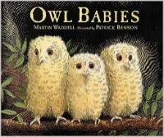 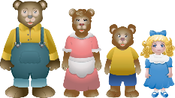 Foundation Stage Topic Web – Autumn 1 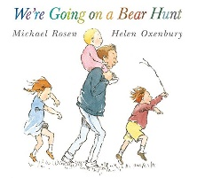
“If you go down to the woods today!”

We will use the themes of familiar stories such as Owl Babies, Goldilocks and Bear Hunt to explore the theme of families and what it means to belong to our new school family. We will also have the great pleasure of meeting a real baby, courtesy of Mrs Savage who has had a new baby boy called Joshua. The emphasis this term will be on settling the children into a safe, secure and happy routine and environment, where everyone understands the need to follow the class rules, so that we can take care of each other by playing nicely and being kind. We will support the children to develop these skills, modelling how to ‘share and play fair’ and supporting the children to ask for help if they feel unhappy. As part of this experience we will visit ‘Build a Bear’ in Leicester to create our own class mascot, Barnaby Bear, which the children will take home for sleepovers. We are grateful to the Parent Staff Association who have subsidised the cost of this trip.
We will be making initial assessments on each child’s development across the curriculum, in order to establish their next steps in learning, and will begin teaching new skills as soon as these are complete.
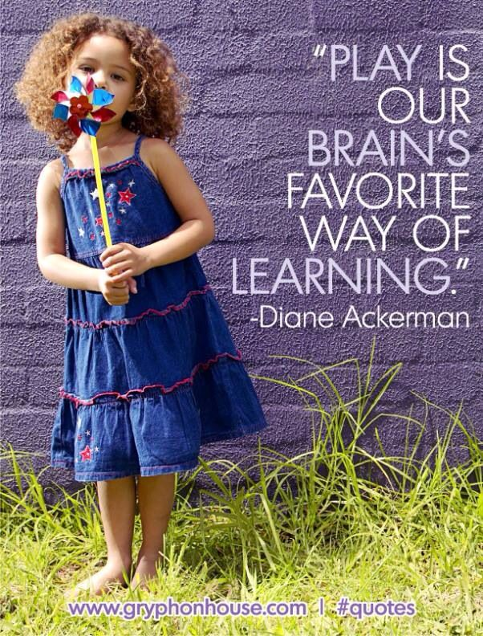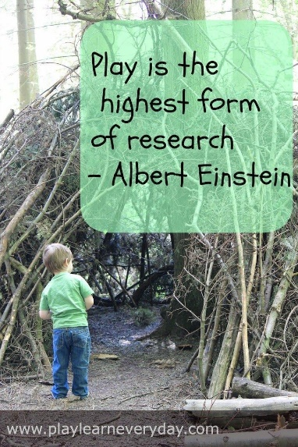
Of course the children will tell you that they have just played all day!

Memorable experiences: Trip to ‘Build a Bear’ and meeting a real baby
What we will be covering in class |  | Supporting your child’s learning at home.
Engage | We will draw on the children’s own experiences at home. Role play in the Home Corner will enable them to act out familiar activities such as making dinner and washing clothes. We will give each child the opportunity to share their Learning Journeys from home, talking about photographs and drawings that they have included. We will establish ourselves as a family in school, who look after and care for each other. | Please help your child to understand why there are rules in school to keep everyone safe and happy.  Encourage your child to tell a grown up if something happens at school that they don’t like.  Encourage your child to talk about what they like or don’t like and to give reasons for their opinions.  Help your child to read their own name and to find their name label in all of their clothes.  Encourage your child to make marks for writing. You could help them to label things around the house.  Support your child to hold writing tools in the correct ‘tripod’ grip like frogs legs!  Give your child a reason to write, for example ‘let’s write a note to let Grandma know where we have gone.’  Build your child’s confidence to relate experiences to you or another family member, encouraging them to add more detail by asking questions to ‘find out more.’  Help your child to count accurately, moving each object in turn as they say the number names.  Talk about size, and order sizes using vocabulary such as big, bigger, biggest.  Sort and match things at home – Mummy’s things, my things, blue toys etc.  Play games to reinforce the names of parts of the body, for example ‘Simon says….’  Talk about your family and relatives. All families are different and all are special.
Develop | We will extend the children’s experiences of family by reading stories such as Owl babies, where the three baby owls are missing their mummy who, of course, comes back for them at the end!  We will further develop the feelings and experiences of family life through the familiar story of Goldilocks and the Three Bears and other stories representing family life in other parts of the world. The children will have the experience of meeting a new baby, considering what a baby needs to be safe, happy and healthy.
Innovate | We will develop the theme using the familiar story The Bear Hunt to encourage participation and prediction skills. The children will create their own cave for The Bear, using building site role play, soft bricks and large junk to construct their homes.
Express | The children will be able to express what they have learnt about taking care of each other through the role play Baby Clinic. They will further develop their understanding of how to keep a baby safe, happy and healthy.  The children will create their own version of The Bear Hunt which will be shared and displayed in a big book. They will create their own story map about hunting for a different animal, drawing the setting where they would find it. During this activity the emphasis will be on language and speaking, connecting ideas and explaining their ideas to others
4/*

Mathematical Development | We will assess, support and develop the children’s counting skills and recognition of numerals through a variety of play opportunities inside and out.  Our Maths topic this half term is ‘Just Like Me!’ where we will be looking at differences and similarities, sorting sets and matching objects. We will be looking at patterns and making repeated patterns. Through the Goldilocks story, we will explore the concepts of size, sorting and matching.
Communication and language | The children will be encouraged to talk about things that are familiar to them through sharing their Learning Journeys, and also by sharing Barnaby Bear’s diary and their ‘Show and Tell’ toy from home. They will learn to ask questions ‘to find out more.’ These skills will be developed through the Baby Clinic role play area and we will give them the opportunity to explore what babies are really like with a visit from a real baby. They will be encouraged to express their own opinions and make comparisons between their own experiences and those of other children. Adults will support the children to act out roles and retell familiar stories, drawing on their own experiences and their understanding of the stories. All children will get the opportunity to play simple participation games in small groups to encourage them to join in and to learn the social skills of sharing and considering the needs of other children.
Literacy | We will focus on stories with a repetitive pattern or structure in order to encourage the children to participate and engage with the texts. We support the children’s recall by using actions and pictures so that they can talk about what happened in the story, their favourite part, or predict what happens next. We will give the children engaging provocations for writing, so that they really want to write. For example, the children will have to let our Premises Officer, Mr Warwick, know how something got broken in our classroom! We will also look at information print and labels in the environment, in our classrooms and in the clinic role play area.  The children will have daily Phonics lessons and weekly Guided reading sessions to teach and develop reading and writing skills.  Our main focus this half term will be on speaking and listening skills, encouraging the children to talk about what they think and to speak in full sentences, building confidence and adding as much detail as they can.
Personal, Social and Emotional Development | The children will have daily routines to give them a sense of security, and the responsibility of performing jobs that benefit the class, such as ringing the bells to signal ‘stop and listen.’ Adults will support the children to form friendships and to play cooperatively with others. They will have access to a variety of stimulating activities designed to encourage them to develop their independence and an interest in learning – related to topic work or following their own interests. We will explore the feelings of being away from our families and the importance of taking care of each other. This will be further developed through our work in the baby clinic, discussing what we need to be safe, happy and healthy.
Physical Development | We will start our day with some Shake up wake up! physical exercises which focus on posture and stamina, developing the strength and control in their shoulder, arm and finger muscles. In P.E. we will learn to move in big spaces, stopping and starting on a signal. We will explore the story Goldilocks and the Three Bears through music and movement. Daily outdoor play and learning will challenge the children as they explore spaces and resources, learning to control their own bodies and responses. Forest Schools will also develop these skills. We will begin to practice writing patterns using the Penpals scheme used throughout school, learning to use and control mark making tools.
Understanding the World | We will make simple observations about the differences and similarities between our varied home lives, such as what duvet cover children have or where they keep their toys. We do a daily weather board and learn the days of the week. We will talk about healthy food, answering questions such as ‘Why can’t we have chocolate for breakfast?’ We will name body parts through songs and sequence pictures in age order. The children will enjoy drawing and playing games on the big Interactive Whiteboard and also learning to control a computer mouse to make marks. We will use lots of pretend technology in our role play areas, such as a phone, computer keyboard and cooking equipment.
Expressive arts and design | The children will be supported to act out roles and experiences through role play and small world play. They will have many opportunities to cut, stick and paint of their own free choice, developing their physical skills as well as their creative and imaginative expression. We will support children to develop their manipulative skills, using their cutting and sticking skills to make a paper bag owl and a story puppet. We will sing familiar songs and rhymes, using instruments to keep a beat and accompany rhymes. Adults will encourage the children to express their own thoughts and ideas, and will support them to pursue their own interests within the environment.
Key Dates:

