**Fixed Penalty Notices**

**Penalty Notices can also be issued to each parent of a child when:**

* a child is recorded as being persistently late after the register is closed 10 sessions in 6 months
* a child has at least 10 unauthorised half day absences (5 days)

**Cost of Fixed Penalty Notices:**

* £60 per parent, per child if paid within 21 days of receipt of the notice or
* £120 if paid after 21 days but within 28 days of receipt of the notice
* Non Payment will trigger a prosecution for non-attendance under Section 444(1) of the Education Act 1996.
* Any child with 2 fines in a school year, should be considered for prosecution.

**Attendance and Punctuality**

**Guidance for Parents / Carers**

**2022-2023**

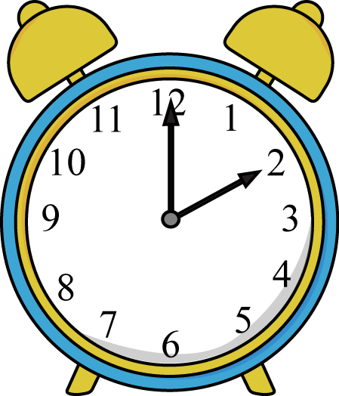

**New guidelines (2022) for attendance and use of penalty notices in schools**

Circumstances under which school will consider the use of a penalty notice:

* 10 sessions of unauthorised absence (including lateness)
* Any incidence of unauthorised holiday in term time
* Any pattern or repeated absences without suitable evidence/justification
* Any unauthorised absence immediately following a leave of absence in term time.
* Any incidence of an excluded pupil being in a public place without reasonable justification during the first 5 days of exclusion
* Any child with 2 fines in a school year, should be considered for prosecution.

**Requests for exceptional leave**

All parents should complete a ‘Request for Exceptional Leave’ form to request a planned absence. Each request will be considered on an individual basis and **all evidence** and context to support your application for exceptional leave at the point of the initial application as further information provided at a later date **will not** be considered.

Exceptional leave **will not** be authorised during examination periods.

* All requests must be considered on their own merits but there must be very particular and exceptional circumstances before the request will be granted
* Reduced cost of holidays in term time does not amount to exceptional circumstances
* Awkward flight times do not amount to exceptional circumstances
* Parental work patterns are unlikely to amount to exceptional circumstances
* Weddings, at home or abroad are unlikely to amount to exceptional circumstances
* Other family members booking holidays when ignorant of school term times does not amount to exceptional circumstances

**Lateness**

Each group has a start and end time - your child will receive a late mark if they arrive after this time. The register closes 30 mins. after arrival. If your child arrives after this time, they will receive an **unauthorised absence** mark.

**10 unauthorised absence marks may result in a fixed penalty notice.**

**If your child is too ill to attend school**

* Contact school on each day of absence and provide reasons for the absence.
* If your child is absent for an extended period, please keep school informed on a regular basis.
* Failure to do these things may result in your child’s absence being recorded as unauthorised.
* Unauthorised absences will be recorded on the register when there is no valid reason given for absences such as a holiday not approved by the school, lateness after the register closes or illness without medical evidence.



**Key Bench Marks for Attendance**

|  |  |
| --- | --- |
| 100% | Letter home and certificate of praise! (Individual school rewards) |
| 99 -97% | Courtesy letter (informing parents) Letter ‘1’ Attendance is ‘good’. |
| 95-96% | This is below target. Monitor and review.  Consider moving to Tier 1 concern? |
| 91-95% | Tier 1 Concern Letter issued – phone call and/or meeting with Headteacher |
| 90% and below | Tier 2 Concern Letter issued – Formal meeting with the Headteacher and Trust Attendance and Welfare Lead.  Support Plan put in place |
| 85% and below | Tier 3 Concern Letter issued – Parents invited to meeting with Attendance and Welfare Lead to review support plan and consider and Early Help.  Review of legal/medical position. |

**All pupils attendance will be reviewed on a rolling 6 month cycle.**

**Medical Appointments**

If it is possible, any appointment should be made out of school time. If this is not possible, your child should miss the minimum amount of school time necessary. **If your child is  
well enough to go back to school following the appointment they should do so.**

**Procedures for following up absence/lateness**

If a pupil is absent and no reason has been provided the school will contact parents and/or nominated emergency contacts, as part of the safeguarding procedure. This will be done within the first hour of any absence following the closure of registers.

Where a pupil is absent and the school cannot contact parents and/or nominated contacts the school will carry out a home welfare check: this will take place by the **2nd day of absence** – or sooner.

When a pupil is persistently late or absent without good reason and the School’s efforts to effect change have been unsuccessful a referral may be made to our Attendance & Welfare Officer for further action. This may also involve a home welfare check.

**Holidays in term-time**

The Bradgate Education Partnership Trust policy is that **holidays in term time will not be authorised**. Unauthorised absence may be referred to Leicestershire County Council, at the discretion of the Head Teacher. A referral may result in Leicestershire County Council issuing a Fixed Penalty Notice.

**Medical Evidence**

If you are asked for medical evidence you will need to provide copies of G.P appointment cards or letters, medication details or other relevant information.