EYFS Curriculum 2021 / 2022

2021-2022 | Autumn 1 (8 weeks) | Autumn 2(8 weeks) | Spring 1(6 weeks) |  | Spring 2(5 weeks) |  | Summer 1(7 weeks) |  | Summer 2(5weeks)
Main project | 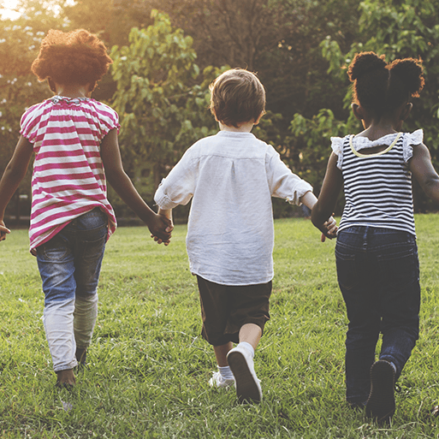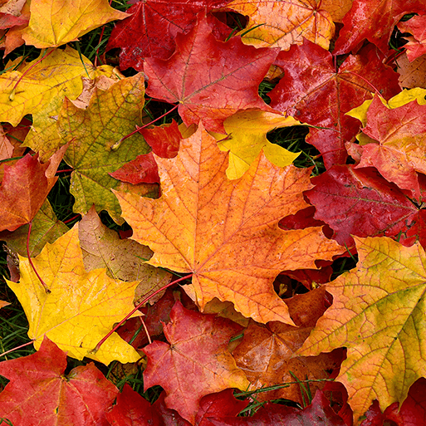  Me and my Community | 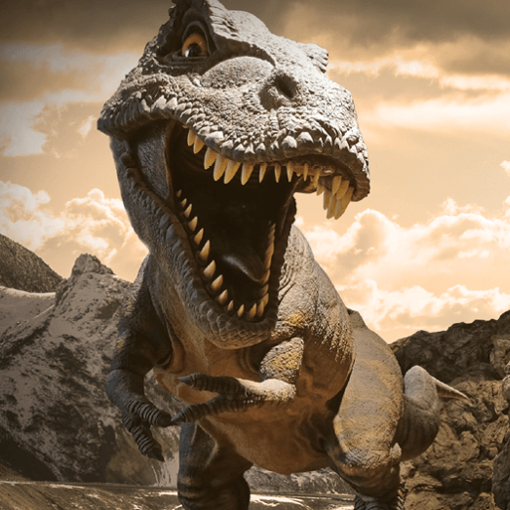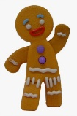  Dangerous  Dinosaurs | 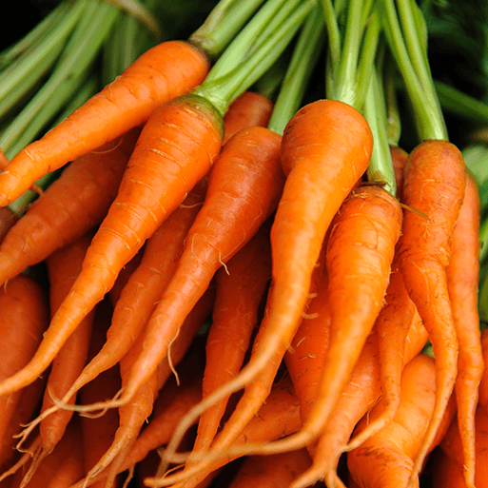  Winter Wonderland  Are carrots orange? |  | Big Wide World |  | Once Upon a Time |  | 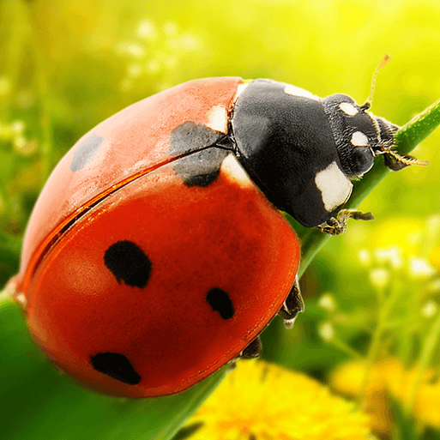  Why do ladybirds have spots?
Mini project | Exploring Autumn | Catch me if you can | Lost and Found  Supertato |  | Fantastic journeys  Pets  Easter |  | Jack and the beanstalk  Castles
Topic / texts | Settling in  Owl Babies – 2 weeks  Goldilocks- 4 weeks  Bear Hunt - 2 weeks | Dinosaur Roar! Harry and his bucketful of dinosaurs –3 weeks  Gingerbread Man – 3 weeks  Christmas -2 weeks | Lost and found – 2 weeks  Supertato –  Creative scenarios |  | The naughty bus  Pets - Cat in a tree |  | Jack and the Beanstalk  Farm trip – 1 week |  | Mini beasts  What the ladybird heard  Superworm  Fiction and non fiction books
Memorable Experience | Visit from a hedgehog | Dinosaur Museum | Handling real fish  Superhero day |  | Pet Roadshow |  | Visit to a farm  Drama |  | Ugly Bug Ball
Personal, social and emotional Development | Daily routines, Golden rules and responsibilities | My emotions, family and friends, Identity and diversity | Growth mindset |  | Resilience |  | Healthy lifestyles |  | My body and growing up
Communication and language | Participation songs, rhymes and familiar stories  Marvellous Me, talking about familiar things and asking questions to find out more  Role play – Doctors surgery, Home corner | Extend questioning skills  Vocabulary  Oral story telling  Making observations  Comparative language  Role play – dinosaur museum, Bakery / supermarket | Extend questioning skills  Vocabulary  Making observations  Role play – Arctic land / Superhero centre |  | Vocabulary  Oral recounts of holidays and pets  Expressing opinions  Role play – Home corner / Pet shop |  | Vocabulary – improving a sentence  Creating narrative, stories  Role play – castle, Home corner |  | Vocabulary – improving a sentence / adjectives  Making observations, using all senses  Role play – Home corner,
Literacy | Narrative: Stories with predictable and patterned language  Traditional story Goldilocks  Labels and captions  Writing a letter  Sequencing a story / story maps  Composition – writing a caption / sentence  Non fiction: books about owls, hedgehogs, woodland animals and bears  Big Write: Write about a different animal to hunt | Narrative: Stories about the same character – Harry and his dinosaurs, writing a sentence  Recount what the dinosaurs did, Rhyming words  Non fiction: Descriptions of dinosaurs, signs and labels, recounts, lists, information books about dinosaurs  Big Write: invent a different ending to the Gingerbread Man story ‘He will go to the..’ | Narrative: story structure and composition – extending writing to 2 sentences or more / conjunctive ‘and’  ‘Speech’ – what did penguin say?  Books by Oliver Jeffers  Recount what was frozen in the ice?  Rhyming words  Non fiction: Recounts / newspaper reports of where the evil pea is and what he has done  Lists, labels  Big Write: Favourite superpower |  | Narrative: Story maps, story writing – beginning to write at length  Non fiction:buildings in ratby, recount of holidays  Big Write: Letter to recommend a pet |  | Narrative: Sequencing a story, writing a letter, retelling a familiar story, rhyming pairs  Non fiction: Instructions to plant a bean  Big Write: Recount of the farm trip |  | Narrative: Story recount, writing at length, descriptive words, rhyming pairs  Non fiction: books and information posters about bugs / comparing fiction and non fiction books  Big Write: what the ladybird heard
Maths | White Rose Maths  Getting to know you  Baseline Assessments  Just Like me  Number: Match and Sort / Compare Amounts Shape, Space & Measures:  Compare Size, Mass and Capacity / Exploring Pattern | White Rose Maths It’s me 1,2,3  Number: Representing 1,2,3 / Comparing 1,2,3 / Composition of 1,2,3 Representing Numbers to 5 / 1 more and less  Shape, Space and measures: Circles and Triangles  Shapes with 4 sides / Time |  | White Rose Alive in 5  Number: Comparing Numbers to 5 / Composition of 4 and 5  Shape,Space and Measures: Compare Mass and Capacity |  | White Rose Maths Growing 6,7,8  Number: 6,7,8 / Making Pairs / Combining 2 groups  Shape,Space and Measures: Length, Height, Time |  | White Rose Maths Building 9 and 10  Numbers: 9 and 10 / Comparing Numbers to 10 / Bonds to 10  Shape, Space and Measures: 3D Shape / Pattern |  | White Rose Maths Find my pattern / On the move  Number: Counting Patterns beyond 10 / Doubling, Sharing and Grouping / Even and Odd / Deepening Understanding / Patterns and Relationships
Understanding the World | Families, Community helpers, Woodland area and animals, settings  Hibernation.  Developing observation and language skills | Autumn festivals: Bonfire night, Diwali, Christmas  Seasonal changes - signs of Autumn  All about dinosaurs / what’s in the egg? / fossils / bones  Floating and sinking |  | Ice experiments  Handling real fish  Playing with light toys / shadows / reflection  Feeding the birds  Healthy eating – vegetables  Examine fruit and vegetables  Healthy eating  Oral hygeine  Spring festival – Easter, Chinese New Year |  | Children of the world / Ratby, world climate  Caring for pets – how to keep them safe, happy and healthy  Pet’s roadshow |  | Life cycle of a frog  Planting beans / diary of growth  Food from the farm  Kings and queens |  | Using all of our senses to observe bugs  Recycling – make a junk costume for Ugly Bug Ball  Investigating bugs  Observation of snails
Science experiment | Exploring leaves | Dissolving a gingerbread biscuit |  | Snowman melting / handling real fish |  | World water day |  | Building Materials |  | Magnification – look at flowers
ICT | Beats and rhythms | Technology and me (Dinosaur museum) |  | Shape Hunt |  | Animal safari (Pets) |  | My Online Life |  | Pretty Pictures
Expressive Arts and designs | Ongoing provision throughout the year Creative table, role play, small world play, construction, sand, water, dressing up costumes, musical instruments etc
 | Make a birthday card  Make puppets in different ways – paper bag and stick  Paint bears  Woodland art  3 bear’s mask  Sponge printing leaves  Colour mixing  Transient art – leaf man | Dinosaur art  Dinosaurs skeletons  Fossil print in clay  Designing a gingerbread man  Poppies  Bonfire pictures  Rangoli |  | Junk modelling - make a trap to catch the evil pea  Penguins on ice collage art work  Design a supertato  Still life – drawing fruit and vegetables |  | Floormaps of Ratby  World habitats  Pets artwork |  | Build a castle / den building  Painting a giant  Create a beanstalk  Make 3D castles with bricks  Make stick puppets  Make a moving toy  Drawing castles  Monet Waterlillies / pond plate |  | Matisse snail collage  Stone bugs  Transient art
Music Kapow | Exploring Sound | Celebration music |  | Music and Movement |  | Moving to Music |  | Big Band |  | Rhythm
Physical Development | Ongoing provision throughout the year  Shake up wake up routines: Cosmic kids yoga / Big Moves Island Adventure / Dough Disco / Go Noodle  Woodland Area / Muddy Kitchen  Small apparatus equipment  Big play: crates, planks, stepping stones, den building, bikes, slide, climbing frame etc  Junk modelling  Construction  Fine motor activities
REAL PE | Dance / personal skills In and Out  Exploring shapes  Rhythm and beat  Big circles, big moves | Gym  Mirror mirror, Sticky body parts, Hide and seek, Jungle trip, Tree hop, |  | Ball skills  Heads and shoulders, Clowning around, Add a move, Hold on tight, Water ski challenge, Relay race |  | Dance / Physical skills  Shapes in the world, Feel the rhythm, Turning together, Show us your best |  | Physical skills  Big top time, Dice dance, RINGO |  | Relay races / sports day

