Hello………………………………….

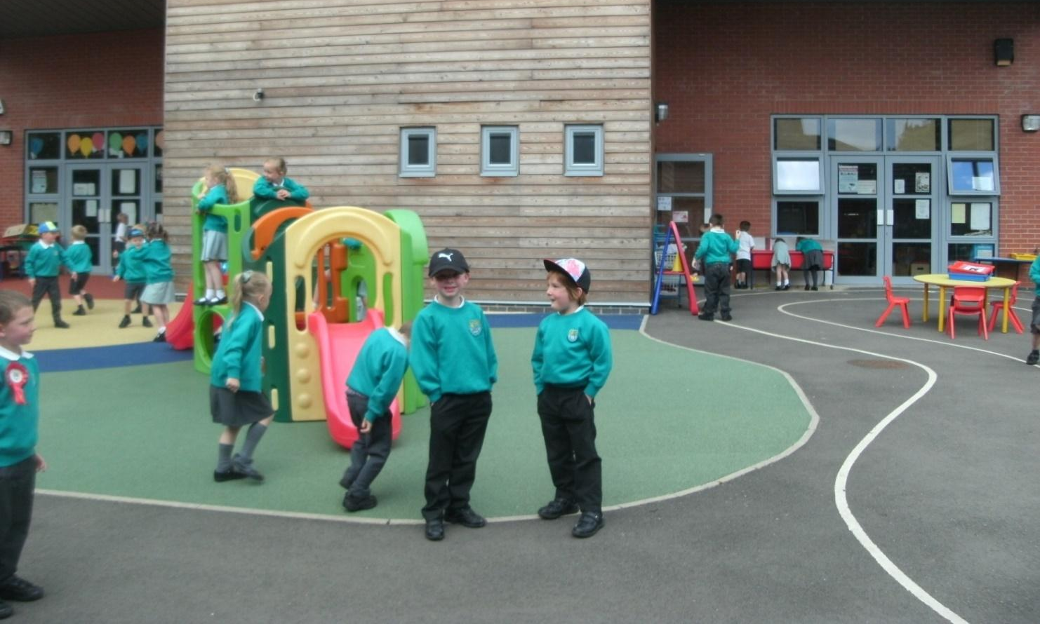
We are looking forward to you
starting Ratby Primary School

Your School Uniform
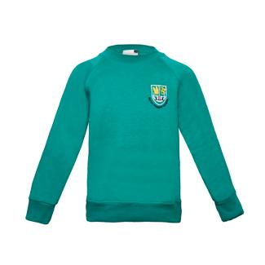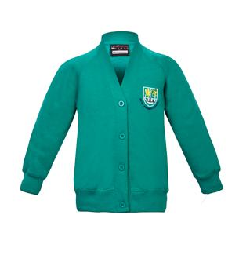 Green jumper or cardigan

Grey trousers, white polo shirt 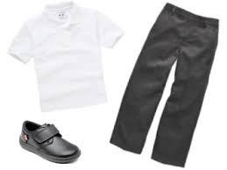
and black school shoes

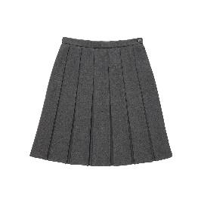 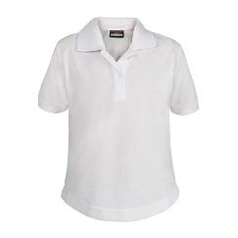 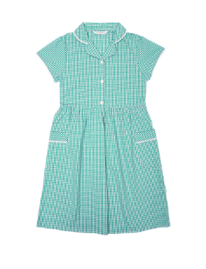 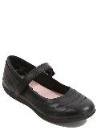 Grey skirt and white polo shirt, or gingham dress, and black school shoes

You will look smart!

P.E. Kit
You will need comfortable clothes
to play games and run around in.

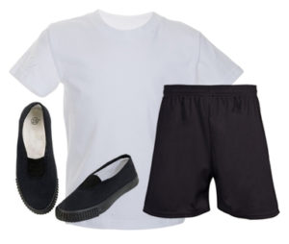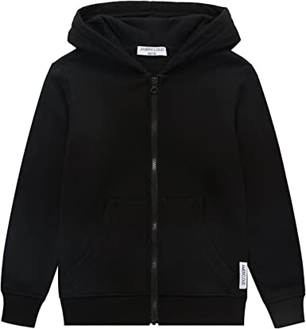

White t-shirt, black shorts , black hoodie and black velcro trainers.

On our P.E. day you will arrive at school in your P.E. kit and wear it for the whole day.

Book bag
You will need to bring your book bag to school every day.
It will keep all of your books safe.
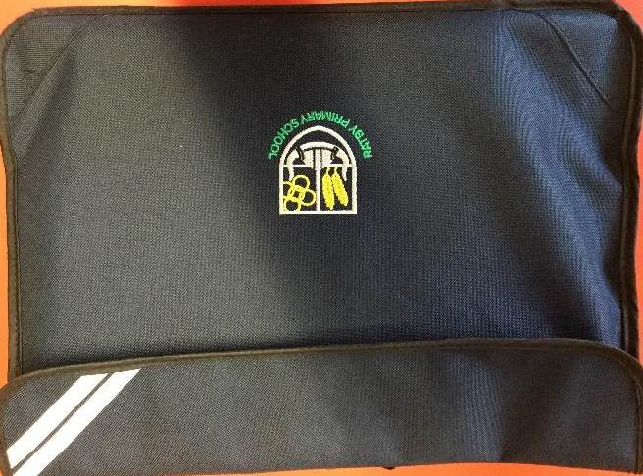

Please keep these things inside:
Your Home School diary
A school reading book
Your Reading Journal
A free choice book from the class Book Box
which you can change every day if you would like to.

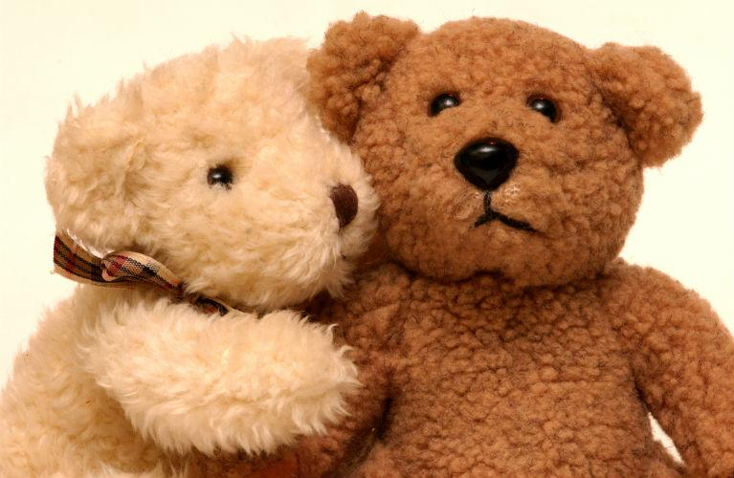
A small cuddly toy will fit in your bag if you wish to bring one on your first few days at school!
When you arrive at school…
If you have a lunchbox, please put it on the trolley outside your classroom. | 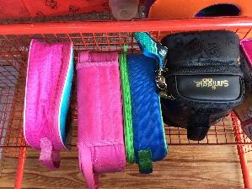
Please put your water bottle on the trolley. | 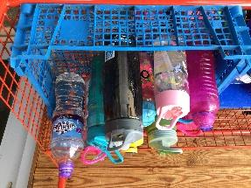
Put your Home School diary  in the basket. | 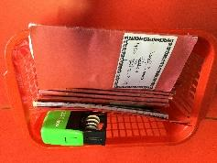
Put your book bag in your box | 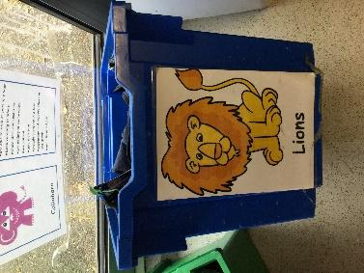
You will have your own special peg to hang your coat in the cloakroom. | 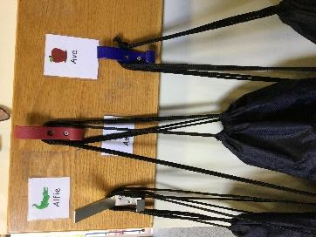
The toilets are in the cloakroom and they look like your toilet at home.

If you need help you just have to ask and we will be there to help you!
You will have lots of fun playing at school

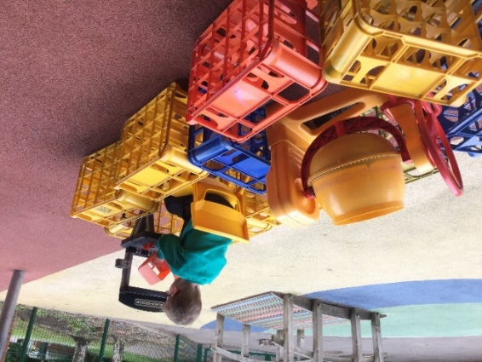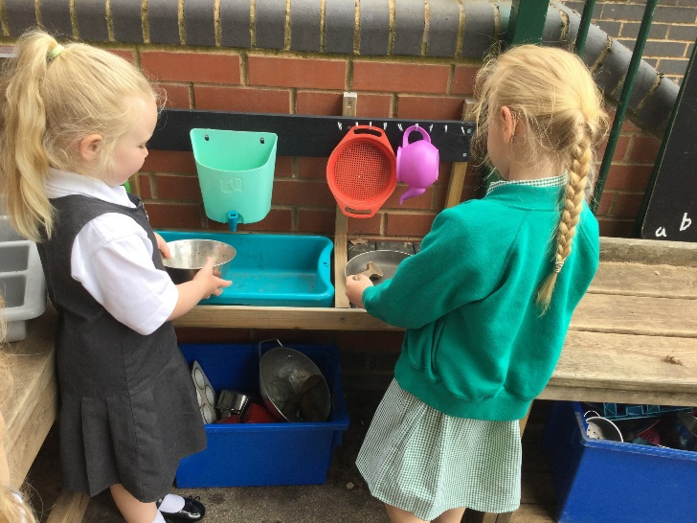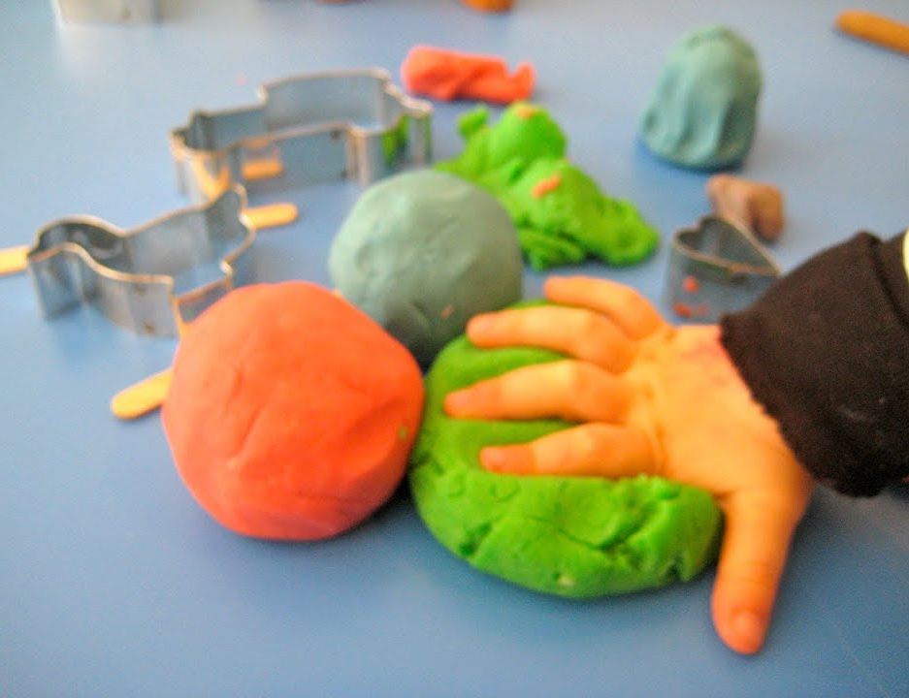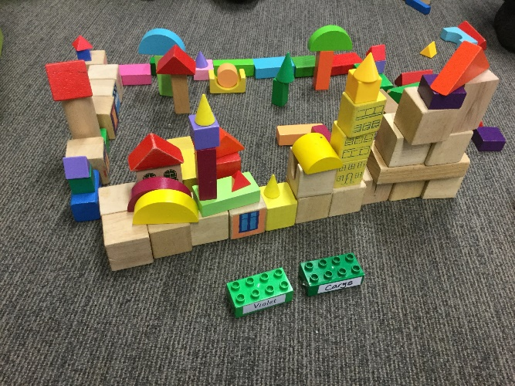
Fruit bar and Lunchtime

All of this fun will make you hungry!
We will share some fruit and a drink.

You will eat your lunch in the big hall with your friends. You can choose to have a lovely hot dinner or bring a lunchbox from home.
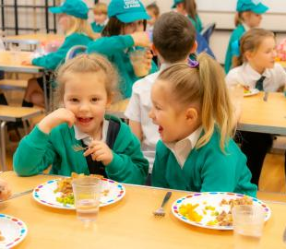

The teachers will help you to choose the food
you like and to help you to cut it up.
If you need help opening bags and boxes in
your lunchbox, we are there to help!
Story time
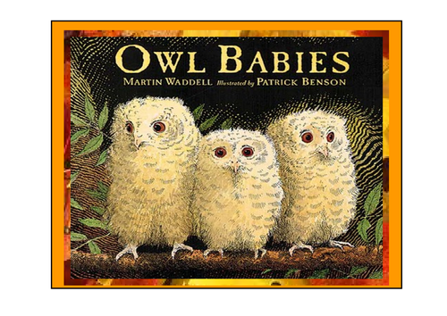
We love reading stories!
This one is called ‘Owl Babies’ and it is about
three baby owls who are missing their family
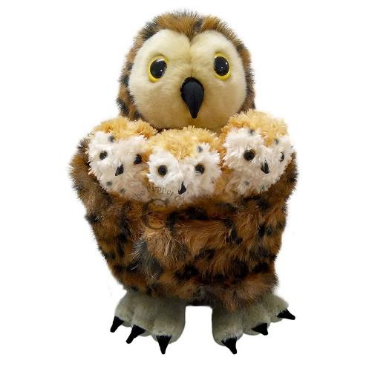
Your grown-ups will come back to pick you up at the end of the day. We know that you will always have a lovely day at school. Your grown-ups will be really excited to hear about everything you have done at school!
See you soon!

