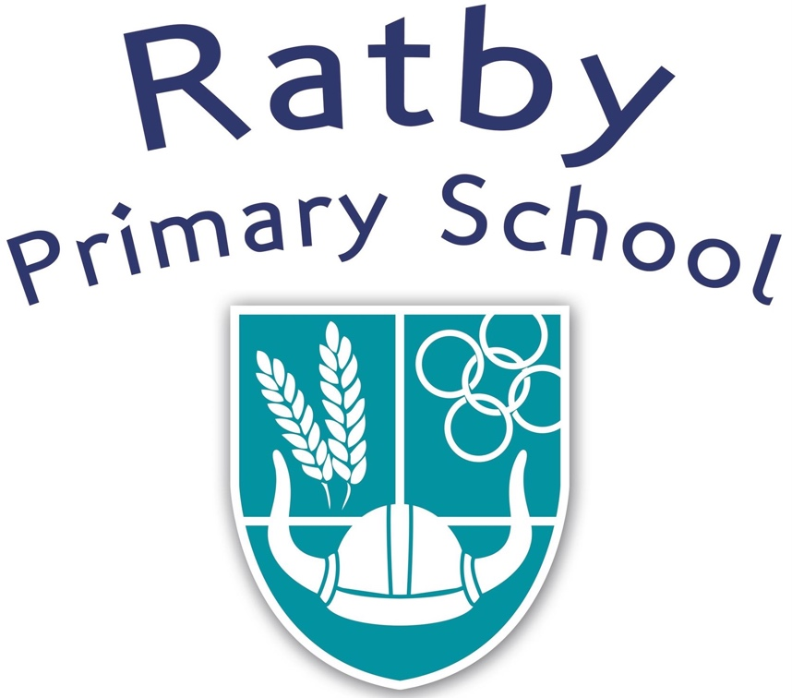

**EYFS**

**Induction Booklet for Parents**

**August 2022**

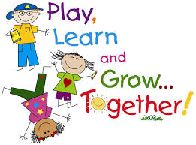



Starting ‘Big School’ is a huge change for the whole family. We aim to do everything we can to make your child feel happy and secure, and to help you as parents to feel reassured and well informed.

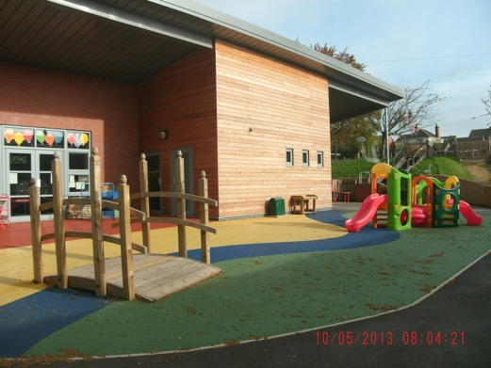 **Induction programme**

We hope that our induction programme will make the transition from home and Pre School as smooth and as happy as possible. We see our role as very much in partnership with parents, and value our induction programme as a way of sharing our practice with you. Hopefully by working together we can ensure that all children have a positive experience with us and can look forward to starting school.

**Visits to School** During the Summer Term we welcome visits from Pre Schools and Parents to come and spend some time playing at School accompanied by adults who are familiar to them. We will contact Pre Schools to arrange this but if your Pre School is not able to bring your child, please contact the School Office to arrange a visit.

**Workshops** You will be invited to visit school with your child to attend two workshops where you can engage in some activities with your child, meet the Teachers and become familiar with the environment. Your child will also be invited to attend an afternoon session on their own to build their confidence within the setting.



**Part time attendance and Home Visits**

During the first week of the Autumn Term, Tuesday 30th August – Friday 2nd September, the Teachers will arrange a time to visit you at home. This will give us an opportunity to meet your child in a familiar environment and you will have the opportunity to talk to your child’s teacher about your child’s development, to ask any questions and share individual concerns.

In order to support each child to settle securely into the school routine the children will attend on a part time basis for the following week, on alternate mornings and afternoons, starting on Monday 5th September to Thursday 8th September.

Your child’s first full day at school will be Friday 9th September.

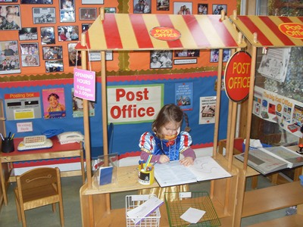**The Learning environment**

The children’s welfare and safety is our first priority and for that reason the Foundation Stage children have routines and facilities that are separate from the rest of the school community.

Our learning environment is organised to allow children to explore and learn securely and safely, and where they can find and use equipment and resources independently. We have our own enclosed outdoor area which allows us to provide them with big physical play and learning opportunities on a different scale to those provided indoors. We use the **Outdoor area** most days, even in inclement weather, as it supports, extends and engages the children in their learning experiences. Therefore it is essential that they come dressed for any weather as a bit of rain rarely stops play!

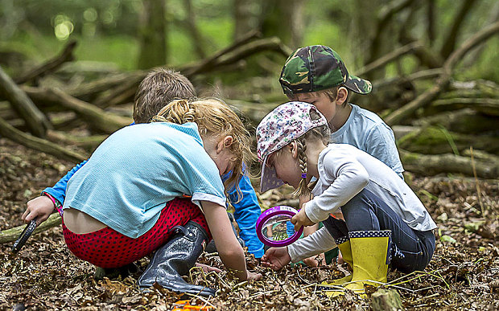

**Teaching and Learning Styles**

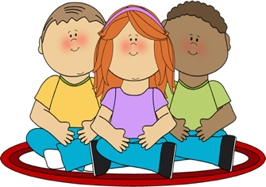

In the Foundation stage we work very much as a team across both classes and there will be several adults who support your child’s development in school.

Children learn and develop in different ways and at different rates. We are constantly observing and assessing children in order to provide them with the ‘next steps’ in their development in all areas of learning. We teach through a variety of adult guided activities where we provide very clear and specific opportunities to move their learning forward, but much of our time is also spent supporting and extending their own initiated play, helping them to practice and achieve skills across the curriculum.

Our curriculum is able to capture a wide range of children’s learning and development outcomes so that all children can reach their potential.

It is our aim to give all children a secure structure and discipline, upon which a positive attitude to learning and success is based. We support children to access these expectations with a variety of visual prompts appropriate to their level of understanding.

We have ‘come to the carpet’ and register time routines and songs to involve children and help them to understand and feel secure, with behaviour expectations at certain times of the day. Visual timetables and Makaton signing are used to support all children’s understanding and levels of engagement.

Children are valued and respected as individuals, and the curriculum is appropriately structured to allow for the different styles of learning and the individual needs of our children. The children are taught to express their own needs in appropriate ways and to value and respect other children’s needs.

**The Curriculum**

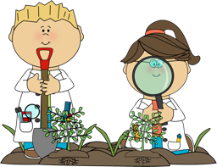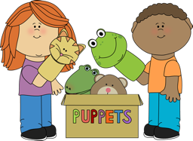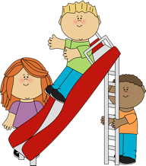

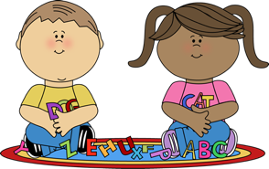

**Our aim is to provide a secure foundation through learning and development opportunities which are planned around the needs and interests of each individual child. We follow these seven Educational Programmes.**

|  |  |
| --- | --- |
| **Personal, Social and Emotional Development** | Children’s personal, social and emotional development (PSED) is crucial for children to lead healthy and happy lives, and is fundamental to their cognitive development. Underpinning their personal development are the important attachments that shape their social world. Strong, warm and supportive 9 relationships with adults enable children to learn how to understand their own feelings and those of others. Children should be supported to manage emotions, develop a positive sense of self, set themselves simple goals, have confidence in their own abilities, to persist and wait for what they want and direct attention as necessary. Through adult modelling and guidance, they will learn how to look after their bodies, including healthy eating, and manage personal needs independently. Through supported interaction with other children, they learn how to make good friendships, co-operate and resolve conflicts peaceably. These attributes will provide a secure platform from which children can achieve at school and in later life. |
| **Communication and Language** | The development of children’s spoken language underpins all seven areas of learning and development. Children’s back-and-forth interactions from an early age form the foundations for language and cognitive development. The number and quality of the conversations they have with adults and peers throughout the day in a language-rich environment is crucial. By commenting on what children are interested in or doing, and echoing back what they say with new vocabulary added, practitioners will build children's language effectively. Reading frequently to children, and engaging them actively in stories, non-fiction, rhymes and poems, and then providing them with extensive opportunities to use and embed new words in a range of contexts, will give children the opportunity to thrive. Through conversation, story-telling and role play, where children share their ideas with support and modelling from their teacher, and sensitive questioning that invites them to elaborate, children become comfortable using a rich range of vocabulary and language structures |
| **Physical Development** | Physical activity is vital in children’s all-round development, enabling them to pursue happy, healthy and active lives7. Gross and fine motor experiences develop incrementally throughout early childhood, starting with sensory explorations and the development of a child’s strength, co-ordination and positional awareness through tummy time, crawling and play movement with both objects and adults. By creating games and providing opportunities for play both indoors and outdoors, adults can support children to develop their core strength, stability, balance, spatial awareness, co-ordination and agility. Gross motor skills provide the foundation for developing healthy bodies and social and emotional well-being. Fine motor control and precision helps with hand-eye co-ordination, which is later linked to early literacy. Repeated and varied opportunities to explore and play with small world activities, puzzles, arts and crafts and the practice of using small tools, with feedback and support from adults, allow children to develop proficiency, control and confidence. |
| **Literacy** | It is crucial for children to develop a life-long love of reading. Reading consists of two dimensions: language comprehension and word reading. Language comprehension (necessary for both reading and writing) starts from birth. It only develops when adults talk with children about the world around them and the books (stories and non-fiction) they read with them, and enjoy rhymes, poems and songs together. Skilled word reading, taught later, involves both the speedy working out of the pronunciation of unfamiliar printed words (decoding) and the speedy recognition of familiar printed words. Writing involves transcription (spelling and handwriting) and composition (articulating ideas and structuring them in speech, before writing) |
| **Mathematics** | Developing a strong grounding in number is essential so that all children develop the necessary building blocks to excel mathematically. Children should be able to count confidently, develop a deep understanding of the numbers to 10, the relationships between them and the patterns within those numbers. By providing frequent and varied opportunities to build and apply this understanding - such as using manipulatives, including small pebbles and tens frames for organising counting - children will develop a secure base of knowledge and vocabulary from which mastery of mathematics is built. In addition, it is important that the curriculum includes rich opportunities for children to develop their spatial reasoning skills across all areas of mathematics including shape, space and measures. It is important that children develop positive attitudes and interests in mathematics, look for patterns and relationships, spot connections, ‘have a go’, talk to adults and peers about what they notice and not be afraid to make mistakes. |
| **Understanding the world** | Understanding the world involves guiding children to make sense of their physical world and their community. The frequency and range of children’s personal experiences increases their knowledge and sense of the world around them – from visiting parks, libraries and museums to meeting important members of society such as police officers, nurses and firefighters. In addition, listening to a broad selection of stories, non-fiction, rhymes and poems will foster their understanding of our culturally, socially, technologically and ecologically diverse world. As well as building important knowledge, this extends their familiarity with words that support understanding across domains. Enriching and widening children’s vocabulary will support later reading comprehension. |
| **Expressive Arts and design** | The development of children’s artistic and cultural awareness supports their imagination and creativity. It is important that children have regular opportunities to engage with the arts, enabling them to explore and play with a wide range of media and materials. The quality and variety of what children see, hear and participate in is crucial for developing their understanding, self-expression, vocabulary and ability to communicate through the arts. The frequency, repetition and depth of their experiences are fundamental to their progress in interpreting and appreciating what they hear, respond to and observe |

The Foundation Stage curriculum also focuses on a young child’s ***characteristics of learning*** – supporting them as they play, explore and engage with activities, developing their levels of motivation and concentration and their ability to think creatively and critically about the world around them.

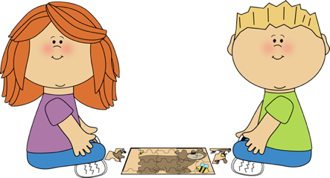**Frequently asked questions!**

**I don’t know if my child is ready for school yet?**

**How will school provide for such a range of needs?**

Our provision is based around the fact that all children start school at varying levels of ‘readiness.’ There can also be a year’s difference in age between our September born and August born children. This is why we prioritise gathering information about each child from their families and Pre Schools. Every child is ready to learn and our job is to tailor our curriculum to meet every child’s individual learning needs and styles.

The first half term is spent making observations and assessments. We begin to work with different groups of children on specific learning objectives as soon as we have identified their ‘next steps’ in learning so that we can provide every child with appropriate activities and a level of challenge that enables them to make progress.

Interventions are quickly put into place to support children who require more support.

**What if my child makes mistakes and does not follow the class rules?**

Personal, Social and Emotional Developmentforms a large part of the Foundation Stage Curriculum, and it is planned for as much as any other area of learning. Children need to feel secure and happy before effective teaching and learning can take place. All children want to please adults and do the right thing but when faced with a lot of new and different expectations it is not easy for them to understand exactly what that is!

Expectations in behaviour and learning are shared with the children using picture prompts and support at an appropriate level for individual children. Very few children start school with the social skills to cope with sharing toys, and many children do not have the confidence or the communication skills to ensure that their needs are met in appropriate ways. It is a natural survival technique for a child to snatch something that they want and it is a developmental stage that they need to be supported through to understand the concept of sharing and taking turns.

We spend a great deal of time modelling how to **‘play fair and share’** and how to get help if someone upsets them. We use persona dolls to discuss these issues so that we do not single out an individual child’s behaviour but instead help our persona doll to make the **right choices**.

When children consistently do not follow simple instructions and prompts, we support them with more individual picture prompts and lots of praise. We will keep you informed of any intervention and with your support we do get there in the end!



**What if my child has problems using toilets outside our home?**

**It is our expectation that all children are toilet trained and able to clean themselves independently whilst at school. If your child is still in nappies at this point in time please could you try to ensure they are as independent as possible when they start school.**

It is often daunting for children to use different toilets on their own. We understand that this can cause anxiety. This is one of the subjects we can discuss during your meeting but rest assured that we offer a lot of support to children in the first few weeks of school.

**What help are the children given at lunchtime?**

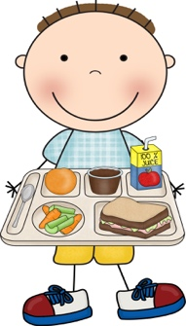This is often a vulnerable time for the children because they are away from the security of the classroom, but we prepare them for the experience. We stay with them, helping them to choose their dinner and they are given help to cut up food or open packed lunches. All children are entitled to have a free hot dinner but your child is welcome to bring a packed lunch if they wish to. The dinner supervisors monitor what the children eat and will let us know if they are not eating enough so that we can inform you.

**What progress can I expect my child to make?**

If your child has attended a Pre School they will already have begun their learning journey within the Foundation Stage Curriculum. Pre Schools send the children’s profiles to school and we use these to adapt our curriculum planning so that we can build on the children’s previous learning and meet the children’s individual needs. Your child’s progress will be closely monitored and targets identified to move their learning forward.

Most children will achieve the expected learning outcomes for the end of the year (the Early Learning Goals), after which they will follow the National Curriculum. For those that are not on target to achieve the expected level, interventions will be put in place to support them in making consistent progress appropriate to their needs. You will be kept informed of your child’s progress.

**How will I know how my child is getting on?**

We have two parents’ evenings during the year as well as a Mid Term and End of Year report, but in the Foundation Stage more regular contact is essential, through informal chats before and after school. We also have a Home School book for daily dialogue with parents, and we share your child’s individuality through their ‘Learning journey’ books which contain a wonderful collection of photographs, observations, pieces of writing, creative and imaginative work from school and home. Your child’s individual targets will be shared with you throughout the year so that you can support your child at home. Of course, if at any time you wish to see your child’s work or discuss their progress, we will be more than happy to arrange this any time after school.



**How can I get involved and support my child?**

We value the contribution that Parents and Carers make to our understanding of their children and to enhancing the quality of their wellbeing, education and progress. The Parent Meetings will give us an opportunity to talk in detail about your child. When we inform you of your child’s next targets we also suggest ways in which you can help them to develop and practise the skills. Parents are encouraged to contribute to their Learning Journeys, sharing special moments and events in your child’s life.

 We know that most of the time when you ask your child what they have done at school the response will invariably be ‘I just played!’ We keep you informed about your child’s learning experiences with weekly posts on Tapestry, and we encourage you to share these posts with your child as prompts for them to talk about what they have done, and to post your own observations of your child or achievements and experiences that you wish to share.

**How will my child learn the sounds that letters make?**

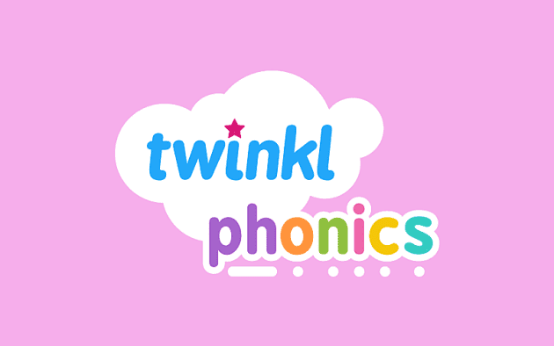We follow the Twinkl Phonics scheme of work which builds skills in a systematic and multi-sensory way, which suits the style of learning for young children. We learn a new phoneme with an action, song and a story. It is very important that links are made between phonics, reading and writing so that the children do not see phonics in isolation, but as an essential part of reading and writing skills. The scheme quickly builds up a bank of sounds so that children can begin to blend them together to make words e.g. ‘s – a – t sat.’ The children will bring home a phonics booklet so that you can help them to practice and learn at home. It is important to keep revising sounds already learnt so that children are confidently using these sounds in their reading and writing. We will assess their Phonics progress each half term and will annotate their phonics book so that you can track their progress too.



**How will my child learn to read?**

At Ratby Primary School we develop reading skills in a systematic way through whole class shared reading, reading print in the environment, quality story times, and reading with an adult, where very specific skills are taught to develop independent and confident reading.

* Books without words are used initially to encourage the children to look at the pictures.This is a vital skill that they will need to use as their reading skills progress. Pictures give excellent clues to the context of text and talking about the pictures helps to prepare children for the vocabulary which may appear in the text.
* The children are encouraged to follow the text from left to right,pointing to each word in turn as you read together. This is important as it develops their understanding of what a word is.

Children are encouraged to work out a word by using the picture and the initial sound of the word, for example

* **c**  for cat
* Children begin to sound out the letters and blend them together to read, for example

c - a - t ‘cat’

* Children point to the words as they read, only sounding out unknown words, and demonstrating a sound understanding of what they have read
* When children can remember repeated text they begin to read more fluently, only stopping to work out unknown words, and using a range of clues to decode them.

Your child will read with their Teacher every week and they will bring home a new Reading Scheme book every two weeks. These books will closely match your child’s Phonics level. During the first week we will focus on decoding skills, using their phonics to read words, and in the second week we expect them to read the book more fluently because they will have practiced at home, and we will focus on Comprehension skills, supporting them to understand the text that they have read.

Reading targets will be put in the children’s Reading Journals so you will be kept well informed of the skills that they are developing and practicing. It is helpful to us if you can date the times that you read with your child, and please feel free to write a comment. We find that little and often is the best way to practice reading – just a few minutes a day will have an impact on your child’s progress and confidence.

Some children become fluent very quickly, but most children need a lot of support and repetition to develop these skills. One of the most important things is for your child to feel successful so please use lots of praise. Your support in this process is vital to your child’s success because you have the quality one to one contact that we find hard to achieve in the classroom! Please continue to read a range of story and information books to your child and not just the ones that we send home, as children need a variety of reading experiences.

***Questions to ask your child when reading – Early Years***

**At the end of the book:**

• Did you like this book? Why?

• What was your favourite part? Why?

• Which character did you like the best? Why?

• Why did that character do … (give a situation/ event from the story)?

• What happened in the story?



***Questions to ask your child when reading – Early Years***

**Before reading the book:**

* Can you point to the title? or What is this? (pointing to the title)
* What do you think this story will be about? What might happen in the story?
* Who is in the story?

**During the reading of the book:**

* What is happening here?
* What is ______ doing?
* What might happen next?
* How do you think the story might end?
* Is __________ friendly/ mean/ nice…?
* What does ______ mean? (To check understanding of a word



**How will my child learn to write?**

We do not expect children to start school being able to write using the correct letters to represent words. We value and encourage the children to make marks and give meaning to their marks, reading it back to us. To begin with, these marks will possibly resemble a scribble, or be random letter shapes. We model writing skills daily to teach the children to begin to use phonic knowledge to write using the first sounds of words. As their confidence develops, we expect them to begin to sound out words and write in ways that match their spoken language, for example ‘A cat eets fish.’ We model sounding out words, leaving finger spaces and spelling *Tricky words* correctly, such as *the* and *to.* Children are taught to write in Phonics lessons and in small groups, giving them support they need to practice and apply their knowledge. Some children begin to apply these skills quickly, but most children find it difficult, and many children find letter formation a huge challenge! You can help your child by letting them see you making notes so that they begin to understand the purpose of writing. Writing a shopping list together is a perfect way of practicing skills, for example “carrots starts with a *‘c,’* let’s sound outham *h – a - m.’*

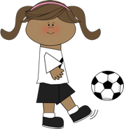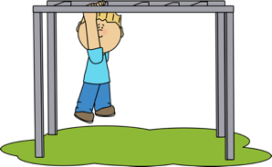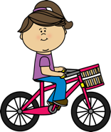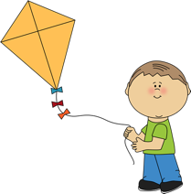

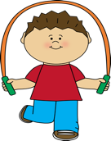

Learning to write is closely linked to a child's [physical development](https://www.surreycc.gov.uk/schools-and-learning/childcare-professionals/early-years-foundation-stage-eyfs/physical-development-in-the-eyfs). Before children can control the muscles in their hands, they need to develop their gross motor skills (those that need large or whole body movements). For babies this means the freedom and space to kick, roll and crawl. And for older children this also means the chance to run, climb, balance, throw, push, pull and swing their arms.

**What can I expect my child to do in Mathematics?**

We cover many strands of Mathematics in the first year of school (Numbers, Calculation, Shape, Space and Measures including time, length and money) and there is an incredible amount of language and vocabulary associated with each of these, from number names to 20 to the names of 2D and 3D shapes.

We call our Maths teaching sessions ***Marmalade Maths***because Paddington Bear always has a problem for us to solve for him.The children will be taught mathematical skills through practical activities, touching and moving real objects and solving real problems. We spend several weeks on each number up to 10, but the children will be exploring the relationships between numbers each day, concepts such as accurate counting, comparing, estimating, 1 more and 1 fewer, addition, subtraction, sharing, doubling and halving. They will be challenged in their thinking with questions such as ‘How do you know?’ ‘Convince me?’ ‘Can you find another way?’ The children will begin to record their understanding with numerals and jottings. Please find the enclosed Maths Mastery booklet for more information about how we teach maths in the Foundation Stage.

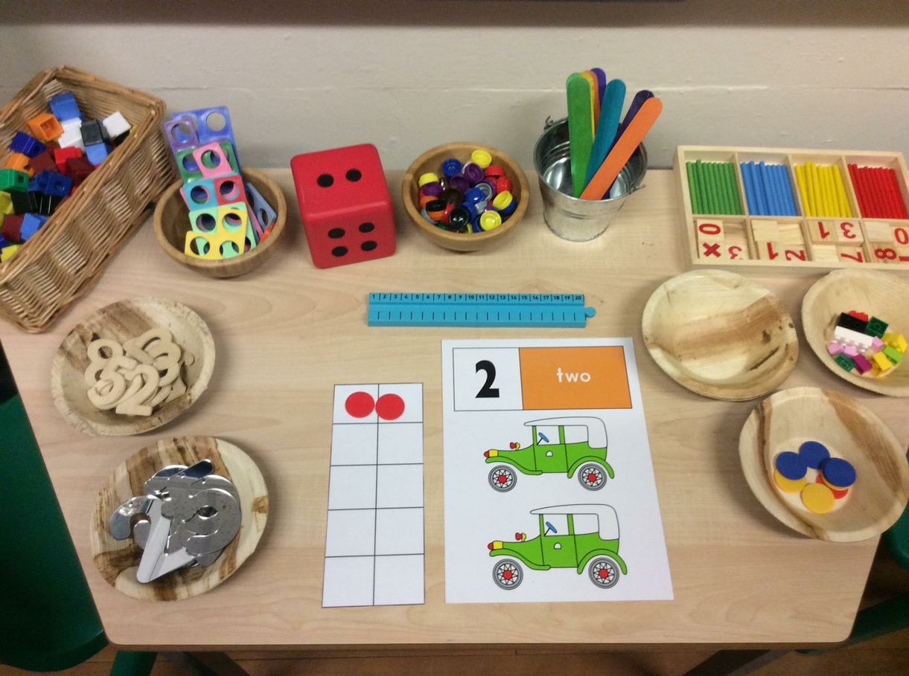

**General School Information**

**Your child’s book bag**

The school’s Parent Staff Association is giving your child a book bag as a welcome present.

Please ensure that they are brought to school each day with the items below included:

* Home school diary
* A School reading book
* One self chosen book from the book box – your child change this each day if they wish to
* Reading journal

**PE kit**

Your child will need a PE kit consisting of a white t shirt, navy or black shorts, black hoodie and plimsoles. Your child will come to school in their PE kit on PE days. In line with the whole school policy, if your child has pierced ears then we ask that earrings are taken out on PE days or covered with micropore tape.

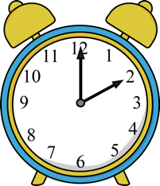

**School hours** are 8.55 a.m. to 3.10p.m. but you are welcome to arrive from 8.45 a.m.

If your child is late you will need to enter the building through the main entrance and sign in at the School Office to make sure that they are included on the register.

Please report **absences** on the school answer phone (Tel: 0116 239 3610). If we do not receive a message we will need to contact you.

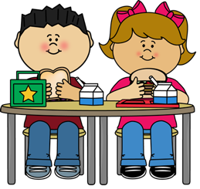**School Dinners**

All our school mealsare cooked on the premises and offer a good, balanced and varied menu. We will help your child to choose from the selection and you can get copies of the menu so that you can prepare them each day. Every child in the Foundation Stage and KS1 are entitled to a free meal, but if your family receives other benefits then could you please fill in the separate sheet enclosed in your pack because this will release extra money to support your child in school. If you decide to send a packed lunch in for your child, please do not include nuts, chocolate or sweets.

**Uniforms**

**School jumpers** are available fromUniform Direct ([www.uniform-direct.com](http://www.uniform-direct.com)).

**Please label everything clearly and keep checking** because they do wear off!

The school uniform includes black school shoes and may we recommend velcro fasteners if possible please!

**Milk**



Your child will be entitled to **free milk** until they turn 5, after which there is a small charge if you wish to continue with it.

Please send in a named beaker of **water** for your child if you wish to, particularly if your child does not have milk. We like it to be accessible because we do encourage them to drink throughout the day.

**Fruit**



The school receives a piece of fruit each day for each child so we have a healthy snack.



Separation from a parent is often very difficult for the children but we have lots of tried and tested distraction techniques! Sometimes it helps to have a pre prepared routine such as ‘Two squeezes and a hug and I’ll see you later!’ If your child is distressed then we will ask for your permission to hold them as you leave and we will ring you to let you know when they have calmed down – which is almost certainly the minute you have gone!

We do hope that you have found this booklet helpful but if you have any more questions please do not hesitate to ask! We hope that you and your child have a happy and successful time at Ratby Primary School and we look forward to getting to know you.

**The Foundation Stage Team**

Mrs Anstey – Rainbows Class Teacher & EYFS Lead

Miss Hughes (Mon, Tues, Weds) & Mrs Hurn (Thurs, Fri) – Sunshines Class Teachers

Mrs Brooks - Rainbows Class Learning Support Assistant

Mrs Wright – Sunshines Class Learning Support Assistant



**Headteacher: Lisa Jones**

**Ratby Primary School**

**Main Street**

**Ratby**

**Leicestershire**

**LE6 0LN**

**Tel: 0116 239 3610**

**Email: office@ratby.bepschools.org**

**Website: www.ratby.bepschools.org**