Re: Safeguarding - Operation Encompass

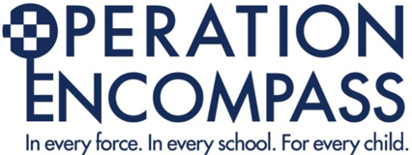
Monday 3rd October 2022

Dear Parent/Carer,

All schools in Leicestershire and Leicester City are part of a safeguarding initiative which aims to improve outcomes for children and families affected by domestic violence and abuse.

This scheme has been designed to provide early reporting to schools of any domestic abuse incidents that might have an impact on a child that attends their school. The approach, known as Operation Encompass, is also used nationally, and is run in partnership with Leicestershire Police.

During the school term our Designated Safeguarding Leads are informed when any domestic abuse incident has been reported to the police and one of our pupils was in the household. It will not give any details about the incident.

This was introduced because domestic abuse in a household can have a big impact on children, even if they do not see what is happening.

This information is used to ensure the school is able to provide appropriate support to our pupils. The information will remain confidential and only shared on a strictly need-to-know basis, for example with the class teacher. It will not be shared with any pupils.

If you would like to speak to someone in confidence about domestic abuse, call the Leicester, Leicestershire& Rutland Domestic Abuse Helpline on 0800 802 0028 or visit https://www.leicester.gov.uk/your-community/emergencies-safety-and-crime/domestic-and-sexual-abuse/

We look to offer the best support possible for our pupils and believe that this scheme is beneficial and supportive for all those involved - it has been found to be an effective way of supporting children at a difficult time in their lives.

Autumn term 2022 update

Building upon the national success of Operation Encompass, police are expanding the information that they are sharing confidentially with the safeguarding leads in schools.
As part of the Operation Encompass Information Sharing Platform our Police Force will also share with the Designated Safeguarding Lead information about police attended incidents where they feel that there has been a tangible impact upon a child’s physical, emotional or mental well-being. This is a phased rollout that started on 19th September 2022.

This confidential information is shared so that our school can better understand children’s living experience and can support, nurture and care for them more effectively.

Our Designated Safeguarding Lead has attended a briefing about this information sharing and has disseminated information to the Deputy Safeguarding Leads and the Safeguarding Governor and to all members of staff.

More information about Operation Encompass including their statement can be found on their website www.operationencompass.org

Regards

Mrs Jones
Headteacher and Designated Safeguarding Lead

