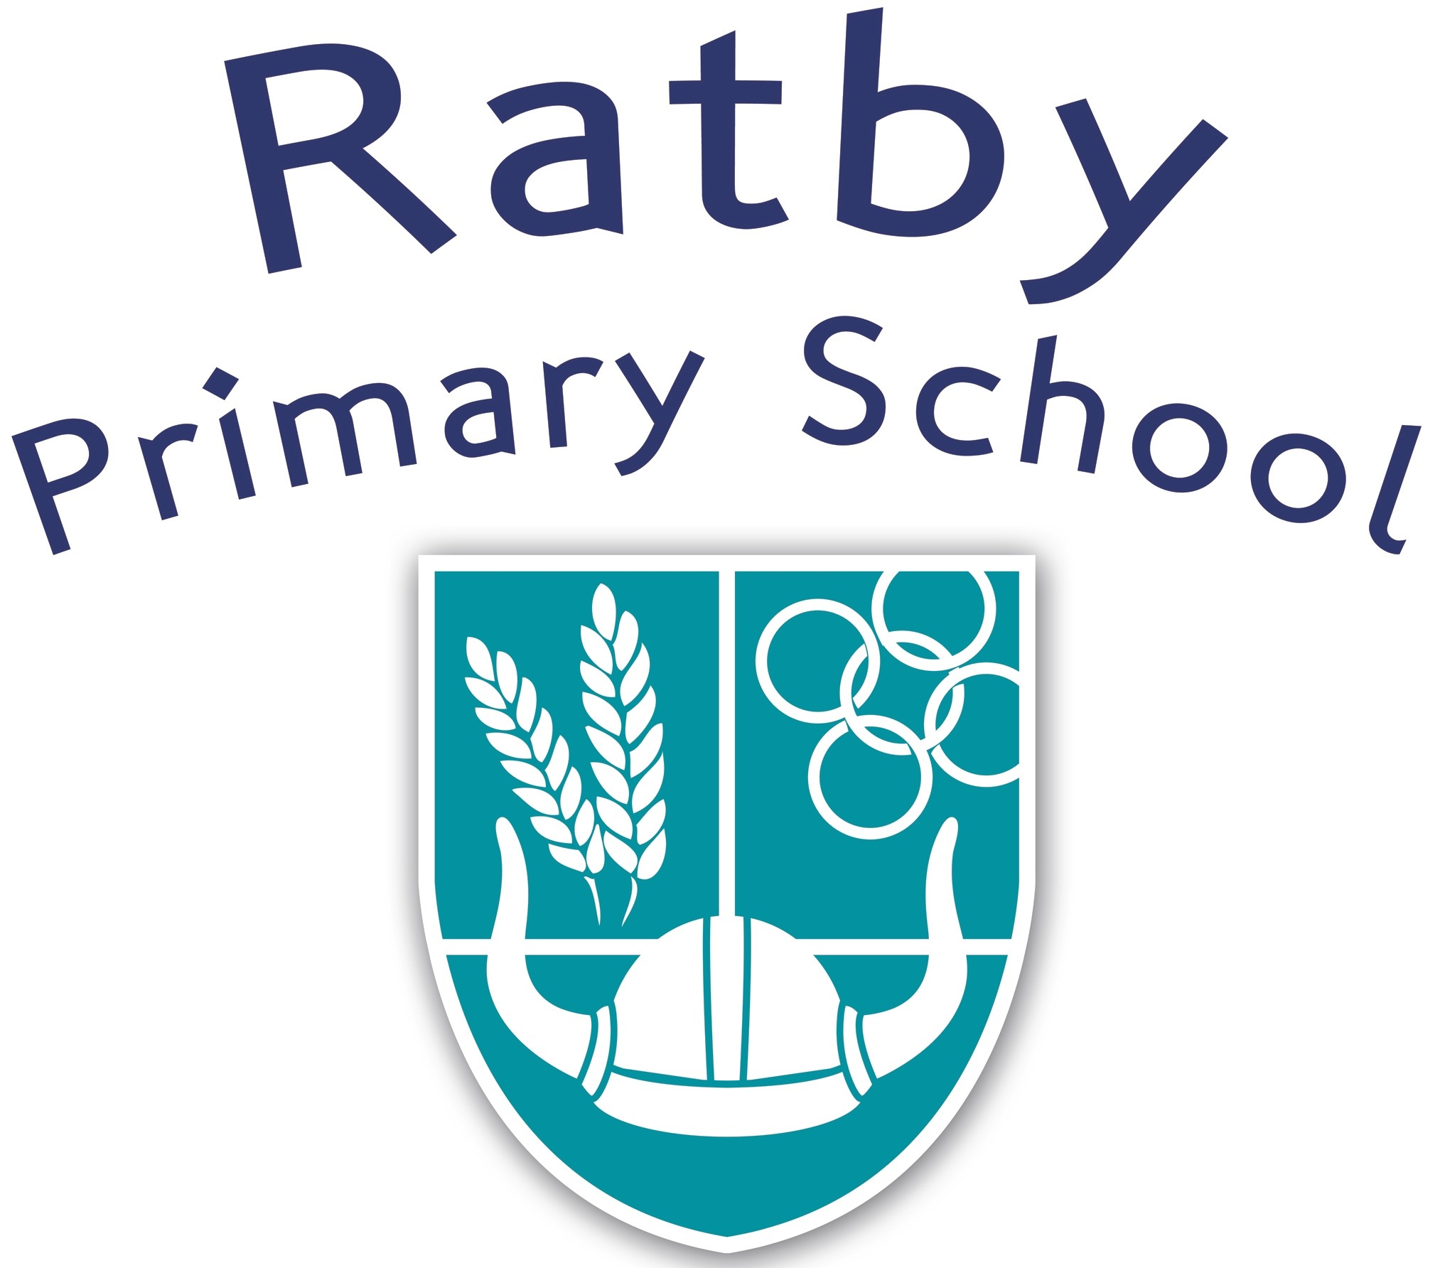

PSHE and RSHE Policy
2022

Reviewed | September 2022
Frequency of Review | Every 2 years
Written by | Nicola Clarke
Approved by: | Lisa Jones - Headteacher

What is PSHE and RSHE?

This policy covers our approach to PSHE (Personal, Social, Health and Economic) and RSHE (Relationships, Sex and Health Education); a statutory component of the PSHE and Citizenship curriculum from September 2020. It aims to set out the purpose of PSHE and RSHE and the intended outcomes for pupils, what is covered in our curriculum and how it is delivered.
We define Personal, Social, Health and Economic (PSHE) education as a subject through which pupils develop the knowledge, skills and attributes they need to manage their lives, now and in the future. Relationships Education (RSHE) as learning about the many strands of relationships and growing up. This includes family relationships, friendships and relationships with peers and adults, healthy and unhealthy relationships, the characteristics of positive relationships, relationships online and the emotional, social and physical aspects of growing up.

Statutory Regulations
The Education and Inspections Act 2006 places a requirement on schools to promote pupils’ wellbeing as well as their academic achievement. We are committed to promoting the health and wellbeing of children and of the whole school community, and fully recognise the important relationship between wellbeing and learning.

From September 2020, all primary schools must deliver Relationship Education. Under the Education Act 2002/Academies Act 2010, all schools must provide a balanced and broadly-based curriculum which:
promotes the spiritual, moral, cultural, mental and physical development of pupils at the school and of society, and prepares pupils at the school for the opportunities, responsibilities and experiences of later life.

Documents that inform the school’s PSHE and Relationship and Sex Education Policy include:

- Education Act (1996)
- Learning and Skills Act (2000)
- Education and Inspections Act (2006)
- Equality Act (2010),
- Supplementary Guidance SRE for the 21st century (2014)
- Keeping children safe in education – Statutory safeguarding guidance (2016)
- Children and Social Work Act (2017)

Other school policies that are relevant to our provision of these are:

- PSHE and Citizenship
- Safeguarding and Child Protection
- Science
- Confidentiality
- Behaviour
- Anti-Bullying
- Inclusion
- Equality
- Staff Health and Wellbeing
- Healthy Schools.
At Ratby Primary School we believe:

At our school, we believe in providing every pupil with open, honest, accurate and age-appropriate lessons all about personal, spiritual, and economic educations including Health education and relationships. Through the school’s ethos and values, we aim to develop children’s knowledge, skills, opinions, strategies and confidence - enabling them to cope with life and live safely and happily in the modern world.

We highly value the partnership between school and home and will promote open and informative two-way communication. We aim to provide parents and carers with accurate information about what their child is learning in school and to provide the best learning environment and opportunities for our children.

Our Relationship, Sex and Health Education curriculum is inclusive and meets the needs of all children, including those with special educational needs or disabilities (SEND). We also aim to promote gender, age, racial equality and diversity and represent the LGBTQI+ community through our Relationships curriculum.

Through our comprehensive provision, we aim to enable young people to gain information, develop and transfer skills and explore attitudes and values, in order to support informed decision-making by;

- ensuring our entire school community understands the role of PSHE within the ethos of our school
- promoting a healthy, safe and caring environment for all pupils and staff;
- providing a broad and balanced curriculum for all our pupils, which values their diverse backgrounds and needs;
- ensure that children receive an entitlement curriculum with progression and a high quality experience of teaching and learning
- ensure that staff have the knowledge, understanding and skills to deliver the PSHE curriculum with the ability to identify any concerns they have about a relationship;
- promote pupil’s self-esteem and emotional wellbeing and help them to form and maintain worthwhile and satisfying relationships, based on respect for themselves and for others, at home, at school, at work and in the community;
- prepare our pupils to confidently engage with the challenges of adult life;
- provide sufficient information and support to enable our pupils to make safe and healthy choices.
- the knowledge and understanding of a variety of relationships;
- coping strategies, understanding emotions and an awareness of how and where to seek support;
- an understanding of their rights and responsibilities within a range of relationships;
- an awareness of the process of growing up and the changes they and others will experience;
- an understanding of the characteristics of positive relationships.

Delivering the Curriculum

Our lessons are taught by staff who are trained in delivering the specific content of the lessons. They will consist of PSHE (physical, social, health and wellbeing), Citizenship (living in the wider world) and RSE (relationship and sex education)

Ground rules will be established in class and children reminded of these. Special consideration will be given when teaching particularly sensitive content and staff will be fully aware of the children in their class and how they might relate to the lesson content.

We aim to create and maintain a safe environment within which all children feel able to ask questions and discuss issues openly. For any child wishing to discuss something confidential, relating to the lesson content, an opportunity will be provided.

We acknowledge that sensitive and potentially difficult issues will arise in as children will naturally share information and ask questions. Each class also has a question box, which gives children the option to write down their questions and receive an answer on a one-to-one basis, rather than in front of the whole class. If a member of staff is uncertain about the answer to a question, or indeed whether they wish to answer it they will seek guidance from the PSHE leader.

Distancing techniques will be employed in our RSE, as with other areas of the PSHE curriculum, meaning that children are able to discuss fictional characters and scenarios, rather than discuss their own lives and experiences.

Our inclusive curriculum supports the statutory requirements for Key Stage 1 and 2 set out by the DfE. It forms a core part of our comprehensive Personal, Social and Health Education (PSHE) curriculum.

We are committed to working closely with parents and carers and we do this by: communication about when relationships lessons will be taking place and the content; leaflets; links to other websites on school website;
home learning opportunities to follow-up learning at home.

This policy will be available to view on our school website by all stakeholders.

What is taught?

Below is a summary of the key learning objectives for PSHE including Relationship and Sex Education lessons. Topics areas taught cover Relationship Education, Health and Well Being and Living in the Wider World. We have chosen the Twinkl Scheme of Work as we believe it meets the needs of our children’s learning and development having incorporated the Rising Stars Wellbeing and Attitudes to Learning Survey, collaboration with staff, consultation with parents and by understanding what the children in our school require. The red units are in addition to the curriculum, where each year group in taught about an area which we consider to be of importance to the age and needs of the children.
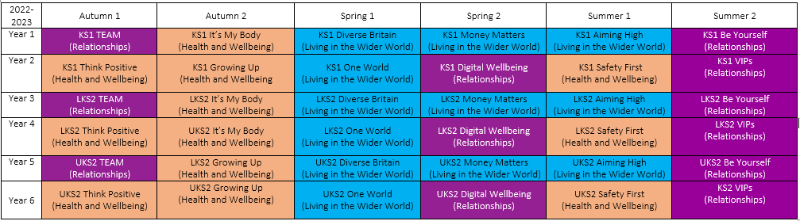

In early years, children are taught to:
- Talk to help work out problems and build constructive and respectful relationships.
- Develop an awareness of similarities and differences in people and value themselves
- Express their feelings (socially and emotionally) and consider the feelings of others.
- Show resilience and perseverance in the face of challenge.
- Think about the perspectives of others.
- Manage their own needs- such as personal hygiene and physical development
- Know and talk about the different factors that support their overall health and wellbeing
- Talk about members of their immediate family and community.
- Name and describe people who are familiar to them.
- Recognise that people have different beliefs and celebrate special times in different ways.

Children in KS1 and KS2 will learn more about topics such as:
- Healthy and unhealthy lifestyles
- Ourselves, growing and changing
- Keeping and feeling safe
- Families and different family structures, positive relationships and friendships
- Managing hurtful behaviour and bullying (violence and harassment)
- Safe and trusted relationships and consent
- Internet Safety
- Economic wellbeing
- Shared responsibility
- Drugs, medicine and alcohol
- Communities
- Mental health and well being
- Respecting yourself and others
- Influential behaviour

PSHE time is also allocated (but not limited to) as follows: -
- Designated PSHE time for class and whole school assemblies
- Cross curricular subjects across the curriculum, e.g., science, literacy, RE, Design Technology
- Enrichment weeks/days, e.g., Anti-bullying week, healthy school’s week, Food for Life Award, 50 ways to Happiness, Happy Lunchtimes, SRTRC, Cyber bullying and Internet safety.
- Visitors, e.g., Anti-Social Behaviour Team, PCSOs, School Nurse, Oxfam, Local Church, RNLI, NSPCC
- Residential and day visits, e.g., Year 6 visit to the Warning Zone, Year visits to Condover Hall, Year 5 contribution to Young Voices, Year 2 visit to Mablethorpe.
- small group work, e.g., social skills groups.
Use of Visits and Visitors
Where appropriate we use visits and visitors from outside agencies or members of the community to support the PSHE programme. This is an enrichment of our programme and not a substitute for our core provision which is based upon the strong relationships between teachers and pupils.

Our partnership with the local community is a priority, and we recognise and value its contribution to the PSHE/PD programme. This reflects our approach to active Citizenship.
We include a range of opportunities for community involvement and activities, such as:

- Links with the church (e.g., harvest festival)
- Charity fundraising (e.g., links with the local food bank, supporting events such as Comic Relief and Children in Need)
- School clubs (e.g., choir performance in care home)
- Invitation lunches (e.g., grandparents’ day)
- Citizenship visits (e.g., ‘Ask your MP’ day, Diversity workshops)
- Links with local services (e.g., visits from the Police Community Support Officer, links with the school nurse)
- Community use of school premises (e.g. beavers).

Inclusion

We understand the importance of ensuring that all children in our school receive their entitlement to PSHE and RSE. We will carefully consider special educational needs or disability, gender, sexual orientation and age, nationality, religion, cultural and linguistic background when planning and delivering RSE.
In relation to nationality, sexual orientation, religion, and cultural diversity, we value the different backgrounds of our pupils and, in addressing different views and beliefs, seek to promote tolerance and understanding.

In order to ensure the RSE Curriculum meets the needs of all:

- We will not promote one particular lifestyle over another.
- We will not seek to gain consensus but will accept and celebrate difference.
- We will encourage respect and discourage abuse and exploitation.
- We will not ask children to represent the views of a particular religious or cultural group to their peers, unless they choose to do so.

In relation to those with special educational needs or disability, we have and will continue to review our programme to ensure that provision is made for those with additional needs. We will consider:
- their level of vulnerability
- their need to learn and demonstrate appropriate behaviour
- their need to develop self-esteem and positive body image
- the need to involve all staff, including ancillary staff and carers, in policy development, planning and training
- the management of personal care
- clarity about sources of support for pupils.

Relationship and Sex Education

It’s my Body and Growing Up are units that focus more specifically on ‘our bodies and how to look after them’.
Whilst coverage earlier on in the curriculum makes reference to learning the names of the main body parts and your body being your own, Year 5 and 6 children are taught lessons on human reproduction and let’s talk about sex as part of their ‘sex education’ lessons. The National Curriculum for Science(KS2) states that it is statutory for children to be taught lessons about puberty, how the human body changes and human reproduction. We will continue to teach this is year 5 and 6, where children will be taught age-appropriate gender identity, changing emotions, love and trust, harassment, banter and unwanted behaviour. Children are given the opportunity to ask questions relating to these lessons.

In early years, children are taught the main names of external genitalia

Year 1 - Recap on the name of the main parts of the body including external genitalia
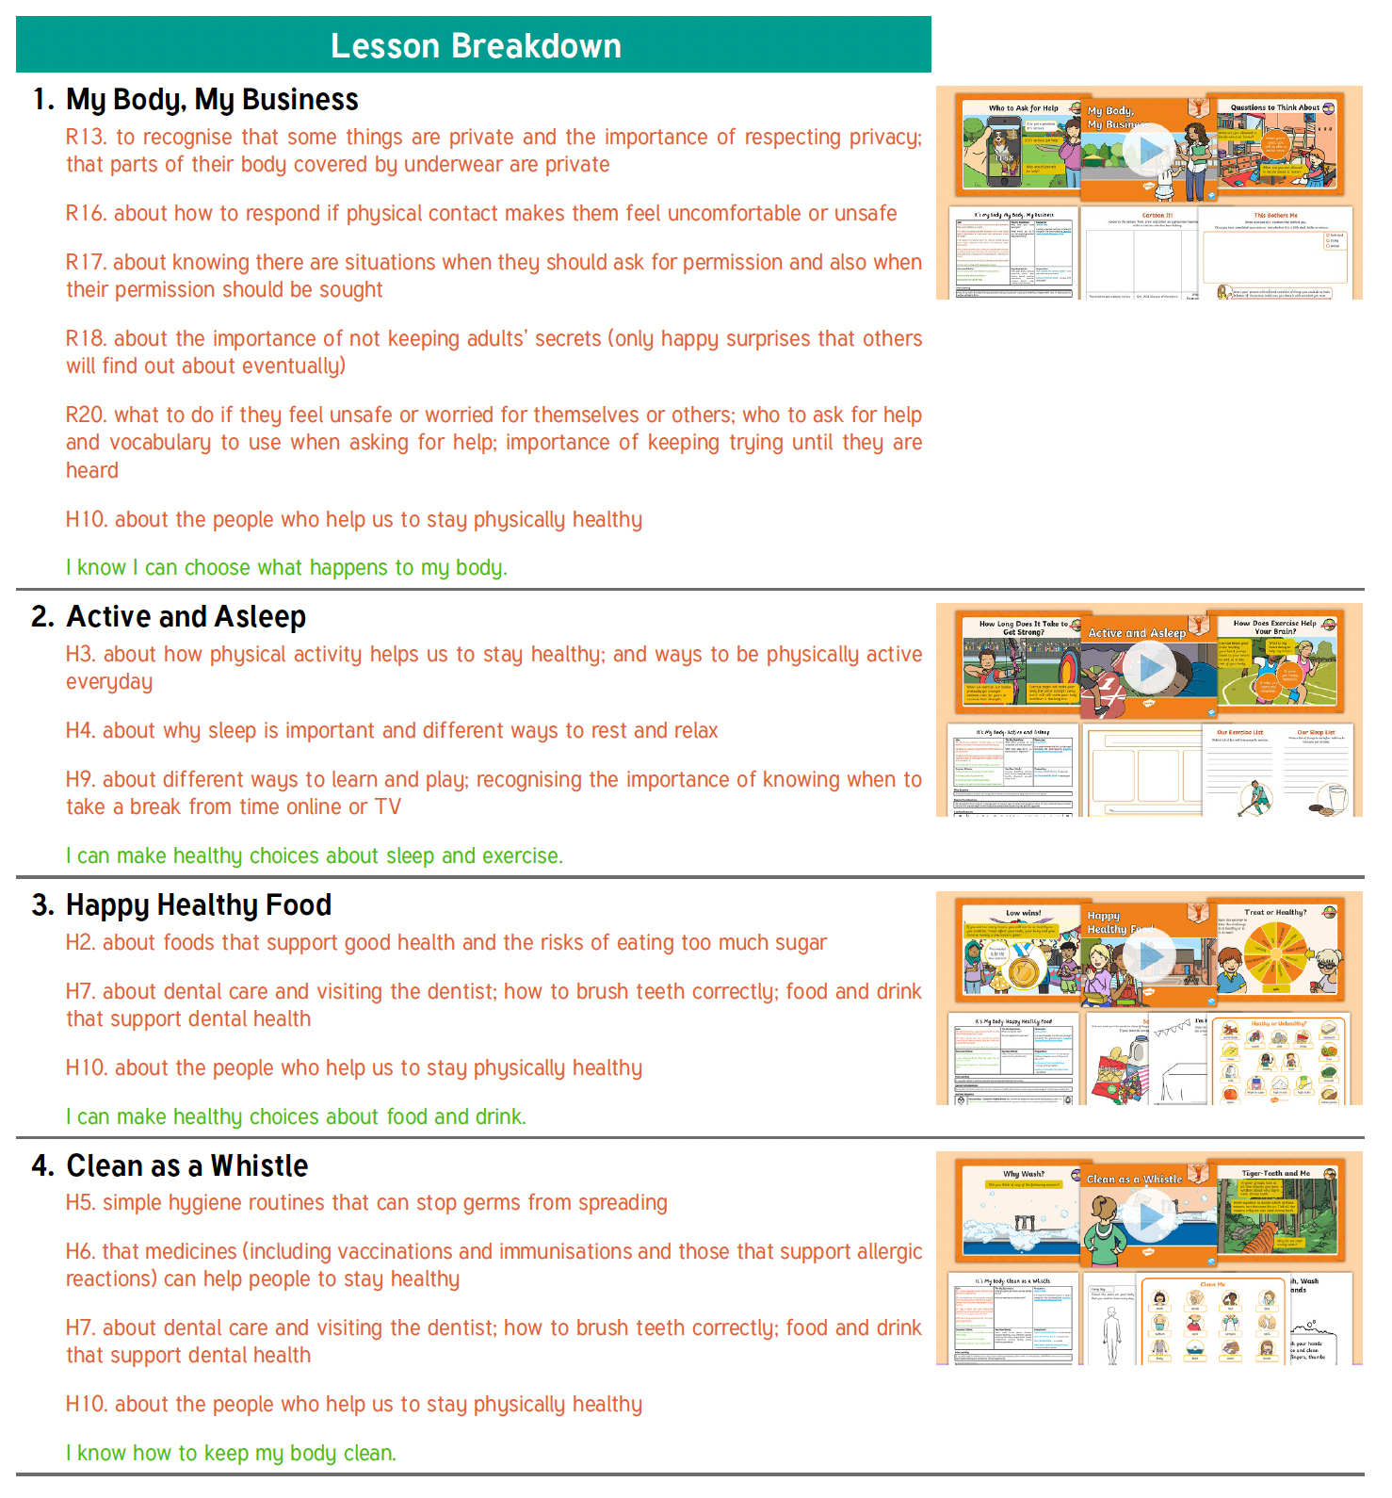
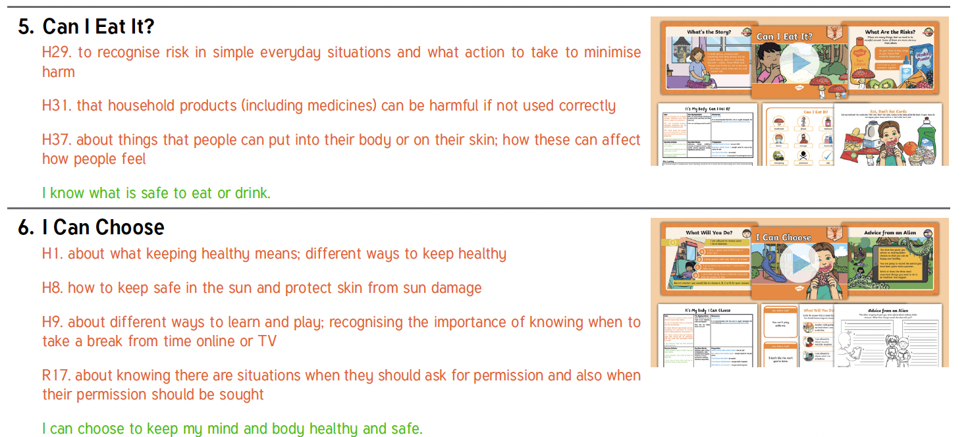

Year 2 - Recap on the name of the main parts of the body including external genitalia
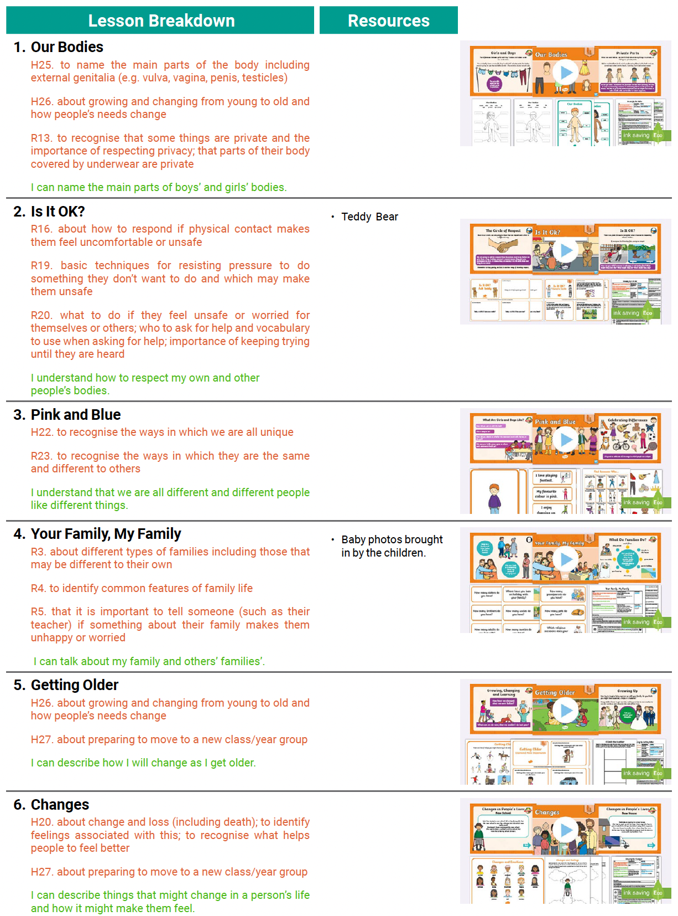

Year 3 – Recap on the name of the main parts of the body including external genitalia (e.g. vulva, vagina, penis, testicles)
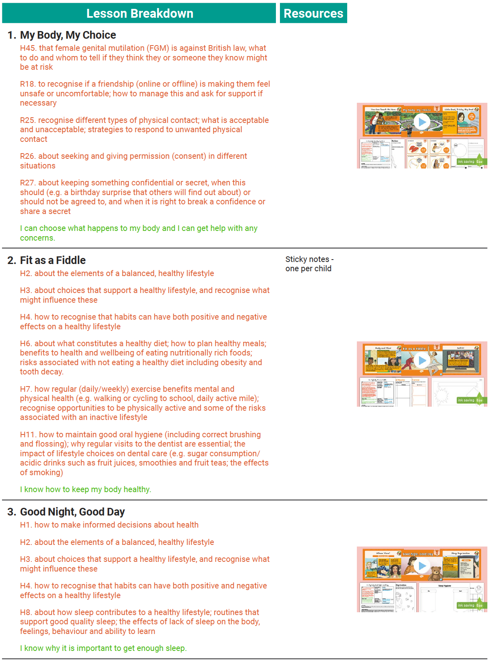
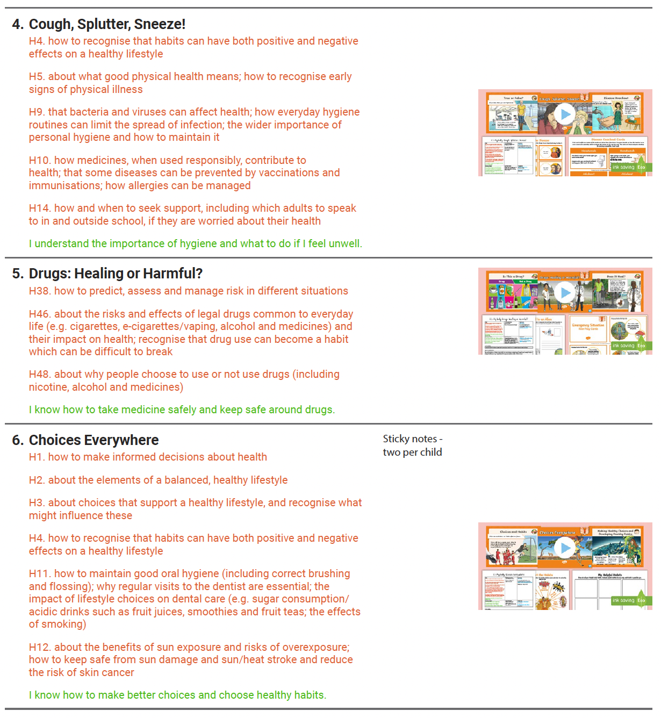

Year 4 – Recap on the name of the main parts of the body including external genitalia (e.g. vulva, vagina, penis, testicles)
- Possible lessons introducing periods but this is reviewed annual based on the needs of the year group
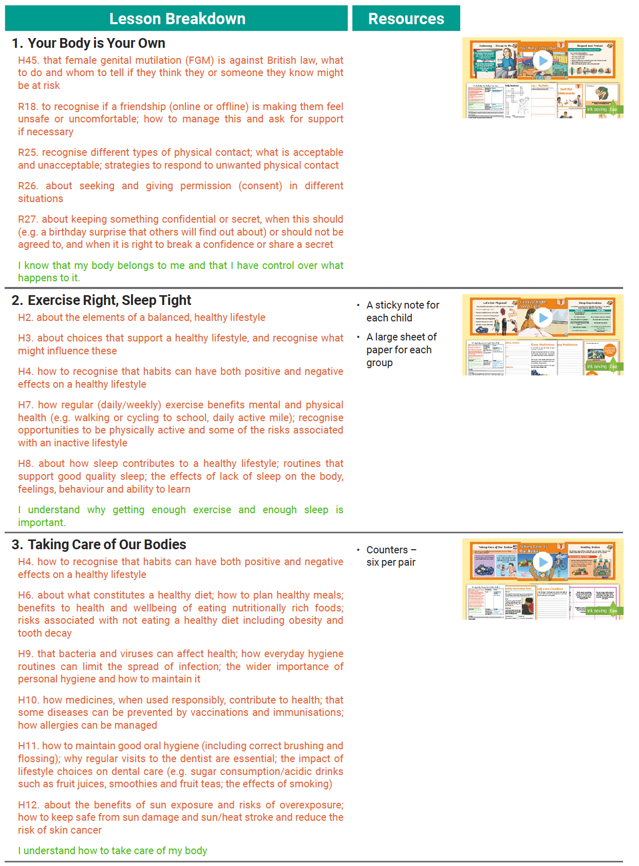

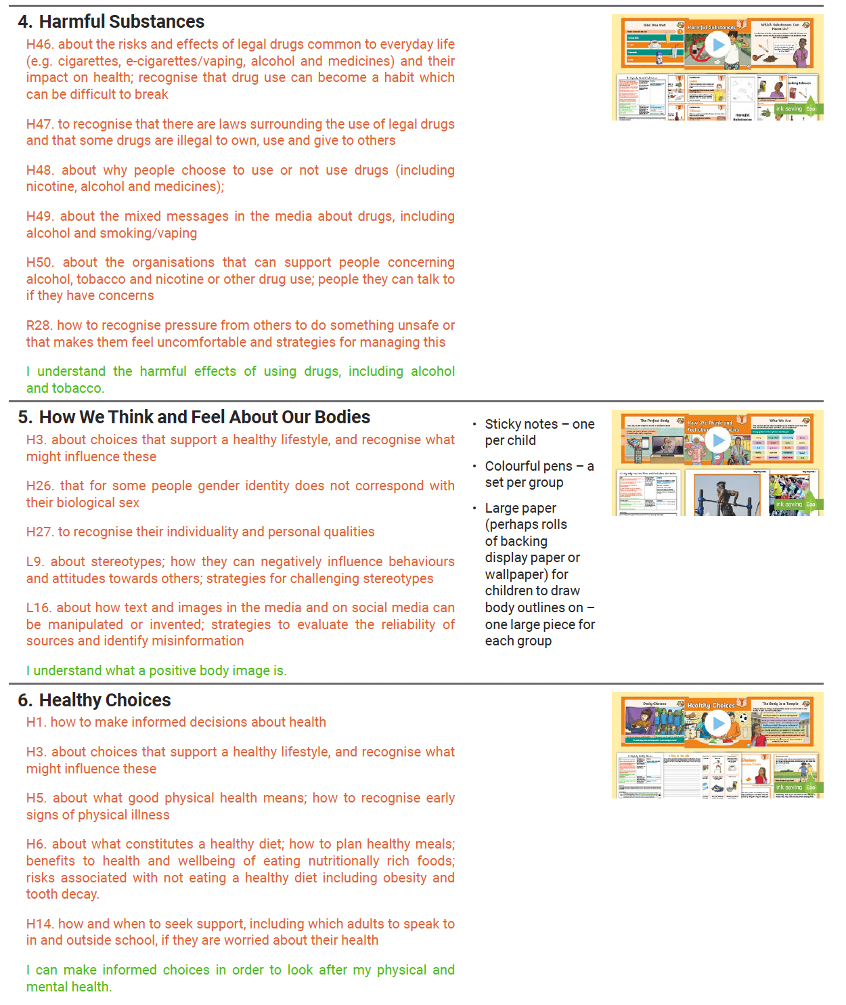

Year 5 - Year 5 lessons will cover how babies are conceived and puberty including periods.
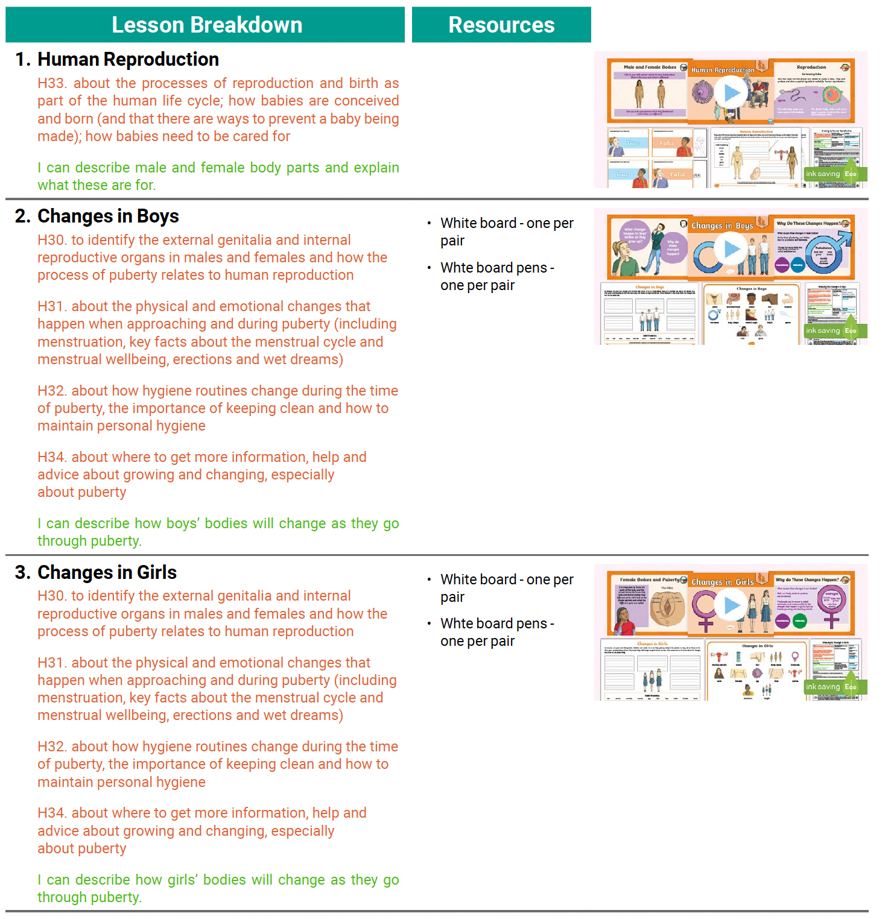
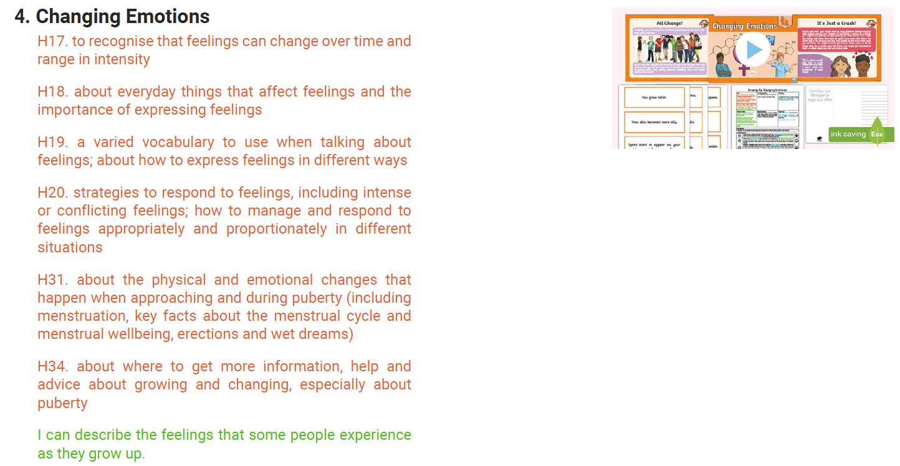
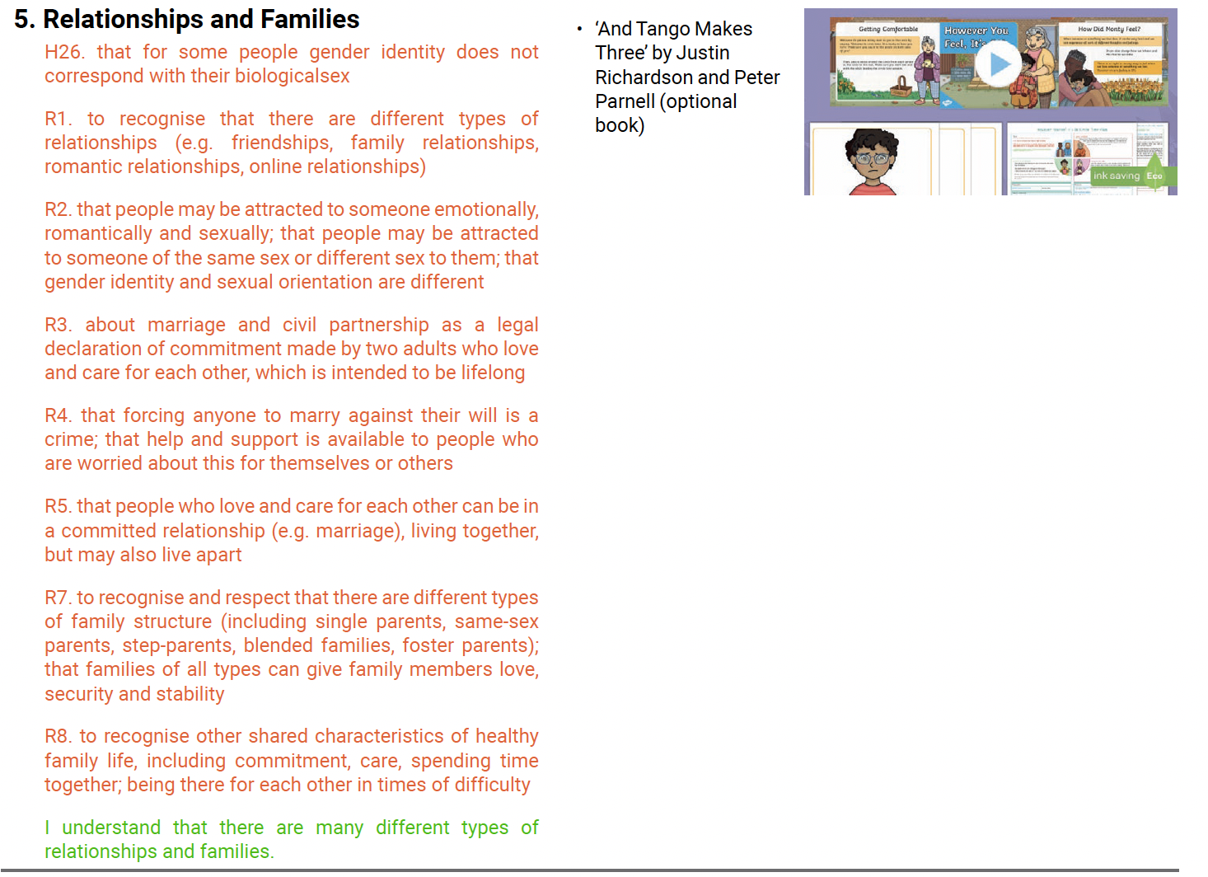
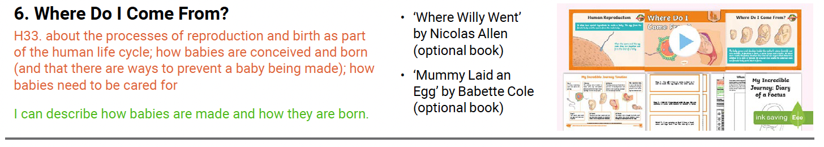

Year 6 – Children will be taught age appropriate content along with additional lessons that discuss areas such as sexual relationships, contraception, consent, gender identity, changing emotions, love and trust, harassment, banter and unwanted behaviour.
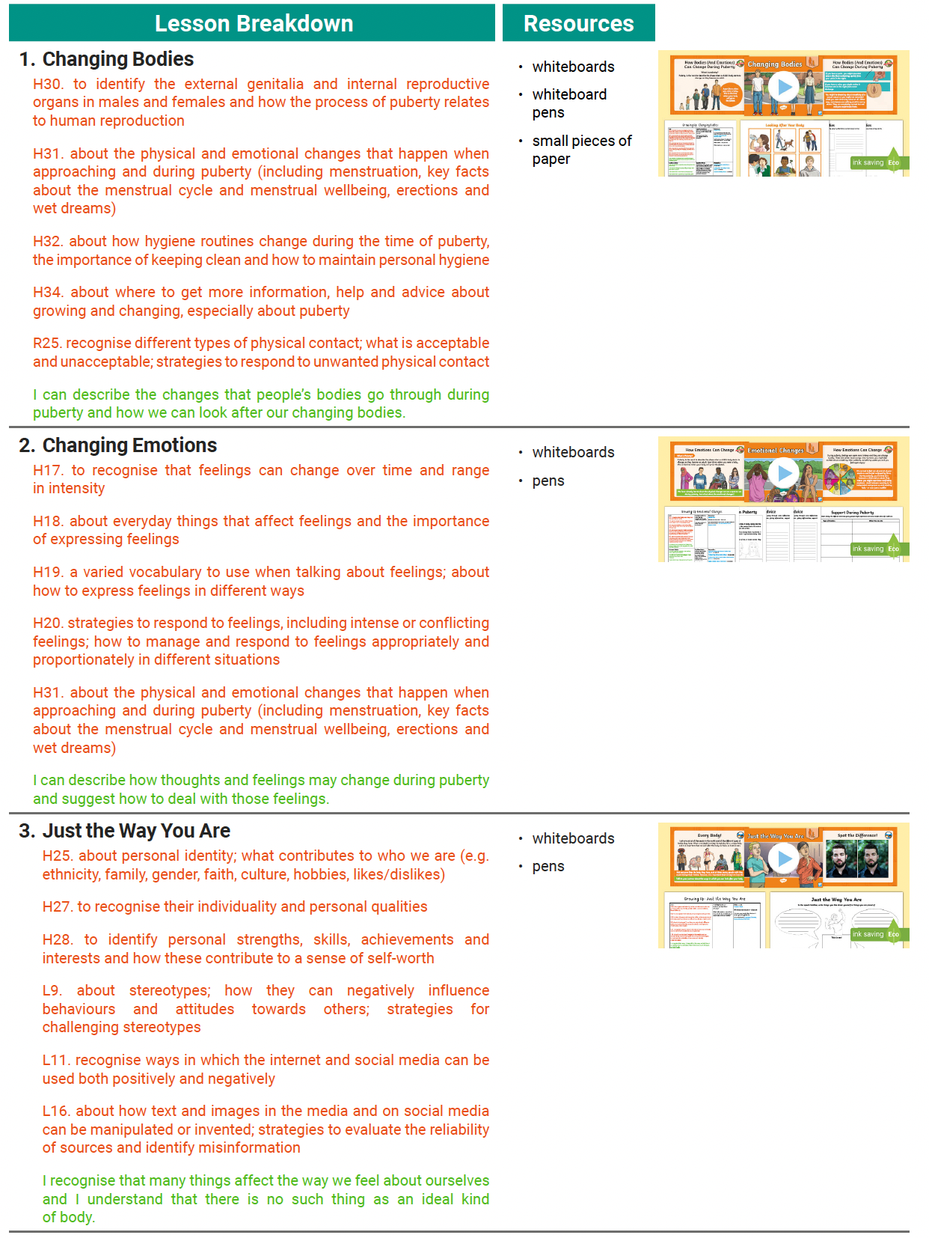

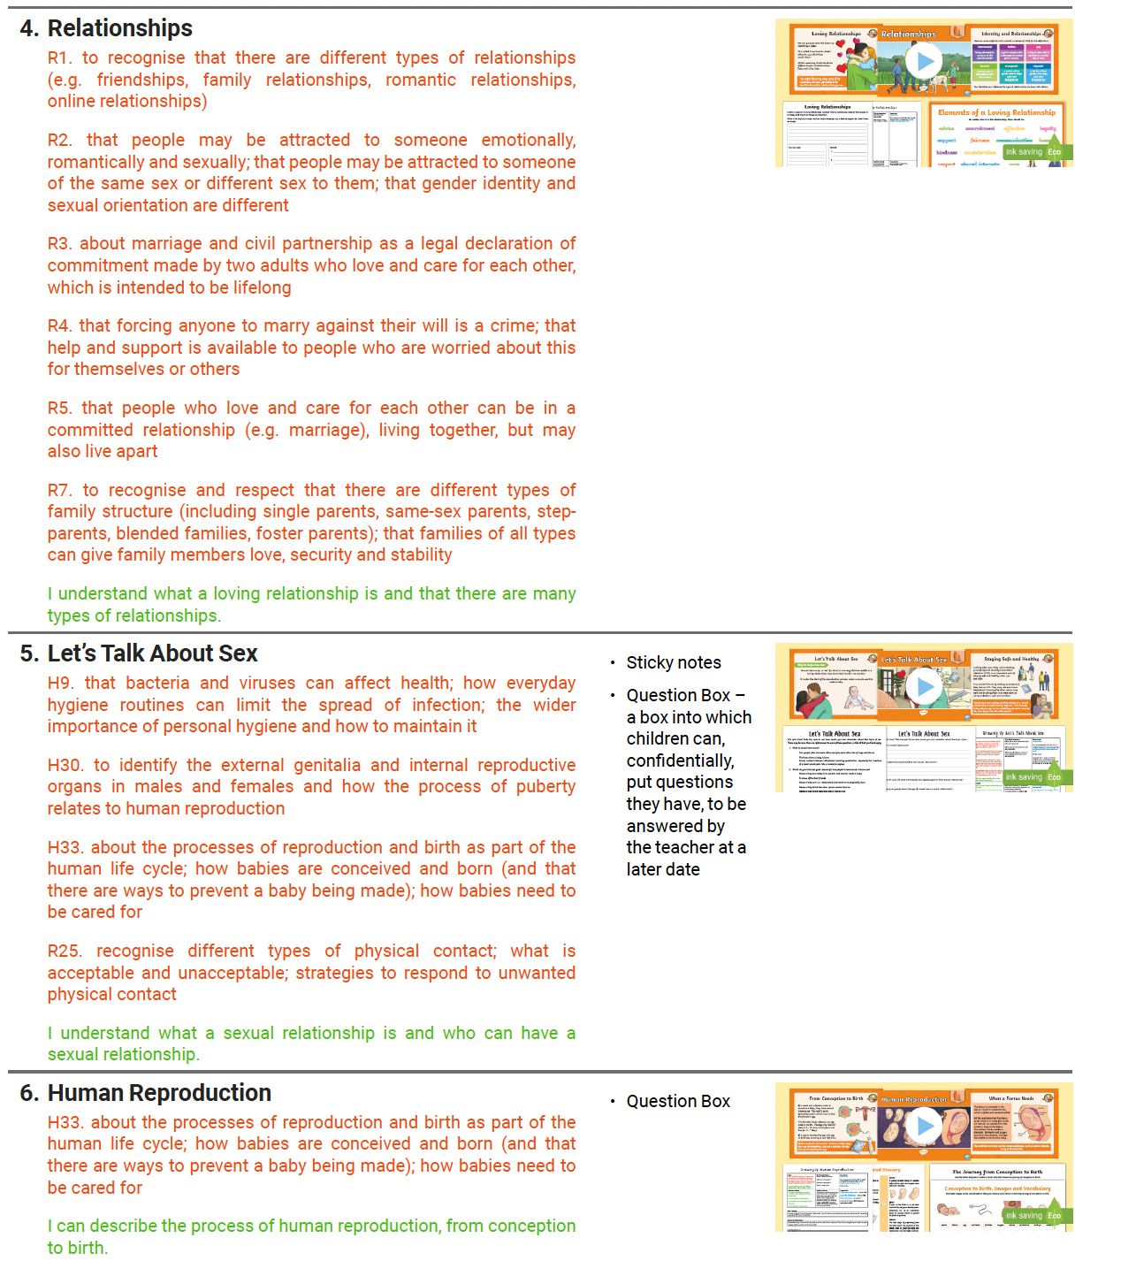

We recognise the importance of ensuring that young people understand about the physical and emotional changes of puberty before they reach it, in order to allay fears or concerns. We also recognise that young people develop at different rates. When teaching about puberty in our RSE programme, we will be sensitive to the needs of those developing at different rates.

We recognise that many primary-aged children are more aware than others and have begun to understand that adults do not only engage in sexual activity when they wish to reproduce. Children may ask direct questions about contraception, abortion or may reveal knowledge (accurate or inaccurate) about reproduction in discussion with adults or their peers. We will address this issue directly in very broad terms as part of the taught RSE Curriculum at Year 5 and 6. The learning will be set in the context of responsible parenting decisions.

We understand that at times children will benefit from varying methods of delivering the RSE curriculum. For example, we will use single-sex groups or small group teaching where this will help us to meet the needs of children more effectively, we will use team teaching where this enables us to best use teacher expertise. We will ensure there are positive educational reasons for each method of delivery.

Working with Staff, Stakeholders and our School Community
Within the context of the School Development Plan/staff Professional Development plan, support and training will be made available to all staff as appropriate. This includes allocating time at staff meetings to introduce new areas of work and to review the effectiveness of the approaches used. Whole staff Inset is used where there are development needs for the whole staff. Individual staff members are offered training opportunities as appropriate.

Parents and carers are the key figures in supporting their children through the emotional and physical aspect of growing up. We recognise that many children would prefer to receive information about RSE from their parents and carers. Therefore, we seek to work in partnership with parents and carers when planning and delivering SRE. We will encourage this partnership by:

- Informing parents and carers by letter of our school RSE curriculum.
- Providing parents with an opportunity to comment on RSE within school and voice any concerns
- Inviting parents to learn more about resources and activities used in RSE
- Gathering parents’ views on the RSE Policy and taking these into account when it is being reviewed
- Informing parents and carers about the RSE programme as their child joins the school through the school brochure/prospectus/website
- Providing supportive information about parents’ role in RSE
- Inviting parents to discuss their views and concerns about RSE on an informal basis.

Involving the children
We recognise that an interactive approach to PSHE will better develop the skills of our children, and also that, if they are involved in shaping the programme, it is more likely to meet their needs. We involve young people in the evaluation and development of their PSHE in ways appropriate to their age.
- We refer to local/countywide/national data e.g. Health Related Behaviour Survey for our school/locality.
- We engage the children in activities to establish their development needs, for example ‘Draw and Write’ activities.
- We encourage children to ask questions as they arise by providing anonymous question boxes and other similar approaches.
- We ask children to reflect on their learning using appropriate success criteria and to set goals for future learning.
- We consult with children, through School and Class Councils, about their perception of the strengths of our PSHE programme and the areas to be further developed.
- Through assessment, in particular self-assessment, we will learn more from the children about the effectiveness of the teaching and learning and its impact.

The Role of Governors
We have a named link governor for PSHE who works closely with and in support of the coordinator.
When aspects of PSHE appear in whole school development planning/the School Improvement Plan, a governor will be assigned to reflect on, monitor and review the work as appropriate.
The governing body as a whole plays an active role in monitoring, reviewing and developing the policy and its implementation in school.

Right to Withdraw
Parents and carers have the legal right to withdraw their child from all or part of sex education taught as part of statutory Relationships Education, with the exception of the objectives included in National Curriculum for science. Those considering this option are asked to speak with Mrs Clarke (Lead Teacher for PSHE) or contact Mrs Jones (Head Teacher) in order to find out more about this.

Safeguarding
Teachers are aware that effective RSE, which brings an understanding of what is and what is not appropriate in a relationship, can lead to a disclosure of a child protection issue. Where a question or comment from a pupil in the classroom indicates the possibility of abuse, teachers will pass this information to the designated person for child protection in line with school policy.
In all instances, teachers will consult with the designated safeguarding lead and in his/her absence, their deputy.
- Designated Safeguarding Lead: Mrs Lisa Jones (Headteacher)
- Deputy Designated Safeguarding Lead: Mrs Astill (Deputy Headteacher)
- Deputy Designated Safeguarding Lead: Mrs Denton (Assistant Headteacher)

Visitors and external agencies which support the delivery of Relationships Education will be required to
adhere to the school’s safeguarding policy and policies relating to the subjects they are teaching or
contributing towards.

Assessment, Monitoring and Reporting
Self-assessment is an important part of learning in Relationships Education and PSHE. Children will reflect
on their learning throughout the units. We highly value pupil voice and will take into account the opinions
and comments of our children about what they would like to learn.

Staff delivering the curriculum will critically reflect on their teaching and best practice will be
shared through lesson observations, monitoring of planning and children’s work and training opportunities.
Monitoring and evaluation of the Policy is the responsibility of the Local Advisory Board

Review
Our policy has been developed through discussion with the Governor responsible for this in school, the Local Advisory Board, staff, children, PSHE Co-ordinator and with the support of the Head Teacher.

It was discussed and ratified by the Local Advisory Board on 12th September 2022
The Policy will be formally reviewed every year based on feedback from staff/parents, assessment data, current issues and new government guidance.

