UniformPolicy
2022

Reviewed | September 2022
Frequency of Review | Annual
Written by | Lisa Jones
Approved by: | Lisa Jones

Contents
1. Aims 3
2. Our school’s legal duties under the Equality Act 2010 3
3. Limiting the cost of school uniform 3
4. Expectations for school uniform 4
5. Expectations for our school community 5
6. Monitoring arrangements 6
7. Links to other policies 6

1. Aims
This policy aims to:
- Set out our approach to requiring a uniform that is of reasonable cost and offers the best value for money for parents and carers
- Explain how we will avoid discrimination in line with our legal duties under the Equality Act 2010
- Clarify our expectations for school uniform

2. Our school’s legal duties under the Equality Act 2010

The Equality Act 2010 prohibits discrimination against an individual based on the protected characteristics, which include sex, race, religion or belief, and gender reassignment.

To avoid discrimination, our school will:
- Avoid listing uniform items based on sex, to give all pupils the opportunity to wear the uniform they feel most comfortable in or that most reflects their self-identified gender
- Make sure that our uniform costs the same for all pupils
- Allow all pupils to have long hair (though we reserve the right to ask for this to be tied back)
- Allow all pupils to style their hair in the way that is appropriate for school yet makes them feel most comfortable
- Allow pupils to request changes to swimwear for religious reasons
- Allow pupils to wear headscarves and other religious or cultural symbols
- Allow for adaptations to our policy on the grounds of equality by asking pupils or their parents to get in touch with Mrs Jones (Headteacher), who can answer questions about the policy and respond to any requests

3. Limiting the cost of school uniform
Our school has a duty to make sure that the uniform we require is affordable, in line with statutory guidance from the Department for Education on the cost of school uniform.
We understand that items with distinctive characteristics (such as branded items, or items that have to have a school logo or a unique fabric/colour/design) cannot be purchased from a wide range of retailers and that requiring many such items limits parents’ ability to ‘shop around’ for a low price.
We will make sure our uniform:
- Is available at a reasonable cost
- Provides the best value for money for parents/carers

We will do this by:
- Carefully considering whether any items with distinctive characteristics are necessary
- Limiting any items with distinctive characteristics where possible for example, by only asking that the jumper / cardigan, worn over the school t-shirt, features the school logo
- Considering cheaper alternatives to school-branded items, such as logos that can be ironed on, as long as this doesn’t compromise quality and durability
- Avoiding specific requirements for items pupils could wear on non-school days, such as coats, bags and shoes
- Keeping the number of optional branded items to a minimum, so that the school’s uniform can act as a social leveler
- Avoiding different uniform requirements for different year/class/house groups
- Avoiding different uniform requirements for extra-curricular activities
- Making sure that arrangements are in place for parents to acquire second-hand uniform items
- Avoiding frequent changes to uniform specifications and minimising the financial impact on parents of any changes
- Consulting with parents and pupils on any proposed significant changes to the uniform policy and carefully considering any complaints about the policy

4. Expectations for school uniform
4.1 Our school’s uniform
Item | Guidance
- White polo shirts or shirts or blouse (with plain or with the school logo embroidered on them)
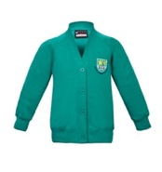  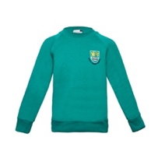  - Jade green sweatshirt or cardigan (school jade green colour) or cardigan with the school’s logo embroidered on them ) | We do not allow dark green cardigans or jumpers.

Item | Guidance
- Grey Socks or Tights | Socks must be plain white or black. Tights must be plain, black or grey opaque. We do not allow leggings to be worn with skirts.
- Grey (only) trousers or knee length pleated skirts or pinafore dresses  - 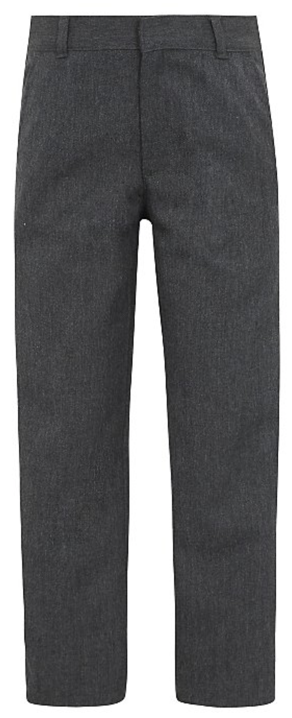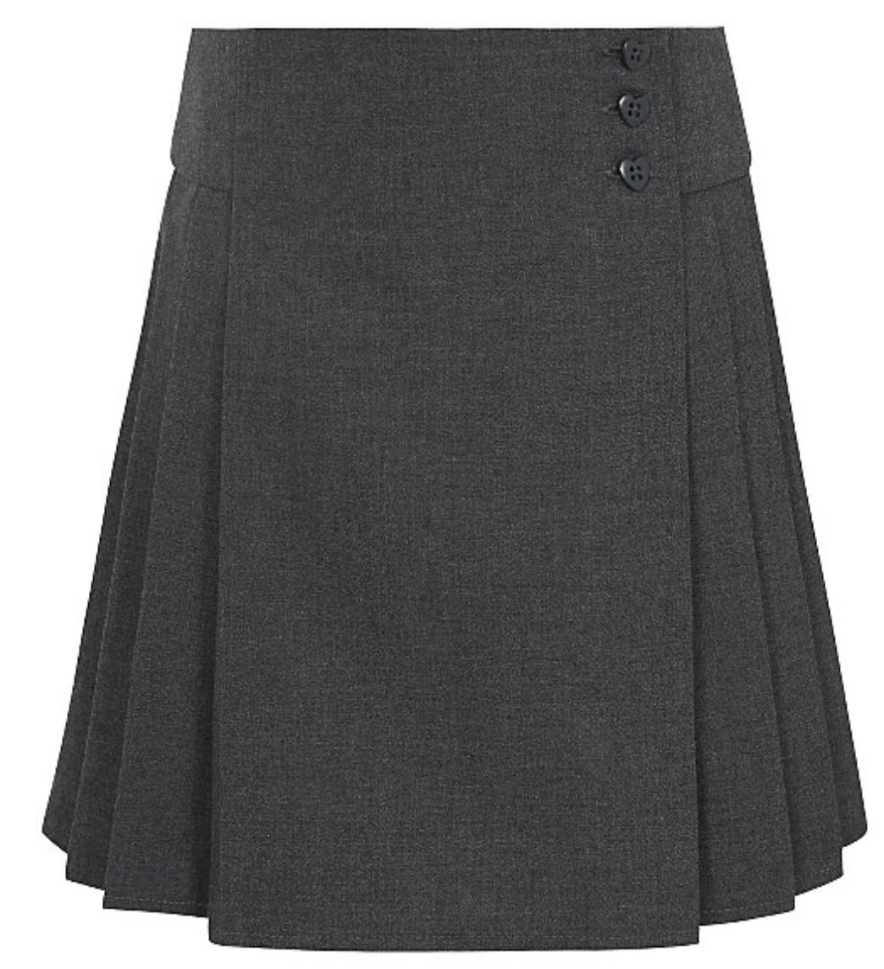 | We do now allow denim, rivets, leggings, low-waisted trousers, chinos, trousers that are tight on the legs or made of stretchy material, trousers made of any fabric other than standard school trouser fabric nor any trousers that follow current a current fashion trend.  Ideally skirts should be fully pleated or pleated with front plain panel. No stretchy skirts/skater skirts/pencil skirts
- Plain Black flat or low heel shoes or plain black trainers. | No sandals, high heels, wellingtons, doc-martins, The soles of all shoes/boots must be black. In winter months boots should be changed on arrival at school.
PE Kit  - A plain white round neck t-shirt  - A pair of navy or black shorts or leggings or jogging bottoms  - A pair of rubber-soled plimsolls (indoor) or trainers (outdoor games)  - If PE is outdoors, it may be necessary to bring a tracksuit. This should be plain navy or black.  - Long hair should be worn up in a ponytail | - Only sports items with small discreet logos are permitted  - Football kits are not permitted  - Children not wearing appropriate PE kit may be asked to change into spare kit or asked to bring a different kit for future sessions.
Summer Uniform

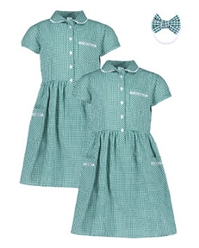
- Green and white knee length gingham dress.
- Grey knee length shorts
- A sun hat or cap.

4.2 Where to purchase it
For branded items:
Online
From our designated supplier,
Uniform Direct: www.uniform-direct.com
In store
Open 9am to 5:30pm
Monday to Saturday
Tel: 0116 2511844
Direct from the Uniform Direct shop
in Leicester City Centre:
54-56 Humberstone Gate
Leicester,
LE1 3PJ

Second Hand Uniform
There will be regular sales of second hand uniform or lost property at Parent’s Evenings and after school on the playground at regular intervals throughout the year.
If you are interested in second hand uniform at other times, please contact the school office for further help.

5. Expectations for our school community
5.1 Pupils
Pupils are expected to wear the correct uniform at all times (other than specified non-school uniform days) while:
- On the school premises
- Travelling to and from school
- At out-of-school events or on trips that are organised by the school, or where they are representing the school (if required)
Pupils are also expected to contact Mrs Jones if they want to request an amendment to the uniform policy in relation to their protected characteristics.
5.2 Parents and carers
Parents and carers are expected to make sure their child has the correct uniform and PE kit, and that every item is:
- Clean
- Clearly labelled with the child’s name
- In good condition
Parents are also expected to contact Mrs Jones if they want to request an amendment to the uniform policy in relation to:
- Their child’s protected characteristics
- The cost of the uniform
Parents are expected to lodge any complaints or objections relating to the school uniform in a timely and reasonable manner.
Disputes about the cost of the school uniform will be:
- Resolved locally
- Dealt with in accordance with our school’s complaints policy
- The school will work closely with parents to arrive at a mutually acceptable outcome.
5.3 Staff
Staff will closely monitor pupils to make sure they are in correct uniform. They will give any pupils and families breaching the uniform policy the opportunity to comply, but will follow up with the headteacher if the situation doesn’t improve.
Ongoing breaches of our uniform policy will be dealt with by sanctions as outlined in our behaviour policy.
In cases where it is suspected that financial hardship has resulted in a pupil not complying with this uniform policy, staff will take a mindful and considerate approach to resolving the situation.
5.4 Governors
The governing board will review this policy and make sure that it:
- Is appropriate for our school’s context
- Is implemented fairly across the school
- Takes into account the views of parents and pupils
- Offers a uniform that is appropriate, practical and safe for all pupils
The board will also make sure that the school’s uniform supplier arrangements give the highest priority to cost and value for money, for example by avoiding single supplier contracts and by re-tendering contracts at least every 5 years.

6. Monitoring arrangements
This policy will be reviewed annually by the Headteacher. At every review, it will be approved by Local Advisory Board

7. Links to other policies

This policy is linked to our:
- Behaviour policy
- Equality information and objectives statement
- Anti-bullying policy
- Complaints policy

