 | Autumn Term |  |  |  |  | Spring Term |  |  |  |  | Summer Term
Class Books  (Pie Corbett Reading Spine and Page Turners) | Owl Babies  Goldilocks and The Three Bears  We’re Going on a Bear Hunt  Dinosaurs- Information Books |  |  |  |  | Lost and Found  Penguin  Pets- Information Books  The Cat in the Tree  The Gingerbread Man  Supertato |  |  |  |  | Jack and the Beanstalk  The Three Little Pigs  What the Ladybird Heard  Jasper’s Beanstalk  Information books on the Life Cycle of a Frog  Minibeast Books
READING
TOPIC | Autumn 1 – If you go down to the woods today! |  | Autumn 2 – Dinosaurs Roar Catch me if you can! |  |  | Spring 1 – Lost and Found  The Perfect Pet |  | Spring 2 – Supertato |  |  | Summer 1 – Fee, Fi, Fo, Fum! |  | Summer 2 – Down in the Jungle
Talk for Writing Text | Owl Babies  Goldilocks and The Three Bears  We’re Going on a Bear Hunt |  | NF- Dinosaurs |  |  | Lost and Found  Penguin  Pets  The Cat in the Tree |  | The Gingerbread Man  Suoertato |  |  | Jack and the Beanstalk  The 3 Little Pigs |  | What the Ladybird Heard!  Superworm
Poetry, eg, riddles | Alliteration  Poetry basket – a poem a week |  | Dinosaurs Roar  Poetry basket – a poem a week |  |  | Poetry basket – a poem a week |  | Rhyming pairs  Poetry basket – a poem a week |  |  | Rhyming pairs  Poetry basket – a poem a week |  | Poems about jungle animals  ‘Down in the Jungle’  Poetry basket – a poem a week
Traditional Tales | Goldilocks and The Three Bears |  |  |  |  |  |  | The Gingerbread Man |  |  | Jack and the Beanstalk  3 Little Pigs
Other Stimulus e.g. visual literacy, videos, pictures, | Youtube versions of the stories – look at similarities and differences |  | Launch day – finding eggs on playground. What could be inside the egg? |  |  | Lost and Found  Frozen penguin – what can we do to look after him? What does he need?  Vimeo story - Penguin  The cat stuck in the tree  A toy cat is actually in a tree and we discuss ways of getting him down safely |  | Video version of Gingerbread Man  Supertato – lots of stimulus – provocations of what the evil pea has done to the vegetables, including video animations |  |  | Going to the Giant’s castle  Role Play to take the golden egg back to the Giant;s castle  Receive a letter from the Giant  Farm Trip to Manor farm |  | Frogs- Life Cycle  Growing tadpoles in ‘pond’ outside
WRITING
Cold Task | Oral Storytelling |  | Independent Phonics activities |  |  | Labelling the boy and the penguin’s lunchbox |  | List of Gingerbread Man characters - cvc words |  |  | What will the magic beans grow into? |  | News writing
Hot Task Outcome & Suggested Level of Innovation | Imitation – retelling the story using a story map  Innovation- Changing the breakfast for Goldilocks  Independent writing - Invention- A letter to the Three Bears to say sorry |  | Innovation- What’s inside the egg?  Independent writing – Role play non fiction writing in the Dinosaur Museum |  |  | What does the penguin need?  Vimeo story penguin - What the penguin would say?  Innovation- How did you get the cat down?  How to look after the guinea pig |  | Invention – invent a new setting – ‘he ran to / he will go to the  Newspaper report about the Evil Pea |  |  | Writing At the top of the beanstalk …  Writing a letter to the Giant  Write about what the wolf did in the story?  The 3 little pigs have to leave home – where could they go to live? – to a town, seaside, tree house, another country?  NF- Instructions for how to plant a bean seed  Independent writing – labelling a plant |  | Recount of Superworm story  Jungle Recount  - Independent writing

EYFS KEY WRITING KNOWLEDGE AND SKILLS

Writing Objectives
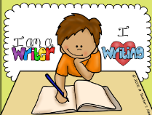
Birth-Three  -Enjoy drawing freely.  -Add some marks to their drawings, which they give meaning to. For example: “That says mummy.”  -Make marks on their picture to stand for their name.  Handwriting  . Develop manipulation and control. PD.FMS.B-3  . Explore different materials and tools. PD.FMS.B-3 | Three- Four Years  . Use some of their print and letter knowledge in their early writing. For example: writing a pretend shopping list that starts at the top of the page; write ‘m’ for mummy. Writing.3-4  • Write some or all of their name. Writing.3-4  . Write some letters accurately. Writing.3-4  Handwriting  .Use a comfortable grip with good control when holding pens and pencils. PD FMS.3-4  .Show a preference for a dominant hand. PD FMS.3-4 | Reception  . Form lower-case and capital letters correctly. Writing-Reception  . Spell words by identifying the sounds and then writing the sound with letter/s. Writing-Reception  . Re-read what they have written to check that it makes sense. Writing-Reception  . Write short sentences with words with known letter-sound correspondences using a capital letter and full stop. Writing-Reception  Handwriting  Develop their small motor skills so that they can use a range of tools competently, safely and confidently. Suggested tools: pencils for drawing and writing. PD.FMS - Reception  Develop the foundations of a handwriting style which is fast, accurate and efficient. PD.FMS - Reception. | Writing- ELG .  . Write recognisable letters, most of which are correctly formed. Writing-ELG  • Spell words by identifying sounds in them and representing the sounds with a letter or letters. Writing-ELG  • Write simple phrases and sentences that can be read by others. Writing-ELG  Handwriting  Hold a pencil effectively in preparation for fluent writing- using the tripod grip in almost all cases. FMS-ELG

On Entry  Expected  Secure 3-4 Years | Autumn 2  Expected  Ent Reception | Spring 1  Expected  Developing Reception | Spring 2  Expected  Secure Reception | Summer 1  Expected  Reception/ ELG | Summer 2  Expected  ELG
EYFS Writing Progression and expectations
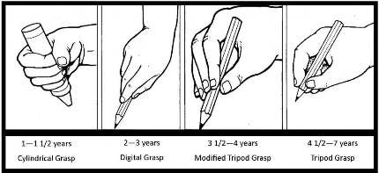

Birth to 3 year olds | 3-4 year olds | Reception | Rec / Early Learning Goal
I can make marks | ‘It says come to my party’  I can read back my marks and  can use some letter shapes | I can use initial sounds to write labels | I can spell words by identifying sounds in them and representing the sounds with a letter or letters
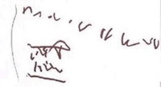  I show more control over the marks I make | I can write some  or all of my name | I can orally segment the sounds in simple words and blend them together | I can leave finger spaces between words
I can imitate writing  (Left to right progression) | a … apple  I can hear initial sounds | d o g  I can read and write  a cvc label | 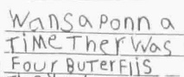  I can write short sentences with words with known sound-letter correspondences that can be read by others.
‘mummy’  I sometimes give meaning to the marks I make | I can use some of my print and letter knowledge in my early writing. For example: writing ‘m’ for mummy. | 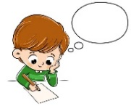  I can say a simple sentence and keep it in my head | I can write some tricky words correctly
 | I can write some letters accurately. | I can write a simple caption | T  I am beginning to use full stops and capital letters
 |  | I can use some correct sounds when I write a sentence | I can re-read what I have written to check that it makes sense.
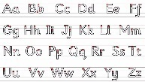
I can form lower-case and capital letters correctly.

