**Attendance and Punctuality**

**Guidance for Parents / Carers**

**2022-2023**

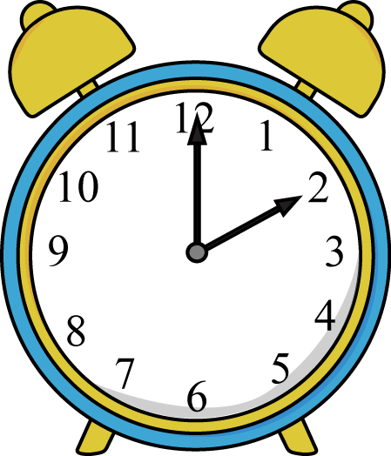

**New guidelines (2022) for attendance and use of penalty notices in schools**

Circumstances under which school will consider the use of a penalty notice:

* 10 sessions of unauthorised absence (including lateness)
* Any incidence of unauthorised holiday in term time
* Any pattern or repeated absences without suitable evidence/justification
* Any unauthorised absence immediately following a leave of absence in term time.
* Any incidence of an excluded pupil being in a public place without reasonable justification during the first 5 days of exclusion
* Any child with 2 fines in a school year, should be considered for prosecution.

**Fixed Penalty Notices**

**Cost of Fixed Penalty Notices:**

* £60 per parent, per child if paid within 21 days of receipt of the notice or
* £120 if paid after 21 days but within 28 days of receipt of the notice
* Non Payment will trigger a prosecution for non-attendance under Section 444(1) of the Education Act 1996.

**Requests for exceptional leave**

All parents should complete a ‘Request for Exceptional Leave’ form to request a planned absence. Each request will be considered on an individual basis and all evidence and context to support your application for exceptional leave at the point of the initial application as further information provided at a later date **will not** be considered.

Exceptional leave will not be authorised during examination periods.

* All requests must be considered on their own merits but there must be very particular and exceptional circumstances before the request will be granted
* Reduced cost of holidays in term time does not amount to exceptional circumstances
* Awkward flight times do not amount to exceptional circumstances
* Parental work patterns are unlikely to amount to exceptional circumstances
* Weddings, at home or abroad are unlikely to amount to exceptional circumstances
* Other family members booking holidays when ignorant of school term times does not amount to exceptional circumstances

**Lateness**

Each group has a start and end time - your child will receive a late mark if they arrive after this time. The register closes 30 mins. after arrival. If your child arrives after this time, they will receive an **unauthorised absence** mark.

**10 unauthorised absence marks may result in a fixed penalty notice.**

**If your child is too ill to attend school**

* Contact school on each day of absence and provide reasons for the absence.
* If your child is absent for an extended period, please keep school informed on a regular basis.
* Failure to do these things may result in your child’s absence being recorded as unauthorised.
* Unauthorised absences will be recorded on the register when there is no valid reason given for absences such as a holiday not approved by the school, lateness after the register closes or illness without medical evidence.



**Key Bench Marks for Attendance**

|  |  |
| --- | --- |
| 100% | Letter home and certificate of praise! (Individual school rewards) |
| 99 -97% | Courtesy letter (informing parents) Letter ‘1’ Attendance is ‘good’. |
| 95-96% | This is below target. Monitor and review.  Consider moving to Tier 1 concern? |
| 91-95% | Tier 1 Concern Letter issued – phone call and/or meeting with Headteacher |
| 90% and below | Tier 2 Concern Letter issued – Formal meeting with the Headteacher and Trust Attendance and Welfare Lead.  Support Plan put in place |
| 85% and below | Tier 3 Concern Letter issued – Parents invited to meeting with Attendance and Welfare Lead to review support plan and consider and Early Help.  Review of legal/medical position. |

**All pupils attendance will be reviewed on a 3 month and 6 month rolling cycle.**

**Medical Appointments**

If it is possible, any appointment should be made out of school time. If this is not possible, your child should miss the minimum amount of school time necessary. **If your child is  
well enough to go back to school following the appointment they should do so.**

**Procedures for following up absence/lateness**

If a pupil is absent and no reason has been provided the school will contact parents and/or nominated emergency contacts, as part of the safeguarding procedure. This will be done within the first hour of any absence following the closure of registers.

Where a pupil is absent and the school cannot contact parents and/or nominated contacts the school **will carry out a home welfare check**: this will take place by the **2nd day of absence** – or sooner.

When a pupil is persistently late or absent without good reason and the School’s efforts to effect change have been unsuccessful a referral may be made to our Attendance & Welfare Officer for further action. This may also involve a home welfare check.

**Holidays in term-time**

The Bradgate Education Partnership Trust policy is that **holidays in term time will not be authorised**. Unauthorised absence may be referred to Leicestershire County Council, at the discretion of the Head Teacher. A referral may result in Leicestershire County Council issuing a Fixed Penalty Notice.

**Medical Evidence**

If you are asked for medical evidence you will need to provide copies of G.P appointment cards or letters, medication details or other relevant information.