Friday 6th January 2023
Dear Parents,

Home Learning

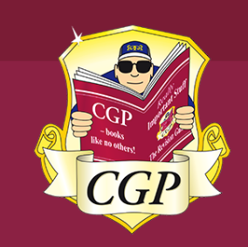
In the run up to our Y6 SATs, we have purchased some homework books for every child. These books will help children develop their reading comprehension skills, grammar and punctuation as well as their mathematical skills.

The GPS homework books have been sent home this week – please take a look at them with your child.

Each week the teachers will set work to complete at home referencing specific pages to complete.

Monday – Grammar homework to be handed in
Wednesday – Maths homework to be handed in
Friday – Reading homework to be handed in

There is still an expectation that children read their own book and fill in their Reading Diary each week.

We appreciate that some children will find this work difficult and we therefore ask that you give your child as much or as little support for them to be able to complete the set tasks as they require. However, they do reflect the correct level of expectation for the year group.

The school has spent a considerable amount of money buying these books so we would really appreciate that the children take good care of them. Unfortunately, we do not have any spare copies in school.

Thank you for your support.

Kind regards

The Y6 Team

