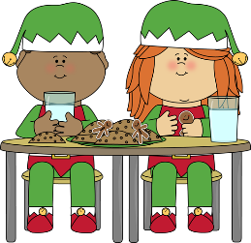
Festive Lunch
On Thursday 8th December, the whole school are invited to take part in a special Christmas Menu as follows:

Roast Turkey, Chipolata, Stuffing & Gravy
or
Quorn Fillet & Vegetarian Sausage
****
Roasted Potatoes
Carrots, Peas or Brussel Sprouts
*****
Christmas Pudding
or
Christmas Biscuit

If you would like your child to have a Festive Lunch, please complete and return the reply form below by Friday 25th November.

Festive Lunch

Child’s Name………………………………………………………………………Class…………………
Child’s Name…………………………………………………………………….. Class………………..
Child’s Name……………………………………………………………………… Class……………….

I would like my child/ren to take part in the special Christmas Dinner on Thursday 8th December.

I have made the payment via Arbor
My child is entitled to the Universal Free School Meal (EYFS and KS1 only)
My child is entitled to a Free School Meal
* Please tick as appropriate

My child has the following dietary requirements……………………………………………………………………………

