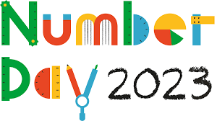

Dear Parents and Guardians,

We are delighted to be supporting the NSPCC by taking part in Number Day on Friday 3rd February 2023.

Everything the NSPCC does protects children today and prevents about tomorrow.

The NSPCC need our support more than ever. By raising money, we can help to fund their vital services such as Childline – the helpline that’s always there for children and young people whatever their problem or concern.
Making maths meaningful
Number Day is a great way to make Maths fun and bring about a positive, ‘can-do’ attitude towards it.

On February 3rd, we will be having a fun day of Maths activities in class – all of our lessons will have a Maths focus and we will be making many cross curricular links. In addition, we will be taking part in Dress up for Digits. Pupils are asked to wear an item of clothing with a number on it (football shirt, cap, netball shirt or even a onesie!). They could be even more creative by dressing in a Maths or Numbers theme – this could even be a ‘Times Table Rock Star!’ To help raise money for the NSPCC, we are asking for a voluntary donation of £1 please pay this via our Just Giving page Numbers Day 2023. Celebrating Number Day 2023 will be a fun, worthwhile day and we would love everyone in the school to take part in this special event.

It all adds up

We’re really looking forward to all the fun of Number Day, and we really appreciate your support. All the money we raise at Ratby Primary School will make an enormous difference to children today and help the NSPCC be there for children tomorrow.

Thank you.

Best wishes,

Mrs Steiner and Mrs Denton

