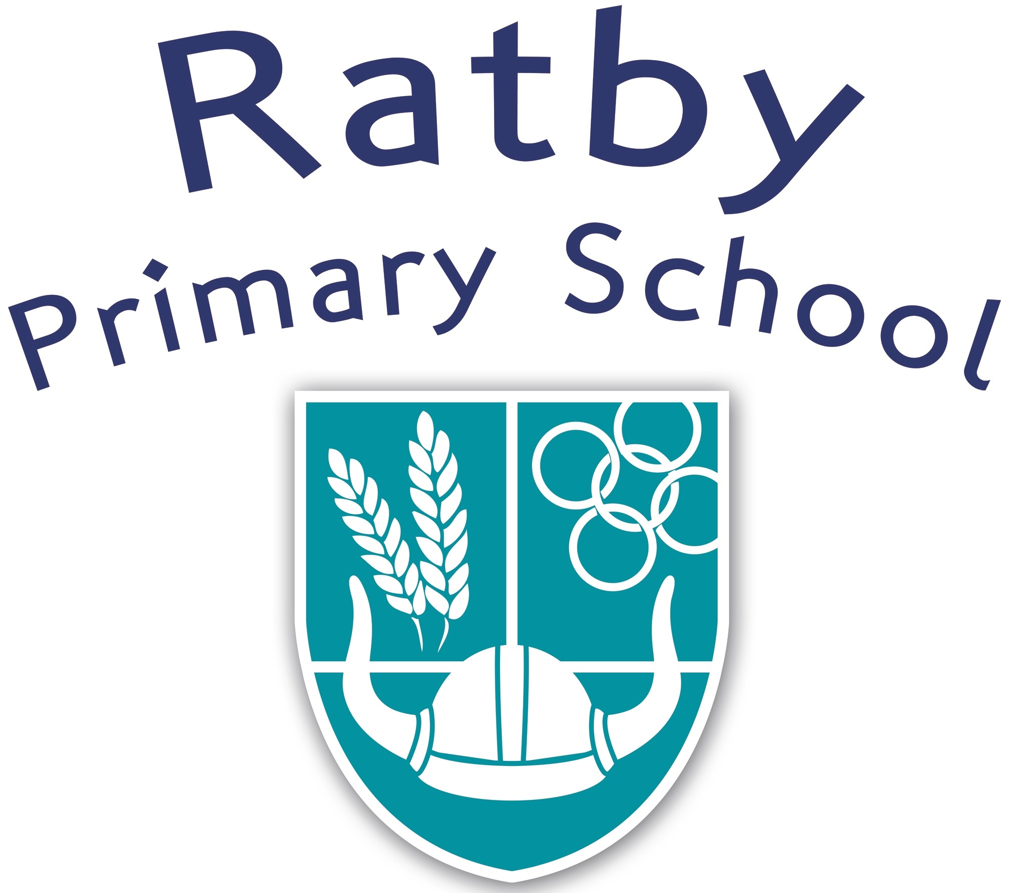

Curriculum Statement

Reviewed | January 2023
Frequency of Review | Annually
Written by | Senior Leadership Team
Approved by: | Headteacher

Curriculum Statement

School Vision, Values and Mission
Mission Statement
Values
Vision
We are committed to being a caring, inclusive school.
We aim to foster a love of learning whilst delivering a first class education - where teaching and learning are exciting, challenging and creative and within a safe, nurturing environment.
We endeavour to promote resilience, empathy, self-awareness, passion, excellence, communication and teamwork.
We aim to assist pupils in developing skills to become independent life-long learners who will succeed and contribute responsibly in the global community.

Resilience

Empathy

Self Awareness

Positivity

Excellence

Communication

Teamwork
Inspiring a love of learning

Our Curriculum

Our aim is to create a nurturing, safe, caring and happy school that provides equal opportunities for all the children in our care.

Ultimately, we want children to leave Ratby Primary as well-rounded individuals who have a strong sense of themselves, their community and the global community. We aim to achieve this through promoting understanding, tolerance and respect for other people’s race, beliefs and cultures.

Our aim is to deliver a curriculum that develops lively, enthusiastic enquiring minds who are able to work independently and solve problems. We enable our pupils to feel pride in their efforts and develop confidence, determination and resourcefulness. We provide a stimulating curriculum, ensuring that our staff are well trained and have a real understanding of how children learn.

We endeavour to enable pupils to achieve high standards in all aspects of the curriculum and help pupils to achieve their true potential. Our school aspires to promote positive relationships, excellent behaviour and polite, well-mannered pupils; where each child is encouraged to make informed choices and develop a healthy life style.

Our curriculum has been developed to: create a nurturing, safe, supportive school with equal opportunities for all. We provide a creative curriculum which inspires and motivates young people to develop their independence and enjoyment for learning.

Our curriculum is designed to ensure that pupils know more and remember more. It has been designed to ensure the following curriculum principles are incorporated consistently:

- units of work are developed in a progressive sequence of learning within each of the National Curriculum subjects so that children build upon previous knowledge and skills where appropriate.
- content is delivered through a range of subject-specific projects, which are planned over 6-8 weeks.
- designed to align with the school’s Teaching and Learning Policy which is based upon a strong understanding of pedagogy and how children learn.
- exposure to a wide range of high-quality reading materials and an abundance of key vocabulary linked to each unit of learning, which children have an opportunity to explore, use and evaluate.
- exposure to a range of wider opportunities and experiences.

Our curriculum is based around the Cornerstones Curriculum, providing a broad and balanced, knowledge-rich primary curriculum.
- Subject-specific projects cover Art and Design, Design and Technology, Geography, History and Science.
- Computing and Music have been designed using content from Kapow.
- PSHE, SRE, RE and PE have been designed using content from Twinkl.

Local Context
- Ratby is a commuter village and civil parish in the Hinckley and Bosworth district of Leicestershire, England, with a population of approximately 4,500.
- It is situated to the west of Leicester, and just south of the M1 motorway between Junction 21 and Junction 22.
- Average house price is £308,591 compared with the National average of £296,000.
- A number of new housing developments have or are taking place in Ratby which have contributed to maintaining the numbers of pupils on roll.
- At the last borough elections, 75% of voters voted for the Conservative Party.
- According to www.police.uk (Nov 2022) The most common incidents of crime are either related to Violence and Sexual Offences; Public order, Burglary and Criminal Damage and Arson.
- Ratby Primary School is the only school within the village. Whilst the majority of pupils do live within the village of Ratby, a number of pupils travel in from further afield.

Map of Enrolled Students
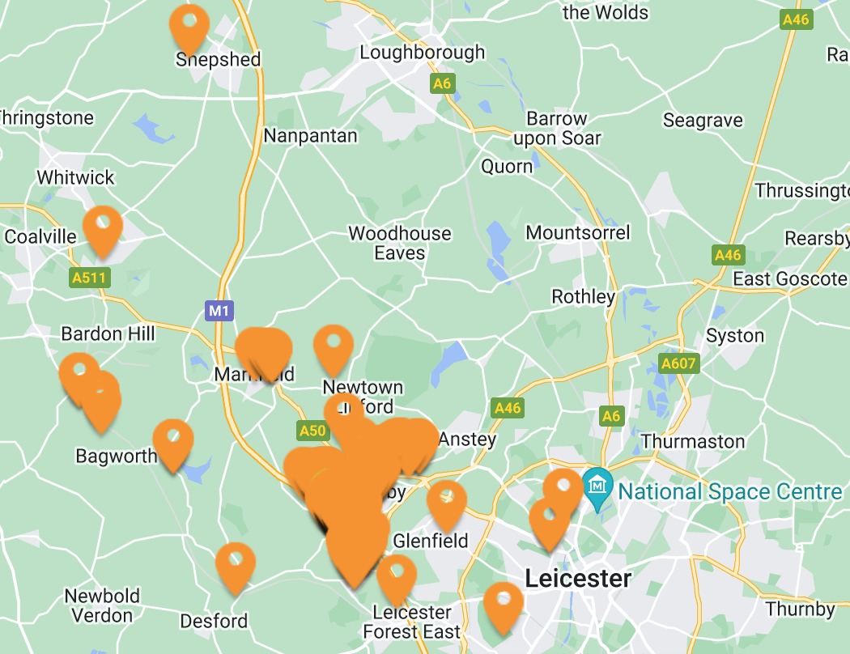

- In the latest index of Multiple Deprivation (2019 IMD) this area was ranked 30,877 out of 32,844 where 1 is the most deprived LSOA. This is amongst the 10% least deprived neighbourhoods in the country.
- The school location deprivation indicator was in quintile 2 (less deprived) of all schools.
- Over the last few years the ethnic diversity of the school has changed from the proportion of White British of 95.6% in 2016 to 87% in 2022 (IDSR info). There are currently 9 ethnic groups within school.
- The percentage of FSM/SEND support and those on an EHCP plan is close to average (IDSR 2022).

Implications for our curriculum design:
- Opportunity to learn about diversity and equality;
- Links to locality should be made where meaningful;
- PSHE curriculum needs to ensure children develop a positive understanding of relationships
Understanding the School’s Values
Our school values are important to creating the ethos which we have at Ratby and their alignment to the curriculum is an essential part of this. Our School Values are: Resilience, Empathy, Self-Awareness, Positivity, Excellence, Communication and Teamwork.
Implications for our curriculum design:
  - Values need to be implemented across the curriculum as well as part of PSHE;
  - Children need opportunity to learn about the school values within different contexts.
Understanding the Children’s Needs
Analysis and observations from a range of sources, have shown us that there needs to be specific elements designed into our curriculum to ensure that it truly meets the needs of the children these include:
- A number of children do not always read widely at home which can also impact on the range of vocabulary which some children present with at school.
- Children are becoming more and more familiar with how to use a range of social median platforms as well as games which can have negative impact upon the children in many ways.
- Children do not always understand their rights but also their responsibilities which they hold not only to ensure their own well-being but also those of the community in which they live whether this be local, national or global community.
- Some children do not have the necessary levels of resilience and independence needed
Implications for our curriculum design:
- Reading must take a priority across the curriculum including the specific teaching of vocabulary and meaning.
- E-safety should be taught fluently across the Computing curriculum regularly and part of every unit. The PSHE curriculum will also include e-safety with a focus on the negative impact of inappropriate use for individuals and society.
- The PSHE curriculum will be taught using the Twinkl scheme as this aligns to the school’s values pertinently.
- Opportunities to develop resilience, perseverance and independence need to be an integral part of the teaching and learning activities across the curriculum
- Curriculum progression documents and knowledge organisers will allow teachers to understand previous learning necessary for a unit of work to commence.

Structure of Curriculum Delivery for each subject
Mini and End of Unit Assessments
Ongoing Retrieval of Knowledge though the unit
Knowledge Organisers for each unit of work

Detailed Medium Term Planning
Subject Units overview for sequence of teaching
Progression documents for each subject
National Curriculum
Objectives for Subjects

Structure of Curriculum Delivery for each year group
Timetable s, planning/
slides produced to deliver curriculum
Progression
Documents for each subject
KO/MTP
adapted where necessary for cohort/
individual
children
Year Group
Long Term Maps

Subject Units Overview for sequence of teaching

Impact of our Curriculum

Through our bespoke curriculum, we endeavour to ensure that all children achieve well in all subject areas regardless of their starting point. We want our children to leave Ratby with the academic skills necessary for their future school journey as well as with a strong understanding of how they can journey forward as safe, prepared and respectful individuals. Our children are provided with opportunities to develop their social, personal and emotional skills as well as their independence and resilience. Ultimately, we want all of our children to be love learning. We will evaluate the impact of our curriculum through:
- Ongoing assessment during and post lessons;
- Use of standardised testing for Reading, Grammar and Mathematics;
- Summative teacher assessments across the curriculum;
- Formative assessments in the wiser curriculum against key knowledge.

