Wednesday 1st February 2023

Dear Parents/Guardians,

On Tuesday 7th February we will be joining schools and youth organisations across the UK in celebrating Safer Internet Day 2023.

Safer Internet Day is a global campaign to promote the safe and responsible use of technology, which calls on children and young people, parents, carers, teachers, social workers, law enforcement, companies, policymakers and more, to help to create a better internet.

Using the internet safely and positively is a key message that we promote in school, and celebrating Safer Internet Day is a great opportunity for us to re-emphasise the online safety messages we deliver throughout the year.

We would be delighted if you could join us in celebrating the day by continuing the conversation at home.

To help you with this, the UK Safer Internet Centre have created some free activities and information
for parents and carers which are available at: https://saferinternet.org.uk/safer-internet-day/safer-internet-day-2023/parents-and-carers. Whether you have 5 minutes to start a conversation or hours to spare, there are top tips, quizzes and films which you can use at home with your child.

Additionally, there is an ‘Online safety advice for parents’ session scheduled on the 7th February 2023 – 7pm to 8pm, which will be delivered by the Regional Cyber Crime Unit within the East Midlands Special Operations Unit. This webinar will go over some of the issues you may be concerned about such as social media safety, online gaming and discussing your child’s online activities with them. It will mainly try to educate you on how you can better protect your children from becoming victims of cybercrime and fraud by following National Cyber Security Centre approved advice. If you are interested, please reserve a spot through https://www.eventbrite.co.uk/e/online-safety-advice-for-parents-safer-internet-day-tickets-511593388597.

If you have any concerns or questions about keeping your child safe online, please do get in touch with your child’s class teacher or a member of our Designated Safeguarding team.

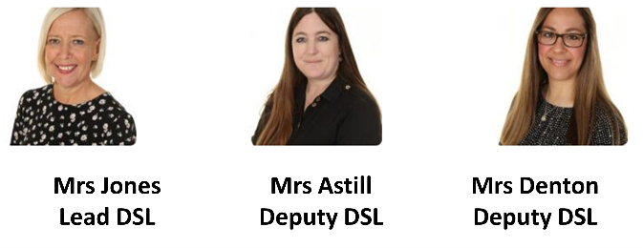
Yours sincerely,
Miss Colbourne
Computing Lead

