Tuesday 14th February 2023
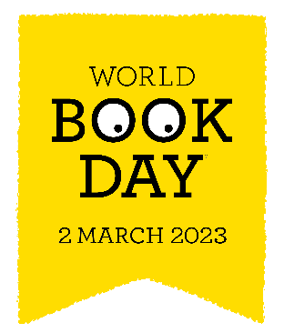

Dear Parent or Carer,

This year, World Book Day takes place on Thursday 2nd March 2023. We would like the children to come to school dressed as a character from a book. Some examples could be: Cat in the Hat, The BFG, Cinderella, Harry Potter and many more.

Throughout the day, we will be celebrating together with our Key Stage assemblies and different reading and writing activities.

World Book Day celebrates the joy and value of books and reading, especially for children.
To help them on their reading journey, every child receives a £1 World Book Day Book Token that can either be exchanged for one of ten special World Book Day books, or used to get £1 off any book costing £2.99 or more. This will come home this week, should you wish to spend it over half term.

You can find your nearest bookseller at:

worldbookday.com/participating-retailers

We’re looking forward to celebrating World Book Day with the children, which could not
happen without the support of parents and carers - thank you.

Mrs Jones
Headteacher

