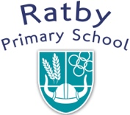

Headteacher: Lisa Jones

Main Street

Ratby

Leicestershire

LE6 0LN

Tel: 0116 2393610

[www.ratbyprimary.co.uk](http://www.ratbyprimary.co.uk)

Email: [admin@ratbyprimary.co.uk](mailto:admin@ratbyprimary.co.uk)

**Reading**

**Newsletter**

**A**

**Newsletter**

**Newsletter**

**AUTUMN TERM 2021**

There has been a lot of excellent reading going on throughout the Autumn term at Ratby Primary school. We would like to introduce you to the Reading Ambassadors for the year 2021-2022. Thank you to all those children who applied for the role but sadly, we could only have one per class.

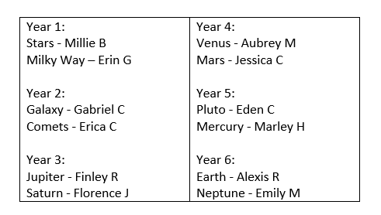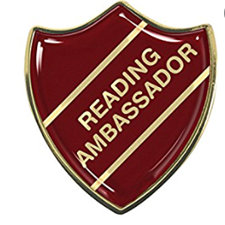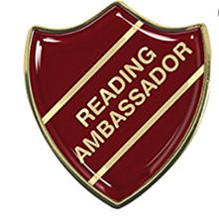**Our Reading Ambassadors 2021-2022 – Well Done!**

**Reading interview with Mr Barber (in year 4)**

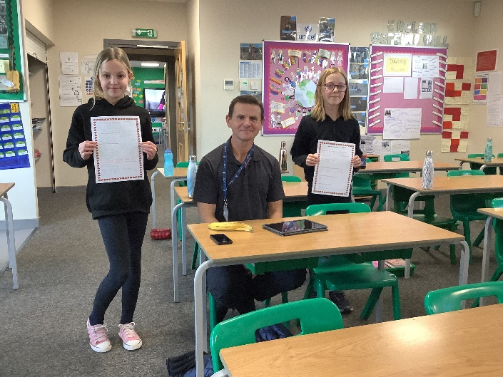Thank you Mr Barber who we interviewed recently. He gave some fascinating answers to our questions and we thoroughly enjoyed listening to him talk about reading. It was a shame that only Y6 Reading Ambassadors could interview Mr Barber – because of Covid we couldn’t all mix and get together as Ambassadors.

**Q: If you had a top three books for children, what would they be?** *‘How the mole got its pockets’ by Eduard Petiska. This was the first book that my dad ever read to me when I was a little boy. Even now it makes me very emotional thinking about my dad and how he would read to me. Another favourite is ‘The Fib and other stories’ by George Layton. I like this story as it is about a bonfire and my dad used to tell stories about when he was a boy and hiding in a bonfire. My final book has to be ‘The Twits’ by Roald Dahl because I like the message that it doesn’t matter what you look like, that the ‘goodliness’ comes out.*

**Q: Who is your favourite author?** *I like David Eddings, he writes fantasy and sci-fi books such as: ‘The Sword in the Storm’ and ‘Midnight Falcon’.*

**Q: Have you got a favourite poem?** *Yes – it is ‘The Race’ by Dr D H Groberg. The poem is about a boy taking part in a cross country race. This also makes me emotional as it is about not giving up and not giving in. Two lines from the poem are:*

**Whenever I start to hang my head in front of failure’s face,  
    my downward fall is broken by the memory of a race.**

**Q: How would you encourage someone to read and what book would you recommend?** *By reading to them. A book of short stories that they can read in one session, not a long story.*

**Q: Why do you think it is important to read?** *Books let you experience another world. Books let you think too. When you are watching TV or a film, you don’t really stop and think, unless you stop the recording. However, with a book, you stop all the time to think and reflect on what you have read. Books let you experience things not in real life – such as climbing Mt Everest or travelling to the Moon and back. I think it is important to visualise pictures and images in your head and to make the time to read and take you to another place.*

**Q: What are some of your favourite words?** *I like adverbs because when we talk, we don’t really use them so often. When we write, we tend to use them all the time. For example, I wouldn’t say “I sensibly entered the room!” but when I write I would use the adverbs. Other favourite words are crocodile, armadillo, elephant, hyperbole. Who thought of the word elephant or crocodile? I also can’t say hyperbole very easily and struggle pronouncing it but I like the word!*

**Q: When in the day do you like to read?** *I like to read first thing in the morning. I try and get up early in order to read. In the past, it has really affected my mind and thinking when reading at this time of the day. When the World is all quiet is when I like to read and I take things in more easily instead of later in the day when I’m wearier and tired.*

**Any other comments about reading?** *I like to read self-help books, about the best way to live your life. When I was in my 20’s, I read ‘Awaking the Giant within’ by Anthony Robbins and I had an epiphany moment – I realized I needed to get serious in life. That was all down to a book! In Japan, even 150 years ago, the majority of the population couldn’t read. During WW2 people started to read and as a consequence the economy and country hugely benefited from reading and sharing information. It is so important to read!*

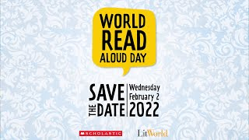Thank you once again, Mr Barber, for your thoughtful and compelling answers.

**Reading Events coming up:**

**World Read Aloud Day:**

**Wednesday February 2nd 2022**

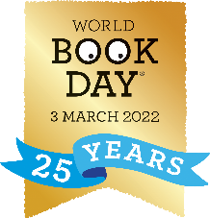

**World Book Day:**

**Thursday 3rd March 2022**