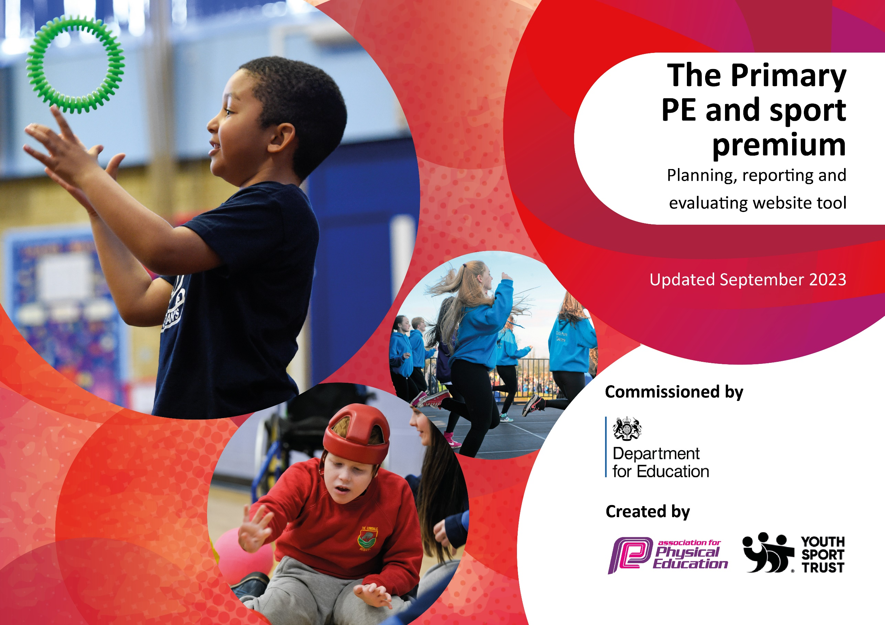

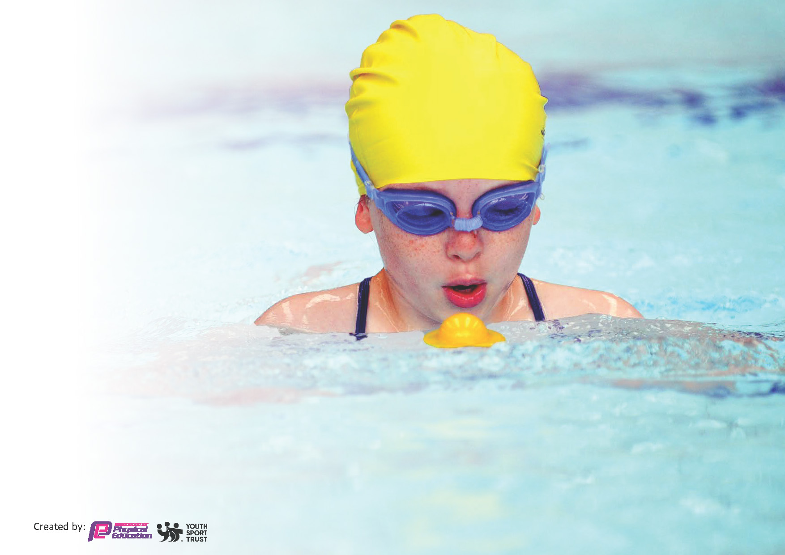
This template can be used for multiple purposes:
by:
- It enables schools to effectively plan their use of the Primary PE and sport premium
- It helps schools to meet the requirements (as set out in guidance) to publish information on their Primary PE and sport premium
- It will be an effective document to support Ofsted inspections enabling schools to evidence progress in Physical Education (PE) and evidence swimming attainment, which forms part of the PE National Curriculum. We would recommend schools consider
the Intent, Implementation and Impact of any spend, as examined within the Education Inspection Framework.

It is important that your grant is used effectively and based on school need.

Schools must use the funding to make additional and sustainable
improvements to the quality of the PE, School Sport and Physical Activity (PESSPA)
they offer. This means that you should use the Primary PE and sport premium to:

- Build capacity and capability within the school to ensure that improvements made now will benefit pupils joining the school in future years
- Develop or add to the PESSPA activities that your school already offers.

The Primary PE and sport premium should not be used to fund capital spend projects; the school’s core budget should fund these. Further detail on capital expenditure can be found in the updated Primary PE and sport premium guidance.

The Primary PE and sport premium guidance, outlines 5 key priorities that funding should be used towards. It is not

necessary that spending has to meet all the key priorities, you should select the priorities that you aim to use any funding towards.

Although completing this template is not a requirement for schools, schools are required to publish details of how they spend this funding. Schools must also outline what the impact this funding has had on pupils’ PE and sport participation and attainment and how any spending will be sustainable in the future. All funding must be spent by 31st July 2024.

The Department for Education has worked closely with the Association for Physical Education (afPE) and the Youth Sport Trust (YST) to develop this template and encourages schools to use it. This template is an effective way of meeting the reporting requirements of the Primary PE and sport premium.
Review of last year’s spend and key achievements (2022/2023)

We recommend you start by reflecting on the impact of current provision and reviewing your previous spend.

Activity/Action | Impact | Comments
Attendance of HABSSA competition and events.  New scooter/cycle rack.  PE/Events notice board in place and regularly updated with latest competitions pupils have taken part in.  Y6 Pupils attended residential visit at Condover Hall | Increased number of pupils taking part in competitions against other local schools.  Increased number of pupils scooting and cycling to school.  Pupils asking about when the next event for their year group will take place. Pupils proud to take part in team events.  Pupils to part in a wide range of outdoor pursuits activities not possible in a school setting. (climbing/kayaking/high rope activities) | Following Covid restrictions, the school has been able to access more competitions and events in 2022-2023.  Rack is full most days.

Key priorities and Planning for 2023/2024 Allocation: £19, 140
This planning template will allow schools to accurately plan their spending.

Action – what are you planning to do | Who does this action impact? | Key indicator to meet | Impacts and how sustainability will be achieved? | Cost linked to the action
Provide PE Lead and Sports Coach with leadership time to promote and organise PE and extra-curricular opportunities for pupil | PE Leads attend Trust Network meetings and HBSSPAN Network meetings.  School buy into HBSSPAN subscription which enables pupils to access wide range of competitions and events as well as other local events. e.g Marconi Football Cup, Area Athletics and Cross Country events. | Participation in inter and intra-school competitions and the promotion of PE within school. | Increased numbers of pupils taking part in intra-schools competitions.  Competitions have been well received by pupils and parents in recent years (22/23) | £940.00  HBSSPAN Buy In  PE Leads will have access to information regarding upcoming festivals, competitions and events that pupils are able to participate in and will be able to plan for school entry into a wide variety of events promoting a wider range of sports
Inspect and replace as necessary any worn equipment / purchase any new resources needed in light of adjustments made to PE provision this year. | All staff and coaches. | Staff are able to carry out all activities planned including warm up. | More pupils meeting their daily physical activity goal, more pupils encouraged to take part in PE and sport activities. | £3,000
CPD for teachers as required. Discuss with staff any training required / gaps in knowledge. | Primary generalist teachers. | Key Indicator 1: Increased confidence, knowledge, and skills of all staff in teaching PE and sport.  Key indicator 5: Increased participation in competitive sport. | Primary teachers more confident to deliver effective PE supporting pupils to undertake extra activities inside and outside of school, including teaching water safety and swimming and as a result improved % of pupil’s attainment in PE.
Support teachers in planning and delivery of two high quality PE lessons every week including gymnastics and dance  Use PE Specialists to ‘team-teach’ with teaching staff to provide high quality lessons and provide CPD opportunities for staff to observe outstanding practice leading to raised standards of attainment in PE | Staff to feel more confident and empowered when teaching the primary PE curriculum as a result of high quality CPD training through Twinkl PE Scheme of Work across school. | Embed new PE Scheme of Work  - Staff training and support  - Teaching and learning, assessment and planning  - Support with inclusion, engagement and developing the school culture  - Tracking system for pupil achievement and progress  - Development of health and well-being  - Competitive opportunities  - Enrichment opportunities  - Whole school self-evaluation tool. | Continue to review, refine PE Long Term Map to ensure it reflects needs of the school. | Twinkl Subscription  Included in main school budget  Metcalfe Sports Coach  £10,450
To offer high-quality lunchtime experiences for pupils, expanding opportunities available for physical activity and school sports for pupils | Through setting up of non-competitive physical activities the number of targeted under-active pupils taking part in physical activity at lunchtime increases  Increased number of pupils choose to engage in range of physical activities at lunchtimes.  Children enjoy lunchtimes due to the range of provision available. Number of lunchtime incidents reduced to do range of activities and adult-led provision on offer.  Staff feel empowered to lead activities which support active lunchtimes, | Continue to deploy lunchtime coaches to support high quality provision at lunchtimes.  Continue to develop lunch time provision to promote active lifestyles and sporting activities.  Additional Coach for 23/24 | Equipment and routines/time tables for pupils to take part in lunchtime activities are now in place and regularly used by pupils. | £4,750
Appoint Sports Ambassadors – Conduct a school survey to share with class regarding current and future provision of lunchtime activities and after-school clubs. | Currently PE Leads hand out Sports Certificates each week and promote/celebrate all Sports Events and raise awareness of worldwide sporting news and events. | Pupils sport ambassadors are in place. | Ambassadors are in place and new ones are appointed each year. They promote upcoming competitions and report on any events that take place or that they take part in.
Consolidate and evaluate the system to support children’s self-evaluation of the knowledge and skills of the PE Curriculum | Knowledge Capture Sheets to be used at the beginning and end of units. Examples collected by PE lead and outcomes shared with staff.

Key achievements 2023-2024
This template will be completed at the end of the academic year and will showcase the key achievements schools have made with their Primary PE and sport premium spending.

Activity/Action | Impact | Comments

Swimming Data
Meeting National Curriculum requirements for swimming and water safety.
Priority should always be given to ensuring that pupils can perform safe self-rescue even if they do not fully meet the first two requirements of the National Curriculum programme of study

Question | Stats: | Further context  Relative to local challenges
What percentage of your current Year 6 cohort can swim competently, confidently and proficiently over a distance of at least 25 metres? | 88% | Transport costs involved in taking children to the nearest pool.  Additional costs involved in swimming coaches.
What percentage of your current Year 6 cohort can use a range of strokes effectively [for example, front crawl, backstroke, and breaststroke]? | 86%
What percentage of your current Year 6 cohort are able to perform safe self-rescue in different water-based situations? | 88%
If your schools swimming data is below national expectation, you can choose to use the Primary PE and sport premium to provide additional top-up sessions for those pupils that did not meet National Curriculum  requirements after the completion of core lessons. Have you done this? | Yes/No
Have you provided CPD to improve the knowledge and confidence of staff to be able to teach swimming and water safety? | Yes/No

Signed off by:

Head Teacher: | Lisa Jones
Subject Leader or the individual responsible for the Primary PE and sport premium: | Lee Barber / Emma Chodynicki KS2 Class Teachers
Governor: | Kat Woodward
Date: | 6.11.2023

