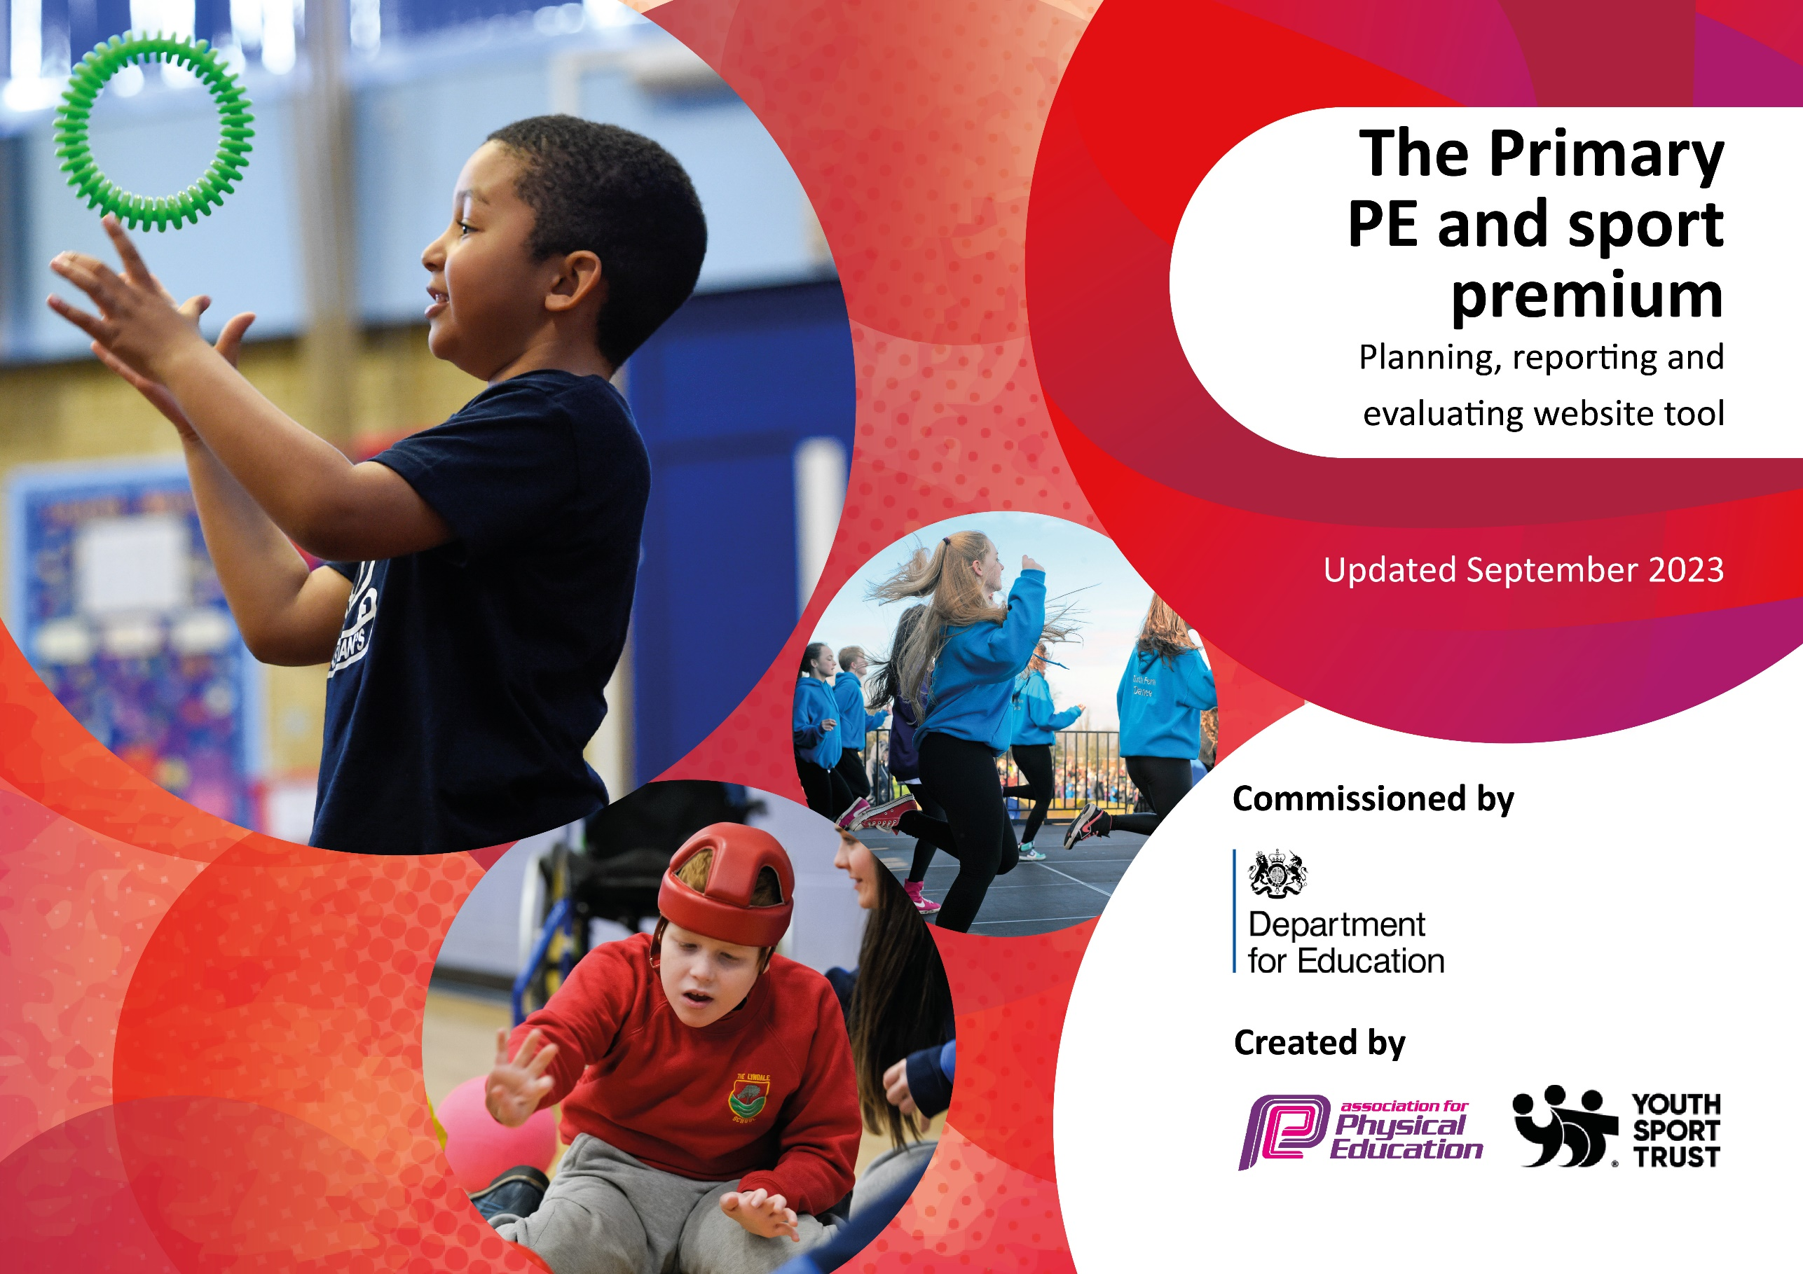

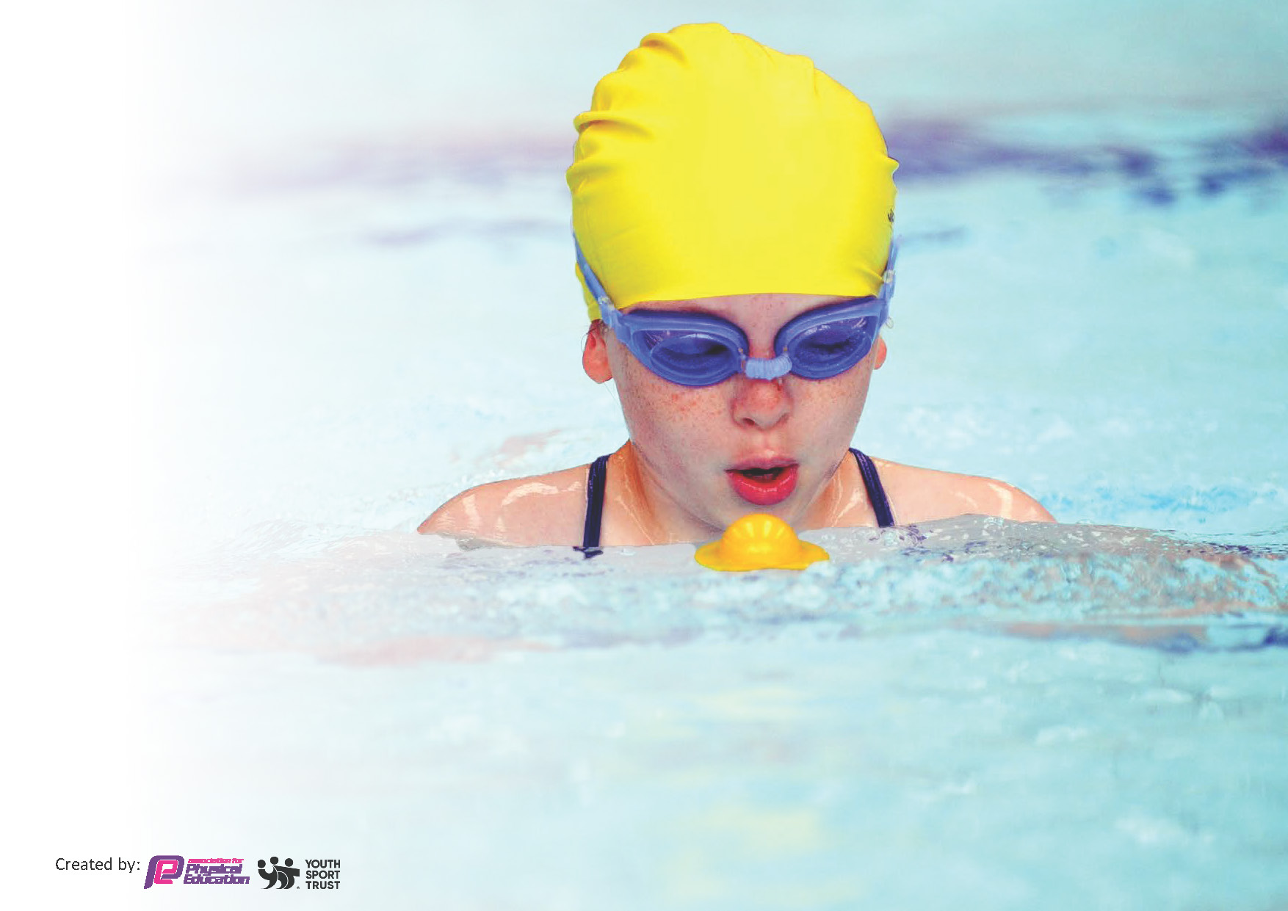
This template can be used for multiple purposes:
by:
- It enables schools to effectively plan their use of the Primary PE and sport premium
- It helps schools to meet the requirements (as set out in guidance) to publish information on their Primary PE and sport premium
- It will be an effective document to support Ofsted inspections enabling schools to evidence progress in Physical Education (PE) and evidence swimming attainment, which forms part of the PE National Curriculum. We would recommend schools consider
the Intent, Implementation and Impact of any spend, as examined within the Education Inspection Framework.

It is important that your grant is used effectively and based on school need.

Schools must use the funding to make additional and sustainable
improvements to the quality of the PE, School Sport and Physical Activity (PESSPA)
they offer. This means that you should use the Primary PE and sport premium to:

- Build capacity and capability within the school to ensure that improvements made now will benefit pupils joining the school in future years
- Develop or add to the PESSPA activities that your school already offers.

The Primary PE and sport premium should not be used to fund capital spend projects; the school’s core budget should fund these. Further detail on capital expenditure can be found in the updated Primary PE and sport premium guidance.

The Primary PE and sport premium guidance, outlines 5 key priorities that funding should be used towards. It is not

necessary that spending has to meet all the key priorities, you should select the priorities that you aim to use any funding towards.

Although completing this template is not a requirement for schools, schools are required to publish details of how they spend this funding. Schools must also outline what the impact this funding has had on pupils’ PE and sport participation and attainment and how any spending will be sustainable in the future. All funding must be spent by 31st July 2025.

The Department for Education has worked closely with the Association for Physical Education (afPE) and the Youth Sport Trust (YST) to develop this template and encourages schools to use it. This template is an effective way of meeting the reporting requirements of the Primary PE and sport premium.
Review of last year’s spend and key achievements (2023/2024)

We recommend you start by reflecting on the impact of current provision and reviewing your previous spend.

Activity/Action | Impact | Comments
Attendance of HABSSA competition and events.  Profile of PE has been raised through PE board and presentation of certificates in assembly to all students who have represented the school and achieved sporting/dance/gymnastics/swimming achievements outside of school.  Use PE Specialists to ‘team-teach’ with teaching staff to provide high quality lessons and provide CPD opportunities for staff to observe outstanding practice leading to raised standards of attainment in PE | Increased number of pupils taking part in competitions against other local schools.  More children are sharing their outside of school achievements in games, swimming, dance, gymnastics, athletics and cheerleading.  Team photos are displayed for all competitions/events where they have represented the school  Staff surveyed at the start of 24/25 year stated gaining increased confidence in the delivery of some games | High demand from students to be able to attend events.  Positive profile of participation has been raised.  For 24/25 year coaches to focus on delivery of outside games, striking and fielding, athletics, and net and wall

Key priorities and Planning for 2024/2025 Allocation: £19,287.25
This planning template will allow schools to accurately plan their spending.

Action – what are you planning to do | Who does this action impact? | Key indicator to meet | Impacts and how sustainability will be achieved? | Cost linked to the action
Provide PE Lead and Sports Coach with leadership time to promote and organise PE and extra-curricular opportunities for pupil | PE Leads attend Trust Network meetings and HBSSPAN Network meetings.  School buy into HBSSPAN subscription which enables pupils to access wide range of competitions and events as well as other local events. e.g Marconi Football Cup, Area Athletics and Cross Country events. | Participation in inter and intra-school competitions and the promotion of PE within school. | Increased numbers of pupils taking part in intra-schools competitions.  Competitions have been well received by pupils and parents in recent years (23/24) | £1.085  HBSSPAN Buy In  PE Leads will have access to information regarding upcoming festivals, competitions and events that pupils are able to participate in and will be able to plan for school entry into a wide variety of events promoting a wider range of sports
Inspect and replace as necessary any worn equipment / purchase any new resources needed in light of adjustments made to PE provision this year. | All staff and coaches. | Staff are able to carry out all activities planned including warm up. | More pupils meeting their daily physical activity goal, more pupils encouraged to take part in PE and sport activities. | £2,900  Large investment in new gymnastics mats and a springboard
CPD for teachers as required. Discuss with staff any training required / gaps in knowledge. | Primary generalist teachers. | Key Indicator 1: Increased confidence, knowledge, and skills of all staff in teaching PE and sport.  Key indicator 5: Increased participation in competitive sport. | Primary teachers more confident to deliver effective PE supporting pupils to undertake extra activities inside and outside of school | Staff time - PE staff surveyed all teachers at the start of the year to assess their confidence with tge curriculum and their ability
Support teachers in planning and delivery of two high quality PE lessons every week including gymnastics and dance  Use PE Specialists to ‘team-teach’ with teaching staff to provide high quality lessons and provide CPD opportunities for staff to observe outstanding practice leading to raised standards of attainment in PE | Staff to feel more confident and empowered when teaching the primary PE curriculum as a result of high quality CPD training through Twinkl PE Scheme of Work across school. | - Staff training and support  - Teaching and learning, assessment and planning  - Support with inclusion, engagement and developing the school culture  - Tracking system for pupil achievement and progress  - Development of health and well-being  - Competitive opportunities  - Enrichment opportunities  - Whole school self-evaluation tool. | Continue to review, refine PE Long Term Map to ensure it reflects needs of the school. | Twinkl Subscription  Included in main school budget  Metcalfe Sports Coach  £ 10,042.25
Investigate new curriculum for 25/26 academic year | Staff were surveyed at the beginning of the year about the PE curriculum. Although responses were generally positive, there were limitations that impacted on the delivery of quality lessons for all students | - Staff to be able to independently deliver all aspects of the PE National curriculum | Staff able to deliver high quality PE lessons without the presence of specialist coaches.  This will lead to greater sustainability as will remove costs of hiring coaches | Get Set 4 PE curriculum to be purchased for 25/26 year from school budget
To offer high-quality lunchtime experiences for pupils, expanding opportunities available for physical activity and school sports for pupils | Through setting up of non-competitive physical activities the number of targeted under-active pupils taking part in physical activity at lunchtime increases  Increased number of pupils choose to engage in range of physical activities at lunchtimes.  Children enjoy lunchtimes due to the range of provision available. Number of lunchtime incidents reduced to do range of activities and adult-led provision on offer.  Staff feel empowered to lead activities which support active lunchtimes, | Continue to deploy lunchtime coaches to support high quality provision at lunchtimes.  Continue to develop lunch time provision to promote active lifestyles and sporting activities. | Equipment and routines/time tables for pupils to take part in lunchtime activities are now in place and regularly used by pupils.  More pupils meeting their daily physical activity goal, more pupils encouraged to take part in PE and sport activities. | £5,150
Consolidate and evaluate the system to support children’s self-evaluation of the knowledge and skills of the PE Curriculum | Knowledge Capture Sheets to be used at the beginning and end of units. Examples collected by PE lead and outcomes shared with staff. | Evidence in Cultural capital books | Pupils have increased retrieval and recall of their PE learning

Key achievements 2024-2025
This template will be completed at the end of the academic year and will showcase the key achievements schools have made with their Primary PE and sport premium spending.

Activity/Action | Impact | Comments
- HBSSPAN extra-curricular activities buy-in  - Equipment replacement  - Use PE Specialists to ‘team-teach’ with teaching staff to provide high quality lessons  - Use of Sports Coaches at lunchtime on a rotating timetable of year groups  - Knowledge Captures | - Pupils took part in a variety of sports competitions including football, dodgeball, cross-country and athletics  - There has been sufficient equipment for all children to take part safely in all PE activities at the same time  - Staff are now more confident in delivering their own PE lessons, especially in outdoor PE  - More children have chosen to take part in physical activities at lunchtime as these have been supervised. A variety of sports have been played so children don’t just play football  - Children are now more aware of the skills that they are learning in each unit of PE and can identify how they have improved year-on-year | Competitions have been well received by pupils and parents, demand outstrips places at all events  Enough gym mats for the lessons but many had become worn and needed replacing  Moving to Get Set 4 Curriculum next year. Teachers will deliver without support from the scheme and PE leads but not external coaches.  Children more active at lunchtime and experiencing competition  Improved retrieval of PE learning across the years  Next year to also focus on key terms for each activity.

Swimming Data
Meeting National Curriculum requirements for swimming and water safety.
Priority should always be given to ensuring that pupils can perform safe self-rescue even if they do not fully meet the first two requirements of the National Curriculum programme of study

Question | Stats: | Further context  Relative to local challenges
What percentage of your current Year 6 cohort can swim competently, confidently and proficiently over a distance of at least 25 metres? | 90%
What percentage of your current Year 6 cohort can use a range of strokes effectively [for example, front crawl, backstroke, and breaststroke]? | 45%
What percentage of your current Year 6 cohort are able to perform safe self-rescue in different water-based situations? | 68%
If your schools swimming data is below national expectation, you can choose to use the Primary PE and sport premium to provide additional top-up sessions for those pupils that did not meet National Curriculum  requirements after the completion of core lessons. Have you done this? | No
Have you provided CPD to improve the knowledge and confidence of staff to be able to teach swimming and water safety? | No

Signed off by:

Head Teacher: | Anne Perry
Subject Leader or the individual responsible for the Primary PE and sport premium: | Trudy Dowson/ Emma Chodynicki KS2 Class Teachers
Governor: | Louise Green
Date: | 10.7.2025

