

RATBY PRIMARY SCHOOL

READING CURRICULUM
2025-2026

At Ratby Primary School, it is our aim for children to nurture a love of books and reading and to learn to read fluently and with understanding. They should have access to quality books that are closely matched to their reading ability throughout the school. Challenging texts are not avoided in our effort to promote reading for pleasure.
This document identifies the planned coverage of reading for each year group.
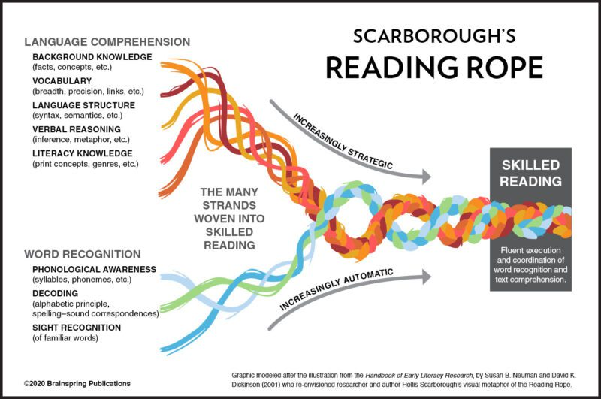
At Ratby Primary, the teaching of reading starts with oracy and phonics. We recognise that systematic, high quality teaching of phonics is essential and this is our focus in EYFS and KS1. We follow the Twinkl phonics scheme and pupils have daily phonics lessons across Foundation Stage and KS1.
Running alongside the teaching of phonics in KS1, we also teaching whole class/guided reading lessons using the VIPERs reading skills.
In KS2, reading is taught through whole class reading lessons which take place every day. Reading lessons in KS2 further develop children’s fluency and prosody and we immerse children in a wide range of texts.
In addition to this, the class novel is used throughout the week as a reading for pleasure activity, where our pupils can hear their teacher read and listen to the chosen text.
Where required, our pupils will continue to have phonics interventions throughout KS2 and have additional support in their reading lessons. Those pupils who are working at a higher level will be challenged with star challenges.
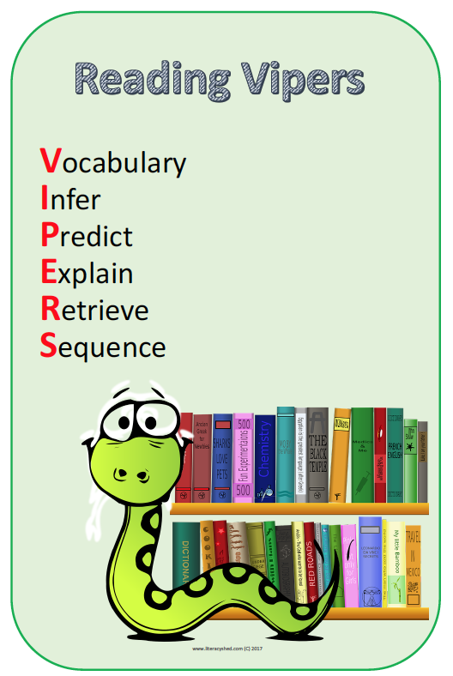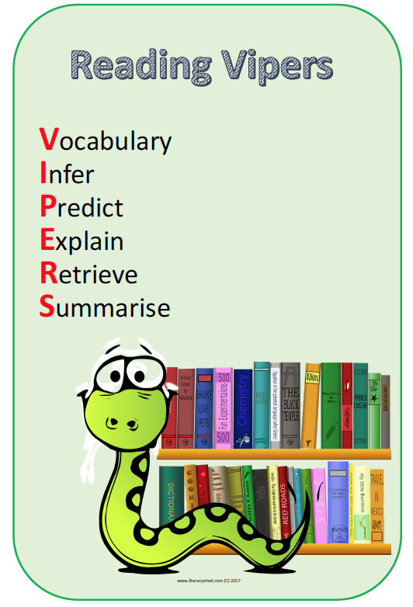
Year 6
Fiction | Non-fiction | Poetry
Pig Heart Boy – Malorie Blackman (CR)  Rose Blanche – Ian McEwan (CR)  Secrets of the Sun King – Emma Carroll (CR)  A Boy called Hope – Lara Williamson (CR)  Journey to the River Sea – Eva Ibbotson (CR)  Room 13 – Robert Swindalls  Ice Fishing text  The Woolly Mammoth text  Marcus Rashford text  Malala text  King Charles III text  Scarecrows text  Joe White text  Tomb Raider text  Dia De Los Muertos text  King of the Sky (No Outsiders)  The Only Way is Badger (No Outsiders)  Leaf (No Outsiders)  The Island (No Outsiders)  Introducing Teddy (No Outsiders)  A Day in the life of Marlon Bundo (No Outsiders | The Last Post - (Keith Campion (CR)  Alan Turing Biography (CR)  Call of the Titanic – Lyndsey Galvin (CR)  Fall off and get back on again – Clare Balding (CR)  Blood heart knowledge organiser  A Child’s War knowledge organiser  Fallen Fields knowledge organiser  Frozen kingdom knowledge organiser  Pharaohs knowledge organiser  Darwin knowledge organiser  The Diary of Anne Frank  William Harvey Biography  WW1 Soldier diary text  Titanic text  A school girl who made history – Ruby Bridges  The man who found the Titanic text  Glaciers text  Alan Turing text  Singing for Freedom text  Tutankhamun text  Charles Darwin text | In Flanders Fields – John McCrae  Dulce est decorum est – Sigfried Sassoon  The Soldier – Rupert Brooke  Range of WW1 poetry  Range of haiku poetry  Range of shape poetry  I am … who I am  The Listeners – Walter de la Mare
Year 5
Fiction | Non-fiction | Poetry
Jazz Harper (fiction – Twinkl)  Mars Achieved (fiction - LiteracyShed)  Maya Civilisation Creation story (fiction – LiteracyShed)  Grandmother (fiction – LiteracyShed)  The Helicidaes War (fiction – LiteracyShed)  James & the Giant Peach Extract (fiction)  Diary of Catherine Parr (fiction – LiteracyShed)  Tudor Time Traveller (fiction – LiteracyShed)  Guilty (Fiction - LiteracyShed)  Boy in the Girl’s Bathroom – Louis Sachar  Holes - Louis Sachar  Beetle Boy – MG Leonard  Street Child – Berlie Doherty  Hatchet – Gary Paulsen  Kenny Livers with Erica and Martina (No Outsiders)  Mixed: An inspiring story about colour (No Outsiders)  How to heal a broken wing (No Outsiders)  The Girls (No Outsiders)  And Tango makes Three (No Outsiders) | Stargazers KO(non-fiction – Curriculum Maestro)  Man on the Moon (non-fiction – DK Guide)  The Moon (non-fiction – LiteracyShed)  Black women of NASA (non-fiction)  Hola Mexico KO (non-fiction – Curriculum Maestro)  The Maya (non-fiction – LiteracyShed)  Maya Cities (non-fiction – LiteracyShed)  Allotment KO (non-fiction – Curriculum Maestro)  Farming in the UK & USA (non-fiction – Curriculum Maestro)  The Problem of Plastic Pollution (non-fiction – Deepening Understanding)  Off with her Head KO (non-fiction – Curriculum Maestro)  Tudor Food & Drink (non-fiction - LiteracyShed)  William Shakespeare (Non-fiction - LiteracyShed)  Hertha Ayrton & Lillian Gilbreth (Non-fiction – women in science book)  Frida Kahlo (non-fiction – Women in Art book)  George Washington Carver (non-fiction – Twinkl) | Space Oddity (poetry/lyrics - Manic Street Teachers)  The Rainforest (poetry - Twinkl)  What’s this (poetry/lyrics – Manic Street Teachers)  The Majesty of Spring (poetry – Twinkl)  Holi Festival (non-fiction – LiteracyShed)  Lost Magic – Brian Moses  The Magic Box – Kit Wright  The Works 4 – Pie Corbett
Year 4
Fiction | Non-fiction | Poetry
Bloom  The storm and the minotaur  Famous legends  Harry Potter Extracts  Diary of a killer cat  Isadora Moon  Firework Maker’s Daughter  Harry Potter extracts  Bear Grylls and the volcano challenge  Frankie vs the Rowdy Romans  The Eagle of Rome  The Secret explorers and the plant poachers  The secret explorers and the smoking volcano  Diary of Illiona  Along came a different (No Outsiders)  Dogs don’t do ballet (No Outsiders)  Red: a crayon’s story (No Outsiders)  Asilfred and Aabert a love story (NoOutsiders)  When sadness comes to call (No Outsiders)  Julian is a Mermaid (No Outsiders) | Knowledge organisers (All topics)  Vipers texts (All topics)  Range of Roman and Greek non fiction books  What if you had animal teeth?  Range of digestive system books  Range of natural disaster and rock books  Newspaper extracts  You wouldn’t want to live without dentists | Macbeth  The Windmill farmer  Mount Vesuvius  Teeth poem

Year 3
Fiction | Non-fiction | Poetry
The Tin Forest  Izzy Gizmo and the Invention Convention  Song of the Dolphin Boy  Dear Greenpeace  Manfish  The Wild Way Home  Stone Age Boy  How to train your dragon  The Legend of King Arthur  The Tunnel  Bear and the Piano  This is our house (No Outsiders)  We’re all Wonders (No Outsiders)  Beegu (No Outsiders)  The truth about old people (No Outsiders)  Super Duper You (No Outsiders)  Planet Omar (No Outsiders) | Can you feel the force?  Dotty inventions  Robots (Hannah Owen)  Forces and Magnets  Gerald A Lawson  Women in Science  Thomas Edison  Balaclava Boy  Greta Thunberg  Wangari Maathai  Shark Fact File  Recycle., Recycle, Recycle  How to wash a woolly mammoth?  Stone Age Bone Age  Nikla Tesla  Famous Landmarks  How Electricity Works  Uses of Electricity  Germonimo  Sitting Bull  Statue of Liberty - Freedom  Viking Long ship  Victorious Vikings fact sheet  How to be a Viking | Candlelight  Molten Metals  James Reeves – The Sea  Journey through the stone age  The Quarry  My Shadow  Rathers  The Longboat

Year 2
Fiction | Non-fiction | Poetry
The Flower  The Pirate Mums  Ruby’s School Walk  The Pirates Next Door  Can I Join Your Club (No Outsiders)  How to be a Lion (No Outsiders)  The Great Big Book of Families (No Outsiders)  Amazing (No Outsiders)  What Happened to You? (No Outsiders)  All Are Welcome (No Outsiders) | Street Detectives knowledge organiser  Towers, Tunnela and Turrets knowledge organiser  Living in a Castle  Beat Band Boogie  The Scented Garden knowledge organiser  Land Ahoy knowledge organiser  Edinburgh Castle  All about Boduim Castle | Winter Parcel  Cobweb Morning  Seasons of Trees  My Music Lesson  The kids poetry club

Year 1
Fiction | Non-fiction | Poetry
Superkid  A Superhero Like You  Super Milly and the Super School Day  Gigantosaurus  The Little Green Dinosaur  Dinosaur Roar  Elliot the Midnight Superhero  Marv and the Dino Attack  Paddington at the Palace  Elmer  Meerkat Mail  Katie in London  Coming to England  The Queen Next Door  Paddington and the Grand Tour  Alan’s Big Scary Teeth  Spider’s Sandwiches  Handa’s Surprise  Handa’s Noisy Night  The Way Back Home  How to Catch a Star  On the Moon  Toys in Space  Man on the Moon  Elmer (No Outsiders)  Going to the Volcano (No Outsiders)  The Perfect Fit (No Outsiders)  The Ten little Pirates (No Outsiders)  My World, Your World (No Outsiders)  Errol’s Garden (No Outsiders) | Superheroes knowledge organiser  Dinosaur Planet knowledge organiser  Fossil books  Mary Anning: Fossil Hunter  Comparing People from the Past Mary Seacole, Florence Nightingale and Edith Cavell  All about Sabre-tooth Tigers  Non-chronological report about dinosaurs  Bright Lights, Big City knowledge organiser  How to Make a Sandwich for a Monster  Dangerous Animals  Paws, Claws and Whiskers knowledge organiser  London Transport  Amazing Animals  Moon Zoom knowledge organiser | Roar  Riddles  Acrostic poems  Free verse poems

EYFS
Fiction | Non-fiction | Poetry
Owl Babies  Goldilocks and the Three Bears  The Three Little Pigs  Superworm  Supertato  The Tiger who came to Tea  Farmer Duck  Winnie the Witch  Cops and Robbers  Not Now Bernard  People Who Help Us  Pirate Pete  Tiddler  The Lighthouse Keepers Lunch  What the Ladybird Heard at the Seaside | Pets  The Cat in a Tree newspaper article  Life Cycle of a Frog  People Who Help Us  You Choose (No Outsiders)  Red Rockets and Rainbow Jelly (No Outsiders)  Hello Hello (No Outsiders)  The Family Book (No Outsiders)  Mommy, Mamma and Me (No Outsiders)  Blue Chameleon (No Outsiders) | Seaside poems

