

Approved:
Review Date: September 26
Responsible Officer: Marie Collins, Director of Education
Personalised by school SENCO: Sally Hurn (September 2026)
Special Educational Needs Policy
Ratby Primary School
POLICY:
Ambitious
Collaborative
Ethical
Stronger Together
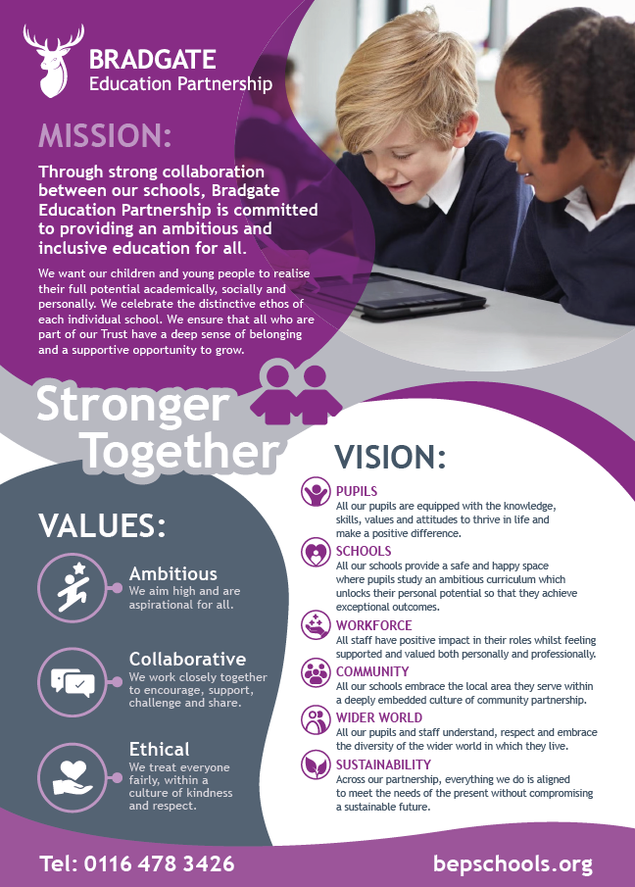
Contents

Section | Title | Page Number
1.0 | Aims | 4
2.0 | Definitions | 4-5
3.0 | Roles & Responsibilities | 5
4.0 | Identification & Assessment of SEN | 6-7
5.0 | Reviewing | 7

Appendices

Appendix | Title | Page Number
Appendix 1

Linked Policies

  - SEN Information Report (updated annually)
  - SEND Code of Practice 0-25 (updated May 2015)
  - Equality Policy & Objectives
  - Safeguarding Policy
  - Accessibility Plan
  - Inclusion Policy
  - Teachers’ Standards (updated 2021)

- Aims

  - All schools within Bradgate Education Partnership share common values and an ethos that every child matters. Our support for all pupils within our care extends to those pupils with additional needs that require assistance to help them fulfil their potential. Ratby Primary School is a mainstream primary school in Leicestershire and is part of The Bradgate Education Partnership group of Primary and Secondary Schools.
  - Our school shall ensure that:
  - the special educational needs of pupils will be addressed and pupils will not be labelled or disadvantaged by any policy or procedure.
  - it works in partnership with parents/carers and appropriate external agencies to support pupils with special educational needs and will use its best endeavours ensure that appropriate provision is secured for any pupil with special educational needs in order to achieve agreed outcomes;
  - it has a qualified Special Educational Needs Co-ordinator (SENCo). At Ratby Primary School the Special Educational Needs Co-ordinator is Mrs Sally Hurn, who is also a Year 1D teacher. Mrs Hurn works part time (2 days class teacher and 2.5 days SENDCo). The SENCO will maintain and regularly review the SEN register held in respective of an individual pupil and co-ordinate support. However, it will be the responsibility of all staff to support individual pupils, to implement strategies suggested by the SENCO and generally be responsible for ensuring that pupils receive provision appropriate to their needs and agreed outcomes; and
  - pupils with SEN engage in the activities of the school alongside pupils who do not have SEND
  - All support provided and decisions taken have regard to these general principles as well as the legal framework set out in the Children & Families Act 2014, the SEND Regulations 2014 and the SEND Code of Practice 2015.

- Definitions

  - Under the Children & Families Act 2014, a child/young person will have SEN if they have a learning difficulty or disability which calls for special educational provision to be made for them.
  - A Child or Young Person will have a learning difficulty or disability if they have:
  - A significantly greater difficulty in learning than the majority of others of the same age; or
  - A disability that prevents or hinders them from making use of facilities that are generally provided for others of the same age in mainstream schools in England.
  - Special Educational Provision is education or training that is additional to, or different from, that made generally for other children/young people of the same age by mainstream schools
- Roles & Responsibilities

  - The implementation of this policy will be monitored by the Local Advisory Board, the Directors of Education and Trust Board and remain under constant review by the school SENCo and Headteacher.
  - Our school will appoint a Local Advisory Board member for SEND, who will support and scrutinise the implementation of this policy.
  - A member of the Board of Trustees will be appointed to monitor the quality and effectiveness of SEN provision across the Trust and work with designated senior leaders to develop the SEN policy and provision.
  - The Headteacher has overall responsibility for the provision and progress of learners with SEND.
  - The SENCO will co-ordinate the school’s approach to SEND provision and will undertake those duties set out in chapter 6 of the SEND Code of Practice 2015.
  - All teachers are responsible for the progress and development of every pupil in their class and will work with the SENCO and support staff to ensure the “assess, plan, do, review” cycle is appropriately implemented to support any pupil with SEND.
  - Our school will work in partnership with pupils, teachers, parents/carers and, where appropriate, other external agencies to ensure that individual learning needs are addressed within the context of the school curriculum.
  - Parents/carers of SEN pupils will be able to discuss the needs of their child with their child’s Class Teacher, or the SENCO.

4.0 Identification & Assessment of SEN

  - Information about previous special educational needs will usually accompany pupils upon entry to the school and this will be used by the SENCO to make sure appropriate provision is continued.

  - The identification of SEND is built into the overall approach to monitoring the progress and development of all children. Class teachers will assess each child’s skills and levels of attainment on entry, building on information from previous settings, or class teachers. This information is collated from the transfer of school files from the previous school or early years setting and during transition meetings which are held with all the early years settings, in the summer term, before students start at the academy. If necessary, a strategy plan will be drawn up for each student with SEND and those with funding. If necessary, additional transition support will be put in place to support a student with SEND. Class teachers make regular assessments of progress for all children identifying in particular where children are making less than expected progress given their age and individual circumstances. Where a child’s progress is causing concern, this may be characterised by progress which:
- is significantly slower than that of their peers starting from the same baseline
- fails to match or better the child’s previous rate of progress
- fails to close the attainment gap between the child and their peers
- widens the attainment gap

It can include progress in areas of need – for instance where a child needs to make additional progress with wider development or social needs.
  - On entry to Early Years Foundation Stage, pupils are assessed with a Baseline Assessment and the data from these tests is then analysed by the SENCo, Head Teacher and EYFS Teachers to identify any potential areas of need. After a discussion with parents / carers and if appropriate, a period of time for settling into school, pupils may then be added to the SEN Record in line with the Code of Practice guidance for SEN.
  - Ongoing identification is also completed alongside the school reporting process as data is collected and analysed in all subject areas by the Class Teacher, SENCO, SLT and The Head Teacher. If a pupil has not made expected progress then interventions will be put in place regardless of need. If a member of staff identifies a pupil whose special educational needs are not met by quality first teaching, then the class teacher will work with the pupil setting clear targets and providing greater adaptations. If the situation improves then no further action is needed. If there is no improvement the SENCO will be informed.
  - At this point information will be gathered. The class teacher will inform the parents about the issue and there will be consultation and discussion around the proposed additional support for the pupil. Parents, and the pupil where appropriate, will be involved in sharing information and agreeing outcomes. It will be decided whether it is appropriate to further monitor the pupil. A plan will be drawn up by the SENCO and Class Teacher with copies shared with all staff concerned with the pupil’s progress and parents.
  - If a parent/carer has a concern about their child regarding SEN, they should contact the SENCO, who will undertake investigations and appropriate assessments (with input from their Class Teacher) to see if they are achieving expected levels of progress. If the pupil is not making appropriate levels of progress, then internal support will be implemented in accordance with paragraphs above. Any initial concerns should be discussed with the child’s Class Teacher at first.
  - In all cases, where internal support is not effective in supporting the pupil, relevant specialist referrals will be completed with the parents’ knowledge and information and strategies for support shared with all staff.
  - Whenever special educational provision is being made, parents and pupils will be involved in developing and reviewing support plans/strategies.
  - All staff teaching pupils on the SEN register will be made aware of the individual needs. The SENCO will help teachers when required to develop techniques to support adaptations and ensure that appropriate resources are available.
- Reviewing

  - All pupils regardless of needs are set targets. Data collated during the school reporting process is analysed and strategies are put in place to support those that are not achieving as expected. All SEN interventions delivered outside the classroom have Specific, Measurable, Achievable Targets (SMART) set to ensure that progress is made. These are recorded using Provision Mapping Learning Plans and are monitored and reviewed against a time frame, agreed within the plan. If expected progress is not made, then the SENCO may refer to a specialist service.
  - If a pupil has an Educational Health Care Plan an annual review is held in accordance with legal requirements.
  - If, as a result of appropriate progress, a pupil may be removed from the SEN register. The pupil will continue to be monitored by the SENCO and teachers.

