If you are being bullied

Do …

- Use eye contact and tell them to go away.
- Ignore them.
- Walk away.
- Act as though you don’t care what they say or do.
- Remember it is NOT your fault and you are NOT alone.
- Make sure you tell someone you can trust who can help.
Don’t
- Do what they say.
- Look upset or cry.
- Get angry.
- Hit them.
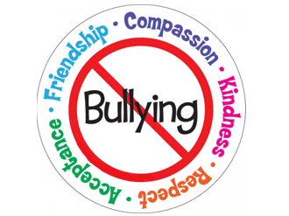

Where can I go?

If you need a friend to play with or someone to talk to, we have Anti-Bullying Ambassadors in the playgrounds who will always help.

Mrs Clarke is our Anti-Bullying Lead and you must always let a trusted adult know what is happening if you think you are being bullied within school or outside of school and they will help you.

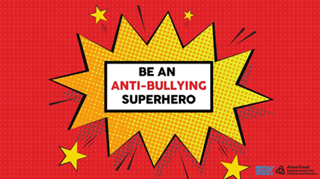



Child Friendly
Anti-Bullying Leaflet



Anti-Bullying Lead: Mrs Clarke

Anti-Bullying Governor: Reverend Bampton

Written in partnership with
the Anti-Bullying Ambassadors

What is bullying?

At Ratby Primary School, we think bullying is someone who hurts somebody more than once, by using behaviour which is meant to hurt, frighten, or upset someone.

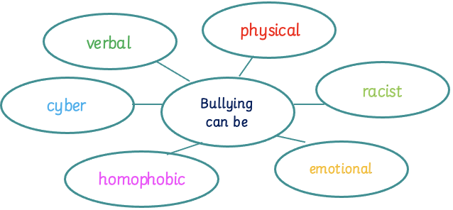

This could be

Physical: hitting, kicking, punching, spitting, pushing

Verbal: teasing, name-calling

Emotional: hurting people’s feelings, leaving them out,

Cyber: through texts, email, social media, online gaming

Racist: calling you racist names, making offensive comments about where you come from, your religious beliefs or how you look.

Homophobic: calling you gay, commenting on your sexuality

Who can I tell?

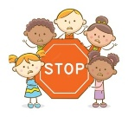
Who can I tell?

S Several S Start

T Times T Telling

O On O Other

P Purpose P People
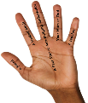
Remember your 5 Trusted Adults can help you too

We can only change the situation if we know about it.

Teachers will get involved to help to end the problem. They will speak with all the children involved and work to find a way to change the behaviour.
Parents could be contacted and there will be consequences for their actions but we will focus on restorative counselling and building positive friendships.

What should I do if I see someone else being bullied?

- Don’t walk away and ignore the bullying.
- Let the teacher or a trusted adult know what is happening.
- Tell the bully to STOP if it is safe to do so.
- Don’t stay silent or the bullying may keep happening.
- Make sure you tell someone you can trust who can help.

