Signs a Child May Be Experiencing Bullying
Children often keep worries to themselves, but certain changes in behaviour may suggest they are struggling. Possible signs include:
- Reluctance to go to school, or suddenly asking to stay home
- Frequent tummy aches or headaches with no clear cause
- Worry or distress on Sunday evenings or after school holidays
- Becoming more quiet, withdrawn, or unusually upset
- Changes in behaviour, such as acting out, getting into trouble, or losing confidence
- Damaged or missing belongings
- Appearing upset after using their phone, tablet or computer
- Leaving for school much earlier or later than necessary
- Difficulty sleeping, nightmares, or signs of sadness or anxiety

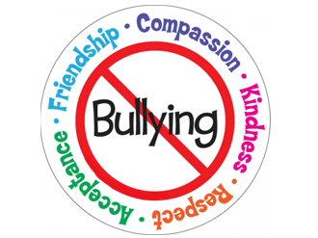
These behaviours may have many causes, but they can also be a sign your child is struggling with bullying or social difficulties.

Your child’s wellbeing always comes first.
Our school follows a clear 3-step process when dealing with bullying. Children, staff and parents are encouraged to report concerns straight away using worry boxes or by speaking to a trusted adult. Incidents are investigated thoroughly, with both the child affected and the child displaying the behaviour spoken to. If bullying is confirmed, parents are informed, restorative work is carried out and support is offered to everyone involved.

We work proactively to prevent bullying by teaching children about kindness, safety and respect through PSHE lessons, assemblies, special themed weeks and trained pupil ambassadors. Staff receive regular training, children are encouraged to speak up and all concerns are monitored closely to maintain our zero-tolerance approach to bullying.

If you notice any of these signs or have any concerns at all, please speak to us. At Ratby Primary School, we take bullying seriously and work closely with families to support children quickly and sensitively.
You know your child better than anyone, so if you notice changes in their behaviour, mood or daily habits, it may be worth checking in with them and speaking to school for support

Parent Friendly
Anti-Bullying Leaflet

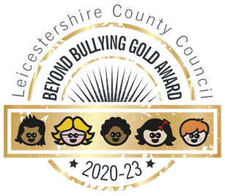

Anti-Bullying Lead: Mrs Clarke

Anti-Bullying Governor: Reverend Bampton

Written in partnership with
the Anti-Bullying Ambassadors

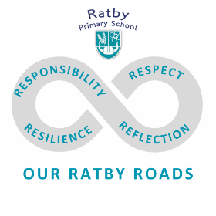
At our school, we want every child to feel safe, valued and able to enjoy their learning each day. Building a positive and caring school community is at the heart of what we do.
Life isn’t always easy and we know that during their school years, some children may experience or witness bullying behaviour. This can be worrying for both children and parents and it’s something we take very seriously.
Understanding what bullying is—and what it isn’t—helps us work together to prevent problems, support children effectively and take action when needed.
By recognising the signs of bullying early and keeping open communication between home and school, we can ensure that every child feels protected, confident and listened to.
Our aim is to support children in developing empathy, kindness, and respect for others, so they can build strong, healthy relationships throughout their time in school and beyond.

What Is Bullying?
The Anti-Bullying Alliance defines bullying as:
“The repetitive, intentional hurting of one person or group by another person or group, where the relationship involves an imbalance of power.”
In everyday terms, this means:
- Bullying happens on purpose
- It happens more than once
- One child or group has more power — this could be physical strength, social status, or confidence
- Bullying can be physical, verbal or emotional
- It can happen in person or online
Who can they tell?

We encourage children to share their concerns with their trusted adults - our hand becomes our reminder of who are adults are
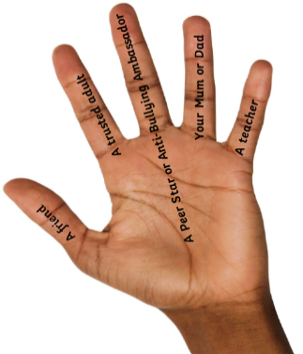
Remember your 5
Trusted Adults can
help you too

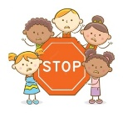

Banter or Bullying?

Helping Children Understand the Difference
Children—especially as they grow and experiment socially—often tease each other in playful ways. This is known as banter and when it’s done kindly, it can be a normal part of friendships.
Banter should be:
- friendly
- fun for everyone involved
- equal and “back and forth”
- not meant to hurt anyone
Sometimes, however, banter can cross the line. Children (and even adults!) may get it wrong and say something that upsets someone. What matters is how they respond once they realise the other person is hurt.
If a child:
- continues after being told to stop
- teases in a way that is not playful
- uses the situation to embarrass or hurt someone
…then it may no longer be banter. It may be unkind behaviour, and if it is deliberate, repeated and involves a power imbalance, it could be considered bullying

.

