

Anti-Bullying Policy
2025

Reviewed | September 2025
Frequency of Review | Annually
Adopted by LGB
Written by | Anne Perry
Approved by: | Local Advisory Board





Aims and Objectives

Pupils at Ratby Primary School will be educated in an environment, which promotes high standards of teaching and learning. In order to achieve a good working environment, our school expects high standards of behaviour throughout the school day. When pupils have problems they must feel confident to tell an adult and know what action will be taken.

Bullying is the planned desire to hurt, upset, threaten or frighten someone else repeatedly. Bullying is anti-social behaviour and affects everyone. It is unacceptable and will not be tolerated. Only when issues of bullying are addressed will all pupils be able to fully benefit from the opportunities available at school.

Doing nothing is the worst reaction to being told about bullying. It causes the targets more pain, without resolving their problems and may suggest tacit approval to the child with bullying behaviour. Everyone at Ratby Primary School is committed to ensuring that all who meet and work on our school premises will feel safe and secure.

All staff within school regardless of their role will be issued with a guidance handout and training relating to bullying, recognising a cry for help and dealing effectively with any child who has reported an incident. All staff are committed to ensuring that all pupils feel safe at school and that their concerns are being addressed and validated.

It is recognised that the Head Teacher and Local Advisory Board have a statutory responsibility for school behaviour and discipline, but that all members of the school community accept collective responsibility for the successful implementation of this policy, including the pupils themselves.

Definition of Bullying

Bullying is present to a greater or lesser extent in all institutions. All members of the school community deserve the right to feel valued, equal and respected and be able to come to school or work without fear. Therefore, this policy applies to school children and staff.

Bullying is different from other kinds of unacceptable behaviour because it has a serious effect on a person’s self-esteem, emotional and mental health, which in turn prevents them from developing their full potential and can seriously affect their life chances. Equally the whole school community and bystanders have a duty to be mindful of situations and to act in line with this policy.

Our school’s definition of bullying is:

Bullying is the repetitive, intentional hurting of one person or group by another person or group, where the relationship involves an imbalance of power. It can happen face to face or online
We talk about it being:
- hurting another person, or group, on purpose, more than once.
- involving using violence, hurtful words or ganging up to make another person feel helpless.
- face-to-face or through the Internet.
We explain this to the children as ‘Several Times On Purpose’ and encourage children to ‘Start Telling Other People’.

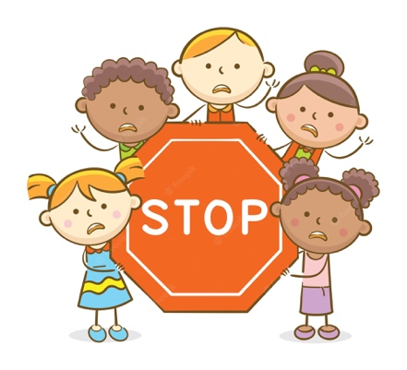
- Different Types of Bullying
There are a number of different kinds of bullying but is it not limited to:

Physical: Hitting, kicking, stealing, hiding belongings, anything physically unpleasant.

Verbal: Name-calling, insults, religious taunting, offensive remarks, teasing, using language, which is threatening, coercive, racist, sexist, homophobic. This includes attacks on non-English speakers, SEN pupils and those with a disability.

Emotional bullying: rumour spreading, malicious gossip, extortion, coercion of the harmed into acts he/she does not wish to do, intimidation, initiation or hazing violence, ostracising, spreading rumours or stories, graffiti, threatening or obscene gestures, inciting others to be unkind, excluding, isolating or ignoring another pupil.

Cyber: All areas of the internet such as email and internet chat room misuse, mobile phone threats by text messages or calls, misuse of associated technology i.e. camera and video facilities.

Instigators may use different pretexts as the basis of their bullying, including the nine protected characteristics (age, disability, gender reassignment, marriage and civil partnership, pregnancy and maternity, race, religion or belief, sex and sexual orientation – See Appendix 1 Equality Act Poster)

Brief definitions: types of prejudice-related bullying (as referred to in our Equality/Behaviour and E-safety policy - https://www.ratby.bepschools.org/our-school/policies/ ) could be considered as:#

Bullying based on disability (disablist) – is where the motivation for bullying behaviour is based on the target’s real or perceived disability, special need, gifted or talented or health conditions or association with someone in those categories or association with someone with a disability/special need.

Bullying based on gender reassignment (transphobic) – is when the motivation for bullying behaviour relates to the target being trans, or perceived to be trans, or their gender or gender identity being seen as different to typical gender norms. A person could also be targeted because they have a trans family member.

Bullying based on race or ethnicity (racist) - is where the motivation for bullying behaviour is based on the target’s actual or perceived skin colour, culture, language, ethnicity or national origin. A person could also be targeted because of their association with someone with the protected characteristic of race.

Bullying based on pregnancy or maternity – is where the motivation for bullying behaviour is based on the grounds of actual or perceived pregnancy or maternity. A person could also be targeted based on their association with someone with the protected characteristic of pregnancy or maternity.
(N.B. this definition is for use in secondary school policies only)

Bullying based on religion or belief – is where the motivation for bullying behaviour relates to the target’s beliefs, faith, or identity. It may also be because of a perception or assumption about religion, belief or lack of belief (which may or may not be accurate), or because of their association with an individual or group of a particular religion or belief.

Bullying based on sexual orientation (homophobic or biphobic) – is where the motivation for bullying behaviour is based on the target’s sexual orientation, or perceived orientation, or that of their family/friends and/or homophobic/biphobic abuse and language used. Bisexual people may experience homophobic bullying, but they are also likely to experience biphobic bullying.

Bullying based on sex (sexist) – is where the motivation for bullying behaviour is based on sexist language, attitudes and behaviours that when expressed demean, intimidate or harm another person because of their actual or perceived sex or gender. A person could also be targeted because of their association with someone with the protected characteristic of sex.

Definitions for other forms of bullying

Bullying based on appearance or health conditions – is where the motivation for bullying relates to the target’s physical appearance (e.g. hair colour or clothing), or a health condition (e.g. a disfigurement, a traumatic injury, or severe skin condition).

Bullying based on weight is where the motivation for bullying behaviour related to a target’s individual weight or size. It can also stem from negative stereotypes and biases about weight.

Bullying based on home circumstance – is where the motivation for bullying is based on the target’s living arrangements (e.g. being a young carer or a child in care), geographic locality (i.e. where they live), their class background, whether they are from a low income family or in receipt of free school meals.

- How we proactively reduce incidents of bullying in school

As a school, we are determined to eradicate bullying of any kind. Bullying can sometimes be misunderstood as ‘falling out’ with other pupils, or a one-off disagreement so it is the job of the whole school to ensure that children understand what bullying is. We are a listening and telling school. This is the message that will be promoted at all times and with all audiences. There is an agreed collective responsibility to address any incidents of bullying observed. Throughout the year as a minimum, we invest time in the list below to achieve this.

- Weekly PSHE lessons and more specifically taught units to support children in their understanding of bullying

- Schools Assemblies that share with the whole school the Anti Bullying message.

- Participate in the National Anti-Bullying Week (November) and The “Beyond Bullying” Award Scheme (last awarded in 2023).

- Internet Safety Week to make children aware of the dangers of cyber bullying.

- Train Behaviour Ambassadors to support our children in the event of bullying.

- Train Anti-Bullying Ambassadors to support our children in the event of bullying.

- Anti-bullying training for Governors and relevant staff plus in house staff training to ensure school adults are aware and kept up to date with the guidance on bullying.

- Within school, we actively promote a culture where children can ‘tell’ in a supportive environment, without fear of reprisals. We use PSHE, mindfulness and resilience techniques to help promote this philosophy.

- This policy will be discussed with all pupils and be made available to parents on request. This is to ensure that all pupils understand the school’s policy of zero tolerance of bullying and their role in making it a success.

- The School Council will include bullying as an agenda item regularly.

- On a daily basis numerous, structured, lunchtime activities for all pupils to participate in will be provided.

- Incidents will be logged and monitored on a termly basis by the Head Teacher. The information will be given to the Governing body each term as part of the Head Teachers Report and shared with members of the teaching staff as and when deemed appropriate

- What is our approach to dealing with an allegation of bullying?

Our 3-step response to bullying aims to ensure a consistent, restorative and effective approach to responding to bullying incidences.
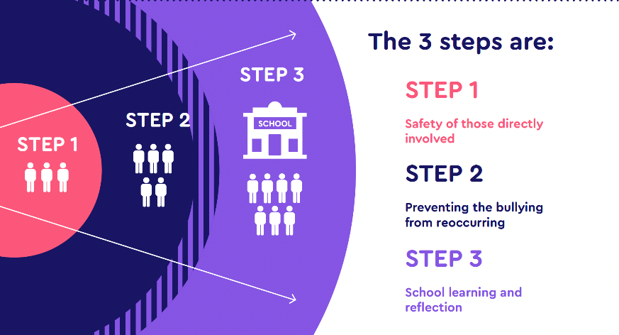

- All pupils, parents, members of staff and volunteers must report allegations of bullying, including cyber-bullying issues, to a member of the teaching staff. Pupils are encouraged to talk to their parents or their trusted adults who can champion their concerns. All classrooms use worry boxes or monsters, which children are encouraged to use should they require a non-speaking route to report an incident. Any bystander who witnesses an incident of bullying will be encouraged to tell an adult in school (or their parents) so that the bullying can be out in the open. The child making the allegation will be spoken to obtaining the details in a factual way.

- The perpetrator will be spoken to at length to ascertain details and facts. They must be asked to tell the truth and if they do not own up, further investigations must take place. If the allegations are founded, it will be made clear to the perpetrator/s that bullying is not tolerated at our school. Parents will be informed of any allegations. Opportunities will be given to resolve the situation between the children involved and appropriate sanctions will be put into place in line with the school’s behaviour policy.

We aim to employ restorative strategies which could include the following approaches depending on the circumstances, which are followed up afterwards ‘checking in’ on both parties.

Support groups
Mediation by adults
Mediation by peers
Inclusion Team Support/ELSA
Social Skills groups
Antibullying Ambassador representation

When talking about the incident we will use the following language:
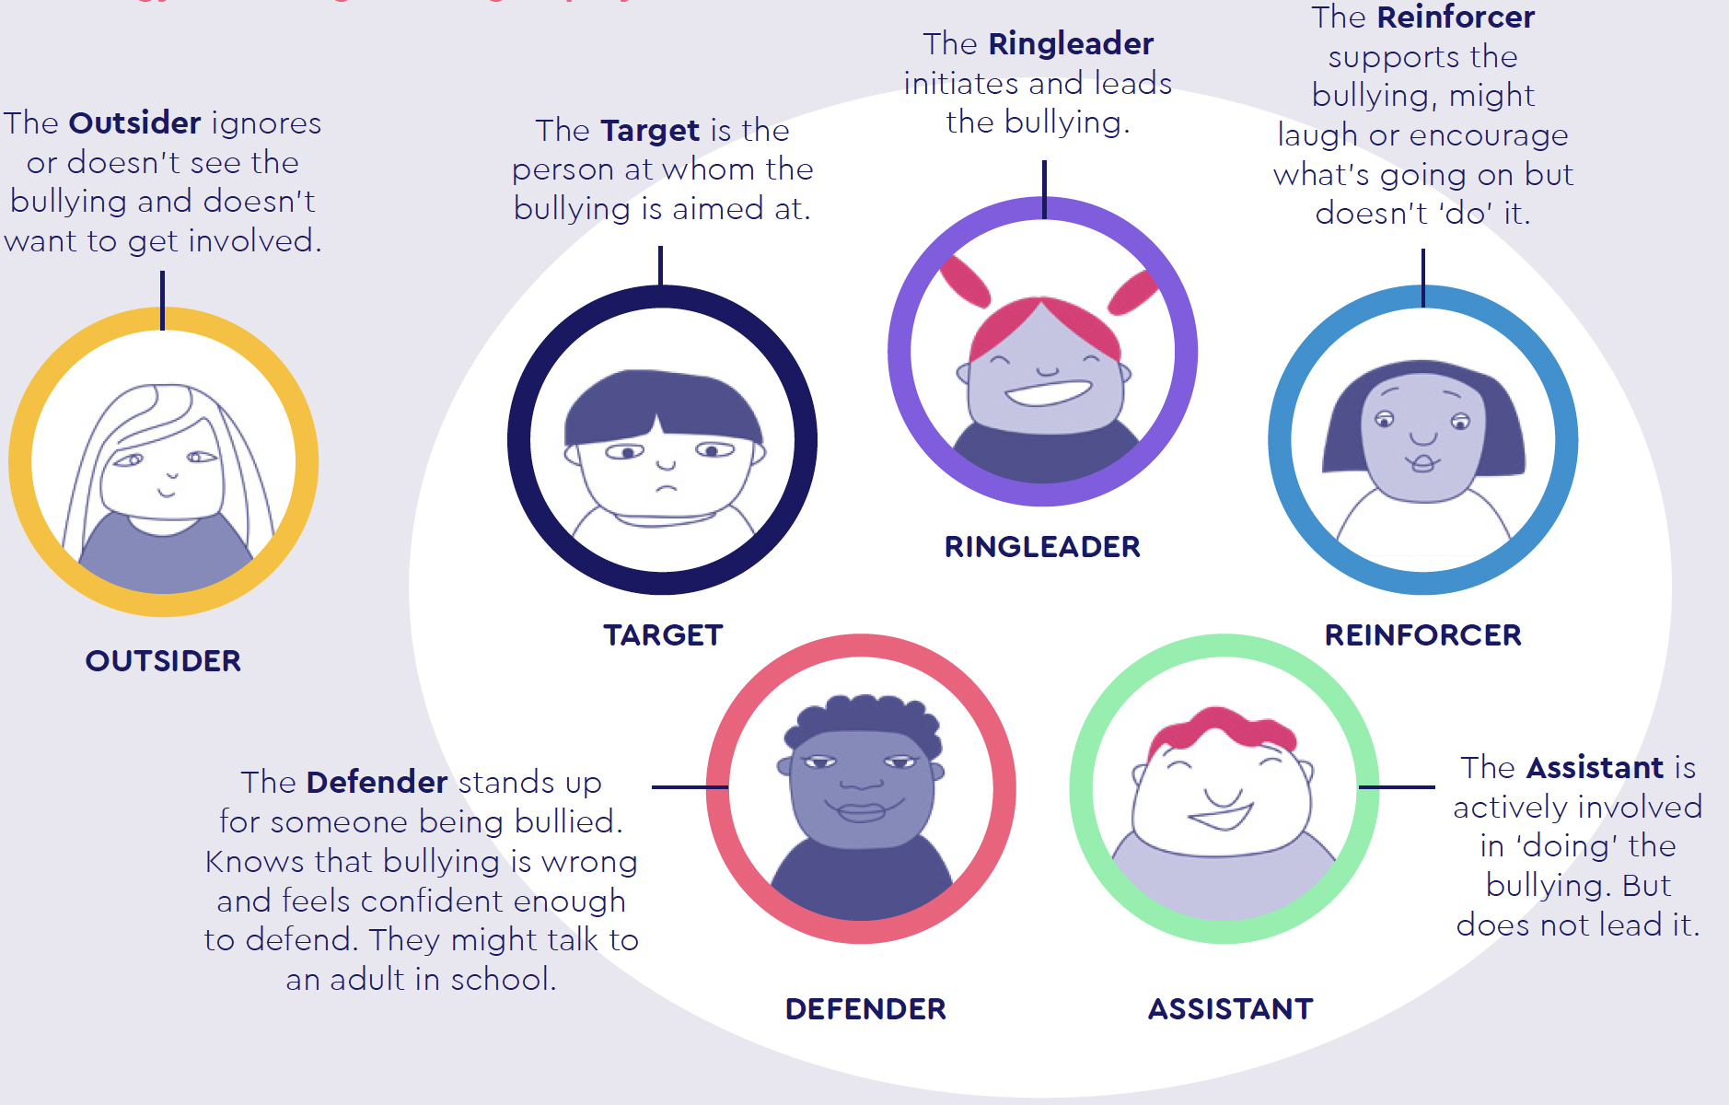
- Procedure for Reporting and Dealing with an Incident
6a. The procedure for a child reporting a possible bullying allegation is as follows:
If any child feels concerned about any issue of bullying, they can approach any adult in our school to report the incident either verbally or in writing if this is preferred. They may feel happier being accompanied by a friend to do this.
If any child or adult sees an incident that they feel constitute bullying, then there is an
expectation that this will be reported to the class teacher initially.

6 b. Parents should, first and foremost, be familiar with the definition of what bullying is and the different types of bullying that can occur. Communication between home and school is key for the school to the identification and prevention of bullying. By supporting the school and their policies, and by informing school if there are any concerns, it means that situations and incidents can be dealt with swiftly and appropriately. Encouraging their child to speak to staff at school if they are worried about bullying will develop positive relationships and ensure that children feel safe and secure.

The procedure for a parent reporting a possible bullying allegation is as follows:
- In the first instance speak to your child’s class teacher. Please do not confront a child yourself.
- Ensure you speak regularly to the class teacher to be informed about how the above investigation is going.
- Keep communicating any further incidents with the class teacher by helping your child to keep a log of any incidents they perceive as bullying over a period of time (normally 3 -4 weeks) – Remember bullying is not often solved overnight.
- Be prepared for a meeting with the other parents
- If you are not satisfied with the outcome refer to a senior member of staff (Headteacher, Deputy Headteacher, Assistant Headteacher) in the first instance.

6c. The procedure for a teacher investigating a bullying allegation is as follows:
  - The class teacher will talk to both the alleged target and the alleged perpetrator(s). A clear and precise account of what has occurred will then take place and supporting statements from any witnesses will be taken.
  - The class teacher will record allegation on Arbor (as a behaviour incident)
  - Following the investigation, the class teacher will decide if the situation is bullying, a one-off incident or a general falling out – seek SLT guidance if required.
  - If it is deemed a bullying incident always inform the Headteacher and the parents of both target and perpetrator(s) – this could be done separately or in a joint meeting depending on the nature of the bullying.
  - If it is deemed a bullying record on Arbor under the category of ‘Bullying’.
  - Any pupil who has been the target will be given the opportunity to discuss their experience with their class teacher, the Pastoral Lead or a member of the Senior Leadership Team. Where necessary, they will be offered additional support.
  - We will provide the target with the chance to log any further incident in our Anti-Bullying Log so that we can monitor patterns and address all further issues promptly.
  - The Pastoral Lead or member of the Senior Leadership Team will work with the child who has been identified as the perpetrator to address the issues raised
  - The staff involved may also seek to organise restorative work between both parties using a variety of techniques to resolve the issues between those who child with bullying behaviours and those who have been bullied as described above.

Lunchtime Supervision

All midday supervisors will monitor children’s behaviour. They will have clear instructions to report all incidents of bullying to the Midday Manager, who will either:

- Deal with the incident personally

- Report the incident to the Class Teacher, who will take action to deal with the situation and log the incident on Arbor.

- Anti-Bullying Ambassadors
We have 10 Anti-Bullying Ambassadors in school (1 representative per class in Year 2-6). Pupils completed application forms to apply for these roles and were selected by Mrs Clarke. An Anti-Bullying Ambassador is someone who has been trained to help educate their peers on bullying, lead on anti-bullying campaigns, promote a culture which celebrates and tolerates difference and help keep their peers safe both online and offline

Dealing with Extreme Cases

Extreme cases, for instance if a serious act of violence is committed against a pupil, may result in exclusion from school. In these cases, the school will follow the LA’s Exclusion Policy and the police may be contacted if a criminal offence has been committed.

In all cases both the child with bullying behaviour and the target will have the opportunity to explain what happened and will be offered future support as necessary. Witnesses will be interviewed separately. The member of staff dealing with the incident will make notes of what was said and by whom. These will be passed on to the Head Teacher or Deputy Head Teacher as appropriate. A phone call may be made to explain how the school has dealt with the issue, or a parent may be told at the end of the school day when they come to collect their child. Full records of all conversations, comments and actions taken will be recorded on CPOMS

- Bullying Outside School:

Head Teachers have a specific statutory power to discipline pupils for poor behaviour outside of the school premises. Section 89(5) of the Education and Inspections Act 2006 gives Head Teachers the power to regulate pupils’ conduct when they are not on school premises and are not under the lawful control or charge of a member of school staff. This can relate to any bullying incidents occurring anywhere off the school premises, such as on school or public transport, outside the local shops, or in a town or village centre. Where bullying outside school is reported to school staff, it should be investigated and acted on. The Head Teacher should also consider whether it is appropriate to notify the police or anti-social behaviour coordinator in their local authority of the action taken 5 against a pupil. If the misbehaviour could be criminal or poses a serious threat to a member of the public, the police should always be informed.

- What to do if you think your child is being bullied?

Parents who believe their child has been harmed as a result of bullying, or believes their child is harming others, should share their concerns with the school at the earliest opportunity and be prepared to work with the school to keep the children safe. The first port of call should be to contact the class teacher. All expressions of concern will be taken seriously and investigated thoroughly and, if there is a concern regarding incidents of bullying, this will be shared with the Headteacher or Deputy Headteacher. Should parents still be concerned, contact should be made with the Headteacher or the Deputy Headteacher.

Statutory Duty of Schools

Head Teachers have a legal duty under the School Standards and Framework Act 1998 to
draw up procedures to prevent bullying among pupils and to bring these procedures to the attention of staff, parents and pupils. This is a whole school policy which is reviewed periodically as part of the process.

Note: The School currently holds the Leicestershire Anti-Bullying Award for the 3rd time. The award last for 3 years and is currently completing the assessment paperwork for our 4th award.

