Anti-Bullying
Our school is committed to ensure that every child enjoys their time at school, free from discrimination of any type and a safe place to play. Our Anti-Bullying Ambassadors work hard to share the message that bullying is both harmful and wrong and will not be tolerated. If any pupil feels they are being bullied then we want them to be confident and empowered to speak to their trusted adults and know that in school we will deal with it in a caring and sensitive way.
As part of our ongoing work in class and assemblies, we remind children what defines bullying and what they must do if they feel they are being bullied. We encourage all pupils to report this to our school staff.

‘Our school’s definition of bullying is:

Bullying is the repetitive, intentional hurting of one person or group by another person or group, where the relationship involves an imbalance of power. It can happen face to face or online

We talk about it being:
- hurting another person, or group, on purpose, more than once.
- involving using violence, hurtful words or ganging up to make another person feel helpless.
- face-to-face or through the Internet.

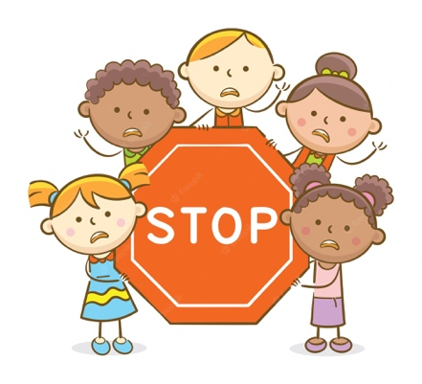

Here at Ratby, we explain bullying as being ‘Several Times On Purpose’ and encourage children to ‘Start Telling Other People’.

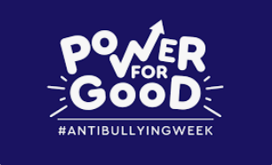
Every year we support ‘Anti-Bullying Week’ organised by the Anti- Bullying Alliance. ‘By making a positive change to show kindness and respect to everyone then we can stop bullying and create a safer environment where children can live, grow, play and learn’. (ABA)


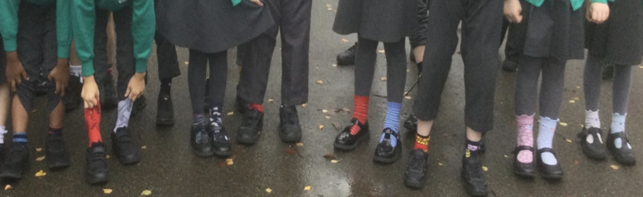
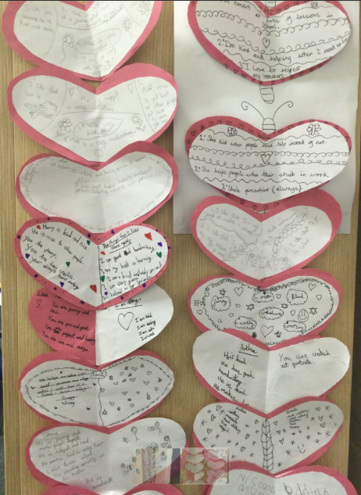
We must recognise and celebrate our differences. We are all unique and no-one should feel excluded or bullied as a result.

The links in the section below will hopefully help with further advice and information on a range of e-safety issues including online gaming, social media, live-streaming and cyberbullying).

