Bradgate Education Partnership – Religious Education Curriculum

Why teach RE?
Bradgate Education Partnership curriculum for religious education promotes the following:
- Respect
- Awareness of cultural difference
- Tolerance
- Diversity
- Acceptance
- British Values
- Beliefs
Curriculum Aims: At the end of their education in a BEP primary school, children will have developed mutual respect and tolerance for different faiths and beliefs. The curriculum enables both children and adults, within schools, to feel included and valued. Pupils will have an informed, empathetic and respectful view of society in order to promote tolerance and become responsible citizens. Children will be able to co-operate and engage critically with religions and beliefs in order to prepare them for later life and the society in which they live.
Stories are at the heart of this curriculum; many faiths have different stories that are fundamental to their beliefs. Subject matter is rich and relevant and enrichment opportunities such as visitors/visits/artefacts need to play a central part.

In our RE lessons, we aim to ensure that both our pupils’ substantive and disciplinary knowledge is built upon year on year.
Substantive Knowledge: Knowledge and ‘substance’ of our curriculum e.g. people, dates, features of something
Disciplinary Knowledge: Skills our children develop on how to interpret the world around them and the methods we use to gather information.
Personal Knowledge: The attitudes, experiences and assumptions which shape the way that students experience the religious and non-religious. Part of this knowledge is being aware of how this is changing over time and why.

Our curriculum is organised around four substantive strands of learning.
Substantive Strands of Learning
Belonging | Sacred and Special | Creation | Community
When you belong to a group, you feel welcomed and understood by other people in the group. An important part of belonging is that there is mutual understanding, acceptance and support. | Something sacred is holy, devoted to a religious ceremony, or simply worthy of awe and respect.  Special is distinctive, exceptional or extraordinary. | To make or bring in to existence. | A community is a group of people who have things in common. It could be they live in the same area, have similar backgrounds or worship a particular religion.

Five Fingers of Faith
All children will be familiar with the, ‘Five Fingers of Faith’. These cover five facts for each of the religions:
- Followers
- God/Founder
- Place of Worship
- Holy Text
- Celebrations
- Symbol
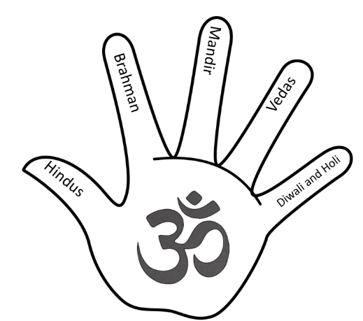
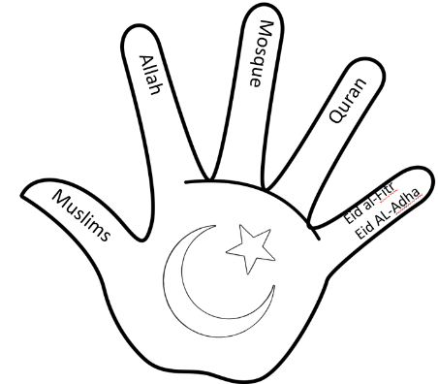
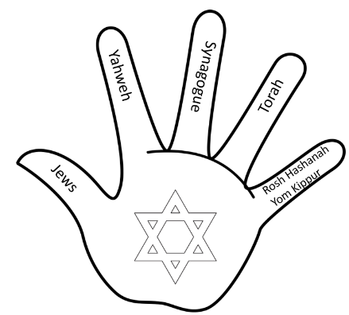
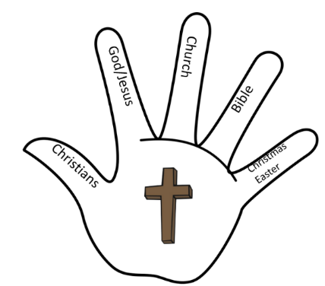
Children will have been exposed to these by the end of KS1. See Appendix 1.

