Below is the full 42 book list to the No Outsiders programme of work. We encourage our families to look at the books in order to gain a fully informed picture of the No Outsiders scheme in school.
Term | Autumn 1 | Autumn 2 | Spring 1 | Spring 2 | Summer 1 | Summer 2
Book  Title | You Choose | Red Rockets and Rainbow Jelly | Hello Hello. | Blue Chameleon | The Family Book | Super Duper You
 | 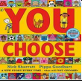 |  | 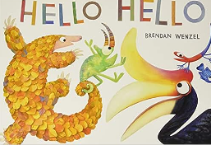 | 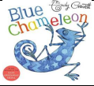 | 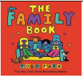 | 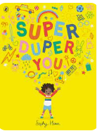
Theme | Pupil voice | Accepting difference | We are all different | Race | All families are different | Being bold, proud and brilliant
Lesson Objective | To say what I think | To understand that it’s okay to like different things. | To say hello | To make friends with someone who may be different to me | To understand that all families are different | To understand what I am like
EYFS

Year 1
Term | Autumn 1 | Autumn 2 | Spring 1 | Spring 2 | Summer 1 | Summer 2
Book  Title | Elmer | I Love me | Going to the Volcano | Errol’s Garden | Someone Just Like You | Bathe the Cat
 | 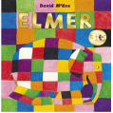 | 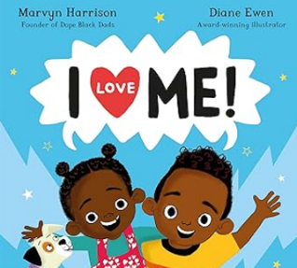 | 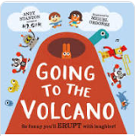 | 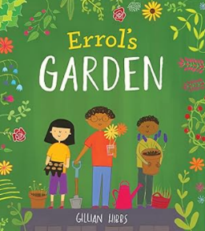 | 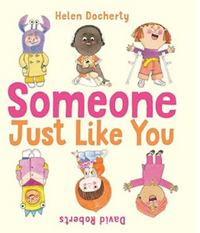 | 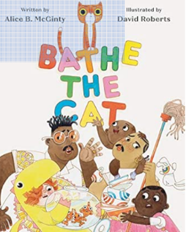
Theme | Race | Change | We can all play together | To ask for help | Feeling safe | To work together
Lesson Objective | To like the way I am | I know I am different/I can tell you how I am different/I can tell you what is great about me. | I know how it feels to join in/I know how it feels to be left out/I can let people join my games. | I know I can ask for help if I need it/I know how to ask for help/I know how to respond if someone asks for help. | How can I make someone feel safe? | I know all houses get messy/I know families can work together to clean the house/I can work as a team and solve a messy problem.

Year 2

Term | Autumn 1 | Autumn 2 | Spring 1 | Spring 2 | Summer 1 | Summer 2
Book  Title | Along Came a Different | Splash | Amazing | How to be a Lion | Is that your Mama? | The Perfect Fit
 | 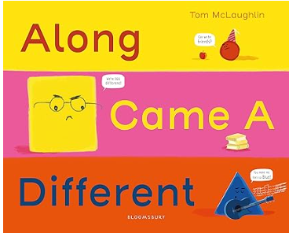 | 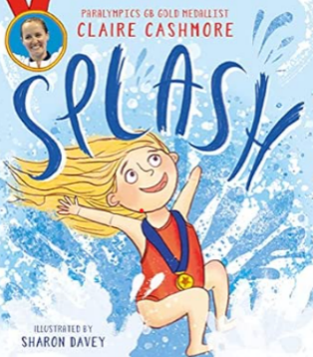 | 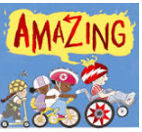 | 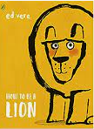 | 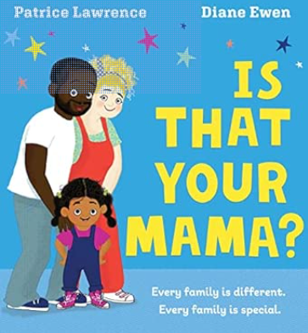 | 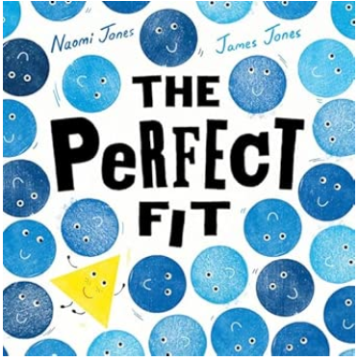
Theme | Being different | I can be what I want to be. | Friendship | That is okay to be different | Families look different | To know I fit in
Lesson Objective | To help someone accept difference | I know we all have dreams/I know sometimes dreams can seem impossible to achieve/I know why it’s important not to give up | To think about what makes a good friend | To have self confidence | I know what a family is/I know families look different/I can tell you about different kinds of families. | I know how it feels to join a game/I know how it feels to be left out of a game/I can think of ways to make sure everyone can join in.

Year 3

Term | Autumn 1 | Autumn 2 | Spring 1 | Spring 2 | Summer 1 | Summer 2
Book  Title | This is Our house | We’re all Wonders | The Truth About Old People | I am Nefertiti | Shu Lin’s Grandpa | Aalfred and Aabert. A Love Story
 | 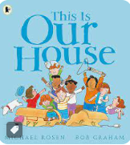 | 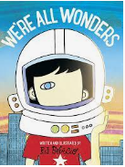 | 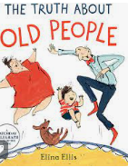 | 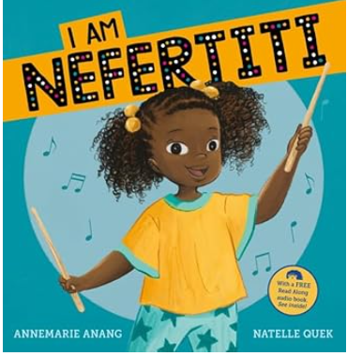 | 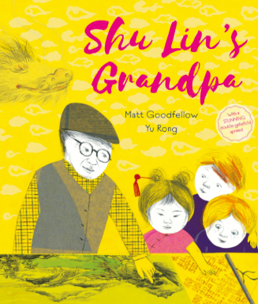 | 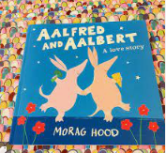
Theme | Discrimination | Anti-bullying | Everyone is different | Show respect | Show welcoming behaviour | To find common ground
Lesson Objective | To understand what discriminations means | To understand what a bystander is | To recognise stereotypes | I know everyone has a name/I know why names are important/I know why I don’t get to decide what to call you. | I know we were all new in class once/I can remember how it feels when you don’t know anyone/I can show empathy. | I know there are more things that we have in common than divide us.

Year 4
Term | Autumn 1 | Autumn 2 | Spring 1 | Spring 2 | Summer 1 | Summer 2
Book  Title | Red: A Crayon’s Story | When Sadness Comes to Call | Julian is a Mermaid | My Beautiful Voice | Remixed | My Brother George
 | 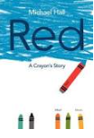 | 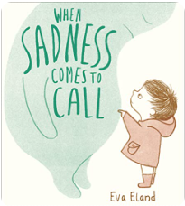 | 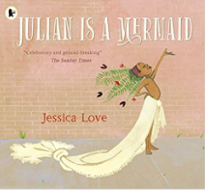 | 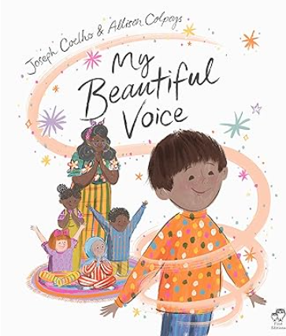 | 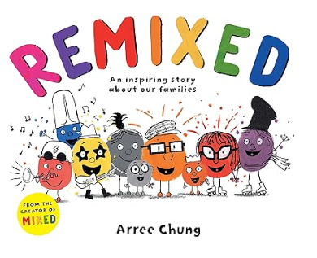 | 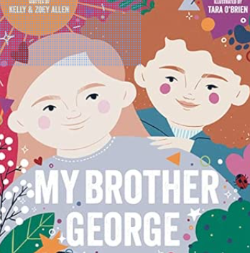
Theme | Acceptance and understanding | Changes in life | We are all different | To speak up. | To understand how families change. | To consider how my language affects others.
Lesson Objective | I know sometimes people change/I know what judgement is/I know how to be non-judgemental. | To look after my mental health | I know people can choose what to wear/I know people in my community wear different things/I can be accepting of differences. | I know I have a voice/I can choose to use my voice to add my ideas/I know sometimes it feels hard to speak out/I can find ways to speak up when I am nervous. | I know how families can change/I know change can be hard to manage/I understand changes are often out of my control. | I know we are all different/I know what judgement is/I know I can choose how to respond in a situation/I know how my language can affect others.

Term | Autumn 1 | Autumn 2 | Spring 1 | Spring 2 | Summer 1 | Summer 2
Book  Title | The Girls | The Boys | And Tango Makes Three | To the Other Side | Mixed. An inspiring story about colour | Milo Imagines the World
 | 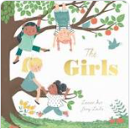 | 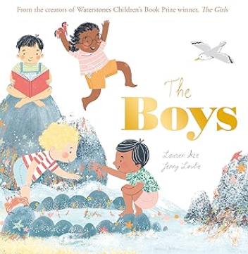 | 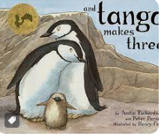 | 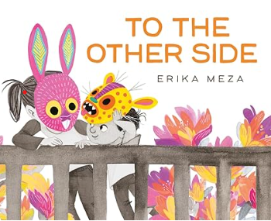 | 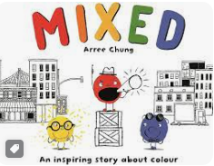 | 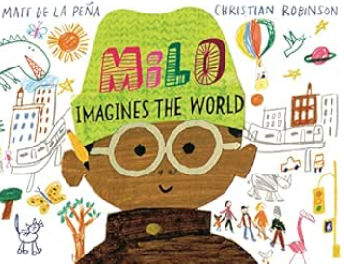
Theme | Secure meaningful relationships | Check in with people | Prejudice, different ideas and coexistence | Explore your dreams | Racism | Try not to judge appearances
Lesson Objective | To explore friendship | I know how to work as a team/I know how mental health can be affected by friendship/I know how to make someone feel valued | To exchange dialogue and express an opinion | To explore whatever your dream are | To consider responses to racist behaviour | I know appearances can deceive/I know it’s hard not to judge someone on their appearance/I know what non-judgemental means/I know how I can try to remain non-judgemental.
Year 5

Year 6

Term | Autumn 1 | Autumn 2 | Spring 1 | Spring 2 | Summer 1 | Summer 2
Book  Title | The Island | Introducing Teddy | The Proudest Blue | You need to Chill | You’re so Amazing | Saving the Butterfly
 | 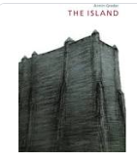 | 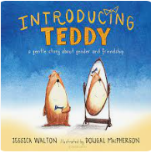 | 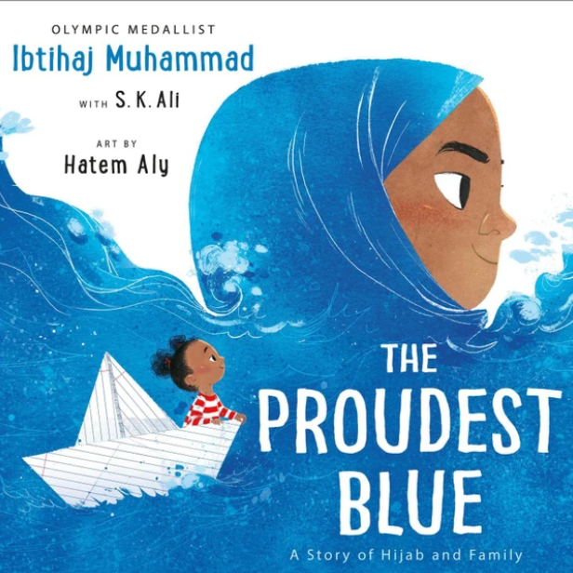 | 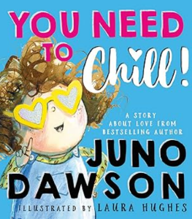 | 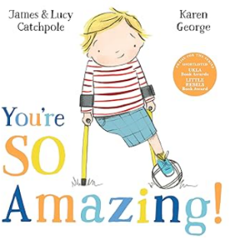 | 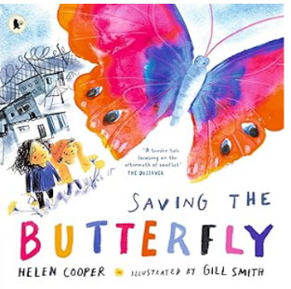
Theme | Race, refugees, prejudice | Celebration | Consider how new experiences affect us | To consider responses to changes | To consider attitudes towards disability. | To share how experiences shape us
Lesson Objective | To consider the causes of racism | To show acceptance | I know how people in my community are different/I can show respect to people different to me. | I know we are all different/I know what judgement is/I can choose to respond in a judgemental or a non-judgemental way. | I know there are often judgemental attitudes in society about disability/I can work to break down those attitudes. | I know people have different experiences that can affect their behaviour/I know how to give someone space when they need it/I know sometimes people need time to be ok/I can give someone space and time if they need it.

