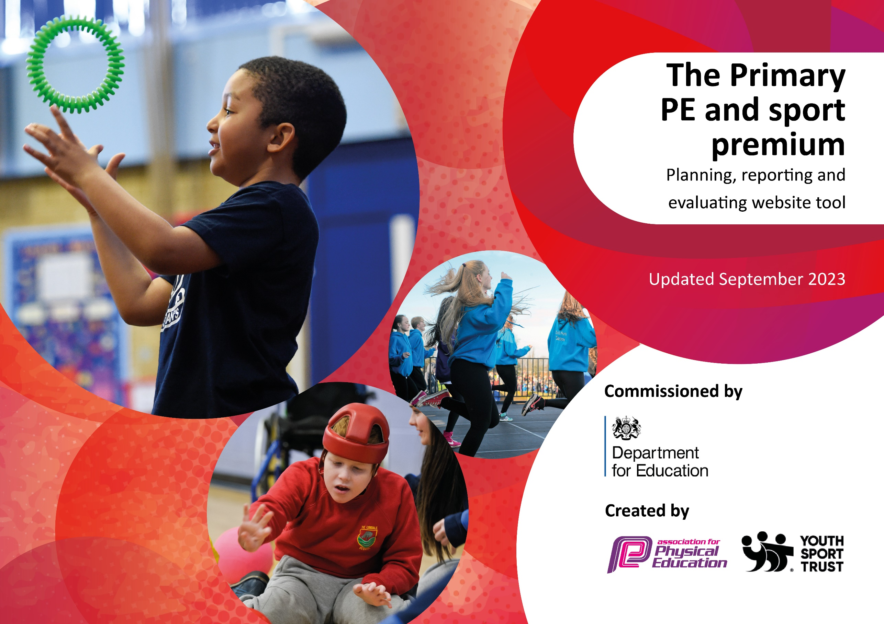

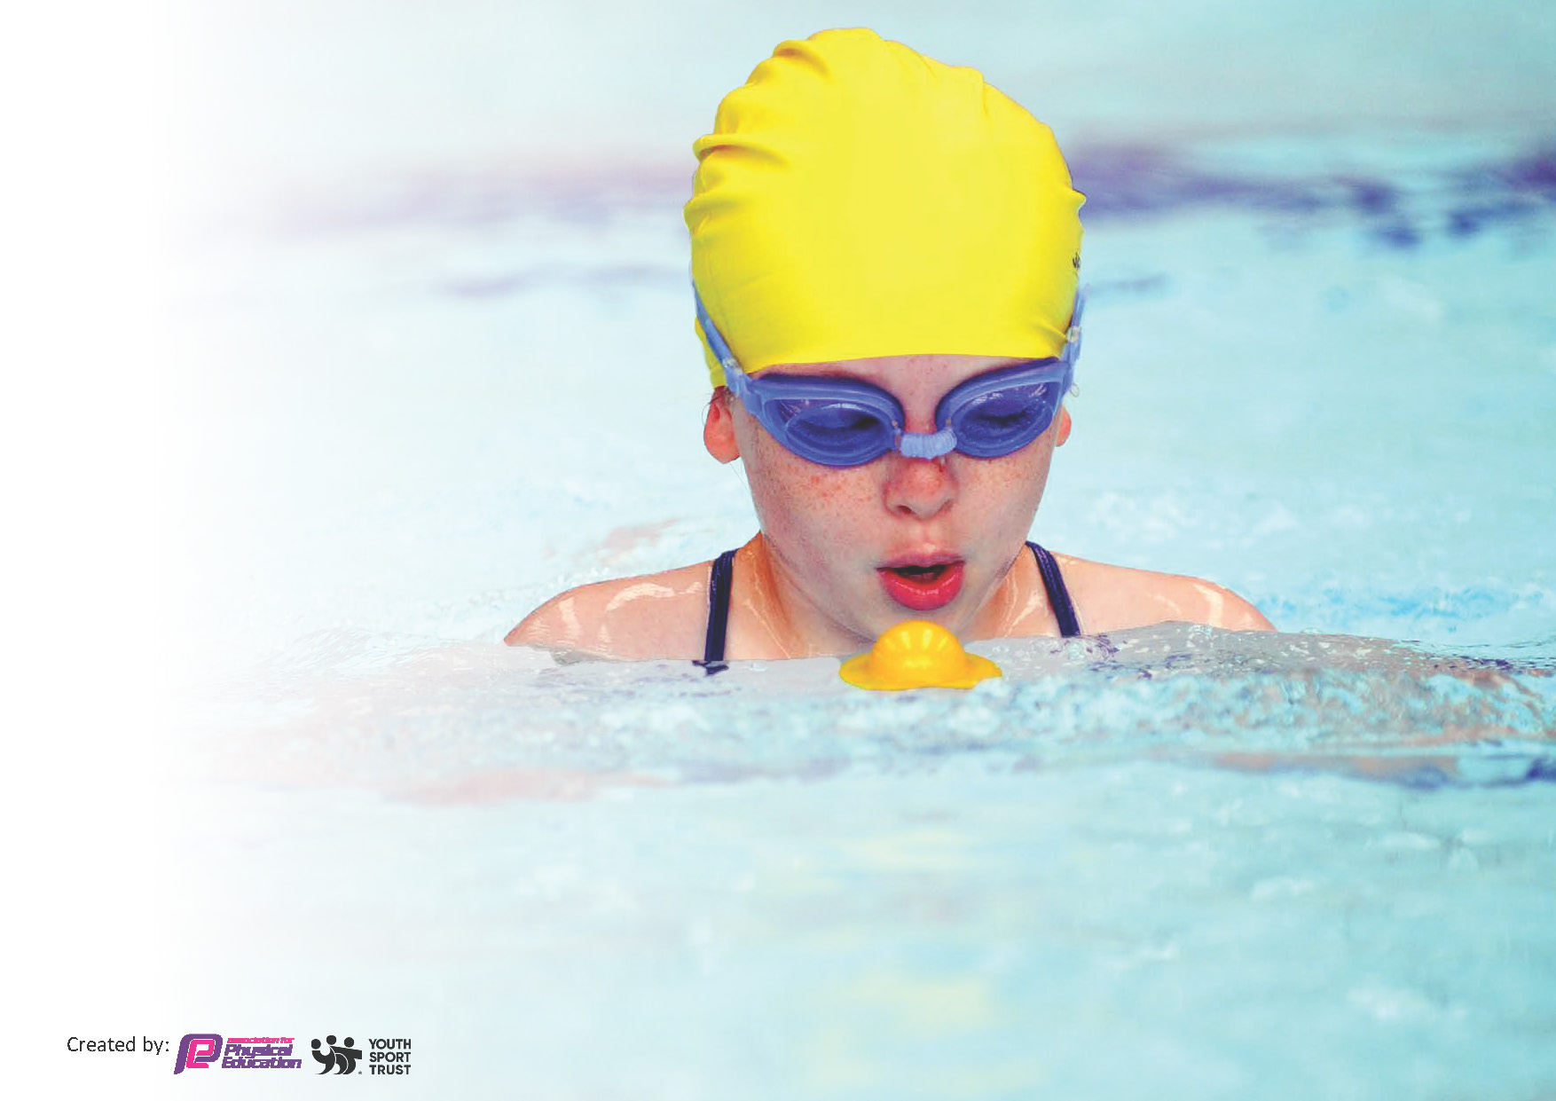
This template can be used for multiple purposes:
by:
- It enables schools to effectively plan their use of the Primary PE and sport premium
- It helps schools to meet the requirements (as set out in guidance) to publish information on their Primary PE and sport premium
- It will be an effective document to support Ofsted inspections enabling schools to evidence progress in Physical Education (PE) and evidence swimming attainment, which forms part of the PE National Curriculum. We would recommend schools consider
the Intent, Implementation and Impact of any spend, as examined within the Education Inspection Framework.

It is important that your grant is used effectively and based on school need.

Schools must use the funding to make additional and sustainable
improvements to the quality of the PE, School Sport and Physical Activity (PESSPA)
they offer. This means that you should use the Primary PE and sport premium to:

- Build capacity and capability within the school to ensure that improvements made now will benefit pupils joining the school in future years
- Develop or add to the PESSPA activities that your school already offers.

The Primary PE and sport premium should not be used to fund capital spend projects; the school’s core budget should fund these. Further detail on capital expenditure can be found in the updated Primary PE and sport premium guidance.

The Primary PE and sport premium guidance, outlines 5 key priorities that funding should be used towards. It is not

necessary that spending has to meet all the key priorities, you should select the priorities that you aim to use any funding towards.

Although completing this template is not a requirement for schools, schools are required to publish details of how they spend this funding. Schools must also outline what the impact this funding has had on pupils’ PE and sport participation and attainment and how any spending will be sustainable in the future. All funding must be spent by 31st July 2025.

The Department for Education has worked closely with the Association for Physical Education (afPE) and the Youth Sport Trust (YST) to develop this template and encourages schools to use it. This template is an effective way of meeting the reporting requirements of the Primary PE and sport premium.
Review of last year’s spend and key achievements (2024/2025)

We recommend you start by reflecting on the impact of current provision and reviewing your previous spend.

Activity/Action | Impact | Comments
HBSSPAN extra-curricular buy in to competition and events  Profile of PE has been raised through PE board, Social Media and celebration assemblies.  Weekly PE certificate for one pupil per class and any certificates or medals received while participating for the school or outside of school are presented at weekly Key Stage assembly includes gymnastics, dance, swimming etc  Replacement of used and worn out equipment  Provision of lunchtime coaches | Increased number of pupils taking part in competitions against other schools  Students are sharing their outside achievements within school, thus raising the profile of non-curricular and extracurricular opportunities.  Team photos are displayed fir all competitions/events where they have represented the school  Appropriate pictures also shared on school Twitter account  Staff able to deliver the curriculum increased participation as not needing the share  Delivery of football and other activities at lunchtime | High demand for participation- demand outstrips available places  Profile of positive participation in physical activity has been raised  Increased awareness of opportunities in the wider community.  Children enjoy using newer equipment and are more excited and motivated.  Very high demand for positive sporting opportunities at lunchtime.

Key priorities and Planning for 2025/2026 Allocation: £19,230
This planning template will allow schools to accurately plan their spending.

Action – what are you planning to do | Who does this action impact? | Key indicator to meet | Impacts and how sustainability will be achieved? | Cost linked to the action
Provide PE Lead and Sports Coach with leadership time to promote and organise PE and extra-curricular opportunities for pupil | PE Leads attend Trust Network meetings and HBSSPAN Network meetings.  School buy into HBSSPAN subscription which enables pupils to access wide range of competitions and events as well as other local events. e.g Marconi Football Cup, Area Athletics and Cross Country events. | Participation in inter and intra-school competitions and the promotion of PE within school. | Increased numbers of pupils taking part in intra-schools’ competitions.  Competitions have been well received by pupils and parents in recent years (24/25) | £1,155  £224  HBSSPAN Buy In  PE Leads will have access to information regarding upcoming festivals, competitions and events that pupils are able to participate in and will be able to plan for school entry into a wide variety of events promoting a wider range of sports
Inspect and replace as necessary any worn equipment / purchase any new resources needed in light of adjustments made to PE provision this year.  Purchase of new equipment to ensure delivery of the new activities in ‘Get Set 4 PE’ curriculum | All staff and coaches. | Staff are able to carry out all activities planned including warm up. | More pupils meeting their daily physical activity goal, more pupils encouraged to take part in PE and sport activities. | £7575.53  Large investment in new gymnastics mats and a springboard  Investment in sensory PE equipment
CPD for teachers at the start of the school year to prepare for implementation of the ‘Get Set 5 PE’ curriculum.  Discuss with staff any training required / gaps in knowledge. | Primary generalist teachers. | Key Indicator 1: Increased confidence, knowledge, and skills of all staff in teaching PE and sport.  Key indicator 5: Increased participation in competitive sport. | Primary teachers more confident to deliver effective PE supporting pupils to undertake extra activities inside and outside of school | £584.25  Staff time – CPD on new ‘Get Set 4 PE’ curriculum provided by PE staff and trainer from ‘Get Set 4 PE’ virtually  Staff and pupil survey conducted at the end of the year.
Support teachers in planning and delivery of two high quality PE lessons every week including gymnastics and dance | Staff to feel more confident and empowered when teaching the primary PE curriculum as a result of high quality CPD training and the resources available in ‘Get Set 4 PE’ | - Staff training and support  - Teaching and learning, assessment and planning  - Support with inclusion, engagement and developing the school culture  - Tracking system for pupil achievement and progress  - Development of health and well-being  - Competitive opportunities  - Enrichment opportunities  - Whole school self-evaluation tool. | Continue to review, refine PE Long Term Map to ensure it reflects needs of the school. | ‘Get Set 4 PE’ subscription funded by school budget
Review PE curriculum for 26/27 | Staff were surveyed at the end of the school year to gather feedback on ‘Get Set 4 PE’ curriculum. | - Staff are independently delivering the new curriculum using new scheme and equipment provided be able to independently deliver all aspects of the PE National curriculum. | Staff now delivering their high-quality PE lessons without the presence of specialist coaches.  This has led to greater sustainability as no need to hire specialist coaches. | Get Set 4 PE curriculum to be purchased for 26/27 year from school budget
To offer high-quality lunchtime experiences for pupils, expanding opportunities available for physical activity and school sports for pupils | Through setting up of non-competitive physical activities the number of targeted under-active pupils taking part in physical activity at lunchtime increases  Increased number of pupils choose to engage in range of physical activities at lunchtimes.  Children enjoy lunchtimes due to the range of provision available. Number of lunchtime incidents reduced to do range of activities and adult-led provision on offer.  Staff feel empowered to lead activities which support active lunchtimes, | Continue to deploy lunchtime coaches to support high quality provision at lunchtimes.  Continue to develop lunch time provision to promote active lifestyles and sporting activities. | Equipment and routines/time tables for pupils to take part in lunchtime activities are now in place and regularly used by pupils.  More pupils meeting their daily physical activity goal, more pupils encouraged to take part in PE and sport activities. | £7752.00
Consolidate and evaluate the system to support children’s self-evaluation of the knowledge and skills of the PE Curriculum | Students and teachers | Get Set 4 PE Scheme builds on learning from previous units but provide sufficient learning that new activities can be introduced at any time during the school year for the first time. | Embedded in the scheme and will continue as scheme is purchased for 26/27

Key achievements 2025-2026
This template will be completed at the end of the academic year and will showcase the key achievements schools have made with their Primary PE and sport premium spending.

Activity/Action | Impact | Comments
- HBSSPAN extra-curricular activities buy-in  - Equipment replacement and different new equipment for new curriculum areas  - Introduction of new Get Set 4 PE curriculum.  - Staff now independently delivering PE lessons  - Use of Sports Coaches at lunchtime on a rotating timetable of year groups  - Knowledge organizers displayed in classrooms  - Focus on key words | - Pupils took part in a variety of sports competitions including football, dodgeball, cross-country and athletics  - There has been sufficient equipment for all children to take part safely in all PE activities at the same time  - Staff are now more confident in delivering their own PE lessons, especially in outdoor PE  - Children exposed to new activities such as Parkour and Handball  - Better resources (music, videos and teaching cards within the lessons plans of the scheme)  - New curriculum develops more consistent progress across the years.  - More children have chosen to take part in physical activities at lunchtime as these have been supervised.  - A variety of sports have been played so children don’t just play football.  - Year 6 Football team, once they reached the play offs, received once weekly football coaching during lunchtime.  - Pupils’ knowledge of familiar and new activities increases.  - Improved knowledge of key skills for different activities.  - Increased PE vocabulary as | Competitions have been well received by pupils and parents, demand outstrips places at all events  New gym mats and spring board purchased to replace worn equipment. Some SEN PE equipment has been purchased and used with specific pupils.  Moved to Get Set 4 Curriculum this year. Teachers delivered all of the PE curriculum with the support of the PE leads and the scheme but no external coaches .  Children more active at lunchtime and experiencing competition  Year 6 football team qualified for and played in the County Final at Leicester City Football Club  Improved retrieval of PE learning across the years  Improved PE literacy due to exposure to key words through teaching and the ‘Get Set 4 PE’ curriculum

Swimming Data
Meeting National Curriculum requirements for swimming and water safety.
Priority should always be given to ensuring that pupils can perform safe self-rescue even if they do not fully meet the first two requirements of the National Curriculum programme of study

Question | Stats: | Further context  Relative to local challenges
What percentage of your current Year 6 cohort can swim competently, confidently and proficiently over a distance of at least 25 metres? | 88% | 7 out of 57 can’t swim  Many children do not have lessons outside of the school curriculum.  Transport costs involved in taking children to the nearest pool. £2200
What percentage of your current Year 6 cohort can use a range of strokes effectively [for example, front crawl, backstroke, and breaststroke]? | 84%
What percentage of your current Year 6 cohort are able to perform safe self-rescue in different water-based situations? | 63%
If your schools swimming data is below national expectation, you can choose to use the Primary PE and sport premium to provide additional top-up sessions for those pupils that did not meet National Curriculum  requirements after the completion of core lessons. Have you done this? | Not sure
Have you provided CPD to improve the knowledge and confidence of staff to be able to teach swimming and water safety? | No

Signed off by:

Head Teacher: | Anne Perry
Subject Leader or the individual responsible for the Primary PE and sport premium:
Governor:
Date: | 5.7.2026

